UNITED STATES
SECURITIES AND EXCHANGE COMMISSION
Washington, D.C. 20549

FORM 6-K

REPORT OF FOREIGN PRIVATE ISSUER
PURSUANT TO RULE 13a-16 OR 15d-16 UNDER
THE SECURITIES EXCHANGE ACT OF 1934

For the month of June 2026

Commission File Number: 001-39436

KE Holdings Inc.
(Registrant’s Name)

Oriental Electronic Technology Building,
No. 2 Chuangye Road, Haidian District,
Beijing 100086
People’s Republic of China
(Address of Principal Executive Offices)

Indicate by check mark whether the registrant files or will file annual reports under cover Form 20-F or Form 40-F.

Form 20-F ☒ Form 40-F ☐

EXHIBIT INDEX

Exhibit No. |  | Description
99.1 |  | Next Day Disclosure Return Dated June 1, 2026
99.2 |  | Next Day Disclosure Return Dated June 1, 2026
99.3 |  | Next Day Disclosure Return Dated June 2, 2026
99.4 |  | Next Day Disclosure Return Dated June 3, 2026
99.5 |  | Next Day Disclosure Return Dated June 4, 2026
99.6 |  | Next Day Disclosure Return Dated June 5, 2026

SIGNATURES

Pursuant to the requirements of the Securities Exchange Act of 1934, the registrant has duly caused this report to be signed on its behalf by the undersigned, thereunto duly authorized.

 | KE Holdings Inc.
 | By | : | /s/ XU Tao
 | Name | : | XU Tao
 | Title | : | Chief Financial Officer

Date: June 8, 2026

Exhibit 99.1
 | 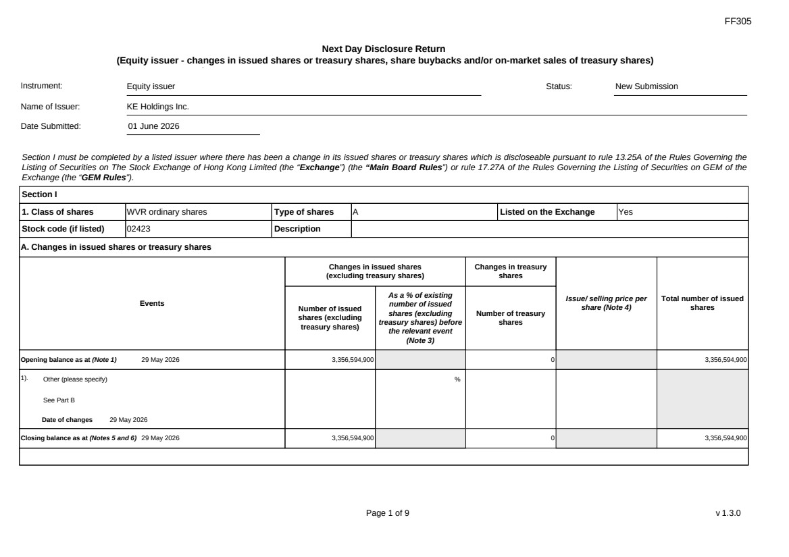 | FF305 Page 1 of 9 v 1.3.0 Next Day Disclosure Return (Equity issuer - changes in issued shares or treasury shares, share buybacks and/or on-market sales of treasury shares) Instrument: Equity issuer Status: New Submission Name of Issuer: KE Holdings Inc. Date Submitted: 01 June 2026 Section I must be completed by a listed issuer where there has been a change in its issued shares or treasury shares which is discloseable pursuant to rule 13.25A of the Rules Governing the Listing of Securities on The Stock Exchange of Hong Kong Limited (the “Exchange”) (the “Main Board Rules”) or rule 17.27A of the Rules Governing the Listing of Securities on GEM of the Exchange (the “GEM Rules”). Section I 1. Class of shares WVR ordinary shares Type of shares A Listed on the Exchange Yes Stock code (if listed) 02423 Description A. Changes in issued shares or treasury shares Events Changes in issued shares (excluding treasury shares) Number of issued shares (excluding treasury shares) As a % of existing number of issued shares (excluding treasury shares) before the relevant event (Note 3) Changes in treasury shares Number of treasury shares Issue/ selling price per share (Note 4) Total number of issued shares Opening balance as at (Note 1) 29 May 2026 3,356,594,900 0 3,356,594,900 1). Other (please specify) See Part B Date of changes 29 May 2026 % Closing balance as at (Notes 5 and 6) 29 May 2026 3,356,594,900 0 3,356,594,900
 | 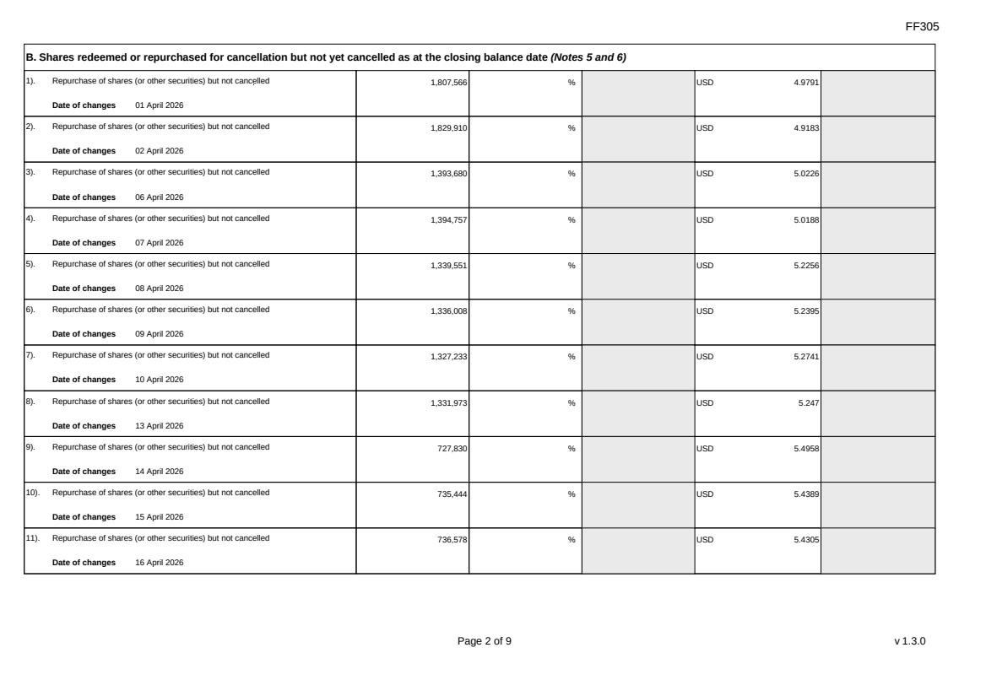 | FF305 Page 2 of 9 v 1.3.0 B. Shares redeemed or repurchased for cancellation but not yet cancelled as at the closing balance date (Notes 5 and 6) 1). Repurchase of shares (or other securities) but not cancelled Date of changes 01 April 2026 1,807,566 % USD 4.9791 2). Repurchase of shares (or other securities) but not cancelled Date of changes 02 April 2026 1,829,910 % USD 4.9183 3). Repurchase of shares (or other securities) but not cancelled Date of changes 06 April 2026 1,393,680 % USD 5.0226 4). Repurchase of shares (or other securities) but not cancelled Date of changes 07 April 2026 1,394,757 % USD 5.0188 5). Repurchase of shares (or other securities) but not cancelled Date of changes 08 April 2026 1,339,551 % USD 5.2256 6). Repurchase of shares (or other securities) but not cancelled Date of changes 09 April 2026 1,336,008 % USD 5.2395 7). Repurchase of shares (or other securities) but not cancelled Date of changes 10 April 2026 1,327,233 % USD 5.2741 8). Repurchase of shares (or other securities) but not cancelled Date of changes 13 April 2026 1,331,973 % USD 5.247 9). Repurchase of shares (or other securities) but not cancelled Date of changes 14 April 2026 727,830 % USD 5.4958 10). Repurchase of shares (or other securities) but not cancelled Date of changes 15 April 2026 735,444 % USD 5.4389 11). Repurchase of shares (or other securities) but not cancelled Date of changes 16 April 2026 736,578 % USD 5.4305
 | 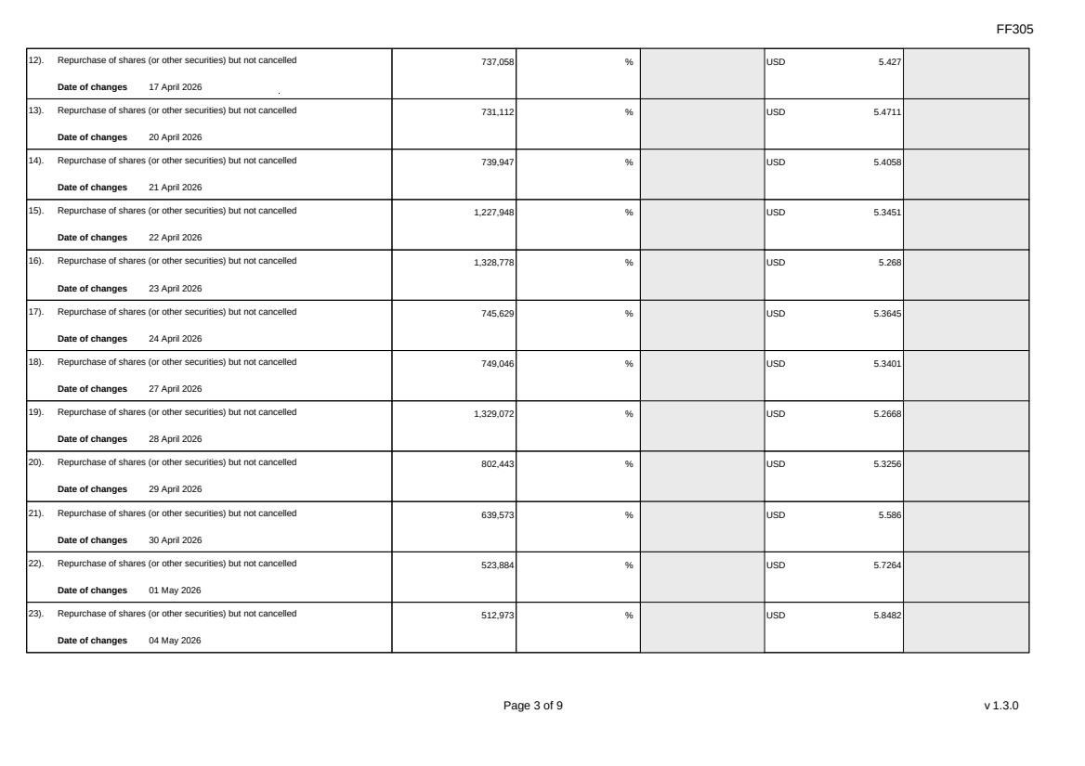 | FF305 Page 3 of 9 v 1.3.0 12). Repurchase of shares (or other securities) but not cancelled Date of changes 17 April 2026 737,058 % USD 5.427 13). Repurchase of shares (or other securities) but not cancelled Date of changes 20 April 2026 731,112 % USD 5.4711 14). Repurchase of shares (or other securities) but not cancelled Date of changes 21 April 2026 739,947 % USD 5.4058 15). Repurchase of shares (or other securities) but not cancelled Date of changes 22 April 2026 1,227,948 % USD 5.3451 16). Repurchase of shares (or other securities) but not cancelled Date of changes 23 April 2026 1,328,778 % USD 5.268 17). Repurchase of shares (or other securities) but not cancelled Date of changes 24 April 2026 745,629 % USD 5.3645 18). Repurchase of shares (or other securities) but not cancelled Date of changes 27 April 2026 749,046 % USD 5.3401 19). Repurchase of shares (or other securities) but not cancelled Date of changes 28 April 2026 1,329,072 % USD 5.2668 20). Repurchase of shares (or other securities) but not cancelled Date of changes 29 April 2026 802,443 % USD 5.3256 21). Repurchase of shares (or other securities) but not cancelled Date of changes 30 April 2026 639,573 % USD 5.586 22). Repurchase of shares (or other securities) but not cancelled Date of changes 01 May 2026 523,884 % USD 5.7264 23). Repurchase of shares (or other securities) but not cancelled Date of changes 04 May 2026 512,973 % USD 5.8482
 | 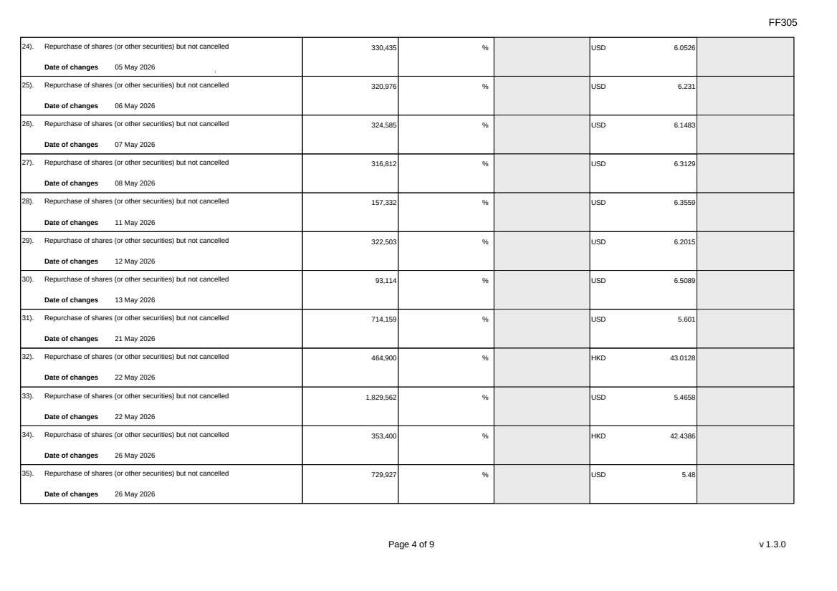 | FF305 Page 4 of 9 v 1.3.0 24). Repurchase of shares (or other securities) but not cancelled Date of changes 05 May 2026 330,435 % USD 6.0526 25). Repurchase of shares (or other securities) but not cancelled Date of changes 06 May 2026 320,976 % USD 6.231 26). Repurchase of shares (or other securities) but not cancelled Date of changes 07 May 2026 324,585 % USD 6.1483 27). Repurchase of shares (or other securities) but not cancelled Date of changes 08 May 2026 316,812 % USD 6.3129 28). Repurchase of shares (or other securities) but not cancelled Date of changes 11 May 2026 157,332 % USD 6.3559 29). Repurchase of shares (or other securities) but not cancelled Date of changes 12 May 2026 322,503 % USD 6.2015 30). Repurchase of shares (or other securities) but not cancelled Date of changes 13 May 2026 93,114 % USD 6.5089 31). Repurchase of shares (or other securities) but not cancelled Date of changes 21 May 2026 714,159 % USD 5.601 32). Repurchase of shares (or other securities) but not cancelled Date of changes 22 May 2026 464,900 % HKD 43.0128 33). Repurchase of shares (or other securities) but not cancelled Date of changes 22 May 2026 1,829,562 % USD 5.4658 34). Repurchase of shares (or other securities) but not cancelled Date of changes 26 May 2026 353,400 % HKD 42.4386 35). Repurchase of shares (or other securities) but not cancelled Date of changes 26 May 2026 729,927 % USD 5.48
 | 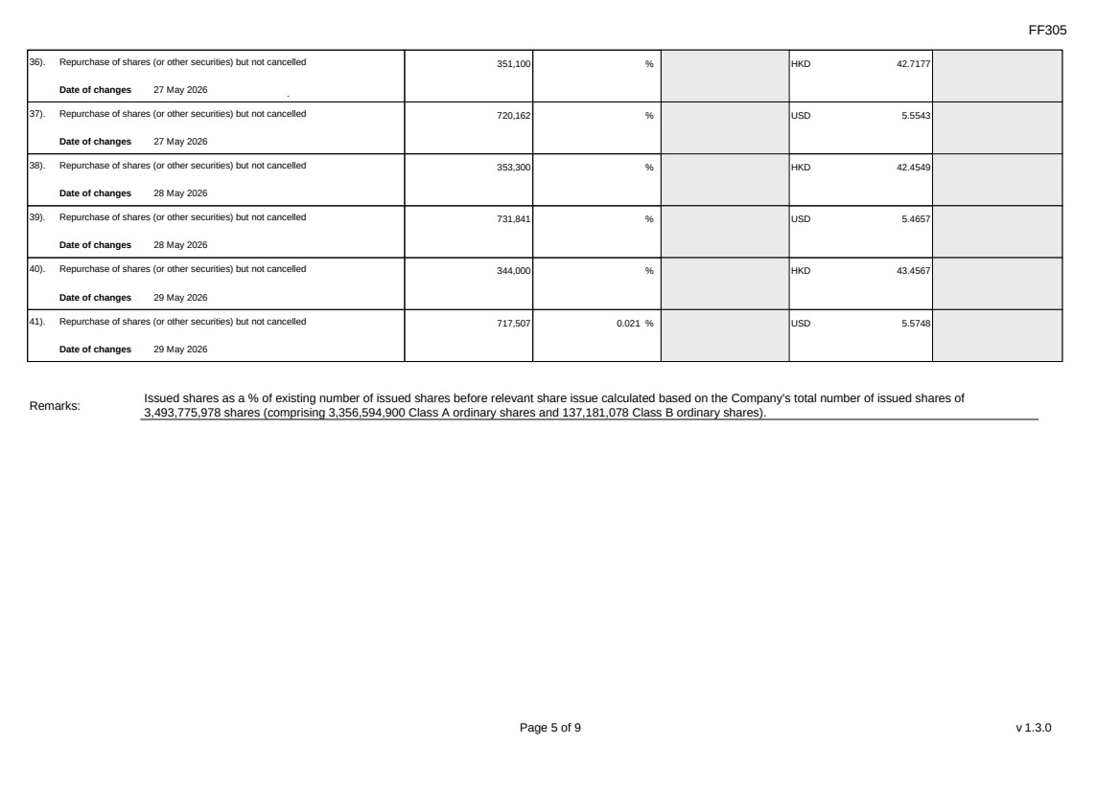 | FF305 Page 5 of 9 v 1.3.0 36). Repurchase of shares (or other securities) but not cancelled Date of changes 27 May 2026 351,100 % HKD 42.7177 37). Repurchase of shares (or other securities) but not cancelled Date of changes 27 May 2026 720,162 % USD 5.5543 38). Repurchase of shares (or other securities) but not cancelled Date of changes 28 May 2026 353,300 % HKD 42.4549 39). Repurchase of shares (or other securities) but not cancelled Date of changes 28 May 2026 731,841 % USD 5.4657 40). Repurchase of shares (or other securities) but not cancelled Date of changes 29 May 2026 344,000 % HKD 43.4567 41). Repurchase of shares (or other securities) but not cancelled Date of changes 29 May 2026 717,507 0.021 % USD 5.5748 Remarks: Issued shares as a % of existing number of issued shares before relevant share issue calculated based on the Company's total number of issued shares of 3,493,775,978 shares (comprising 3,356,594,900 Class A ordinary shares and 137,181,078 Class B ordinary shares).
 | 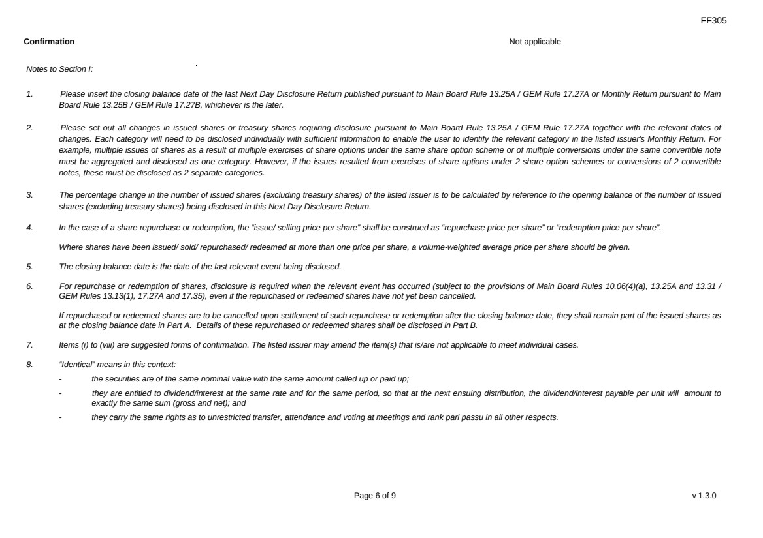 | FF305 Page 6 of 9 v 1.3.0 Confirmation Not applicable Notes to Section I: 1. Please insert the closing balance date of the last Next Day Disclosure Return published pursuant to Main Board Rule 13.25A / GEM Rule 17.27A or Monthly Return pursuant to Main Board Rule 13.25B / GEM Rule 17.27B, whichever is the later. 2. Please set out all changes in issued shares or treasury shares requiring disclosure pursuant to Main Board Rule 13.25A / GEM Rule 17.27A together with the relevant dates of changes. Each category will need to be disclosed individually with sufficient information to enable the user to identify the relevant category in the listed issuer's Monthly Return. For example, multiple issues of shares as a result of multiple exercises of share options under the same share option scheme or of multiple conversions under the same convertible note must be aggregated and disclosed as one category. However, if the issues resulted from exercises of share options under 2 share option schemes or conversions of 2 convertible notes, these must be disclosed as 2 separate categories. 3. The percentage change in the number of issued shares (excluding treasury shares) of the listed issuer is to be calculated by reference to the opening balance of the number of issued shares (excluding treasury shares) being disclosed in this Next Day Disclosure Return. 4. In the case of a share repurchase or redemption, the “issue/ selling price per share” shall be construed as “repurchase price per share” or “redemption price per share”. Where shares have been issued/ sold/ repurchased/ redeemed at more than one price per share, a volume-weighted average price per share should be given. 5. The closing balance date is the date of the last relevant event being disclosed. 6. For repurchase or redemption of shares, disclosure is required when the relevant event has occurred (subject to the provisions of Main Board Rules 10.06(4)(a), 13.25A and 13.31 / GEM Rules 13.13(1), 17.27A and 17.35), even if the repurchased or redeemed shares have not yet been cancelled. If repurchased or redeemed shares are to be cancelled upon settlement of such repurchase or redemption after the closing balance date, they shall remain part of the issued shares as at the closing balance date in Part A. Details of these repurchased or redeemed shares shall be disclosed in Part B. 7. Items (i) to (viii) are suggested forms of confirmation. The listed issuer may amend the item(s) that is/are not applicable to meet individual cases. 8. “Identical” means in this context: - the securities are of the same nominal value with the same amount called up or paid up; - they are entitled to dividend/interest at the same rate and for the same period, so that at the next ensuing distribution, the dividend/interest payable per unit will amount to exactly the same sum (gross and net); and - they carry the same rights as to unrestricted transfer, attendance and voting at meetings and rank pari passu in all other respects.
 | 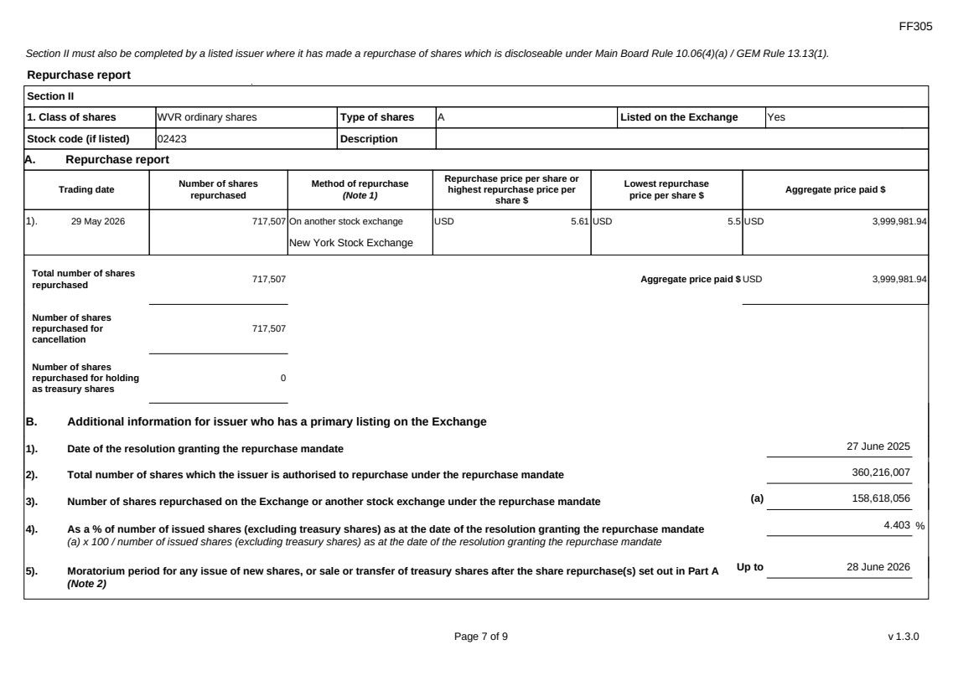 | FF305 Page 7 of 9 v 1.3.0 Section II must also be completed by a listed issuer where it has made a repurchase of shares which is discloseable under Main Board Rule 10.06(4)(a) / GEM Rule 13.13(1). Repurchase report Section II 1. Class of shares WVR ordinary shares Type of shares A Listed on the Exchange Yes Stock code (if listed) 02423 Description A. Repurchase report Trading date Number of shares repurchased Method of repurchase (Note 1) Repurchase price per share or highest repurchase price per share $ Lowest repurchase price per share $ Aggregate price paid $ 1). 29 May 2026 717,507 On another stock exchange New York Stock Exchange USD 5.61 USD 5.5 USD 3,999,981.94 Total number of shares repurchased 717,507 Aggregate price paid $ USD 3,999,981.94 Number of shares repurchased for cancellation 717,507 Number of shares repurchased for holding as treasury shares 0 B. Additional information for issuer who has a primary listing on the Exchange 1). Date of the resolution granting the repurchase mandate 27 June 2025 2). Total number of shares which the issuer is authorised to repurchase under the repurchase mandate 360,216,007 3). Number of shares repurchased on the Exchange or another stock exchange under the repurchase mandate (a) 158,618,056 4). As a % of number of issued shares (excluding treasury shares) as at the date of the resolution granting the repurchase mandate (a) x 100 / number of issued shares (excluding treasury shares) as at the date of the resolution granting the repurchase mandate 4.403 % 5). Moratorium period for any issue of new shares, or sale or transfer of treasury shares after the share repurchase(s) set out in Part A (Note 2) Up to 28 June 2026
 | 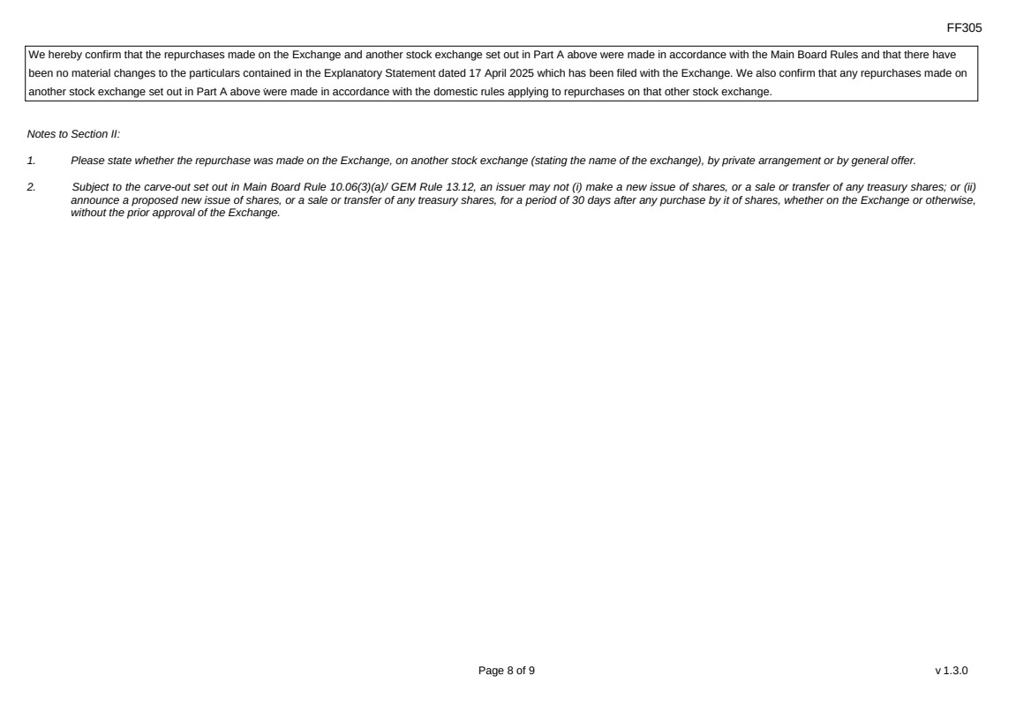 | FF305 Page 8 of 9 v 1.3.0 We hereby confirm that the repurchases made on the Exchange and another stock exchange set out in Part A above were made in accordance with the Main Board Rules and that there have been no material changes to the particulars contained in the Explanatory Statement dated 17 April 2025 which has been filed with the Exchange. We also confirm that any repurchases made on another stock exchange set out in Part A above were made in accordance with the domestic rules applying to repurchases on that other stock exchange. Notes to Section II: 1. Please state whether the repurchase was made on the Exchange, on another stock exchange (stating the name of the exchange), by private arrangement or by general offer. 2. Subject to the carve-out set out in Main Board Rule 10.06(3)(a)/ GEM Rule 13.12, an issuer may not (i) make a new issue of shares, or a sale or transfer of any treasury shares; or (ii) announce a proposed new issue of shares, or a sale or transfer of any treasury shares, for a period of 30 days after any purchase by it of shares, whether on the Exchange or otherwise, without the prior approval of the Exchange.
 | 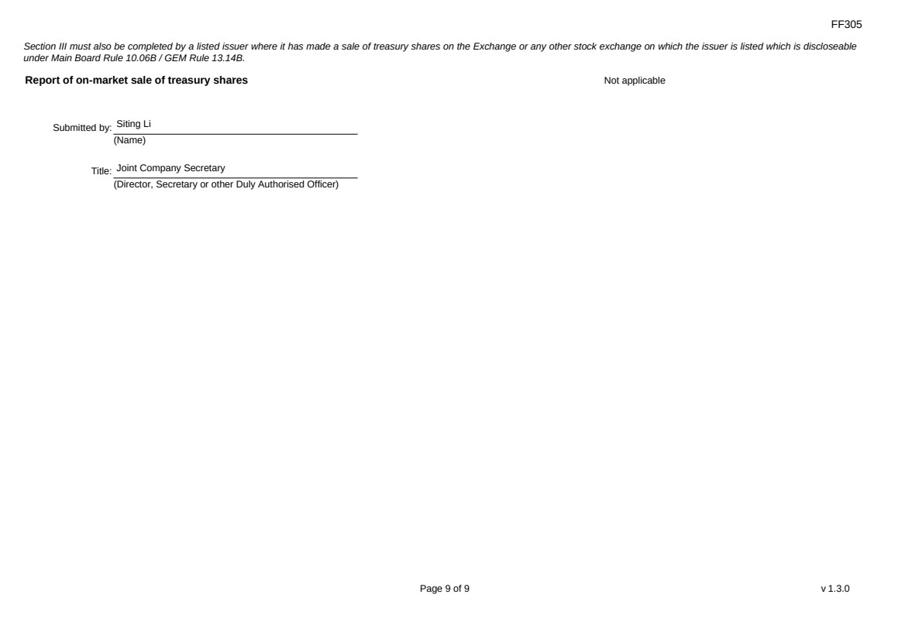 | FF305 Page 9 of 9 v 1.3.0 Section III must also be completed by a listed issuer where it has made a sale of treasury shares on the Exchange or any other stock exchange on which the issuer is listed which is discloseable under Main Board Rule 10.06B / GEM Rule 13.14B. Report of on-market sale of treasury shares Not applicable Submitted by: Siting Li (Name) Title: Joint Company Secretary (Director, Secretary or other Duly Authorised Officer)
Exhibit 99.2
 | 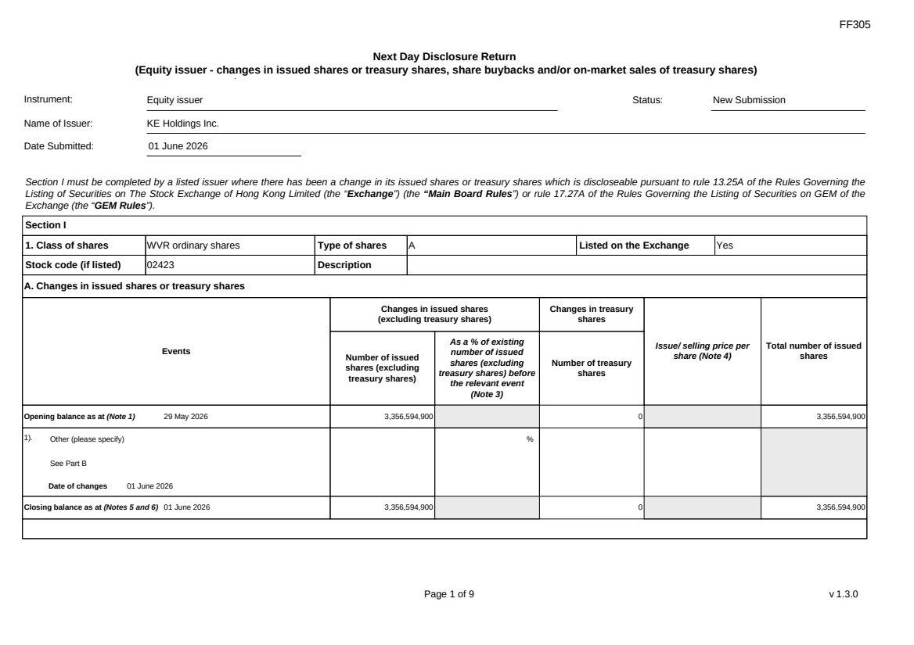 | FF305 Page 1 of 9 v 1.3.0 Next Day Disclosure Return (Equity issuer - changes in issued shares or treasury shares, share buybacks and/or on-market sales of treasury shares) Instrument: Equity issuer Status: New Submission Name of Issuer: KE Holdings Inc. Date Submitted: 01 June 2026 Section I must be completed by a listed issuer where there has been a change in its issued shares or treasury shares which is discloseable pursuant to rule 13.25A of the Rules Governing the Listing of Securities on The Stock Exchange of Hong Kong Limited (the “Exchange”) (the “Main Board Rules”) or rule 17.27A of the Rules Governing the Listing of Securities on GEM of the Exchange (the “GEM Rules”). Section I 1. Class of shares WVR ordinary shares Type of shares A Listed on the Exchange Yes Stock code (if listed) 02423 Description A. Changes in issued shares or treasury shares Events Changes in issued shares (excluding treasury shares) Number of issued shares (excluding treasury shares) As a % of existing number of issued shares (excluding treasury shares) before the relevant event (Note 3) Changes in treasury shares Number of treasury shares Issue/ selling price per share (Note 4) Total number of issued shares Opening balance as at (Note 1) 29 May 2026 3,356,594,900 0 3,356,594,900 1). Other (please specify) See Part B Date of changes 01 June 2026 % Closing balance as at (Notes 5 and 6) 01 June 2026 3,356,594,900 0 3,356,594,900
FF305 Page 2 of 9 v 1.3.0 B. Shares redeemed or repurchased for cancellation but not yet cancelled as at the closing balance date (Notes 5 and 6) 1). Repurchase of shares (or other securities) but not cancelled Date of changes 01 April 2026 1,807,566 % USD 4.9791 2). Repurchase of shares (or other securities) but not cancelled Date of changes 02 April 2026 1,829,910 % USD 4.9183 3). Repurchase of shares (or other securities) but not cancelled Date of changes 06 April 2026 1,393,680 % USD 5.0226 4). Repurchase of shares (or other securities) but not cancelled Date of changes 07 April 2026 1,394,757 % USD 5.0188 5). Repurchase of shares (or other securities) but not cancelled Date of changes 08 April 2026 1,339,551 % USD 5.2256 6). Repurchase of shares (or other securities) but not cancelled Date of changes 09 April 2026 1,336,008 % USD 5.2395 7). Repurchase of shares (or other securities) but not cancelled Date of changes 10 April 2026 1,327,233 % USD 5.2741 8). Repurchase of shares (or other securities) but not cancelled Date of changes 13 April 2026 1,331,973 % USD 5.247 9). Repurchase of shares (or other securities) but not cancelled Date of changes 14 April 2026 727,830 % USD 5.4958 10). Repurchase of shares (or other securities) but not cancelled Date of changes 15 April 2026 735,444 % USD 5.4389 11). Repurchase of shares (or other securities) but not cancelled Date of changes 16 April 2026 736,578 % USD 5.4305
FF305 Page 3 of 9 v 1.3.0 12). Repurchase of shares (or other securities) but not cancelled Date of changes 17 April 2026 737,058 % USD 5.427 13). Repurchase of shares (or other securities) but not cancelled Date of changes 20 April 2026 731,112 % USD 5.4711 14). Repurchase of shares (or other securities) but not cancelled Date of changes 21 April 2026 739,947 % USD 5.4058 15). Repurchase of shares (or other securities) but not cancelled Date of changes 22 April 2026 1,227,948 % USD 5.3451 16). Repurchase of shares (or other securities) but not cancelled Date of changes 23 April 2026 1,328,778 % USD 5.268 17). Repurchase of shares (or other securities) but not cancelled Date of changes 24 April 2026 745,629 % USD 5.3645 18). Repurchase of shares (or other securities) but not cancelled Date of changes 27 April 2026 749,046 % USD 5.3401 19). Repurchase of shares (or other securities) but not cancelled Date of changes 28 April 2026 1,329,072 % USD 5.2668 20). Repurchase of shares (or other securities) but not cancelled Date of changes 29 April 2026 802,443 % USD 5.3256 21). Repurchase of shares (or other securities) but not cancelled Date of changes 30 April 2026 639,573 % USD 5.586 22). Repurchase of shares (or other securities) but not cancelled Date of changes 01 May 2026 523,884 % USD 5.7264 23). Repurchase of shares (or other securities) but not cancelled Date of changes 04 May 2026 512,973 % USD 5.8482
FF305 Page 4 of 9 v 1.3.0 24). Repurchase of shares (or other securities) but not cancelled Date of changes 05 May 2026 330,435 % USD 6.0526 25). Repurchase of shares (or other securities) but not cancelled Date of changes 06 May 2026 320,976 % USD 6.231 26). Repurchase of shares (or other securities) but not cancelled Date of changes 07 May 2026 324,585 % USD 6.1483 27). Repurchase of shares (or other securities) but not cancelled Date of changes 08 May 2026 316,812 % USD 6.3129 28). Repurchase of shares (or other securities) but not cancelled Date of changes 11 May 2026 157,332 % USD 6.3559 29). Repurchase of shares (or other securities) but not cancelled Date of changes 12 May 2026 322,503 % USD 6.2015 30). Repurchase of shares (or other securities) but not cancelled Date of changes 13 May 2026 93,114 % USD 6.5089 31). Repurchase of shares (or other securities) but not cancelled Date of changes 21 May 2026 714,159 % USD 5.601 32). Repurchase of shares (or other securities) but not cancelled Date of changes 22 May 2026 464,900 % HKD 43.0128 33). Repurchase of shares (or other securities) but not cancelled Date of changes 22 May 2026 1,829,562 % USD 5.4658 34). Repurchase of shares (or other securities) but not cancelled Date of changes 26 May 2026 353,400 % HKD 42.4386 35). Repurchase of shares (or other securities) but not cancelled Date of changes 26 May 2026 729,927 % USD 5.48
 | 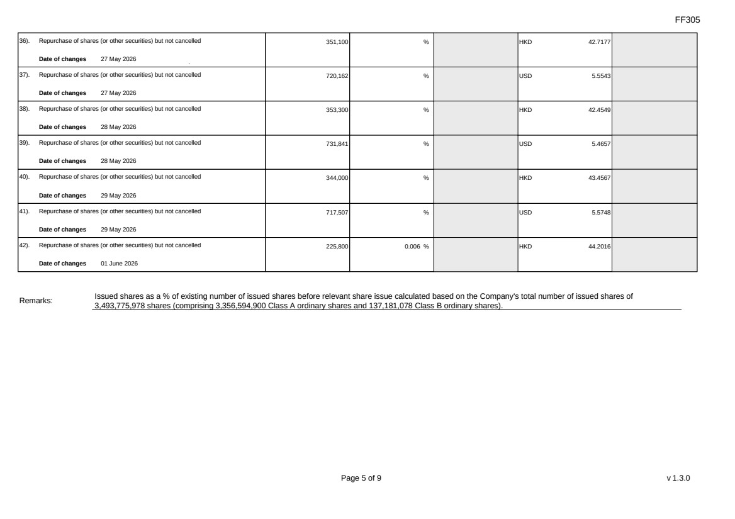 | FF305 Page 5 of 9 v 1.3.0 36). Repurchase of shares (or other securities) but not cancelled Date of changes 27 May 2026 351,100 % HKD 42.7177 37). Repurchase of shares (or other securities) but not cancelled Date of changes 27 May 2026 720,162 % USD 5.5543 38). Repurchase of shares (or other securities) but not cancelled Date of changes 28 May 2026 353,300 % HKD 42.4549 39). Repurchase of shares (or other securities) but not cancelled Date of changes 28 May 2026 731,841 % USD 5.4657 40). Repurchase of shares (or other securities) but not cancelled Date of changes 29 May 2026 344,000 % HKD 43.4567 41). Repurchase of shares (or other securities) but not cancelled Date of changes 29 May 2026 717,507 % USD 5.5748 42). Repurchase of shares (or other securities) but not cancelled Date of changes 01 June 2026 225,800 0.006 % HKD 44.2016 Remarks: Issued shares as a % of existing number of issued shares before relevant share issue calculated based on the Company's total number of issued shares of 3,493,775,978 shares (comprising 3,356,594,900 Class A ordinary shares and 137,181,078 Class B ordinary shares).
FF305 Page 6 of 9 v 1.3.0 Confirmation Not applicable Notes to Section I: 1. Please insert the closing balance date of the last Next Day Disclosure Return published pursuant to Main Board Rule 13.25A / GEM Rule 17.27A or Monthly Return pursuant to Main Board Rule 13.25B / GEM Rule 17.27B, whichever is the later. 2. Please set out all changes in issued shares or treasury shares requiring disclosure pursuant to Main Board Rule 13.25A / GEM Rule 17.27A together with the relevant dates of changes. Each category will need to be disclosed individually with sufficient information to enable the user to identify the relevant category in the listed issuer's Monthly Return. For example, multiple issues of shares as a result of multiple exercises of share options under the same share option scheme or of multiple conversions under the same convertible note must be aggregated and disclosed as one category. However, if the issues resulted from exercises of share options under 2 share option schemes or conversions of 2 convertible notes, these must be disclosed as 2 separate categories. 3. The percentage change in the number of issued shares (excluding treasury shares) of the listed issuer is to be calculated by reference to the opening balance of the number of issued shares (excluding treasury shares) being disclosed in this Next Day Disclosure Return. 4. In the case of a share repurchase or redemption, the “issue/ selling price per share” shall be construed as “repurchase price per share” or “redemption price per share”. Where shares have been issued/ sold/ repurchased/ redeemed at more than one price per share, a volume-weighted average price per share should be given. 5. The closing balance date is the date of the last relevant event being disclosed. 6. For repurchase or redemption of shares, disclosure is required when the relevant event has occurred (subject to the provisions of Main Board Rules 10.06(4)(a), 13.25A and 13.31 / GEM Rules 13.13(1), 17.27A and 17.35), even if the repurchased or redeemed shares have not yet been cancelled. If repurchased or redeemed shares are to be cancelled upon settlement of such repurchase or redemption after the closing balance date, they shall remain part of the issued shares as at the closing balance date in Part A. Details of these repurchased or redeemed shares shall be disclosed in Part B. 7. Items (i) to (viii) are suggested forms of confirmation. The listed issuer may amend the item(s) that is/are not applicable to meet individual cases. 8. “Identical” means in this context: - the securities are of the same nominal value with the same amount called up or paid up; - they are entitled to dividend/interest at the same rate and for the same period, so that at the next ensuing distribution, the dividend/interest payable per unit will amount to exactly the same sum (gross and net); and - they carry the same rights as to unrestricted transfer, attendance and voting at meetings and rank pari passu in all other respects.
 | 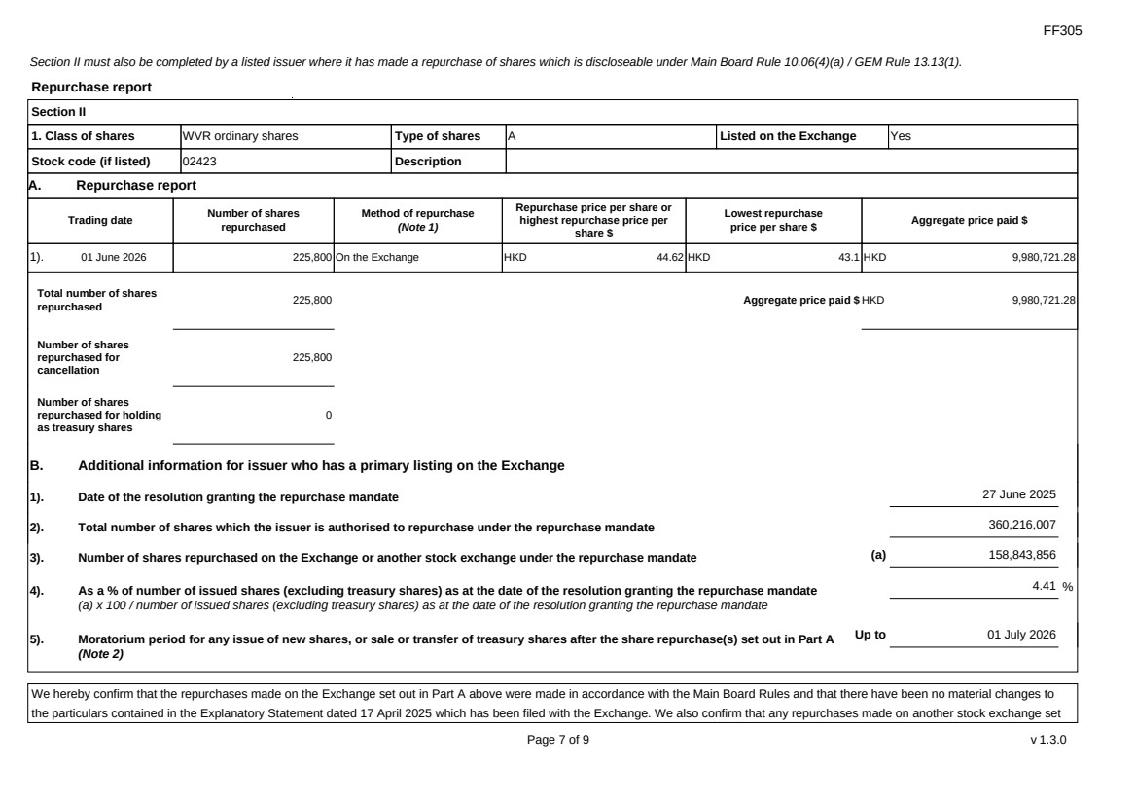 | FF305 Page 7 of 9 v 1.3.0 Section II must also be completed by a listed issuer where it has made a repurchase of shares which is discloseable under Main Board Rule 10.06(4)(a) / GEM Rule 13.13(1). Repurchase report Section II 1. Class of shares WVR ordinary shares Type of shares A Listed on the Exchange Yes Stock code (if listed) 02423 Description A. Repurchase report Trading date Number of shares repurchased Method of repurchase (Note 1) Repurchase price per share or highest repurchase price per share $ Lowest repurchase price per share $ Aggregate price paid $ 1). 01 June 2026 225,800 On the Exchange HKD 44.62 HKD 43.1 HKD 9,980,721.28 Total number of shares repurchased 225,800 Aggregate price paid $ HKD 9,980,721.28 Number of shares repurchased for cancellation 225,800 Number of shares repurchased for holding as treasury shares 0 B. Additional information for issuer who has a primary listing on the Exchange 1). Date of the resolution granting the repurchase mandate 27 June 2025 2). Total number of shares which the issuer is authorised to repurchase under the repurchase mandate 360,216,007 3). Number of shares repurchased on the Exchange or another stock exchange under the repurchase mandate (a) 158,843,856 4). As a % of number of issued shares (excluding treasury shares) as at the date of the resolution granting the repurchase mandate (a) x 100 / number of issued shares (excluding treasury shares) as at the date of the resolution granting the repurchase mandate 4.41 % 5). Moratorium period for any issue of new shares, or sale or transfer of treasury shares after the share repurchase(s) set out in Part A (Note 2) Up to 01 July 2026 We hereby confirm that the repurchases made on the Exchange set out in Part A above were made in accordance with the Main Board Rules and that there have been no material changes to the particulars contained in the Explanatory Statement dated 17 April 2025 which has been filed with the Exchange. We also confirm that any repurchases made on another stock exchange set
 | 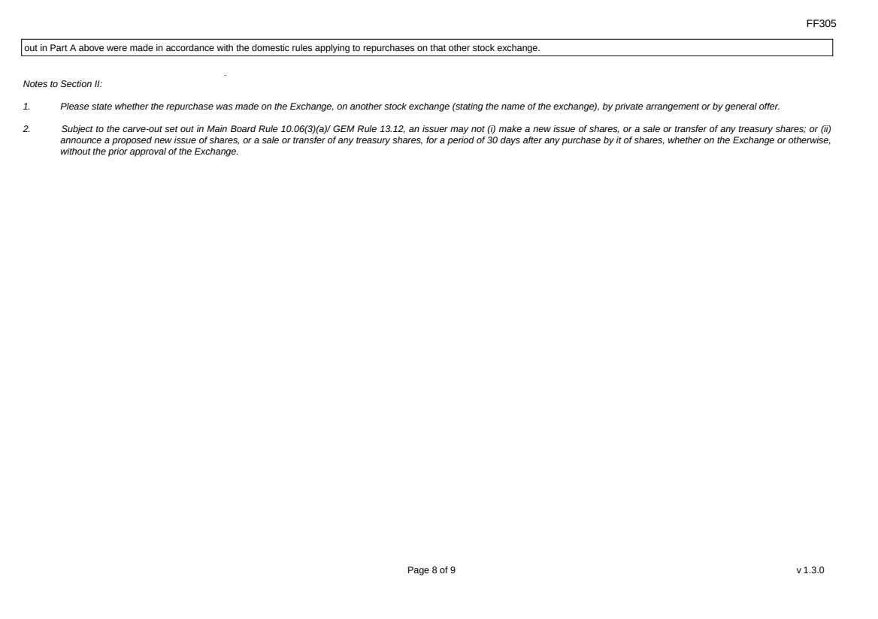 | FF305 Page 8 of 9 v 1.3.0 out in Part A above were made in accordance with the domestic rules applying to repurchases on that other stock exchange. Notes to Section II: 1. Please state whether the repurchase was made on the Exchange, on another stock exchange (stating the name of the exchange), by private arrangement or by general offer. 2. Subject to the carve-out set out in Main Board Rule 10.06(3)(a)/ GEM Rule 13.12, an issuer may not (i) make a new issue of shares, or a sale or transfer of any treasury shares; or (ii) announce a proposed new issue of shares, or a sale or transfer of any treasury shares, for a period of 30 days after any purchase by it of shares, whether on the Exchange or otherwise, without the prior approval of the Exchange.
FF305 Page 9 of 9 v 1.3.0 Section III must also be completed by a listed issuer where it has made a sale of treasury shares on the Exchange or any other stock exchange on which the issuer is listed which is discloseable under Main Board Rule 10.06B / GEM Rule 13.14B. Report of on-market sale of treasury shares Not applicable Submitted by: Siting Li (Name) Title: Joint Company Secretary (Director, Secretary or other Duly Authorised Officer)
Exhibit 99.3
 | 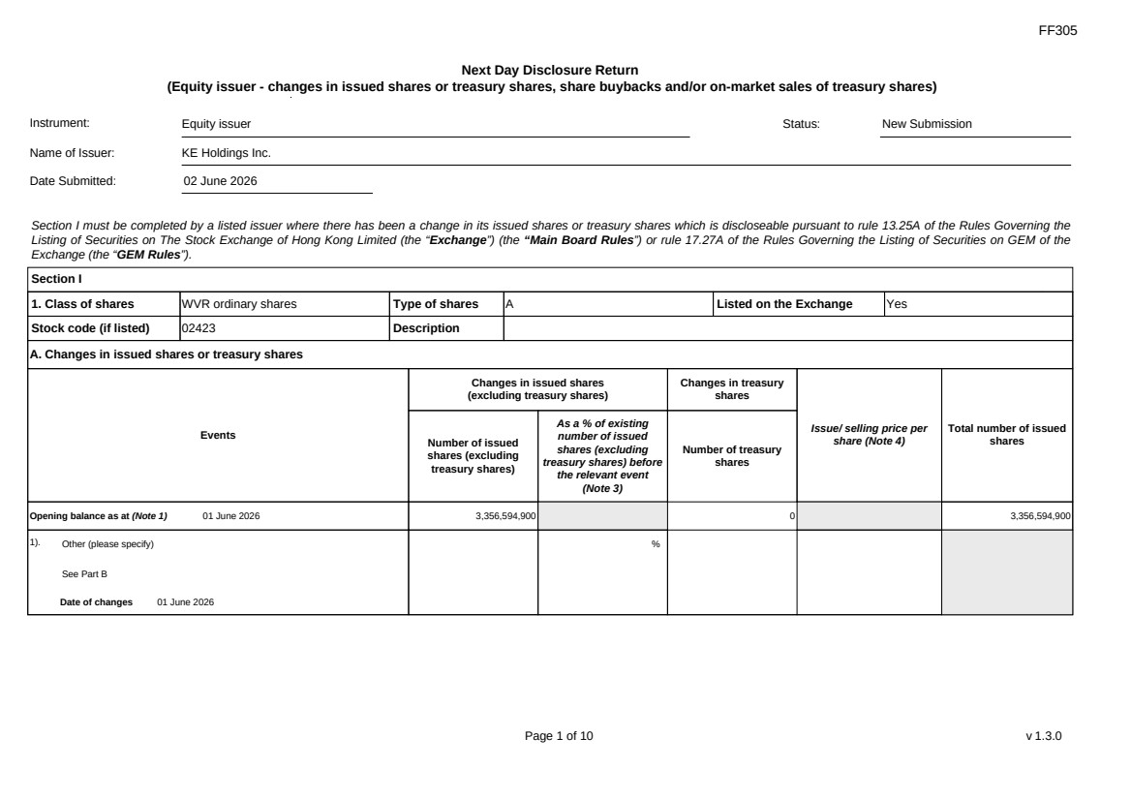 | FF305 Page 1 of 10 v 1.3.0 Next Day Disclosure Return (Equity issuer - changes in issued shares or treasury shares, share buybacks and/or on-market sales of treasury shares) Instrument: Equity issuer Status: New Submission Name of Issuer: KE Holdings Inc. Date Submitted: 02 June 2026 Section I must be completed by a listed issuer where there has been a change in its issued shares or treasury shares which is discloseable pursuant to rule 13.25A of the Rules Governing the Listing of Securities on The Stock Exchange of Hong Kong Limited (the “Exchange”) (the “Main Board Rules”) or rule 17.27A of the Rules Governing the Listing of Securities on GEM of the Exchange (the “GEM Rules”). Section I 1. Class of shares WVR ordinary shares Type of shares A Listed on the Exchange Yes Stock code (if listed) 02423 Description A. Changes in issued shares or treasury shares Events Changes in issued shares (excluding treasury shares) Number of issued shares (excluding treasury shares) As a % of existing number of issued shares (excluding treasury shares) before the relevant event (Note 3) Changes in treasury shares Number of treasury shares Issue/ selling price per share (Note 4) Total number of issued shares Opening balance as at (Note 1) 01 June 2026 3,356,594,900 0 3,356,594,900 1). Other (please specify) See Part B Date of changes 01 June 2026 %
 | 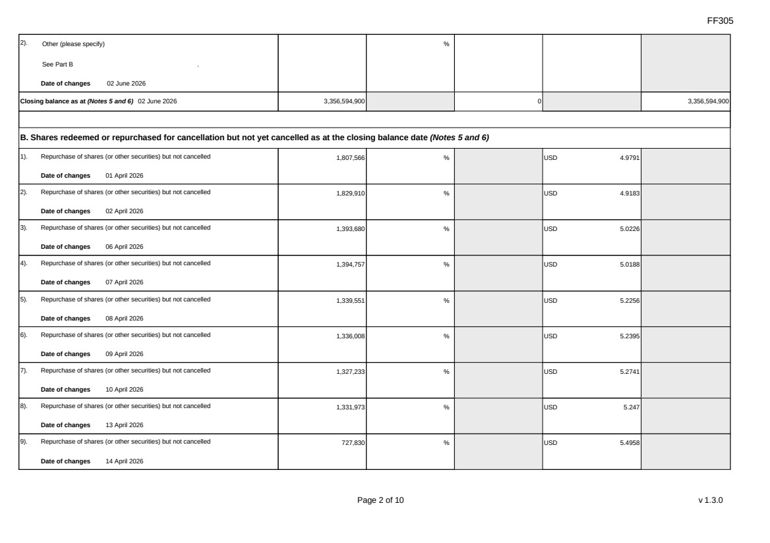 | FF305 Page 2 of 10 v 1.3.0 2). Other (please specify) See Part B Date of changes 02 June 2026 % Closing balance as at (Notes 5 and 6) 02 June 2026 3,356,594,900 0 3,356,594,900 B. Shares redeemed or repurchased for cancellation but not yet cancelled as at the closing balance date (Notes 5 and 6) 1). Repurchase of shares (or other securities) but not cancelled Date of changes 01 April 2026 1,807,566 % USD 4.9791 2). Repurchase of shares (or other securities) but not cancelled Date of changes 02 April 2026 1,829,910 % USD 4.9183 3). Repurchase of shares (or other securities) but not cancelled Date of changes 06 April 2026 1,393,680 % USD 5.0226 4). Repurchase of shares (or other securities) but not cancelled Date of changes 07 April 2026 1,394,757 % USD 5.0188 5). Repurchase of shares (or other securities) but not cancelled Date of changes 08 April 2026 1,339,551 % USD 5.2256 6). Repurchase of shares (or other securities) but not cancelled Date of changes 09 April 2026 1,336,008 % USD 5.2395 7). Repurchase of shares (or other securities) but not cancelled Date of changes 10 April 2026 1,327,233 % USD 5.2741 8). Repurchase of shares (or other securities) but not cancelled Date of changes 13 April 2026 1,331,973 % USD 5.247 9). Repurchase of shares (or other securities) but not cancelled Date of changes 14 April 2026 727,830 % USD 5.4958
 | 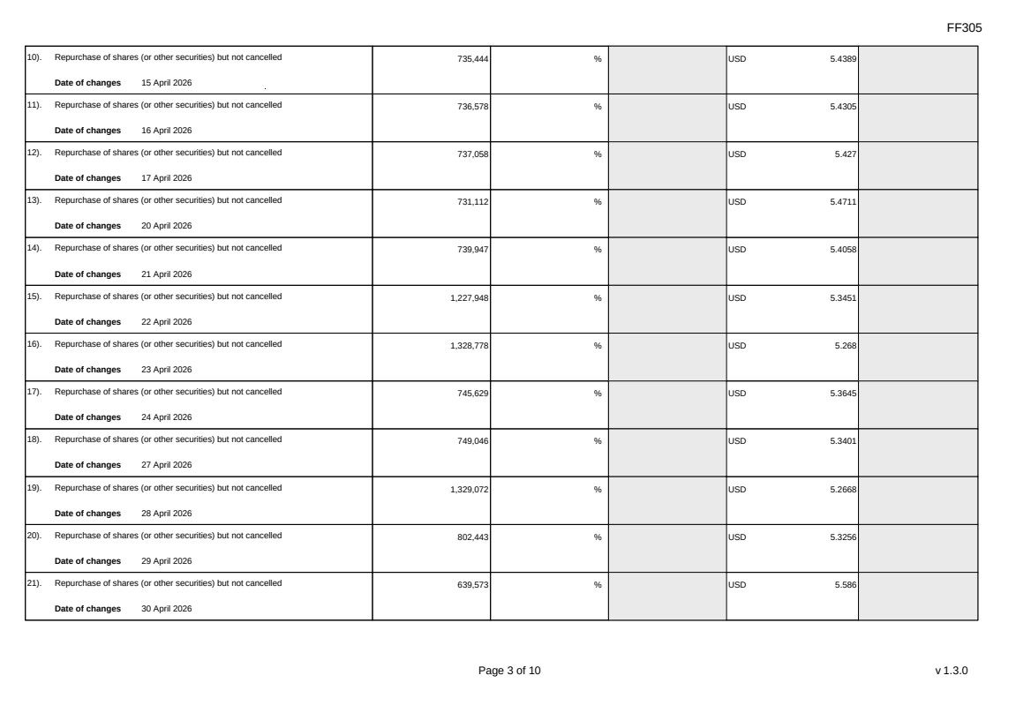 | FF305 Page 3 of 10 v 1.3.0 10). Repurchase of shares (or other securities) but not cancelled Date of changes 15 April 2026 735,444 % USD 5.4389 11). Repurchase of shares (or other securities) but not cancelled Date of changes 16 April 2026 736,578 % USD 5.4305 12). Repurchase of shares (or other securities) but not cancelled Date of changes 17 April 2026 737,058 % USD 5.427 13). Repurchase of shares (or other securities) but not cancelled Date of changes 20 April 2026 731,112 % USD 5.4711 14). Repurchase of shares (or other securities) but not cancelled Date of changes 21 April 2026 739,947 % USD 5.4058 15). Repurchase of shares (or other securities) but not cancelled Date of changes 22 April 2026 1,227,948 % USD 5.3451 16). Repurchase of shares (or other securities) but not cancelled Date of changes 23 April 2026 1,328,778 % USD 5.268 17). Repurchase of shares (or other securities) but not cancelled Date of changes 24 April 2026 745,629 % USD 5.3645 18). Repurchase of shares (or other securities) but not cancelled Date of changes 27 April 2026 749,046 % USD 5.3401 19). Repurchase of shares (or other securities) but not cancelled Date of changes 28 April 2026 1,329,072 % USD 5.2668 20). Repurchase of shares (or other securities) but not cancelled Date of changes 29 April 2026 802,443 % USD 5.3256 21). Repurchase of shares (or other securities) but not cancelled Date of changes 30 April 2026 639,573 % USD 5.586
 | 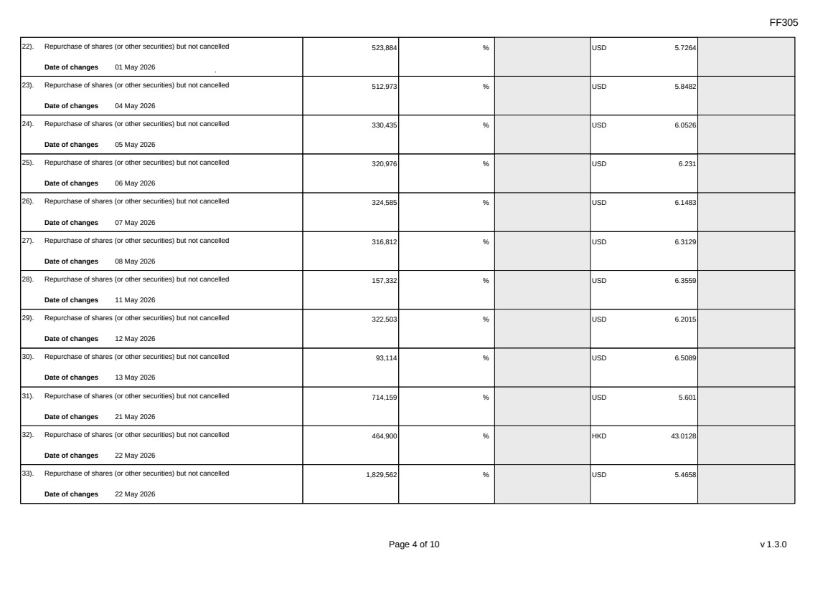 | FF305 Page 4 of 10 v 1.3.0 22). Repurchase of shares (or other securities) but not cancelled Date of changes 01 May 2026 523,884 % USD 5.7264 23). Repurchase of shares (or other securities) but not cancelled Date of changes 04 May 2026 512,973 % USD 5.8482 24). Repurchase of shares (or other securities) but not cancelled Date of changes 05 May 2026 330,435 % USD 6.0526 25). Repurchase of shares (or other securities) but not cancelled Date of changes 06 May 2026 320,976 % USD 6.231 26). Repurchase of shares (or other securities) but not cancelled Date of changes 07 May 2026 324,585 % USD 6.1483 27). Repurchase of shares (or other securities) but not cancelled Date of changes 08 May 2026 316,812 % USD 6.3129 28). Repurchase of shares (or other securities) but not cancelled Date of changes 11 May 2026 157,332 % USD 6.3559 29). Repurchase of shares (or other securities) but not cancelled Date of changes 12 May 2026 322,503 % USD 6.2015 30). Repurchase of shares (or other securities) but not cancelled Date of changes 13 May 2026 93,114 % USD 6.5089 31). Repurchase of shares (or other securities) but not cancelled Date of changes 21 May 2026 714,159 % USD 5.601 32). Repurchase of shares (or other securities) but not cancelled Date of changes 22 May 2026 464,900 % HKD 43.0128 33). Repurchase of shares (or other securities) but not cancelled Date of changes 22 May 2026 1,829,562 % USD 5.4658
 | 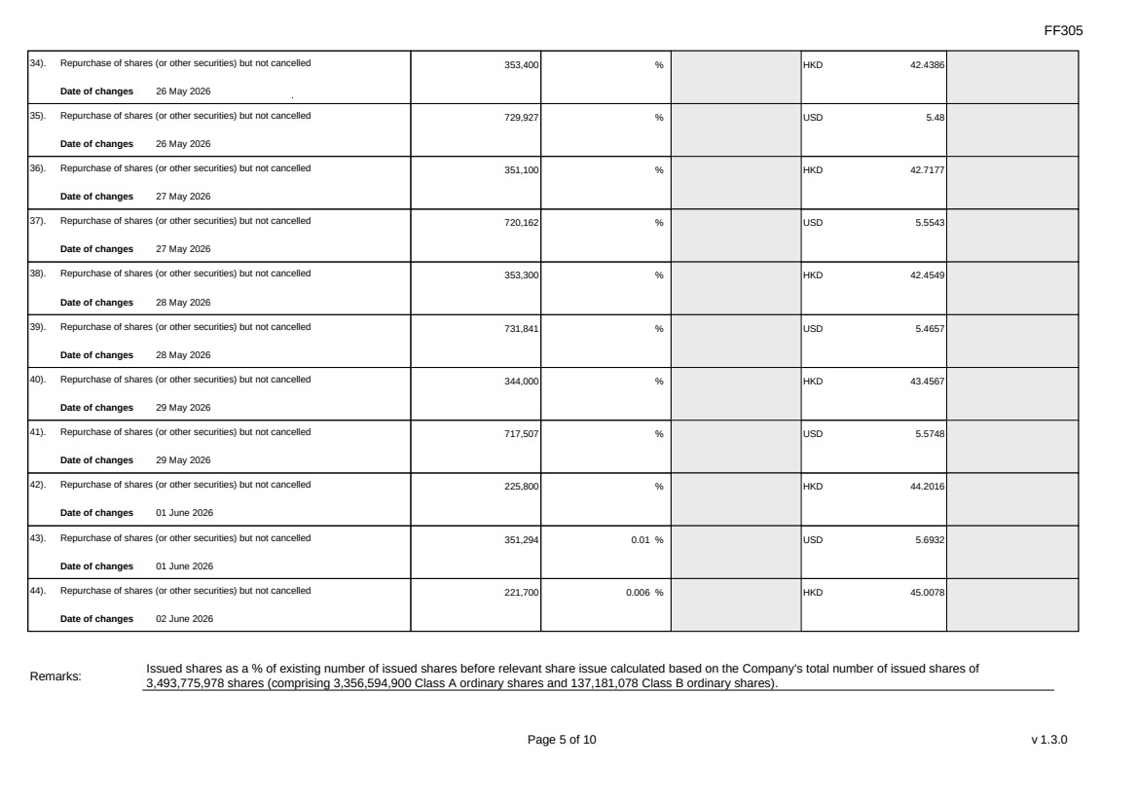 | FF305 Page 5 of 10 v 1.3.0 34). Repurchase of shares (or other securities) but not cancelled Date of changes 26 May 2026 353,400 % HKD 42.4386 35). Repurchase of shares (or other securities) but not cancelled Date of changes 26 May 2026 729,927 % USD 5.48 36). Repurchase of shares (or other securities) but not cancelled Date of changes 27 May 2026 351,100 % HKD 42.7177 37). Repurchase of shares (or other securities) but not cancelled Date of changes 27 May 2026 720,162 % USD 5.5543 38). Repurchase of shares (or other securities) but not cancelled Date of changes 28 May 2026 353,300 % HKD 42.4549 39). Repurchase of shares (or other securities) but not cancelled Date of changes 28 May 2026 731,841 % USD 5.4657 40). Repurchase of shares (or other securities) but not cancelled Date of changes 29 May 2026 344,000 % HKD 43.4567 41). Repurchase of shares (or other securities) but not cancelled Date of changes 29 May 2026 717,507 % USD 5.5748 42). Repurchase of shares (or other securities) but not cancelled Date of changes 01 June 2026 225,800 % HKD 44.2016 43). Repurchase of shares (or other securities) but not cancelled Date of changes 01 June 2026 351,294 0.01 % USD 5.6932 44). Repurchase of shares (or other securities) but not cancelled Date of changes 02 June 2026 221,700 0.006 % HKD 45.0078 Remarks: Issued shares as a % of existing number of issued shares before relevant share issue calculated based on the Company's total number of issued shares of 3,493,775,978 shares (comprising 3,356,594,900 Class A ordinary shares and 137,181,078 Class B ordinary shares).
 | 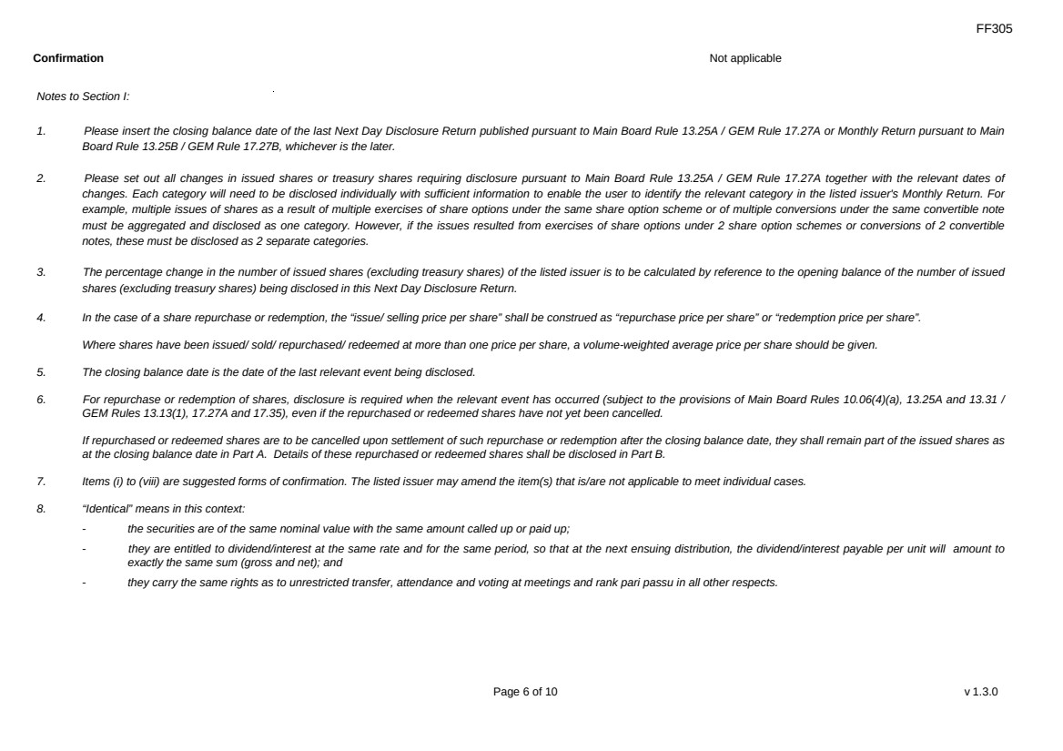 | FF305 Page 6 of 10 v 1.3.0 Confirmation Not applicable Notes to Section I: 1. Please insert the closing balance date of the last Next Day Disclosure Return published pursuant to Main Board Rule 13.25A / GEM Rule 17.27A or Monthly Return pursuant to Main Board Rule 13.25B / GEM Rule 17.27B, whichever is the later. 2. Please set out all changes in issued shares or treasury shares requiring disclosure pursuant to Main Board Rule 13.25A / GEM Rule 17.27A together with the relevant dates of changes. Each category will need to be disclosed individually with sufficient information to enable the user to identify the relevant category in the listed issuer's Monthly Return. For example, multiple issues of shares as a result of multiple exercises of share options under the same share option scheme or of multiple conversions under the same convertible note must be aggregated and disclosed as one category. However, if the issues resulted from exercises of share options under 2 share option schemes or conversions of 2 convertible notes, these must be disclosed as 2 separate categories. 3. The percentage change in the number of issued shares (excluding treasury shares) of the listed issuer is to be calculated by reference to the opening balance of the number of issued shares (excluding treasury shares) being disclosed in this Next Day Disclosure Return. 4. In the case of a share repurchase or redemption, the “issue/ selling price per share” shall be construed as “repurchase price per share” or “redemption price per share”. Where shares have been issued/ sold/ repurchased/ redeemed at more than one price per share, a volume-weighted average price per share should be given. 5. The closing balance date is the date of the last relevant event being disclosed. 6. For repurchase or redemption of shares, disclosure is required when the relevant event has occurred (subject to the provisions of Main Board Rules 10.06(4)(a), 13.25A and 13.31 / GEM Rules 13.13(1), 17.27A and 17.35), even if the repurchased or redeemed shares have not yet been cancelled. If repurchased or redeemed shares are to be cancelled upon settlement of such repurchase or redemption after the closing balance date, they shall remain part of the issued shares as at the closing balance date in Part A. Details of these repurchased or redeemed shares shall be disclosed in Part B. 7. Items (i) to (viii) are suggested forms of confirmation. The listed issuer may amend the item(s) that is/are not applicable to meet individual cases. 8. “Identical” means in this context: - the securities are of the same nominal value with the same amount called up or paid up; - they are entitled to dividend/interest at the same rate and for the same period, so that at the next ensuing distribution, the dividend/interest payable per unit will amount to exactly the same sum (gross and net); and - they carry the same rights as to unrestricted transfer, attendance and voting at meetings and rank pari passu in all other respects.
 | 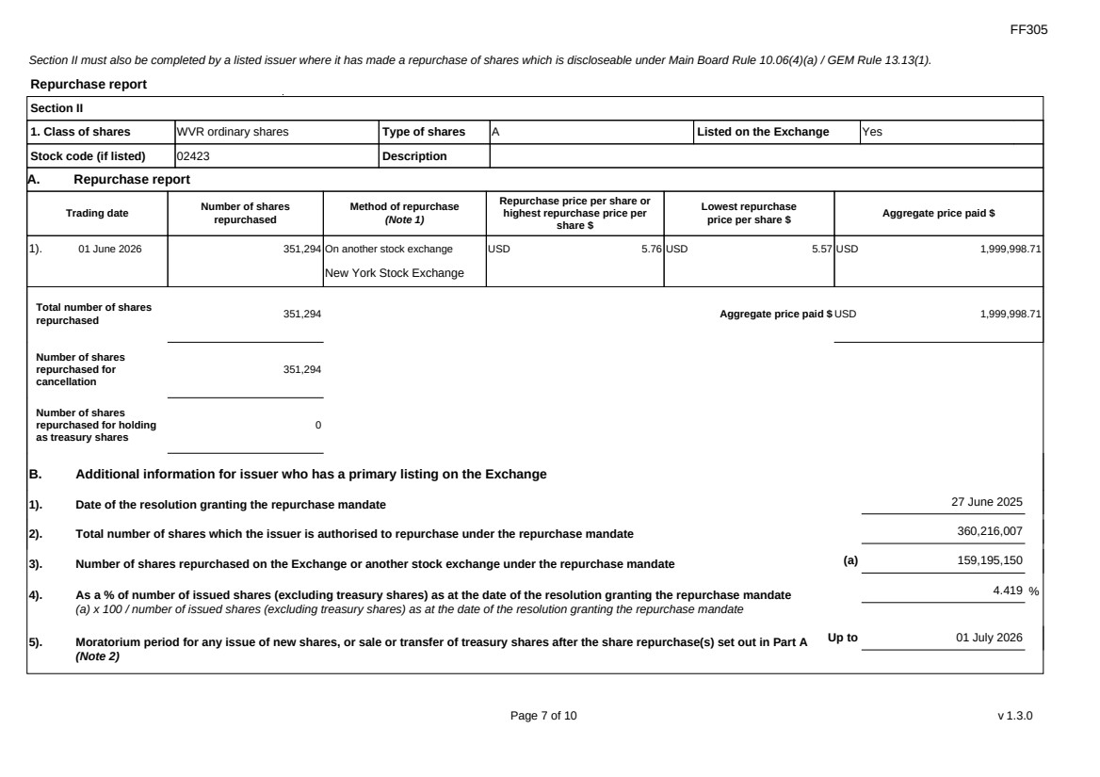 | FF305 Page 7 of 10 v 1.3.0 Section II must also be completed by a listed issuer where it has made a repurchase of shares which is discloseable under Main Board Rule 10.06(4)(a) / GEM Rule 13.13(1). Repurchase report Section II 1. Class of shares WVR ordinary shares Type of shares A Listed on the Exchange Yes Stock code (if listed) 02423 Description A. Repurchase report Trading date Number of shares repurchased Method of repurchase (Note 1) Repurchase price per share or highest repurchase price per share $ Lowest repurchase price per share $ Aggregate price paid $ 1). 01 June 2026 351,294 On another stock exchange New York Stock Exchange USD 5.76 USD 5.57 USD 1,999,998.71 Total number of shares repurchased 351,294 Aggregate price paid $ USD 1,999,998.71 Number of shares repurchased for cancellation 351,294 Number of shares repurchased for holding as treasury shares 0 B. Additional information for issuer who has a primary listing on the Exchange 1). Date of the resolution granting the repurchase mandate 27 June 2025 2). Total number of shares which the issuer is authorised to repurchase under the repurchase mandate 360,216,007 3). Number of shares repurchased on the Exchange or another stock exchange under the repurchase mandate (a) 159,195,150 4). As a % of number of issued shares (excluding treasury shares) as at the date of the resolution granting the repurchase mandate (a) x 100 / number of issued shares (excluding treasury shares) as at the date of the resolution granting the repurchase mandate 4.419 % 5). Moratorium period for any issue of new shares, or sale or transfer of treasury shares after the share repurchase(s) set out in Part A (Note 2) Up to 01 July 2026
 | 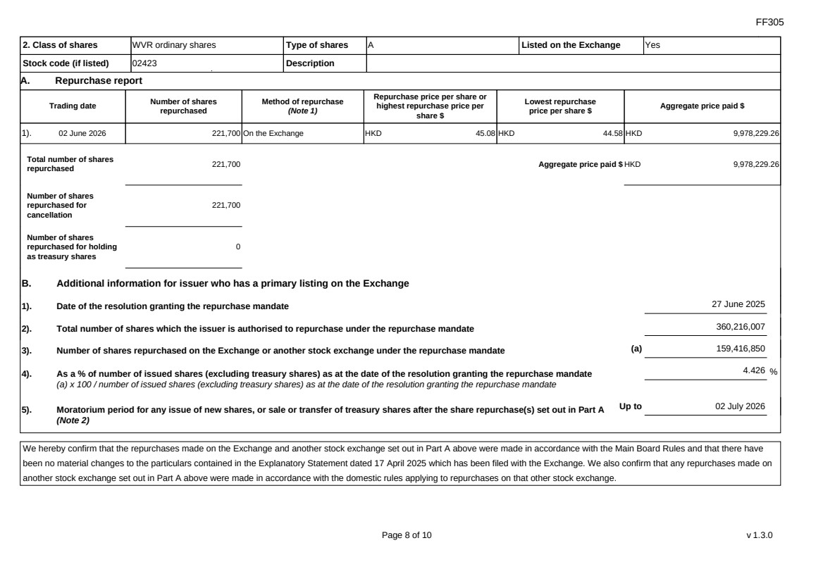 | FF305 Page 8 of 10 v 1.3.0 2. Class of shares WVR ordinary shares Type of shares A Listed on the Exchange Yes Stock code (if listed) 02423 Description A. Repurchase report Trading date Number of shares repurchased Method of repurchase (Note 1) Repurchase price per share or highest repurchase price per share $ Lowest repurchase price per share $ Aggregate price paid $ 1). 02 June 2026 221,700 On the Exchange HKD 45.08 HKD 44.58 HKD 9,978,229.26 Total number of shares repurchased 221,700 Aggregate price paid $ HKD 9,978,229.26 Number of shares repurchased for cancellation 221,700 Number of shares repurchased for holding as treasury shares 0 B. Additional information for issuer who has a primary listing on the Exchange 1). Date of the resolution granting the repurchase mandate 27 June 2025 2). Total number of shares which the issuer is authorised to repurchase under the repurchase mandate 360,216,007 3). Number of shares repurchased on the Exchange or another stock exchange under the repurchase mandate (a) 159,416,850 4). As a % of number of issued shares (excluding treasury shares) as at the date of the resolution granting the repurchase mandate (a) x 100 / number of issued shares (excluding treasury shares) as at the date of the resolution granting the repurchase mandate 4.426 % 5). Moratorium period for any issue of new shares, or sale or transfer of treasury shares after the share repurchase(s) set out in Part A (Note 2) Up to 02 July 2026 We hereby confirm that the repurchases made on the Exchange and another stock exchange set out in Part A above were made in accordance with the Main Board Rules and that there have been no material changes to the particulars contained in the Explanatory Statement dated 17 April 2025 which has been filed with the Exchange. We also confirm that any repurchases made on another stock exchange set out in Part A above were made in accordance with the domestic rules applying to repurchases on that other stock exchange.
 | 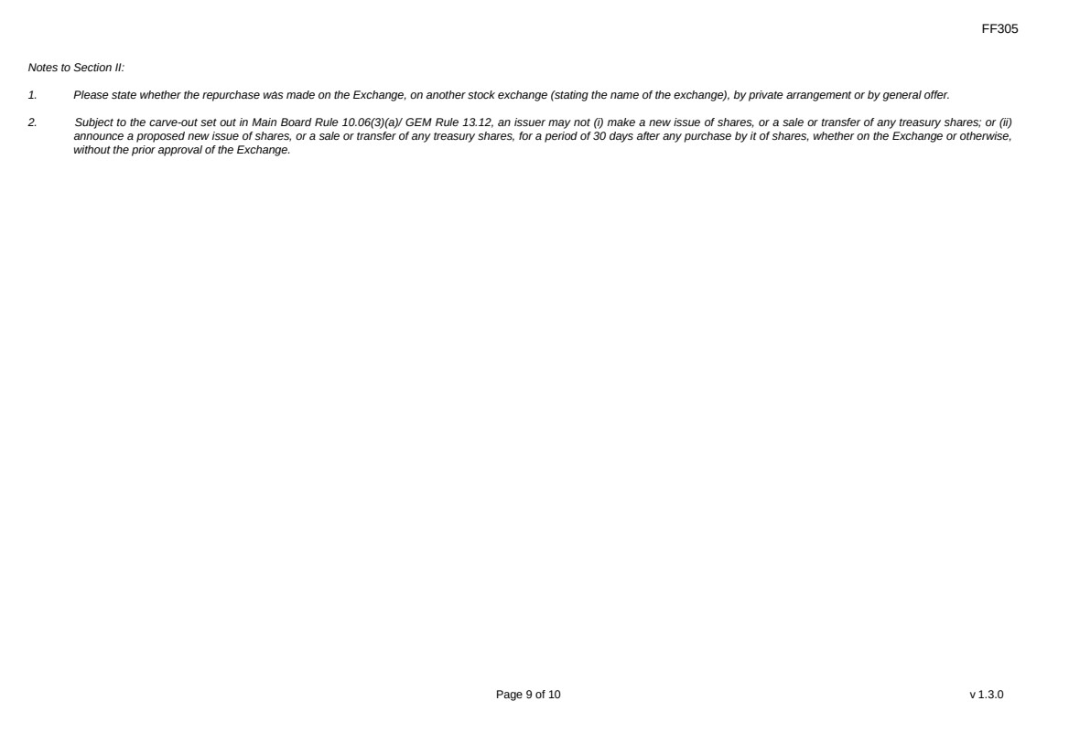 | FF305 Page 9 of 10 v 1.3.0 Notes to Section II: 1. Please state whether the repurchase was made on the Exchange, on another stock exchange (stating the name of the exchange), by private arrangement or by general offer. 2. Subject to the carve-out set out in Main Board Rule 10.06(3)(a)/ GEM Rule 13.12, an issuer may not (i) make a new issue of shares, or a sale or transfer of any treasury shares; or (ii) announce a proposed new issue of shares, or a sale or transfer of any treasury shares, for a period of 30 days after any purchase by it of shares, whether on the Exchange or otherwise, without the prior approval of the Exchange.
 | 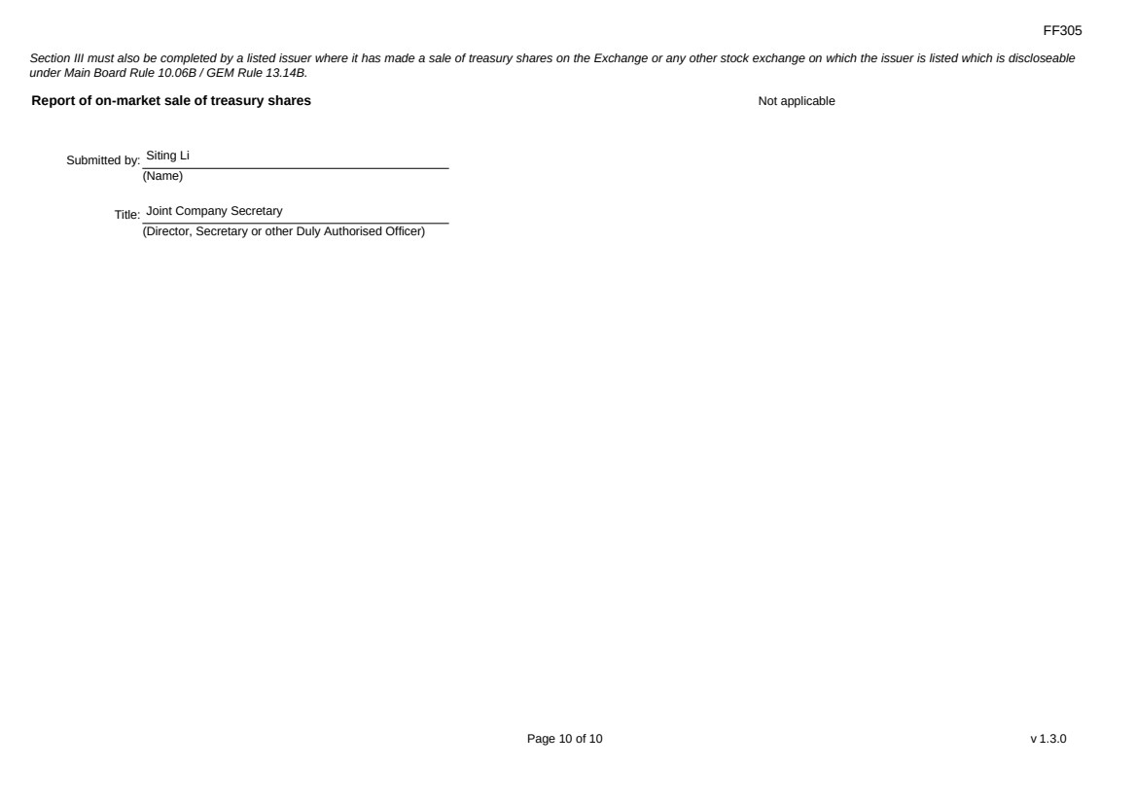 | FF305 Page 10 of 10 v 1.3.0 Section III must also be completed by a listed issuer where it has made a sale of treasury shares on the Exchange or any other stock exchange on which the issuer is listed which is discloseable under Main Board Rule 10.06B / GEM Rule 13.14B. Report of on-market sale of treasury shares Not applicable Submitted by: Siting Li (Name) Title: Joint Company Secretary (Director, Secretary or other Duly Authorised Officer)
Exhibit 99.4
 | 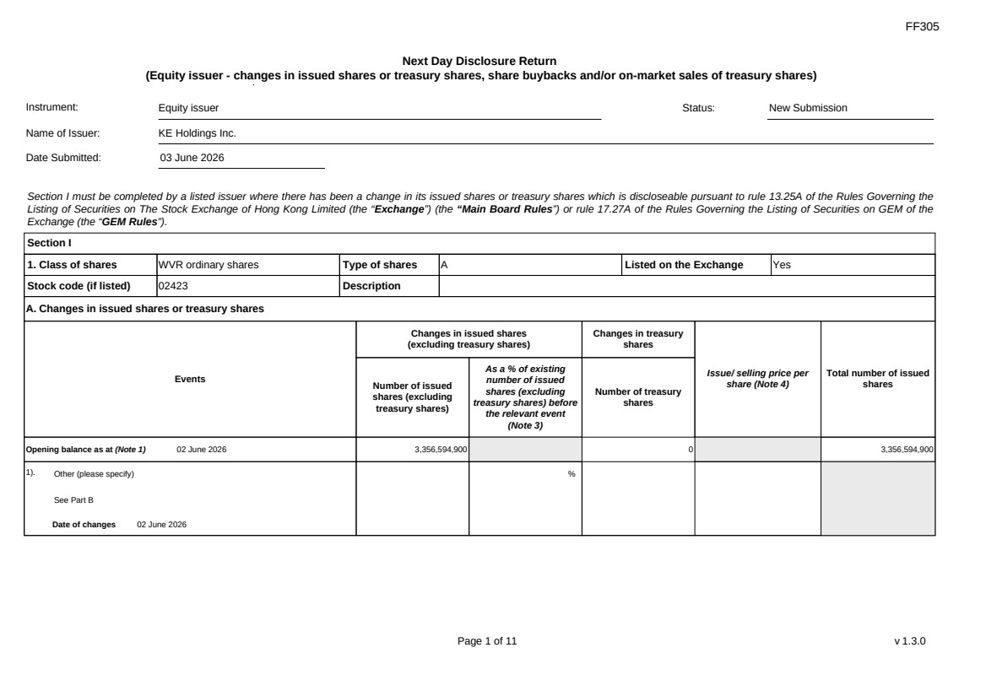 | FF305 Page 1 of 11 v 1.3.0 Next Day Disclosure Return (Equity issuer - changes in issued shares or treasury shares, share buybacks and/or on-market sales of treasury shares) Instrument: Equity issuer Status: New Submission Name of Issuer: KE Holdings Inc. Date Submitted: 03 June 2026 Section I must be completed by a listed issuer where there has been a change in its issued shares or treasury shares which is discloseable pursuant to rule 13.25A of the Rules Governing the Listing of Securities on The Stock Exchange of Hong Kong Limited (the “Exchange”) (the “Main Board Rules”) or rule 17.27A of the Rules Governing the Listing of Securities on GEM of the Exchange (the “GEM Rules”). Section I 1. Class of shares WVR ordinary shares Type of shares A Listed on the Exchange Yes Stock code (if listed) 02423 Description A. Changes in issued shares or treasury shares Events Changes in issued shares (excluding treasury shares) Number of issued shares (excluding treasury shares) As a % of existing number of issued shares (excluding treasury shares) before the relevant event (Note 3) Changes in treasury shares Number of treasury shares Issue/ selling price per share (Note 4) Total number of issued shares Opening balance as at (Note 1) 02 June 2026 3,356,594,900 0 3,356,594,900 1). Other (please specify) See Part B Date of changes 02 June 2026 %
 | 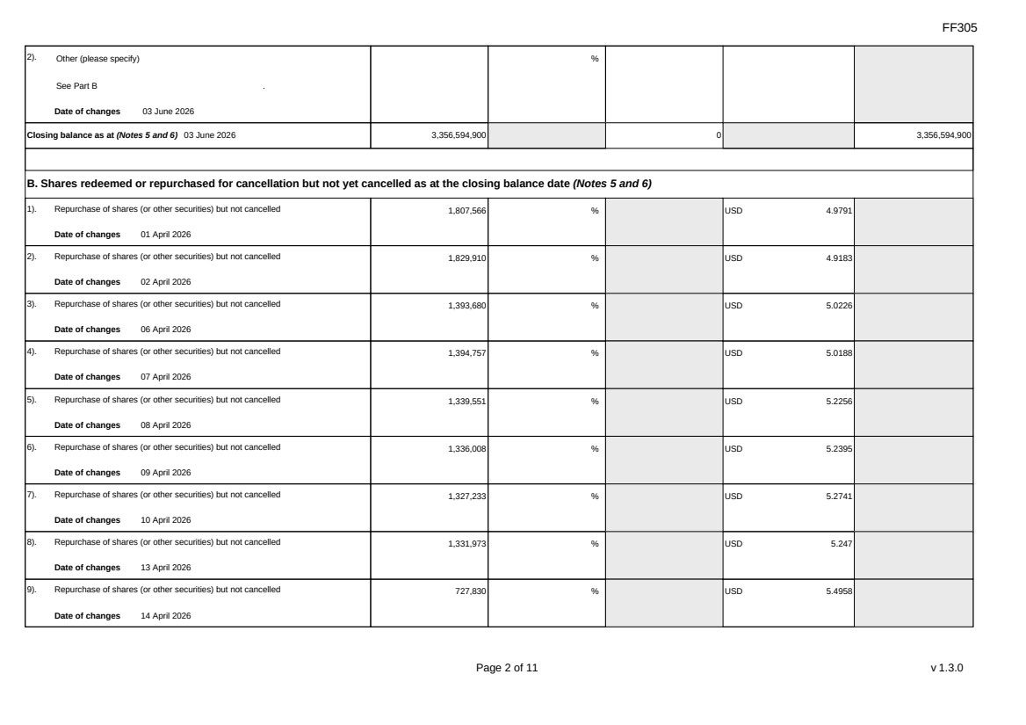 | FF305 Page 2 of 11 v 1.3.0 2). Other (please specify) See Part B Date of changes 03 June 2026 % Closing balance as at (Notes 5 and 6) 03 June 2026 3,356,594,900 0 3,356,594,900 B. Shares redeemed or repurchased for cancellation but not yet cancelled as at the closing balance date (Notes 5 and 6) 1). Repurchase of shares (or other securities) but not cancelled Date of changes 01 April 2026 1,807,566 % USD 4.9791 2). Repurchase of shares (or other securities) but not cancelled Date of changes 02 April 2026 1,829,910 % USD 4.9183 3). Repurchase of shares (or other securities) but not cancelled Date of changes 06 April 2026 1,393,680 % USD 5.0226 4). Repurchase of shares (or other securities) but not cancelled Date of changes 07 April 2026 1,394,757 % USD 5.0188 5). Repurchase of shares (or other securities) but not cancelled Date of changes 08 April 2026 1,339,551 % USD 5.2256 6). Repurchase of shares (or other securities) but not cancelled Date of changes 09 April 2026 1,336,008 % USD 5.2395 7). Repurchase of shares (or other securities) but not cancelled Date of changes 10 April 2026 1,327,233 % USD 5.2741 8). Repurchase of shares (or other securities) but not cancelled Date of changes 13 April 2026 1,331,973 % USD 5.247 9). Repurchase of shares (or other securities) but not cancelled Date of changes 14 April 2026 727,830 % USD 5.4958
 | 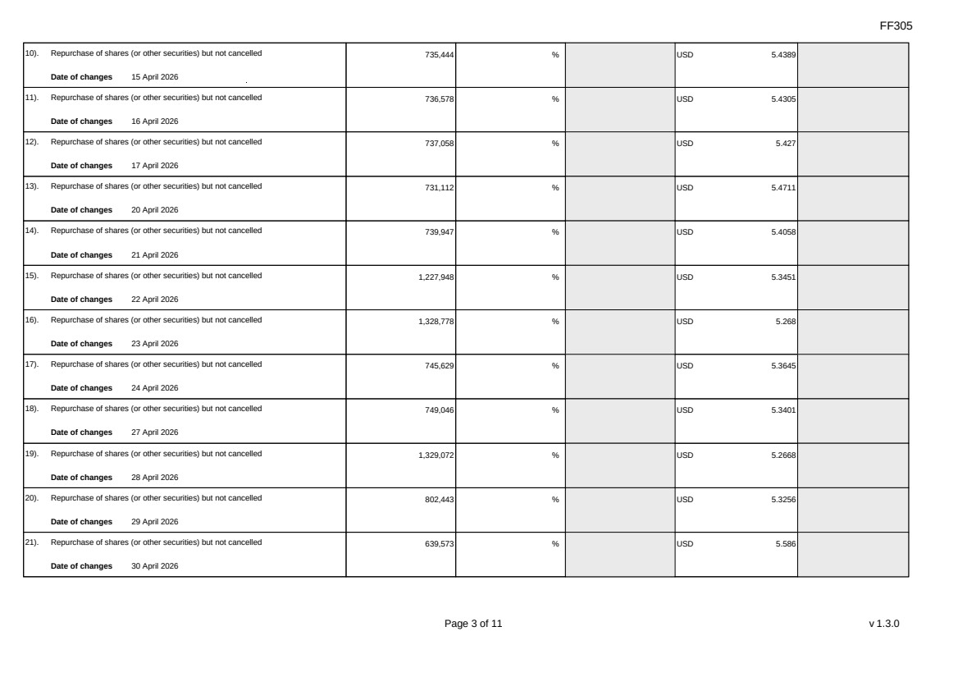 | FF305 Page 3 of 11 v 1.3.0 10). Repurchase of shares (or other securities) but not cancelled Date of changes 15 April 2026 735,444 % USD 5.4389 11). Repurchase of shares (or other securities) but not cancelled Date of changes 16 April 2026 736,578 % USD 5.4305 12). Repurchase of shares (or other securities) but not cancelled Date of changes 17 April 2026 737,058 % USD 5.427 13). Repurchase of shares (or other securities) but not cancelled Date of changes 20 April 2026 731,112 % USD 5.4711 14). Repurchase of shares (or other securities) but not cancelled Date of changes 21 April 2026 739,947 % USD 5.4058 15). Repurchase of shares (or other securities) but not cancelled Date of changes 22 April 2026 1,227,948 % USD 5.3451 16). Repurchase of shares (or other securities) but not cancelled Date of changes 23 April 2026 1,328,778 % USD 5.268 17). Repurchase of shares (or other securities) but not cancelled Date of changes 24 April 2026 745,629 % USD 5.3645 18). Repurchase of shares (or other securities) but not cancelled Date of changes 27 April 2026 749,046 % USD 5.3401 19). Repurchase of shares (or other securities) but not cancelled Date of changes 28 April 2026 1,329,072 % USD 5.2668 20). Repurchase of shares (or other securities) but not cancelled Date of changes 29 April 2026 802,443 % USD 5.3256 21). Repurchase of shares (or other securities) but not cancelled Date of changes 30 April 2026 639,573 % USD 5.586
 | 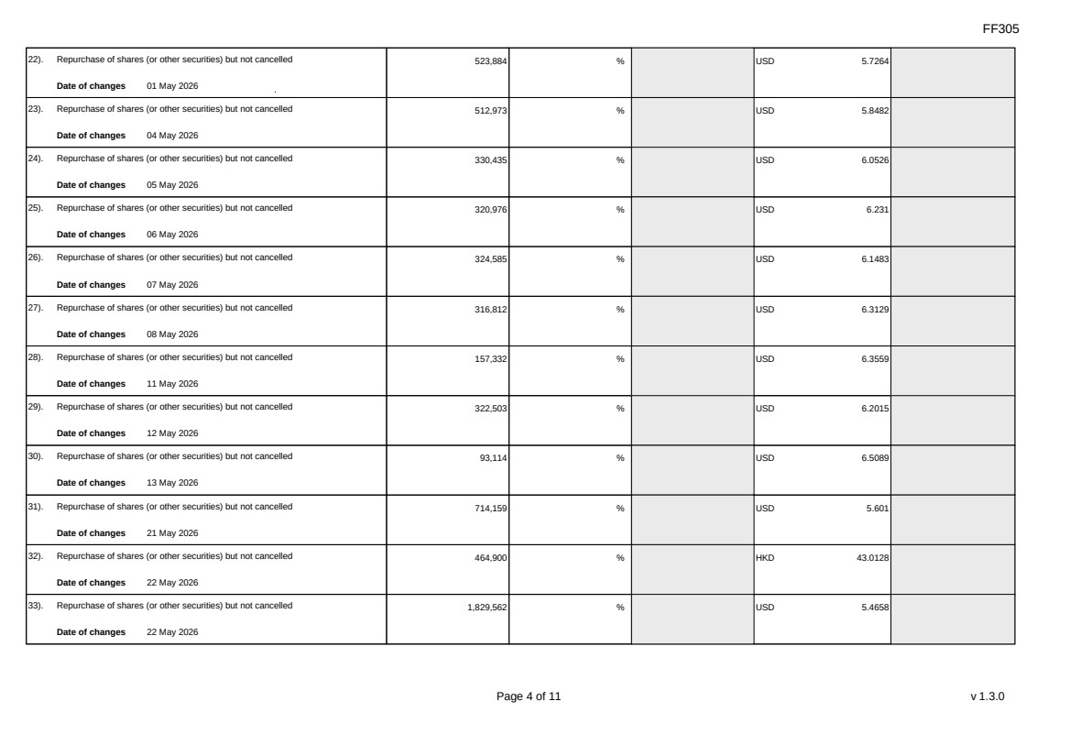 | FF305 Page 4 of 11 v 1.3.0 22). Repurchase of shares (or other securities) but not cancelled Date of changes 01 May 2026 523,884 % USD 5.7264 23). Repurchase of shares (or other securities) but not cancelled Date of changes 04 May 2026 512,973 % USD 5.8482 24). Repurchase of shares (or other securities) but not cancelled Date of changes 05 May 2026 330,435 % USD 6.0526 25). Repurchase of shares (or other securities) but not cancelled Date of changes 06 May 2026 320,976 % USD 6.231 26). Repurchase of shares (or other securities) but not cancelled Date of changes 07 May 2026 324,585 % USD 6.1483 27). Repurchase of shares (or other securities) but not cancelled Date of changes 08 May 2026 316,812 % USD 6.3129 28). Repurchase of shares (or other securities) but not cancelled Date of changes 11 May 2026 157,332 % USD 6.3559 29). Repurchase of shares (or other securities) but not cancelled Date of changes 12 May 2026 322,503 % USD 6.2015 30). Repurchase of shares (or other securities) but not cancelled Date of changes 13 May 2026 93,114 % USD 6.5089 31). Repurchase of shares (or other securities) but not cancelled Date of changes 21 May 2026 714,159 % USD 5.601 32). Repurchase of shares (or other securities) but not cancelled Date of changes 22 May 2026 464,900 % HKD 43.0128 33). Repurchase of shares (or other securities) but not cancelled Date of changes 22 May 2026 1,829,562 % USD 5.4658
 | 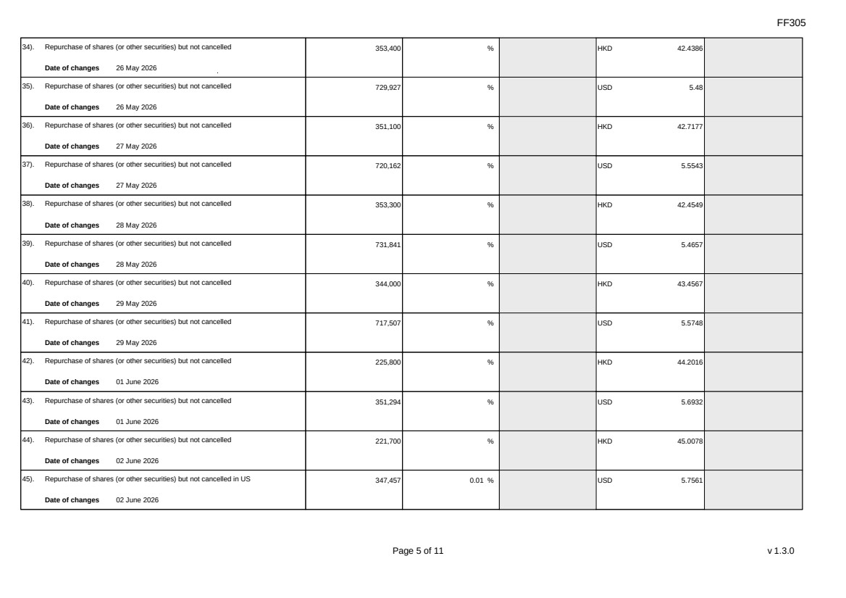 | FF305 Page 5 of 11 v 1.3.0 34). Repurchase of shares (or other securities) but not cancelled Date of changes 26 May 2026 353,400 % HKD 42.4386 35). Repurchase of shares (or other securities) but not cancelled Date of changes 26 May 2026 729,927 % USD 5.48 36). Repurchase of shares (or other securities) but not cancelled Date of changes 27 May 2026 351,100 % HKD 42.7177 37). Repurchase of shares (or other securities) but not cancelled Date of changes 27 May 2026 720,162 % USD 5.5543 38). Repurchase of shares (or other securities) but not cancelled Date of changes 28 May 2026 353,300 % HKD 42.4549 39). Repurchase of shares (or other securities) but not cancelled Date of changes 28 May 2026 731,841 % USD 5.4657 40). Repurchase of shares (or other securities) but not cancelled Date of changes 29 May 2026 344,000 % HKD 43.4567 41). Repurchase of shares (or other securities) but not cancelled Date of changes 29 May 2026 717,507 % USD 5.5748 42). Repurchase of shares (or other securities) but not cancelled Date of changes 01 June 2026 225,800 % HKD 44.2016 43). Repurchase of shares (or other securities) but not cancelled Date of changes 01 June 2026 351,294 % USD 5.6932 44). Repurchase of shares (or other securities) but not cancelled Date of changes 02 June 2026 221,700 % HKD 45.0078 45). Repurchase of shares (or other securities) but not cancelled in US Date of changes 02 June 2026 347,457 0.01 % USD 5.7561
 | 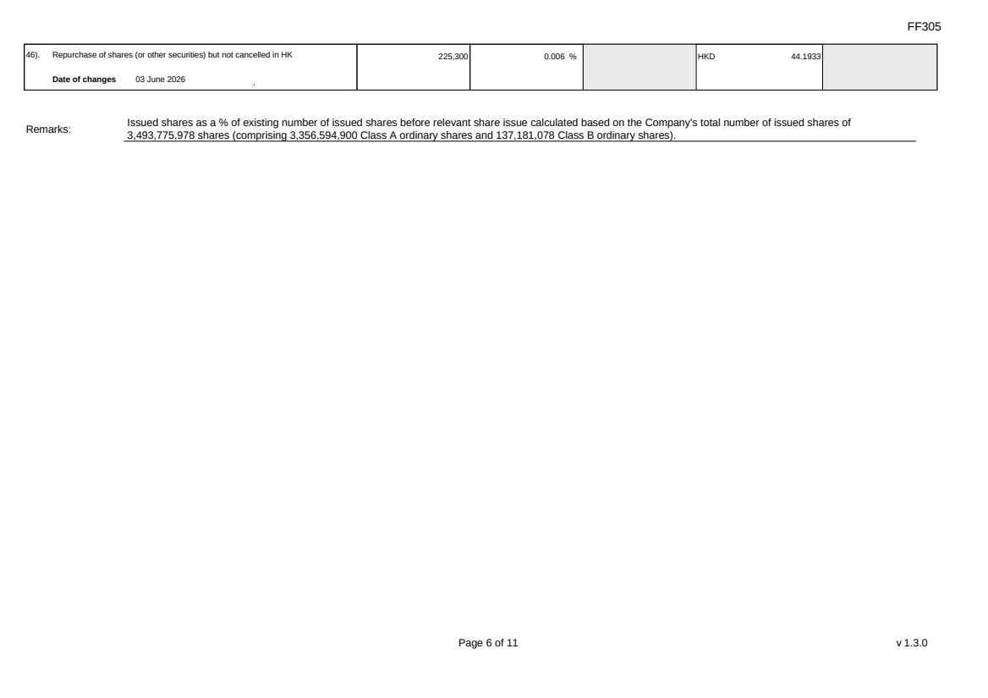 | FF305 Page 6 of 11 v 1.3.0 46). Repurchase of shares (or other securities) but not cancelled in HK Date of changes 03 June 2026 225,300 0.006 % HKD 44.1933 Remarks: Issued shares as a % of existing number of issued shares before relevant share issue calculated based on the Company's total number of issued shares of 3,493,775,978 shares (comprising 3,356,594,900 Class A ordinary shares and 137,181,078 Class B ordinary shares).
 | 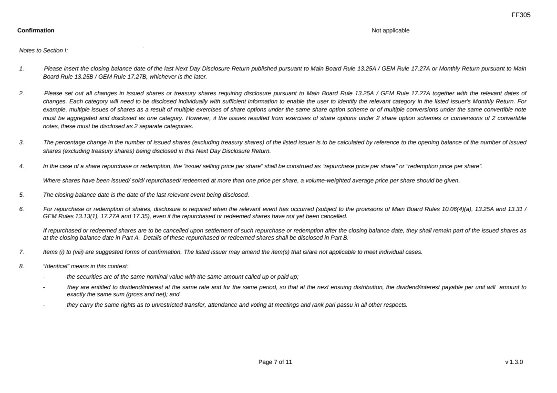 | FF305 Page 7 of 11 v 1.3.0 Confirmation Not applicable Notes to Section I: 1. Please insert the closing balance date of the last Next Day Disclosure Return published pursuant to Main Board Rule 13.25A / GEM Rule 17.27A or Monthly Return pursuant to Main Board Rule 13.25B / GEM Rule 17.27B, whichever is the later. 2. Please set out all changes in issued shares or treasury shares requiring disclosure pursuant to Main Board Rule 13.25A / GEM Rule 17.27A together with the relevant dates of changes. Each category will need to be disclosed individually with sufficient information to enable the user to identify the relevant category in the listed issuer's Monthly Return. For example, multiple issues of shares as a result of multiple exercises of share options under the same share option scheme or of multiple conversions under the same convertible note must be aggregated and disclosed as one category. However, if the issues resulted from exercises of share options under 2 share option schemes or conversions of 2 convertible notes, these must be disclosed as 2 separate categories. 3. The percentage change in the number of issued shares (excluding treasury shares) of the listed issuer is to be calculated by reference to the opening balance of the number of issued shares (excluding treasury shares) being disclosed in this Next Day Disclosure Return. 4. In the case of a share repurchase or redemption, the “issue/ selling price per share” shall be construed as “repurchase price per share” or “redemption price per share”. Where shares have been issued/ sold/ repurchased/ redeemed at more than one price per share, a volume-weighted average price per share should be given. 5. The closing balance date is the date of the last relevant event being disclosed. 6. For repurchase or redemption of shares, disclosure is required when the relevant event has occurred (subject to the provisions of Main Board Rules 10.06(4)(a), 13.25A and 13.31 / GEM Rules 13.13(1), 17.27A and 17.35), even if the repurchased or redeemed shares have not yet been cancelled. If repurchased or redeemed shares are to be cancelled upon settlement of such repurchase or redemption after the closing balance date, they shall remain part of the issued shares as at the closing balance date in Part A. Details of these repurchased or redeemed shares shall be disclosed in Part B. 7. Items (i) to (viii) are suggested forms of confirmation. The listed issuer may amend the item(s) that is/are not applicable to meet individual cases. 8. “Identical” means in this context: - the securities are of the same nominal value with the same amount called up or paid up; - they are entitled to dividend/interest at the same rate and for the same period, so that at the next ensuing distribution, the dividend/interest payable per unit will amount to exactly the same sum (gross and net); and - they carry the same rights as to unrestricted transfer, attendance and voting at meetings and rank pari passu in all other respects.
 | 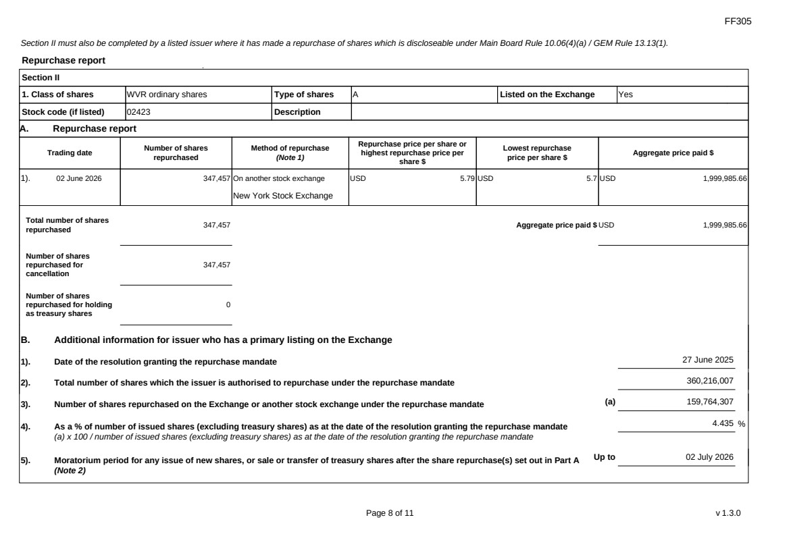 | FF305 Page 8 of 11 v 1.3.0 Section II must also be completed by a listed issuer where it has made a repurchase of shares which is discloseable under Main Board Rule 10.06(4)(a) / GEM Rule 13.13(1). Repurchase report Section II 1. Class of shares WVR ordinary shares Type of shares A Listed on the Exchange Yes Stock code (if listed) 02423 Description A. Repurchase report Trading date Number of shares repurchased Method of repurchase (Note 1) Repurchase price per share or highest repurchase price per share $ Lowest repurchase price per share $ Aggregate price paid $ 1). 02 June 2026 347,457 On another stock exchange New York Stock Exchange USD 5.79 USD 5.7 USD 1,999,985.66 Total number of shares repurchased 347,457 Aggregate price paid $ USD 1,999,985.66 Number of shares repurchased for cancellation 347,457 Number of shares repurchased for holding as treasury shares 0 B. Additional information for issuer who has a primary listing on the Exchange 1). Date of the resolution granting the repurchase mandate 27 June 2025 2). Total number of shares which the issuer is authorised to repurchase under the repurchase mandate 360,216,007 3). Number of shares repurchased on the Exchange or another stock exchange under the repurchase mandate (a) 159,764,307 4). As a % of number of issued shares (excluding treasury shares) as at the date of the resolution granting the repurchase mandate (a) x 100 / number of issued shares (excluding treasury shares) as at the date of the resolution granting the repurchase mandate 4.435 % 5). Moratorium period for any issue of new shares, or sale or transfer of treasury shares after the share repurchase(s) set out in Part A (Note 2) Up to 02 July 2026
 | 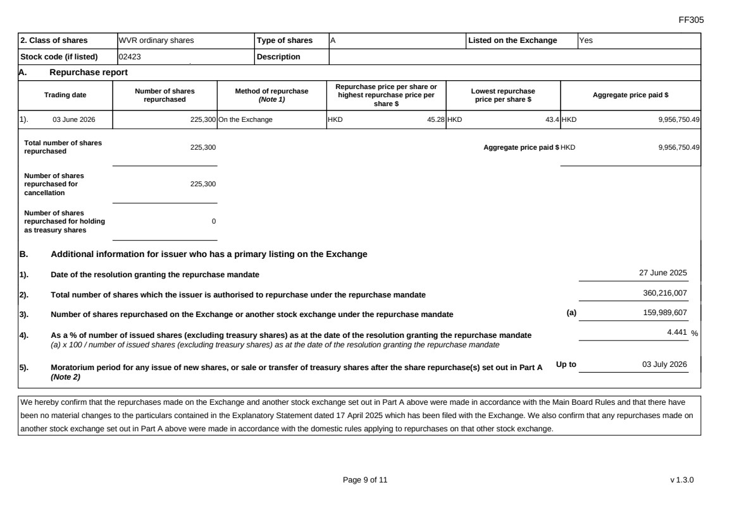 | FF305 Page 9 of 11 v 1.3.0 2. Class of shares WVR ordinary shares Type of shares A Listed on the Exchange Yes Stock code (if listed) 02423 Description A. Repurchase report Trading date Number of shares repurchased Method of repurchase (Note 1) Repurchase price per share or highest repurchase price per share $ Lowest repurchase price per share $ Aggregate price paid $ 1). 03 June 2026 225,300 On the Exchange HKD 45.28 HKD 43.4 HKD 9,956,750.49 Total number of shares repurchased 225,300 Aggregate price paid $ HKD 9,956,750.49 Number of shares repurchased for cancellation 225,300 Number of shares repurchased for holding as treasury shares 0 B. Additional information for issuer who has a primary listing on the Exchange 1). Date of the resolution granting the repurchase mandate 27 June 2025 2). Total number of shares which the issuer is authorised to repurchase under the repurchase mandate 360,216,007 3). Number of shares repurchased on the Exchange or another stock exchange under the repurchase mandate (a) 159,989,607 4). As a % of number of issued shares (excluding treasury shares) as at the date of the resolution granting the repurchase mandate (a) x 100 / number of issued shares (excluding treasury shares) as at the date of the resolution granting the repurchase mandate 4.441 % 5). Moratorium period for any issue of new shares, or sale or transfer of treasury shares after the share repurchase(s) set out in Part A (Note 2) Up to 03 July 2026 We hereby confirm that the repurchases made on the Exchange and another stock exchange set out in Part A above were made in accordance with the Main Board Rules and that there have been no material changes to the particulars contained in the Explanatory Statement dated 17 April 2025 which has been filed with the Exchange. We also confirm that any repurchases made on another stock exchange set out in Part A above were made in accordance with the domestic rules applying to repurchases on that other stock exchange.
 | 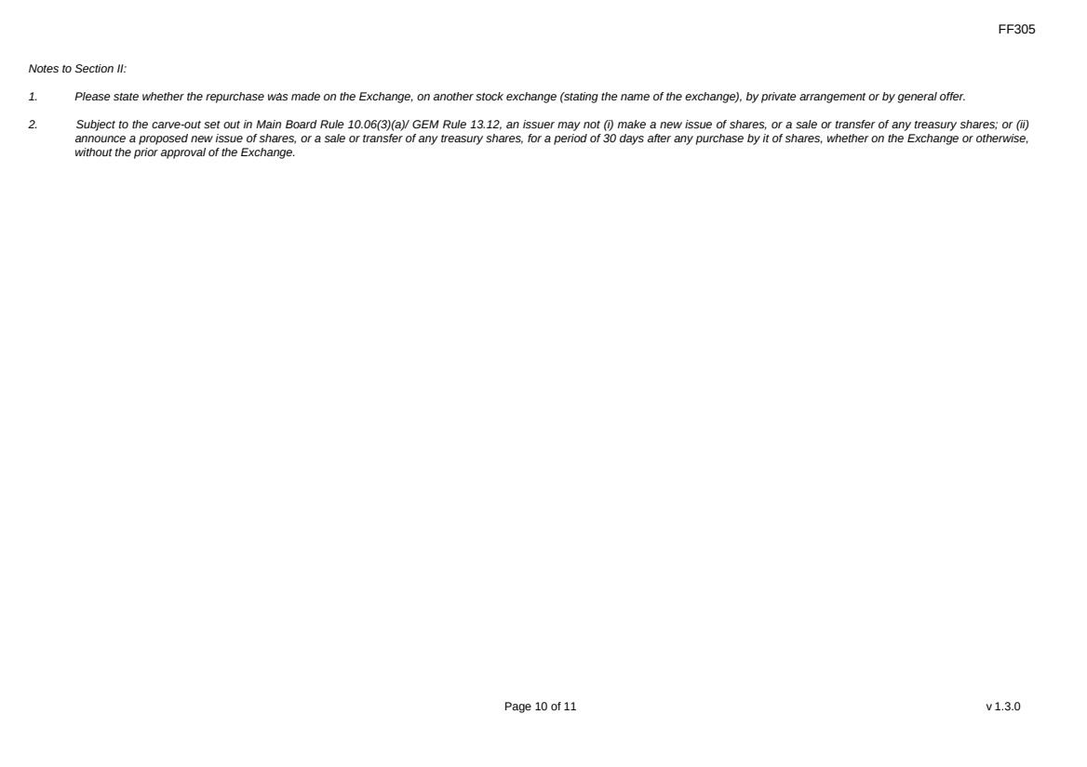 | FF305 Page 10 of 11 v 1.3.0 Notes to Section II: 1. Please state whether the repurchase was made on the Exchange, on another stock exchange (stating the name of the exchange), by private arrangement or by general offer. 2. Subject to the carve-out set out in Main Board Rule 10.06(3)(a)/ GEM Rule 13.12, an issuer may not (i) make a new issue of shares, or a sale or transfer of any treasury shares; or (ii) announce a proposed new issue of shares, or a sale or transfer of any treasury shares, for a period of 30 days after any purchase by it of shares, whether on the Exchange or otherwise, without the prior approval of the Exchange.
 | 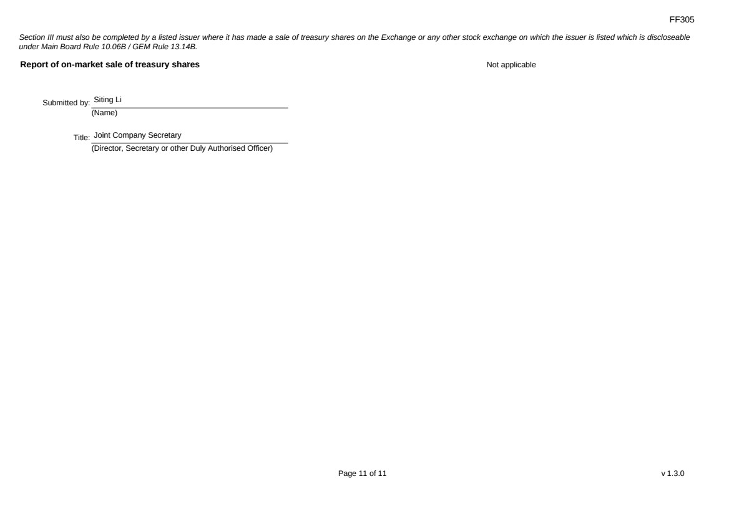 | FF305 Page 11 of 11 v 1.3.0 Section III must also be completed by a listed issuer where it has made a sale of treasury shares on the Exchange or any other stock exchange on which the issuer is listed which is discloseable under Main Board Rule 10.06B / GEM Rule 13.14B. Report of on-market sale of treasury shares Not applicable Submitted by: Siting Li (Name) Title: Joint Company Secretary (Director, Secretary or other Duly Authorised Officer)
Exhibit 99.5
 | 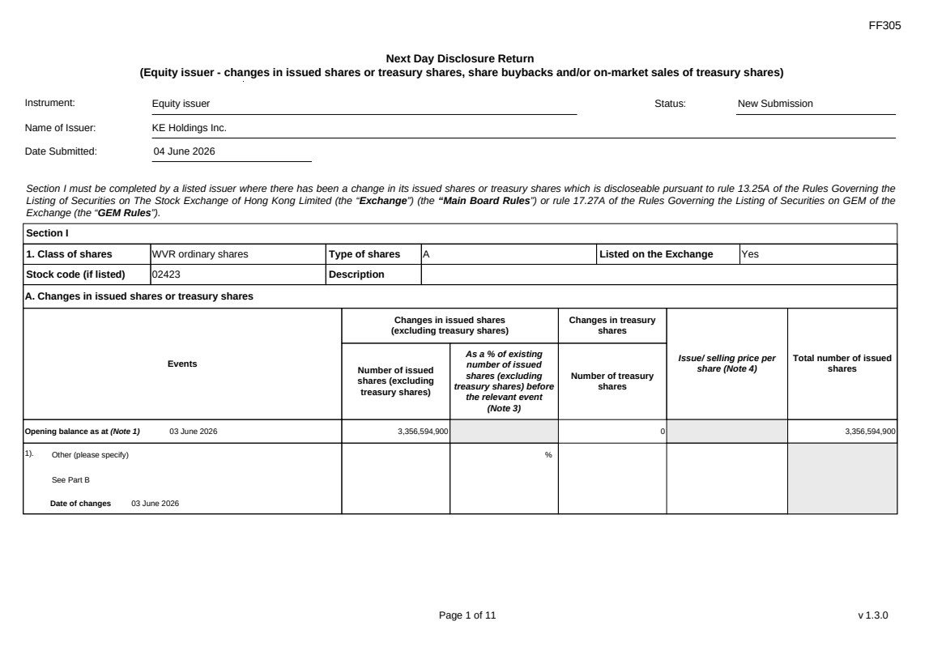 | FF305 Page 1 of 11 v 1.3.0 Next Day Disclosure Return (Equity issuer - changes in issued shares or treasury shares, share buybacks and/or on-market sales of treasury shares) Instrument: Equity issuer Status: New Submission Name of Issuer: KE Holdings Inc. Date Submitted: 04 June 2026 Section I must be completed by a listed issuer where there has been a change in its issued shares or treasury shares which is discloseable pursuant to rule 13.25A of the Rules Governing the Listing of Securities on The Stock Exchange of Hong Kong Limited (the “Exchange”) (the “Main Board Rules”) or rule 17.27A of the Rules Governing the Listing of Securities on GEM of the Exchange (the “GEM Rules”). Section I 1. Class of shares WVR ordinary shares Type of shares A Listed on the Exchange Yes Stock code (if listed) 02423 Description A. Changes in issued shares or treasury shares Events Changes in issued shares (excluding treasury shares) Number of issued shares (excluding treasury shares) As a % of existing number of issued shares (excluding treasury shares) before the relevant event (Note 3) Changes in treasury shares Number of treasury shares Issue/ selling price per share (Note 4) Total number of issued shares Opening balance as at (Note 1) 03 June 2026 3,356,594,900 0 3,356,594,900 1). Other (please specify) See Part B Date of changes 03 June 2026 %
 | 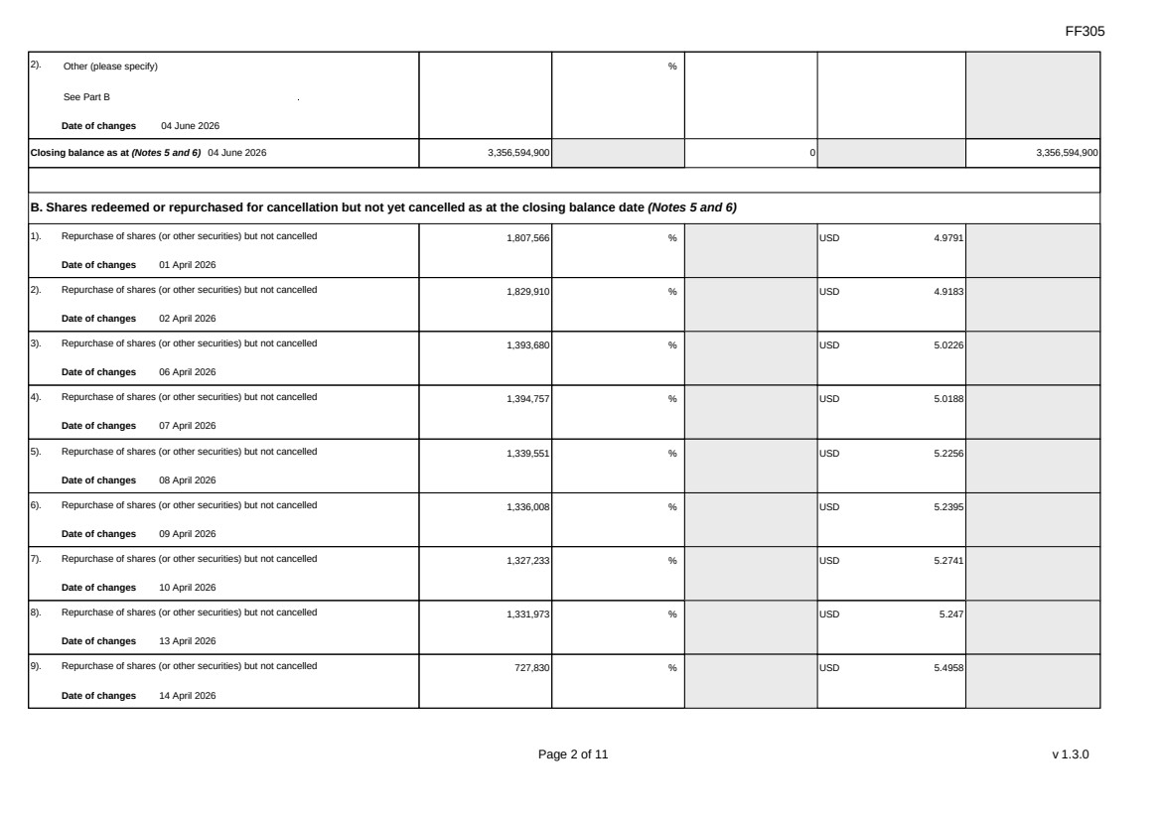 | FF305 Page 2 of 11 v 1.3.0 2). Other (please specify) See Part B Date of changes 04 June 2026 % Closing balance as at (Notes 5 and 6) 04 June 2026 3,356,594,900 0 3,356,594,900 B. Shares redeemed or repurchased for cancellation but not yet cancelled as at the closing balance date (Notes 5 and 6) 1). Repurchase of shares (or other securities) but not cancelled Date of changes 01 April 2026 1,807,566 % USD 4.9791 2). Repurchase of shares (or other securities) but not cancelled Date of changes 02 April 2026 1,829,910 % USD 4.9183 3). Repurchase of shares (or other securities) but not cancelled Date of changes 06 April 2026 1,393,680 % USD 5.0226 4). Repurchase of shares (or other securities) but not cancelled Date of changes 07 April 2026 1,394,757 % USD 5.0188 5). Repurchase of shares (or other securities) but not cancelled Date of changes 08 April 2026 1,339,551 % USD 5.2256 6). Repurchase of shares (or other securities) but not cancelled Date of changes 09 April 2026 1,336,008 % USD 5.2395 7). Repurchase of shares (or other securities) but not cancelled Date of changes 10 April 2026 1,327,233 % USD 5.2741 8). Repurchase of shares (or other securities) but not cancelled Date of changes 13 April 2026 1,331,973 % USD 5.247 9). Repurchase of shares (or other securities) but not cancelled Date of changes 14 April 2026 727,830 % USD 5.4958
FF305 Page 3 of 11 v 1.3.0 10). Repurchase of shares (or other securities) but not cancelled Date of changes 15 April 2026 735,444 % USD 5.4389 11). Repurchase of shares (or other securities) but not cancelled Date of changes 16 April 2026 736,578 % USD 5.4305 12). Repurchase of shares (or other securities) but not cancelled Date of changes 17 April 2026 737,058 % USD 5.427 13). Repurchase of shares (or other securities) but not cancelled Date of changes 20 April 2026 731,112 % USD 5.4711 14). Repurchase of shares (or other securities) but not cancelled Date of changes 21 April 2026 739,947 % USD 5.4058 15). Repurchase of shares (or other securities) but not cancelled Date of changes 22 April 2026 1,227,948 % USD 5.3451 16). Repurchase of shares (or other securities) but not cancelled Date of changes 23 April 2026 1,328,778 % USD 5.268 17). Repurchase of shares (or other securities) but not cancelled Date of changes 24 April 2026 745,629 % USD 5.3645 18). Repurchase of shares (or other securities) but not cancelled Date of changes 27 April 2026 749,046 % USD 5.3401 19). Repurchase of shares (or other securities) but not cancelled Date of changes 28 April 2026 1,329,072 % USD 5.2668 20). Repurchase of shares (or other securities) but not cancelled Date of changes 29 April 2026 802,443 % USD 5.3256 21). Repurchase of shares (or other securities) but not cancelled Date of changes 30 April 2026 639,573 % USD 5.586
FF305 Page 4 of 11 v 1.3.0 22). Repurchase of shares (or other securities) but not cancelled Date of changes 01 May 2026 523,884 % USD 5.7264 23). Repurchase of shares (or other securities) but not cancelled Date of changes 04 May 2026 512,973 % USD 5.8482 24). Repurchase of shares (or other securities) but not cancelled Date of changes 05 May 2026 330,435 % USD 6.0526 25). Repurchase of shares (or other securities) but not cancelled Date of changes 06 May 2026 320,976 % USD 6.231 26). Repurchase of shares (or other securities) but not cancelled Date of changes 07 May 2026 324,585 % USD 6.1483 27). Repurchase of shares (or other securities) but not cancelled Date of changes 08 May 2026 316,812 % USD 6.3129 28). Repurchase of shares (or other securities) but not cancelled Date of changes 11 May 2026 157,332 % USD 6.3559 29). Repurchase of shares (or other securities) but not cancelled Date of changes 12 May 2026 322,503 % USD 6.2015 30). Repurchase of shares (or other securities) but not cancelled Date of changes 13 May 2026 93,114 % USD 6.5089 31). Repurchase of shares (or other securities) but not cancelled Date of changes 21 May 2026 714,159 % USD 5.601 32). Repurchase of shares (or other securities) but not cancelled Date of changes 22 May 2026 464,900 % HKD 43.0128 33). Repurchase of shares (or other securities) but not cancelled Date of changes 22 May 2026 1,829,562 % USD 5.4658
 | 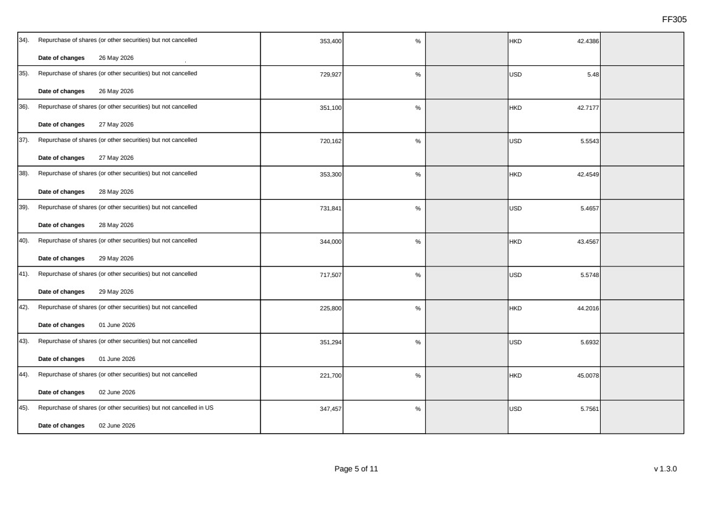 | FF305 Page 5 of 11 v 1.3.0 34). Repurchase of shares (or other securities) but not cancelled Date of changes 26 May 2026 353,400 % HKD 42.4386 35). Repurchase of shares (or other securities) but not cancelled Date of changes 26 May 2026 729,927 % USD 5.48 36). Repurchase of shares (or other securities) but not cancelled Date of changes 27 May 2026 351,100 % HKD 42.7177 37). Repurchase of shares (or other securities) but not cancelled Date of changes 27 May 2026 720,162 % USD 5.5543 38). Repurchase of shares (or other securities) but not cancelled Date of changes 28 May 2026 353,300 % HKD 42.4549 39). Repurchase of shares (or other securities) but not cancelled Date of changes 28 May 2026 731,841 % USD 5.4657 40). Repurchase of shares (or other securities) but not cancelled Date of changes 29 May 2026 344,000 % HKD 43.4567 41). Repurchase of shares (or other securities) but not cancelled Date of changes 29 May 2026 717,507 % USD 5.5748 42). Repurchase of shares (or other securities) but not cancelled Date of changes 01 June 2026 225,800 % HKD 44.2016 43). Repurchase of shares (or other securities) but not cancelled Date of changes 01 June 2026 351,294 % USD 5.6932 44). Repurchase of shares (or other securities) but not cancelled Date of changes 02 June 2026 221,700 % HKD 45.0078 45). Repurchase of shares (or other securities) but not cancelled in US Date of changes 02 June 2026 347,457 % USD 5.7561
 | 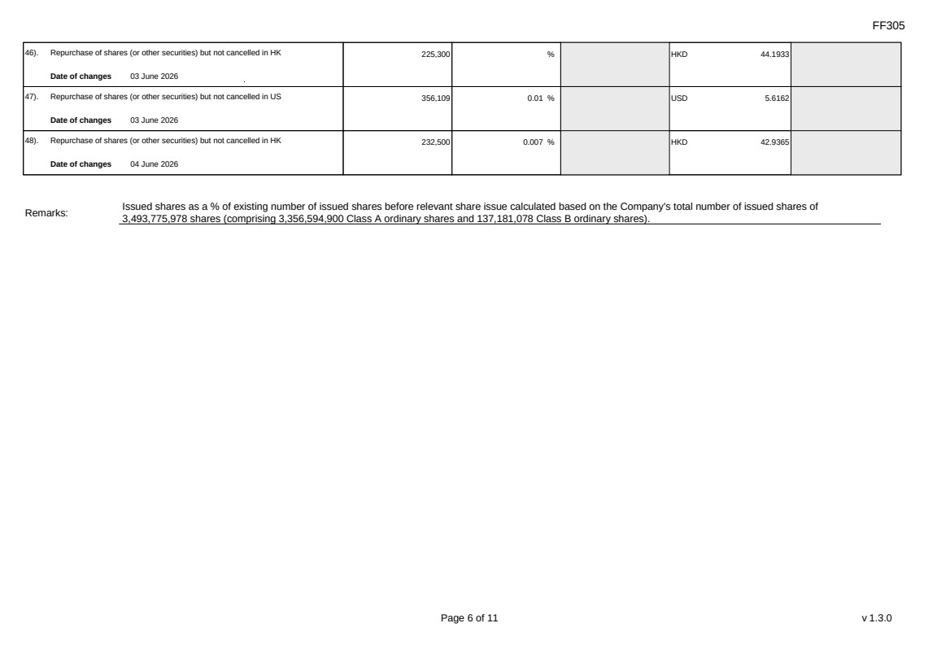 | FF305 Page 6 of 11 v 1.3.0 46). Repurchase of shares (or other securities) but not cancelled in HK Date of changes 03 June 2026 225,300 % HKD 44.1933 47). Repurchase of shares (or other securities) but not cancelled in US Date of changes 03 June 2026 356,109 0.01 % USD 5.6162 48). Repurchase of shares (or other securities) but not cancelled in HK Date of changes 04 June 2026 232,500 0.007 % HKD 42.9365 Remarks: Issued shares as a % of existing number of issued shares before relevant share issue calculated based on the Company's total number of issued shares of 3,493,775,978 shares (comprising 3,356,594,900 Class A ordinary shares and 137,181,078 Class B ordinary shares).
FF305 Page 7 of 11 v 1.3.0 Confirmation Not applicable Notes to Section I: 1. Please insert the closing balance date of the last Next Day Disclosure Return published pursuant to Main Board Rule 13.25A / GEM Rule 17.27A or Monthly Return pursuant to Main Board Rule 13.25B / GEM Rule 17.27B, whichever is the later. 2. Please set out all changes in issued shares or treasury shares requiring disclosure pursuant to Main Board Rule 13.25A / GEM Rule 17.27A together with the relevant dates of changes. Each category will need to be disclosed individually with sufficient information to enable the user to identify the relevant category in the listed issuer's Monthly Return. For example, multiple issues of shares as a result of multiple exercises of share options under the same share option scheme or of multiple conversions under the same convertible note must be aggregated and disclosed as one category. However, if the issues resulted from exercises of share options under 2 share option schemes or conversions of 2 convertible notes, these must be disclosed as 2 separate categories. 3. The percentage change in the number of issued shares (excluding treasury shares) of the listed issuer is to be calculated by reference to the opening balance of the number of issued shares (excluding treasury shares) being disclosed in this Next Day Disclosure Return. 4. In the case of a share repurchase or redemption, the “issue/ selling price per share” shall be construed as “repurchase price per share” or “redemption price per share”. Where shares have been issued/ sold/ repurchased/ redeemed at more than one price per share, a volume-weighted average price per share should be given. 5. The closing balance date is the date of the last relevant event being disclosed. 6. For repurchase or redemption of shares, disclosure is required when the relevant event has occurred (subject to the provisions of Main Board Rules 10.06(4)(a), 13.25A and 13.31 / GEM Rules 13.13(1), 17.27A and 17.35), even if the repurchased or redeemed shares have not yet been cancelled. If repurchased or redeemed shares are to be cancelled upon settlement of such repurchase or redemption after the closing balance date, they shall remain part of the issued shares as at the closing balance date in Part A. Details of these repurchased or redeemed shares shall be disclosed in Part B. 7. Items (i) to (viii) are suggested forms of confirmation. The listed issuer may amend the item(s) that is/are not applicable to meet individual cases. 8. “Identical” means in this context: - the securities are of the same nominal value with the same amount called up or paid up; - they are entitled to dividend/interest at the same rate and for the same period, so that at the next ensuing distribution, the dividend/interest payable per unit will amount to exactly the same sum (gross and net); and - they carry the same rights as to unrestricted transfer, attendance and voting at meetings and rank pari passu in all other respects.
 | 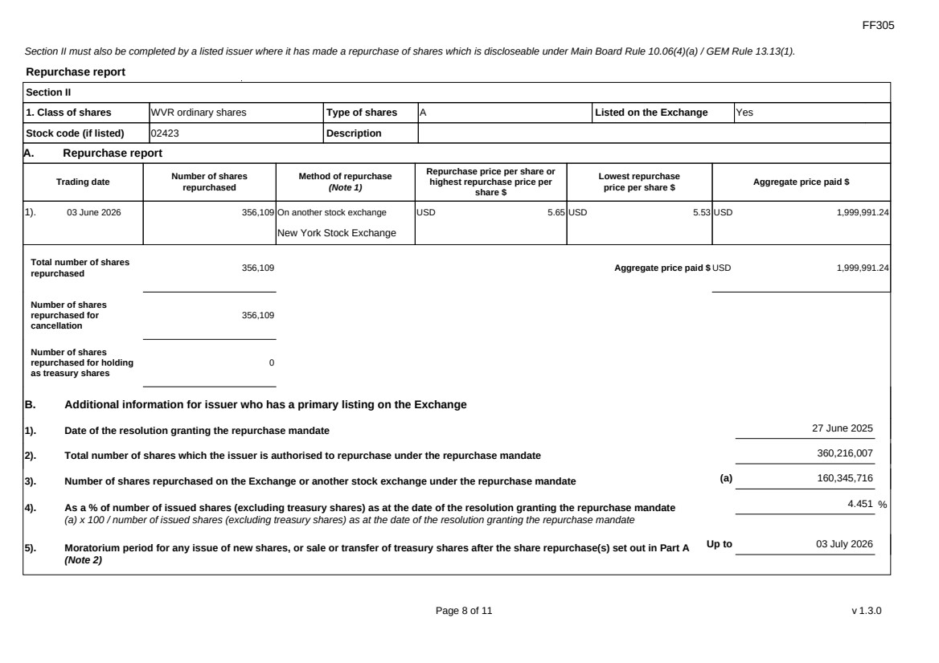 | FF305 Page 8 of 11 v 1.3.0 Section II must also be completed by a listed issuer where it has made a repurchase of shares which is discloseable under Main Board Rule 10.06(4)(a) / GEM Rule 13.13(1). Repurchase report Section II 1. Class of shares WVR ordinary shares Type of shares A Listed on the Exchange Yes Stock code (if listed) 02423 Description A. Repurchase report Trading date Number of shares repurchased Method of repurchase (Note 1) Repurchase price per share or highest repurchase price per share $ Lowest repurchase price per share $ Aggregate price paid $ 1). 03 June 2026 356,109 On another stock exchange New York Stock Exchange USD 5.65 USD 5.53 USD 1,999,991.24 Total number of shares repurchased 356,109 Aggregate price paid $ USD 1,999,991.24 Number of shares repurchased for cancellation 356,109 Number of shares repurchased for holding as treasury shares 0 B. Additional information for issuer who has a primary listing on the Exchange 1). Date of the resolution granting the repurchase mandate 27 June 2025 2). Total number of shares which the issuer is authorised to repurchase under the repurchase mandate 360,216,007 3). Number of shares repurchased on the Exchange or another stock exchange under the repurchase mandate (a) 160,345,716 4). As a % of number of issued shares (excluding treasury shares) as at the date of the resolution granting the repurchase mandate (a) x 100 / number of issued shares (excluding treasury shares) as at the date of the resolution granting the repurchase mandate 4.451 % 5). Moratorium period for any issue of new shares, or sale or transfer of treasury shares after the share repurchase(s) set out in Part A (Note 2) Up to 03 July 2026
 | 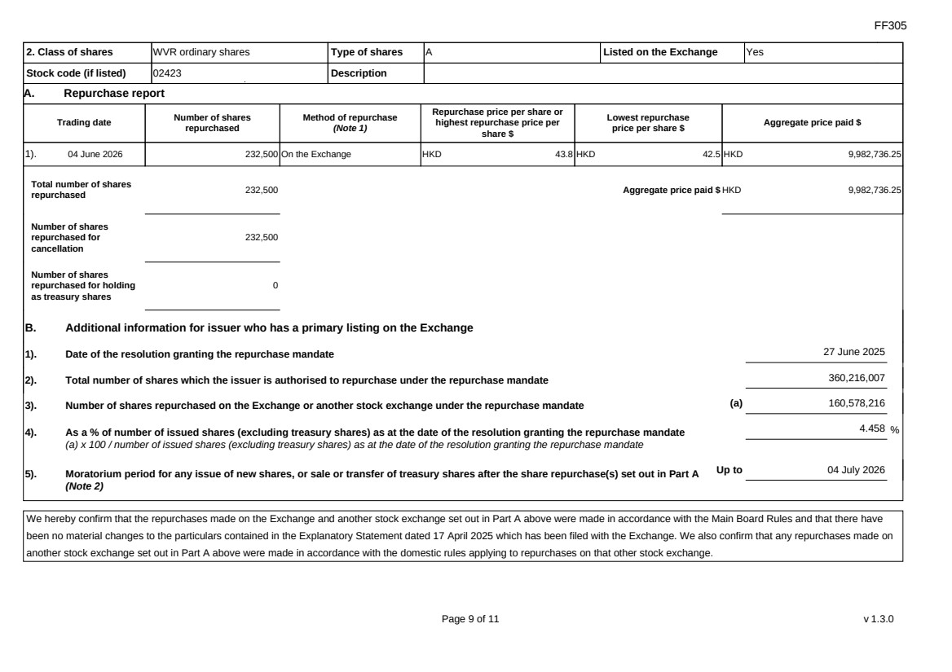 | FF305 Page 9 of 11 v 1.3.0 2. Class of shares WVR ordinary shares Type of shares A Listed on the Exchange Yes Stock code (if listed) 02423 Description A. Repurchase report Trading date Number of shares repurchased Method of repurchase (Note 1) Repurchase price per share or highest repurchase price per share $ Lowest repurchase price per share $ Aggregate price paid $ 1). 04 June 2026 232,500 On the Exchange HKD 43.8 HKD 42.5 HKD 9,982,736.25 Total number of shares repurchased 232,500 Aggregate price paid $ HKD 9,982,736.25 Number of shares repurchased for cancellation 232,500 Number of shares repurchased for holding as treasury shares 0 B. Additional information for issuer who has a primary listing on the Exchange 1). Date of the resolution granting the repurchase mandate 27 June 2025 2). Total number of shares which the issuer is authorised to repurchase under the repurchase mandate 360,216,007 3). Number of shares repurchased on the Exchange or another stock exchange under the repurchase mandate (a) 160,578,216 4). As a % of number of issued shares (excluding treasury shares) as at the date of the resolution granting the repurchase mandate (a) x 100 / number of issued shares (excluding treasury shares) as at the date of the resolution granting the repurchase mandate 4.458 % 5). Moratorium period for any issue of new shares, or sale or transfer of treasury shares after the share repurchase(s) set out in Part A (Note 2) Up to 04 July 2026 We hereby confirm that the repurchases made on the Exchange and another stock exchange set out in Part A above were made in accordance with the Main Board Rules and that there have been no material changes to the particulars contained in the Explanatory Statement dated 17 April 2025 which has been filed with the Exchange. We also confirm that any repurchases made on another stock exchange set out in Part A above were made in accordance with the domestic rules applying to repurchases on that other stock exchange.
FF305 Page 10 of 11 v 1.3.0 Notes to Section II: 1. Please state whether the repurchase was made on the Exchange, on another stock exchange (stating the name of the exchange), by private arrangement or by general offer. 2. Subject to the carve-out set out in Main Board Rule 10.06(3)(a)/ GEM Rule 13.12, an issuer may not (i) make a new issue of shares, or a sale or transfer of any treasury shares; or (ii) announce a proposed new issue of shares, or a sale or transfer of any treasury shares, for a period of 30 days after any purchase by it of shares, whether on the Exchange or otherwise, without the prior approval of the Exchange.
FF305 Page 11 of 11 v 1.3.0 Section III must also be completed by a listed issuer where it has made a sale of treasury shares on the Exchange or any other stock exchange on which the issuer is listed which is discloseable under Main Board Rule 10.06B / GEM Rule 13.14B. Report of on-market sale of treasury shares Not applicable Submitted by: Siting Li (Name) Title: Joint Company Secretary (Director, Secretary or other Duly Authorised Officer)
Exhibit 99.6
 | 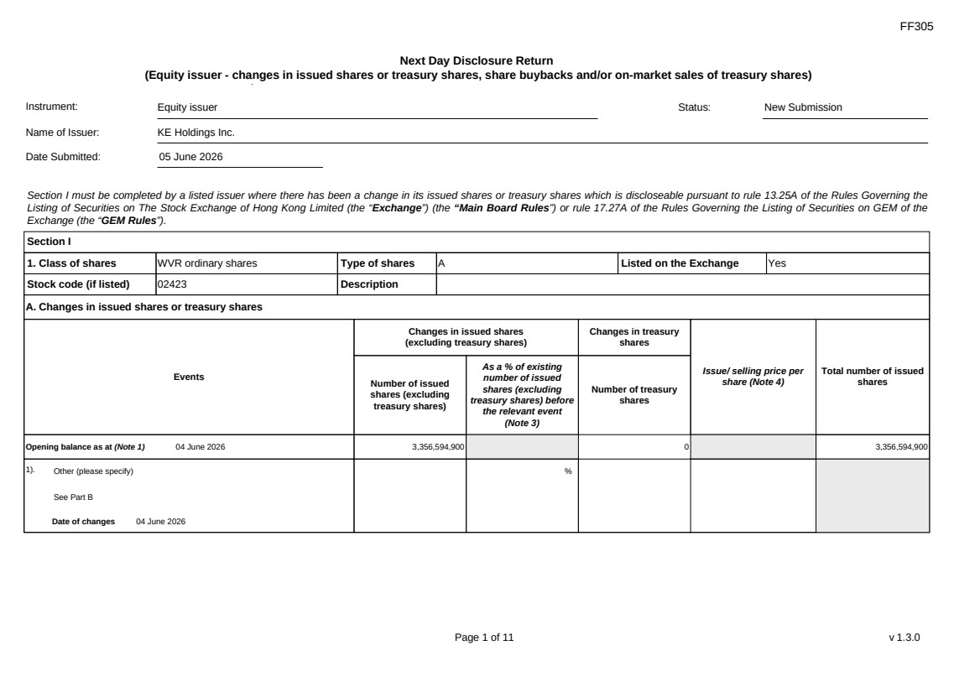 | FF305 Page 1 of 11 v 1.3.0 Next Day Disclosure Return (Equity issuer - changes in issued shares or treasury shares, share buybacks and/or on-market sales of treasury shares) Instrument: Equity issuer Status: New Submission Name of Issuer: KE Holdings Inc. Date Submitted: 05 June 2026 Section I must be completed by a listed issuer where there has been a change in its issued shares or treasury shares which is discloseable pursuant to rule 13.25A of the Rules Governing the Listing of Securities on The Stock Exchange of Hong Kong Limited (the “Exchange”) (the “Main Board Rules”) or rule 17.27A of the Rules Governing the Listing of Securities on GEM of the Exchange (the “GEM Rules”). Section I 1. Class of shares WVR ordinary shares Type of shares A Listed on the Exchange Yes Stock code (if listed) 02423 Description A. Changes in issued shares or treasury shares Events Changes in issued shares (excluding treasury shares) Number of issued shares (excluding treasury shares) As a % of existing number of issued shares (excluding treasury shares) before the relevant event (Note 3) Changes in treasury shares Number of treasury shares Issue/ selling price per share (Note 4) Total number of issued shares Opening balance as at (Note 1) 04 June 2026 3,356,594,900 0 3,356,594,900 1). Other (please specify) See Part B Date of changes 04 June 2026 %
 | 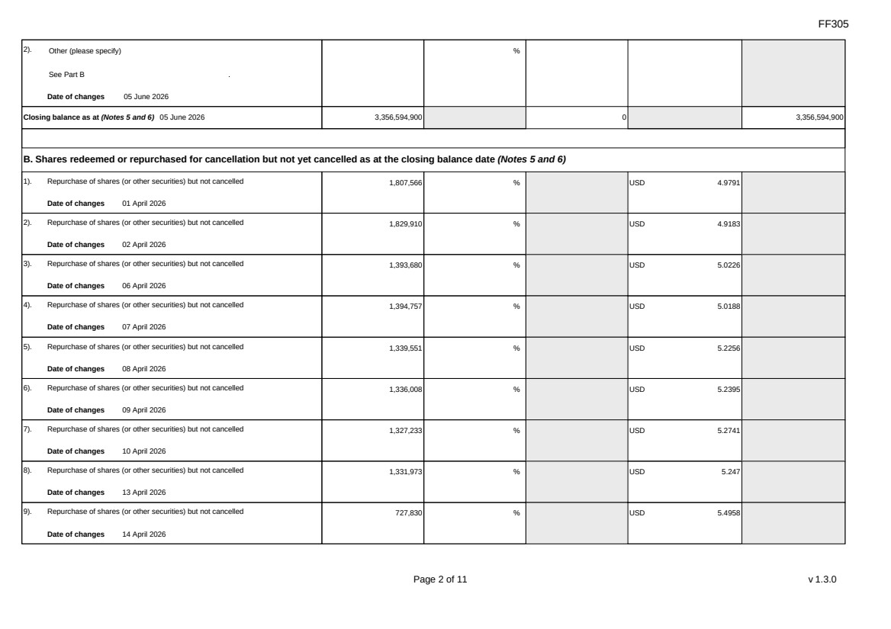 | FF305 Page 2 of 11 v 1.3.0 2). Other (please specify) See Part B Date of changes 05 June 2026 % Closing balance as at (Notes 5 and 6) 05 June 2026 3,356,594,900 0 3,356,594,900 B. Shares redeemed or repurchased for cancellation but not yet cancelled as at the closing balance date (Notes 5 and 6) 1). Repurchase of shares (or other securities) but not cancelled Date of changes 01 April 2026 1,807,566 % USD 4.9791 2). Repurchase of shares (or other securities) but not cancelled Date of changes 02 April 2026 1,829,910 % USD 4.9183 3). Repurchase of shares (or other securities) but not cancelled Date of changes 06 April 2026 1,393,680 % USD 5.0226 4). Repurchase of shares (or other securities) but not cancelled Date of changes 07 April 2026 1,394,757 % USD 5.0188 5). Repurchase of shares (or other securities) but not cancelled Date of changes 08 April 2026 1,339,551 % USD 5.2256 6). Repurchase of shares (or other securities) but not cancelled Date of changes 09 April 2026 1,336,008 % USD 5.2395 7). Repurchase of shares (or other securities) but not cancelled Date of changes 10 April 2026 1,327,233 % USD 5.2741 8). Repurchase of shares (or other securities) but not cancelled Date of changes 13 April 2026 1,331,973 % USD 5.247 9). Repurchase of shares (or other securities) but not cancelled Date of changes 14 April 2026 727,830 % USD 5.4958
FF305 Page 3 of 11 v 1.3.0 10). Repurchase of shares (or other securities) but not cancelled Date of changes 15 April 2026 735,444 % USD 5.4389 11). Repurchase of shares (or other securities) but not cancelled Date of changes 16 April 2026 736,578 % USD 5.4305 12). Repurchase of shares (or other securities) but not cancelled Date of changes 17 April 2026 737,058 % USD 5.427 13). Repurchase of shares (or other securities) but not cancelled Date of changes 20 April 2026 731,112 % USD 5.4711 14). Repurchase of shares (or other securities) but not cancelled Date of changes 21 April 2026 739,947 % USD 5.4058 15). Repurchase of shares (or other securities) but not cancelled Date of changes 22 April 2026 1,227,948 % USD 5.3451 16). Repurchase of shares (or other securities) but not cancelled Date of changes 23 April 2026 1,328,778 % USD 5.268 17). Repurchase of shares (or other securities) but not cancelled Date of changes 24 April 2026 745,629 % USD 5.3645 18). Repurchase of shares (or other securities) but not cancelled Date of changes 27 April 2026 749,046 % USD 5.3401 19). Repurchase of shares (or other securities) but not cancelled Date of changes 28 April 2026 1,329,072 % USD 5.2668 20). Repurchase of shares (or other securities) but not cancelled Date of changes 29 April 2026 802,443 % USD 5.3256 21). Repurchase of shares (or other securities) but not cancelled Date of changes 30 April 2026 639,573 % USD 5.586
FF305 Page 4 of 11 v 1.3.0 22). Repurchase of shares (or other securities) but not cancelled Date of changes 01 May 2026 523,884 % USD 5.7264 23). Repurchase of shares (or other securities) but not cancelled Date of changes 04 May 2026 512,973 % USD 5.8482 24). Repurchase of shares (or other securities) but not cancelled Date of changes 05 May 2026 330,435 % USD 6.0526 25). Repurchase of shares (or other securities) but not cancelled Date of changes 06 May 2026 320,976 % USD 6.231 26). Repurchase of shares (or other securities) but not cancelled Date of changes 07 May 2026 324,585 % USD 6.1483 27). Repurchase of shares (or other securities) but not cancelled Date of changes 08 May 2026 316,812 % USD 6.3129 28). Repurchase of shares (or other securities) but not cancelled Date of changes 11 May 2026 157,332 % USD 6.3559 29). Repurchase of shares (or other securities) but not cancelled Date of changes 12 May 2026 322,503 % USD 6.2015 30). Repurchase of shares (or other securities) but not cancelled Date of changes 13 May 2026 93,114 % USD 6.5089 31). Repurchase of shares (or other securities) but not cancelled Date of changes 21 May 2026 714,159 % USD 5.601 32). Repurchase of shares (or other securities) but not cancelled Date of changes 22 May 2026 464,900 % HKD 43.0128 33). Repurchase of shares (or other securities) but not cancelled Date of changes 22 May 2026 1,829,562 % USD 5.4658
FF305 Page 5 of 11 v 1.3.0 34). Repurchase of shares (or other securities) but not cancelled Date of changes 26 May 2026 353,400 % HKD 42.4386 35). Repurchase of shares (or other securities) but not cancelled Date of changes 26 May 2026 729,927 % USD 5.48 36). Repurchase of shares (or other securities) but not cancelled Date of changes 27 May 2026 351,100 % HKD 42.7177 37). Repurchase of shares (or other securities) but not cancelled Date of changes 27 May 2026 720,162 % USD 5.5543 38). Repurchase of shares (or other securities) but not cancelled Date of changes 28 May 2026 353,300 % HKD 42.4549 39). Repurchase of shares (or other securities) but not cancelled Date of changes 28 May 2026 731,841 % USD 5.4657 40). Repurchase of shares (or other securities) but not cancelled Date of changes 29 May 2026 344,000 % HKD 43.4567 41). Repurchase of shares (or other securities) but not cancelled Date of changes 29 May 2026 717,507 % USD 5.5748 42). Repurchase of shares (or other securities) but not cancelled Date of changes 01 June 2026 225,800 % HKD 44.2016 43). Repurchase of shares (or other securities) but not cancelled Date of changes 01 June 2026 351,294 % USD 5.6932 44). Repurchase of shares (or other securities) but not cancelled Date of changes 02 June 2026 221,700 % HKD 45.0078 45). Repurchase of shares (or other securities) but not cancelled in US Date of changes 02 June 2026 347,457 % USD 5.7561
 | 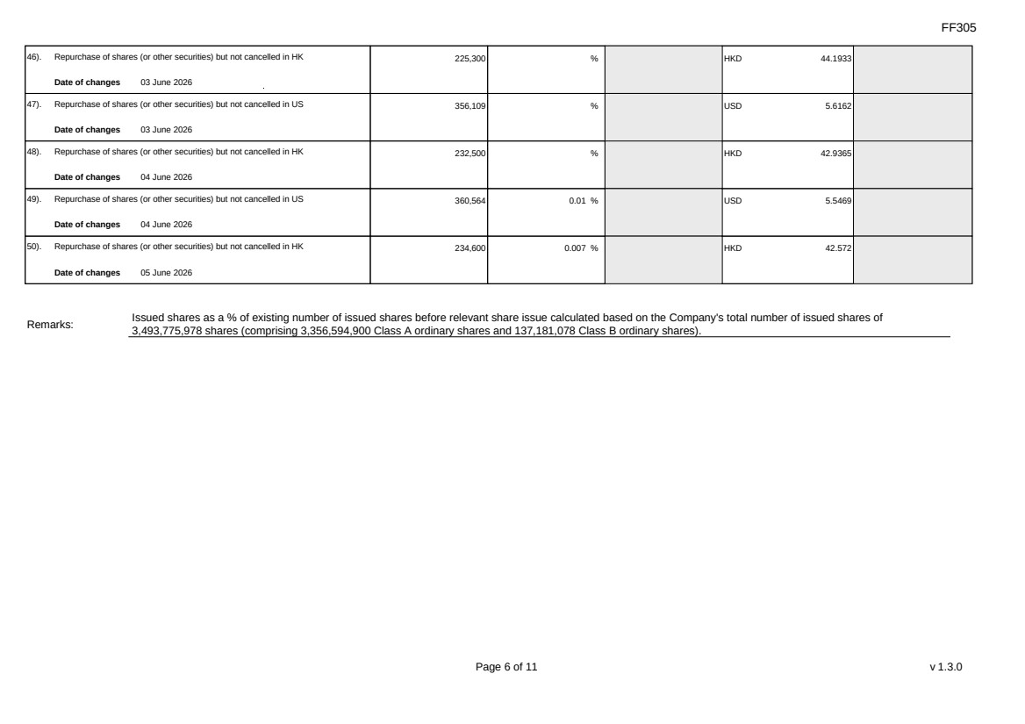 | FF305 Page 6 of 11 v 1.3.0 46). Repurchase of shares (or other securities) but not cancelled in HK Date of changes 03 June 2026 225,300 % HKD 44.1933 47). Repurchase of shares (or other securities) but not cancelled in US Date of changes 03 June 2026 356,109 % USD 5.6162 48). Repurchase of shares (or other securities) but not cancelled in HK Date of changes 04 June 2026 232,500 % HKD 42.9365 49). Repurchase of shares (or other securities) but not cancelled in US Date of changes 04 June 2026 360,564 0.01 % USD 5.5469 50). Repurchase of shares (or other securities) but not cancelled in HK Date of changes 05 June 2026 234,600 0.007 % HKD 42.572 Remarks: Issued shares as a % of existing number of issued shares before relevant share issue calculated based on the Company's total number of issued shares of 3,493,775,978 shares (comprising 3,356,594,900 Class A ordinary shares and 137,181,078 Class B ordinary shares).
FF305 Page 7 of 11 v 1.3.0 Confirmation Not applicable Notes to Section I: 1. Please insert the closing balance date of the last Next Day Disclosure Return published pursuant to Main Board Rule 13.25A / GEM Rule 17.27A or Monthly Return pursuant to Main Board Rule 13.25B / GEM Rule 17.27B, whichever is the later. 2. Please set out all changes in issued shares or treasury shares requiring disclosure pursuant to Main Board Rule 13.25A / GEM Rule 17.27A together with the relevant dates of changes. Each category will need to be disclosed individually with sufficient information to enable the user to identify the relevant category in the listed issuer's Monthly Return. For example, multiple issues of shares as a result of multiple exercises of share options under the same share option scheme or of multiple conversions under the same convertible note must be aggregated and disclosed as one category. However, if the issues resulted from exercises of share options under 2 share option schemes or conversions of 2 convertible notes, these must be disclosed as 2 separate categories. 3. The percentage change in the number of issued shares (excluding treasury shares) of the listed issuer is to be calculated by reference to the opening balance of the number of issued shares (excluding treasury shares) being disclosed in this Next Day Disclosure Return. 4. In the case of a share repurchase or redemption, the “issue/ selling price per share” shall be construed as “repurchase price per share” or “redemption price per share”. Where shares have been issued/ sold/ repurchased/ redeemed at more than one price per share, a volume-weighted average price per share should be given. 5. The closing balance date is the date of the last relevant event being disclosed. 6. For repurchase or redemption of shares, disclosure is required when the relevant event has occurred (subject to the provisions of Main Board Rules 10.06(4)(a), 13.25A and 13.31 / GEM Rules 13.13(1), 17.27A and 17.35), even if the repurchased or redeemed shares have not yet been cancelled. If repurchased or redeemed shares are to be cancelled upon settlement of such repurchase or redemption after the closing balance date, they shall remain part of the issued shares as at the closing balance date in Part A. Details of these repurchased or redeemed shares shall be disclosed in Part B. 7. Items (i) to (viii) are suggested forms of confirmation. The listed issuer may amend the item(s) that is/are not applicable to meet individual cases. 8. “Identical” means in this context: - the securities are of the same nominal value with the same amount called up or paid up; - they are entitled to dividend/interest at the same rate and for the same period, so that at the next ensuing distribution, the dividend/interest payable per unit will amount to exactly the same sum (gross and net); and - they carry the same rights as to unrestricted transfer, attendance and voting at meetings and rank pari passu in all other respects.
 | 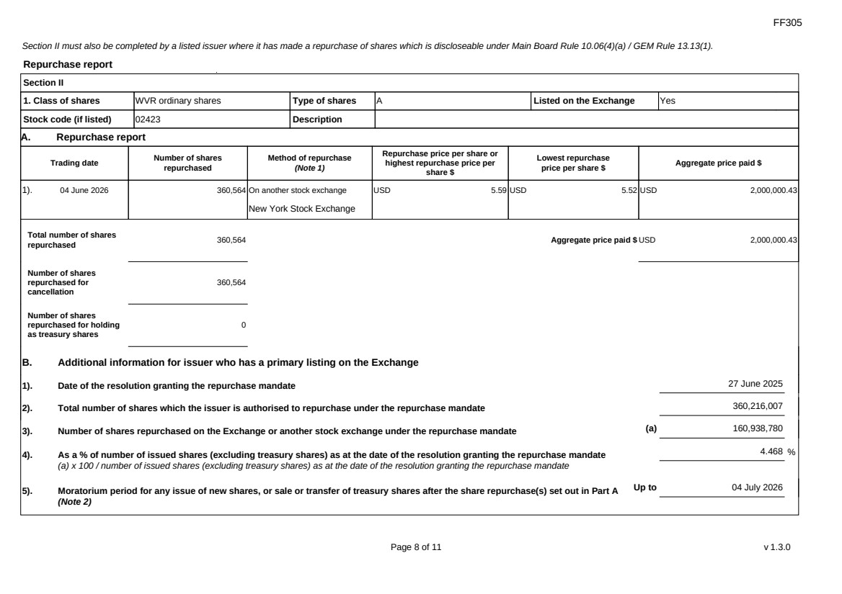 | FF305 Page 8 of 11 v 1.3.0 Section II must also be completed by a listed issuer where it has made a repurchase of shares which is discloseable under Main Board Rule 10.06(4)(a) / GEM Rule 13.13(1). Repurchase report Section II 1. Class of shares WVR ordinary shares Type of shares A Listed on the Exchange Yes Stock code (if listed) 02423 Description A. Repurchase report Trading date Number of shares repurchased Method of repurchase (Note 1) Repurchase price per share or highest repurchase price per share $ Lowest repurchase price per share $ Aggregate price paid $ 1). 04 June 2026 360,564 On another stock exchange New York Stock Exchange USD 5.59 USD 5.52 USD 2,000,000.43 Total number of shares repurchased 360,564 Aggregate price paid $ USD 2,000,000.43 Number of shares repurchased for cancellation 360,564 Number of shares repurchased for holding as treasury shares 0 B. Additional information for issuer who has a primary listing on the Exchange 1). Date of the resolution granting the repurchase mandate 27 June 2025 2). Total number of shares which the issuer is authorised to repurchase under the repurchase mandate 360,216,007 3). Number of shares repurchased on the Exchange or another stock exchange under the repurchase mandate (a) 160,938,780 4). As a % of number of issued shares (excluding treasury shares) as at the date of the resolution granting the repurchase mandate (a) x 100 / number of issued shares (excluding treasury shares) as at the date of the resolution granting the repurchase mandate 4.468 % 5). Moratorium period for any issue of new shares, or sale or transfer of treasury shares after the share repurchase(s) set out in Part A (Note 2) Up to 04 July 2026
 | 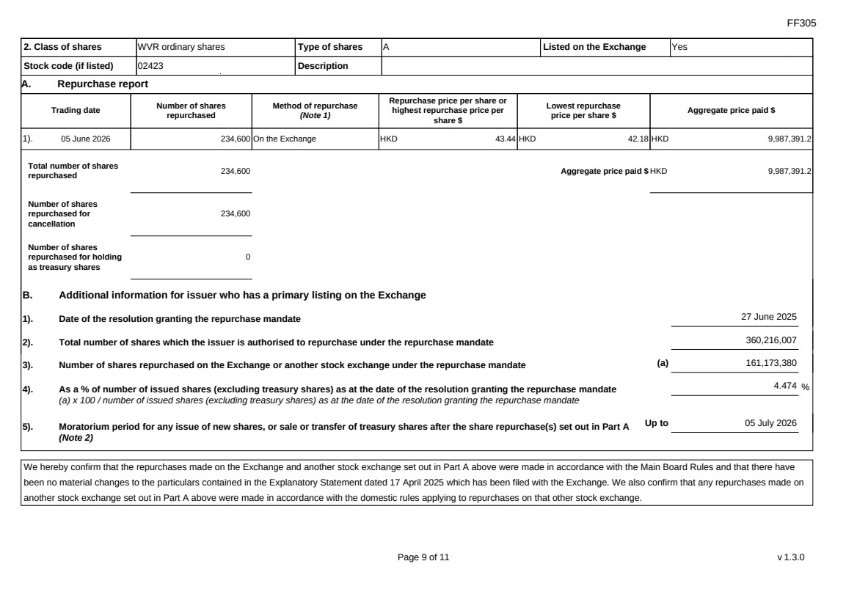 | FF305 Page 9 of 11 v 1.3.0 2. Class of shares WVR ordinary shares Type of shares A Listed on the Exchange Yes Stock code (if listed) 02423 Description A. Repurchase report Trading date Number of shares repurchased Method of repurchase (Note 1) Repurchase price per share or highest repurchase price per share $ Lowest repurchase price per share $ Aggregate price paid $ 1). 05 June 2026 234,600 On the Exchange HKD 43.44 HKD 42.18 HKD 9,987,391.2 Total number of shares repurchased 234,600 Aggregate price paid $ HKD 9,987,391.2 Number of shares repurchased for cancellation 234,600 Number of shares repurchased for holding as treasury shares 0 B. Additional information for issuer who has a primary listing on the Exchange 1). Date of the resolution granting the repurchase mandate 27 June 2025 2). Total number of shares which the issuer is authorised to repurchase under the repurchase mandate 360,216,007 3). Number of shares repurchased on the Exchange or another stock exchange under the repurchase mandate (a) 161,173,380 4). As a % of number of issued shares (excluding treasury shares) as at the date of the resolution granting the repurchase mandate (a) x 100 / number of issued shares (excluding treasury shares) as at the date of the resolution granting the repurchase mandate 4.474 % 5). Moratorium period for any issue of new shares, or sale or transfer of treasury shares after the share repurchase(s) set out in Part A (Note 2) Up to 05 July 2026 We hereby confirm that the repurchases made on the Exchange and another stock exchange set out in Part A above were made in accordance with the Main Board Rules and that there have been no material changes to the particulars contained in the Explanatory Statement dated 17 April 2025 which has been filed with the Exchange. We also confirm that any repurchases made on another stock exchange set out in Part A above were made in accordance with the domestic rules applying to repurchases on that other stock exchange.
FF305 Page 10 of 11 v 1.3.0 Notes to Section II: 1. Please state whether the repurchase was made on the Exchange, on another stock exchange (stating the name of the exchange), by private arrangement or by general offer. 2. Subject to the carve-out set out in Main Board Rule 10.06(3)(a)/ GEM Rule 13.12, an issuer may not (i) make a new issue of shares, or a sale or transfer of any treasury shares; or (ii) announce a proposed new issue of shares, or a sale or transfer of any treasury shares, for a period of 30 days after any purchase by it of shares, whether on the Exchange or otherwise, without the prior approval of the Exchange.
FF305 Page 11 of 11 v 1.3.0 Section III must also be completed by a listed issuer where it has made a sale of treasury shares on the Exchange or any other stock exchange on which the issuer is listed which is discloseable under Main Board Rule 10.06B / GEM Rule 13.14B. Report of on-market sale of treasury shares Not applicable Submitted by: Siting Li (Name) Title: Joint Company Secretary (Director, Secretary or other Duly Authorised Officer)

