UNITED STATES

SECURITIES AND EXCHANGE COMMISSION

Washington, D.C. 20549

FORM 6-K

REPORT OF FOREIGN PRIVATE ISSUER

PURSUANT TO RULE 13a-16 OR 15d-16 UNDER

THE SECURITIES EXCHANGE ACT OF 1934

For the month of May 2026

Commission File Number: 001-39436

KE Holdings Inc.

(Registrant’s Name)

Oriental Electronic Technology Building,

No. 2 Chuangye Road, Haidian District,

Beijing 100086

People’s Republic of China

(Address of Principal Executive Offices)

Indicate by check mark whether the registrant files or will file annual reports under cover Form 20-F or Form 40-F.

Form 20-F ☒ Form 40-F ☐

 |  |  |  |  | EXHIBIT INDEX
Exhibit No. |  |  |  |  |  | Description
 | 99.1 |  |  | Next Day Disclosure Return Dated May 11, 2026
 | 99.2 |  |  | Next Day Disclosure Return Dated May 12, 2026
 | 99.3 |  |  | Next Day Disclosure Return Dated May 13, 2026
 | 99.4 |  |  | Next Day Disclosure Return Dated May 14, 2026
 | 99.5 |  |  | Announcement—Supplemental Announcement in Relation to the Board Meeting

SIGNATURES

Pursuant to the requirements of the Securities Exchange Act of 1934, the registrant has duly caused this report to be signed on its behalf by the undersigned, thereunto duly authorized.

KE Holdings Inc.

By | : | /s/ XU Tao
Name | : | XU Tao
Title | : | Chief Financial Officer

Date: May 18, 2026

Exhibit 99.1
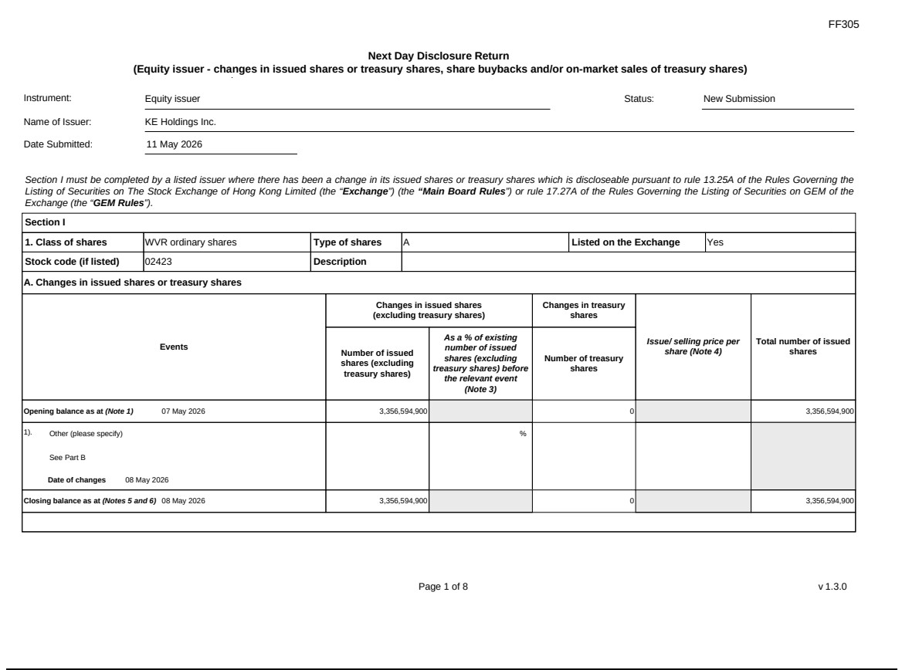

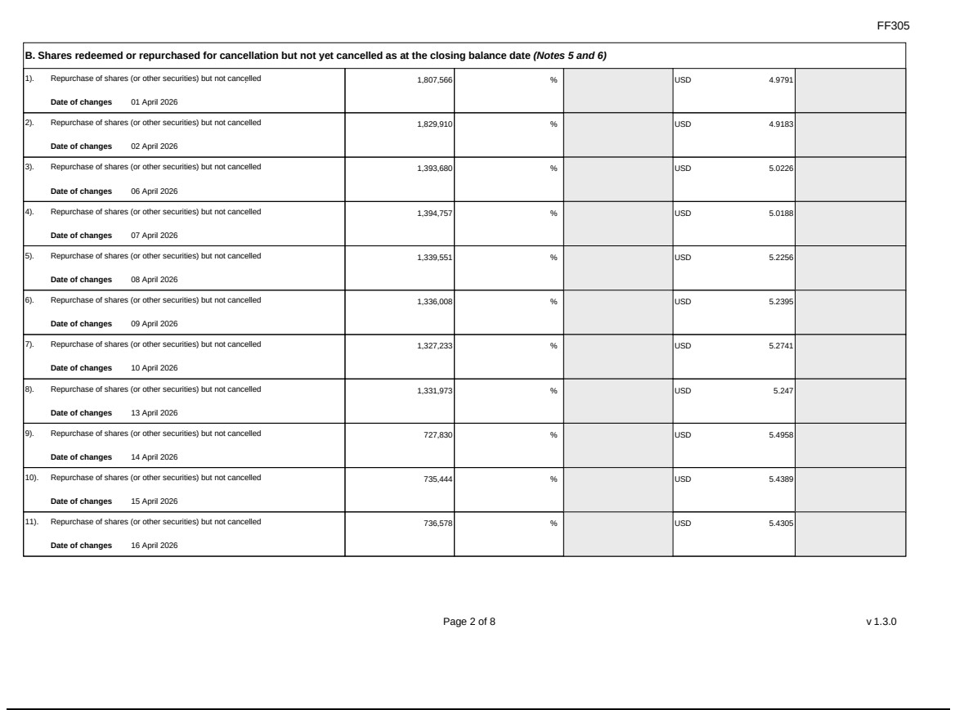

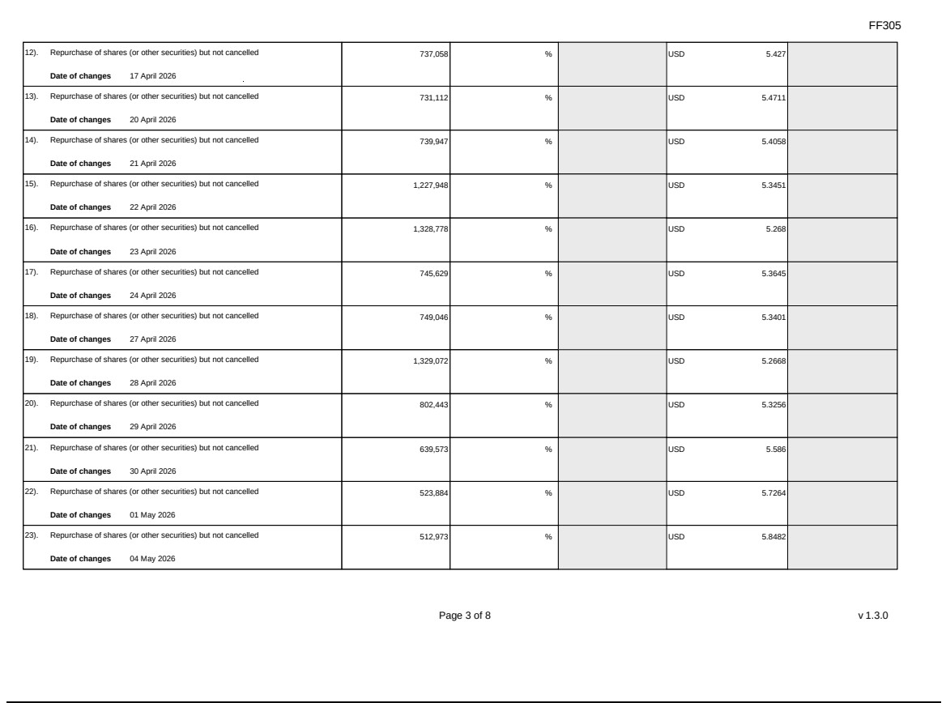

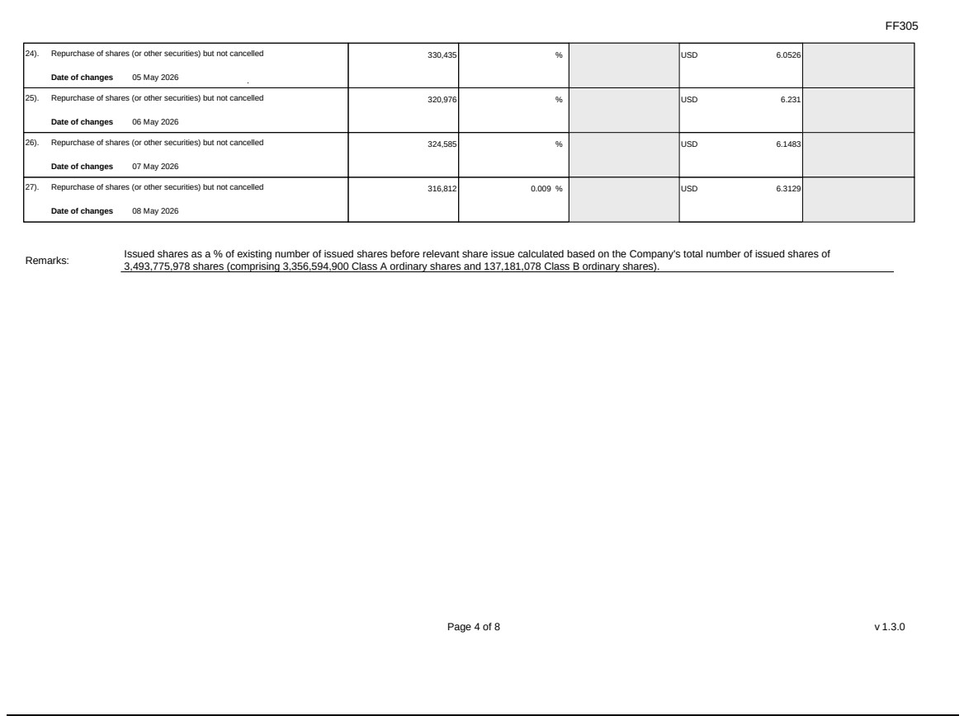

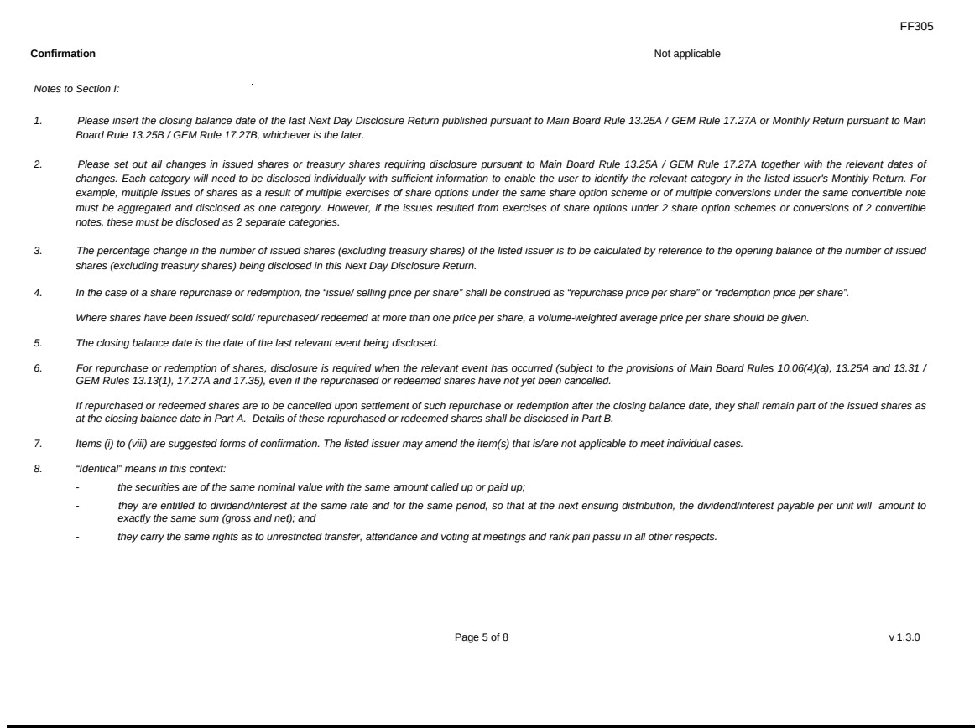

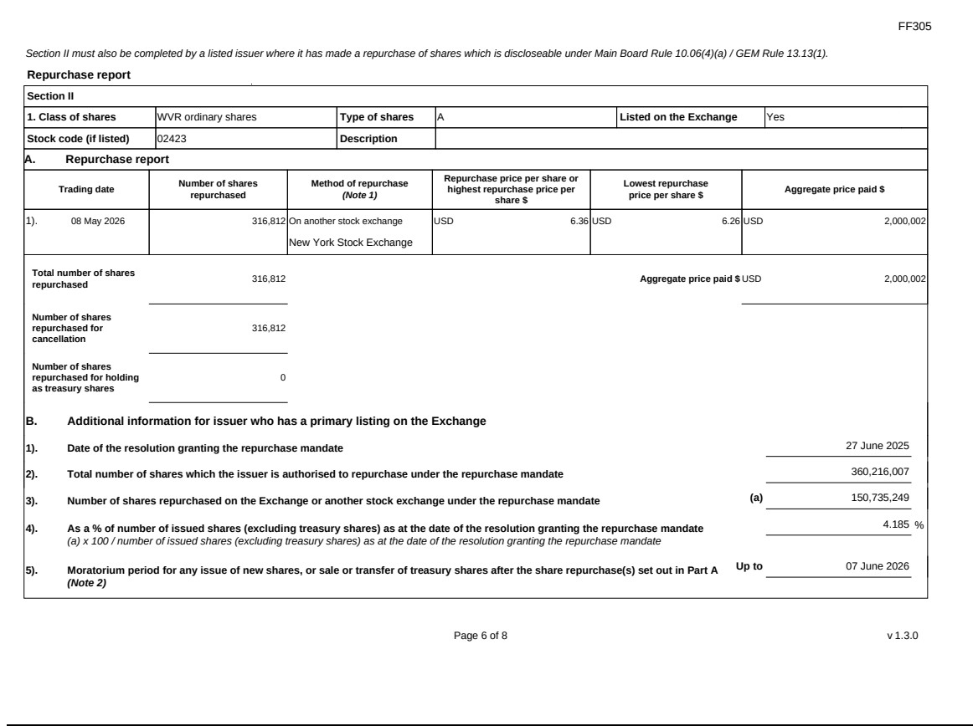

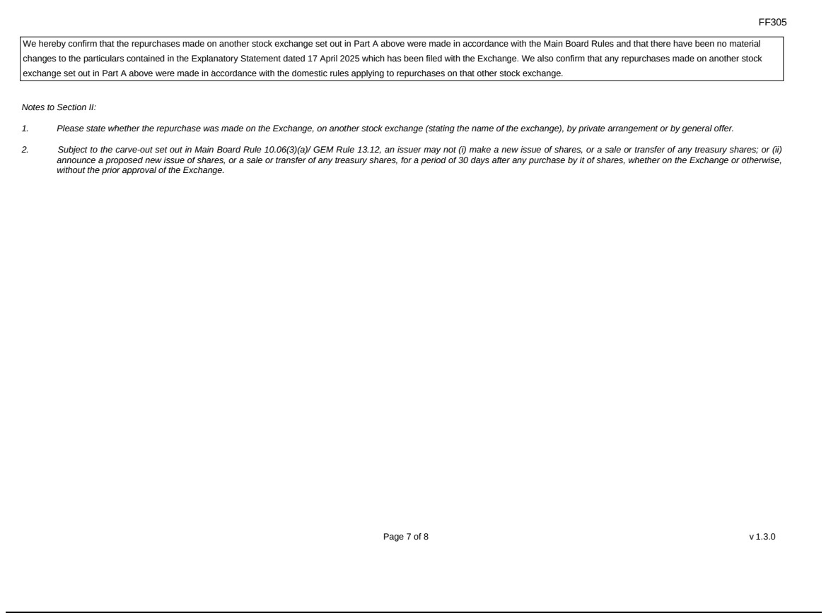

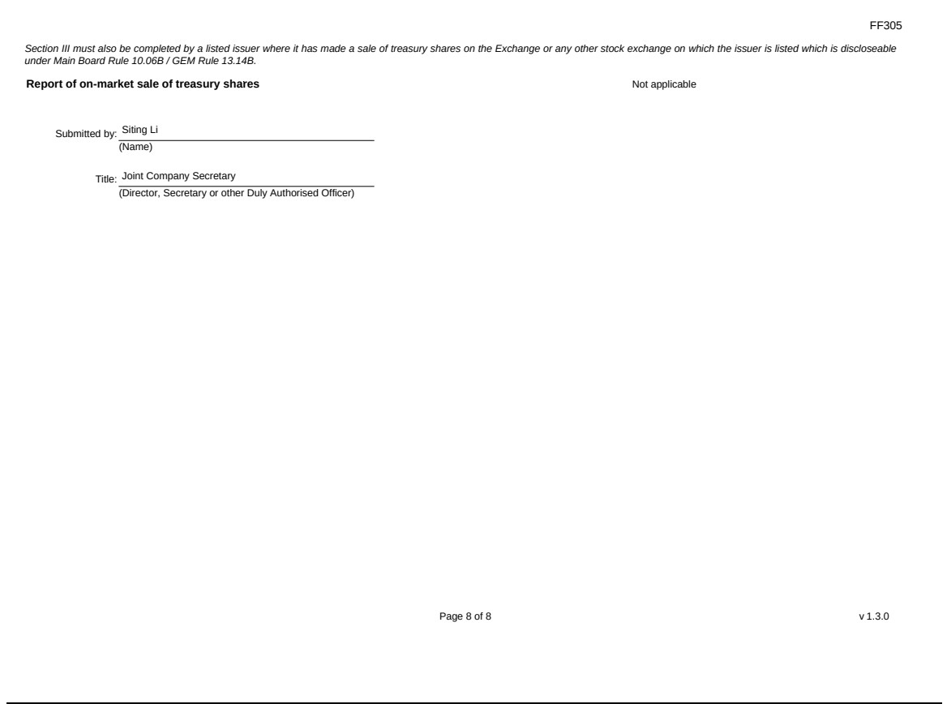

Exhibit 99.2
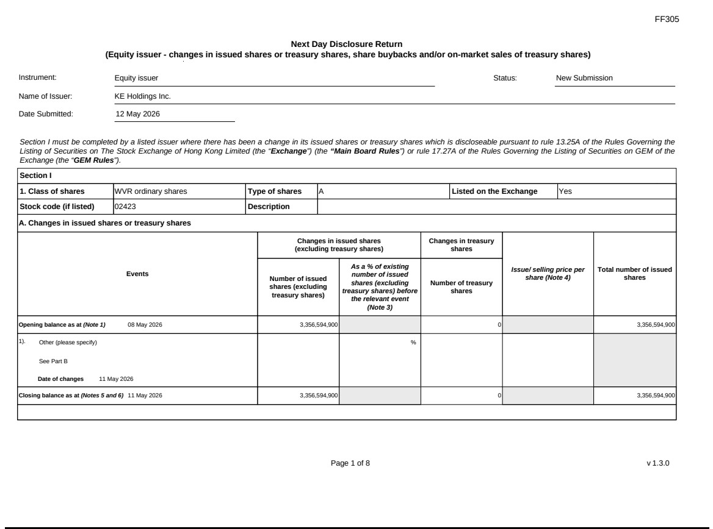

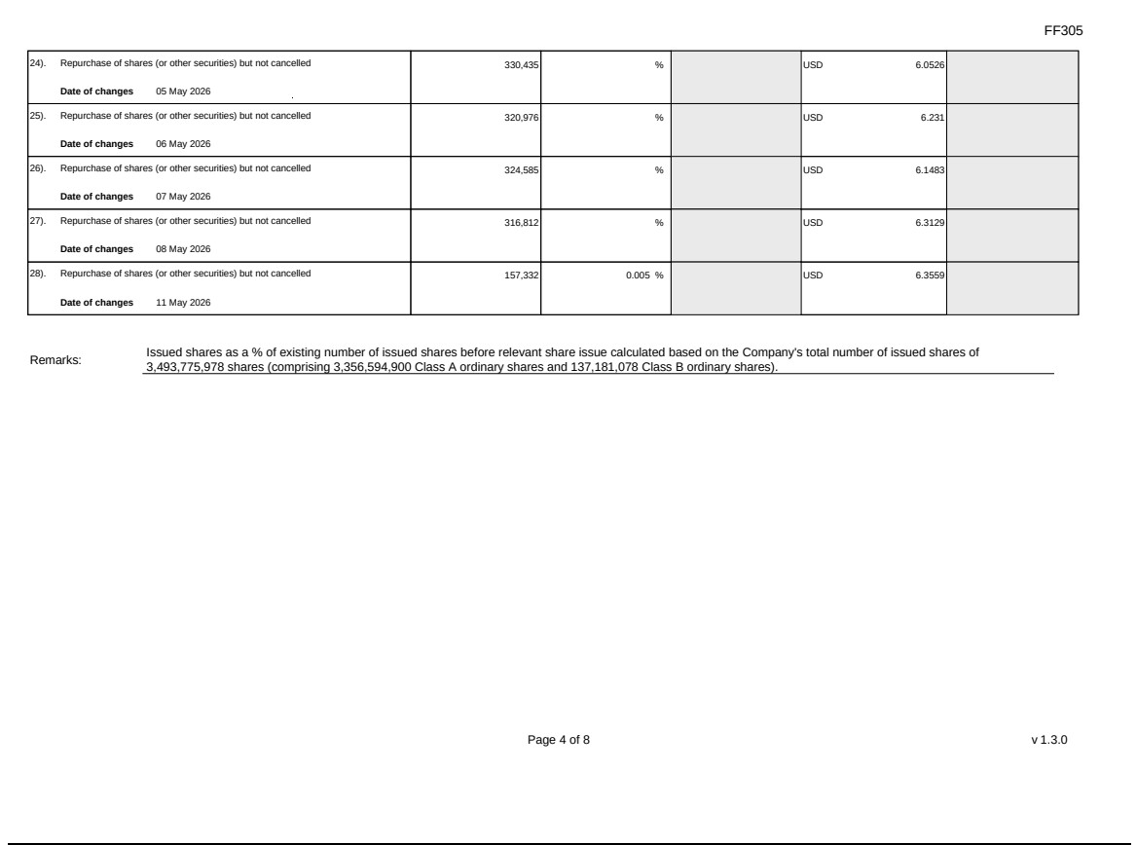

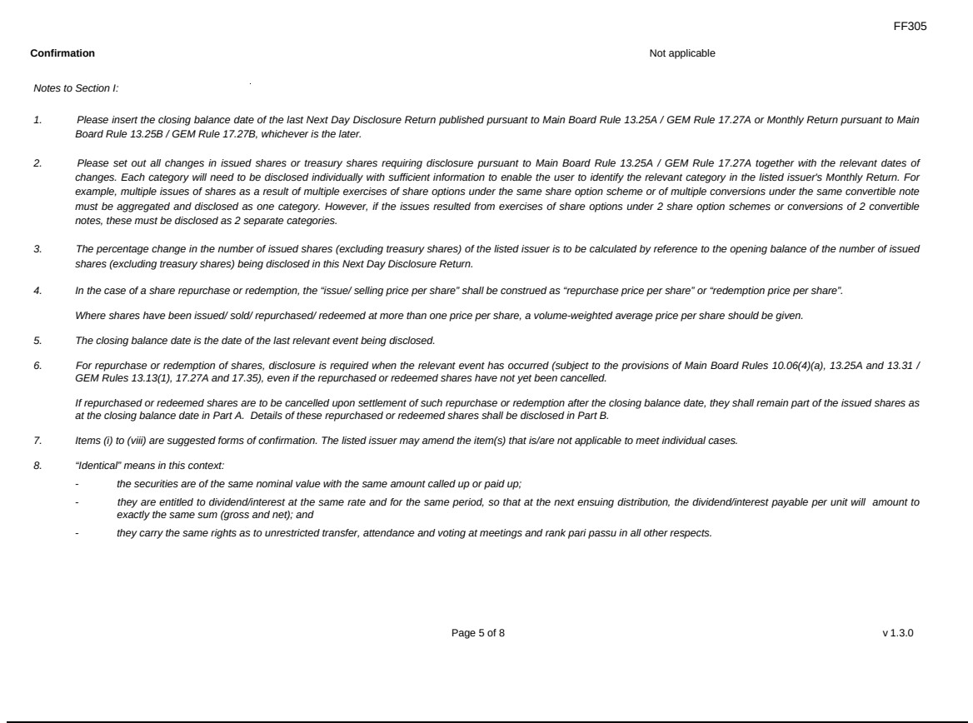

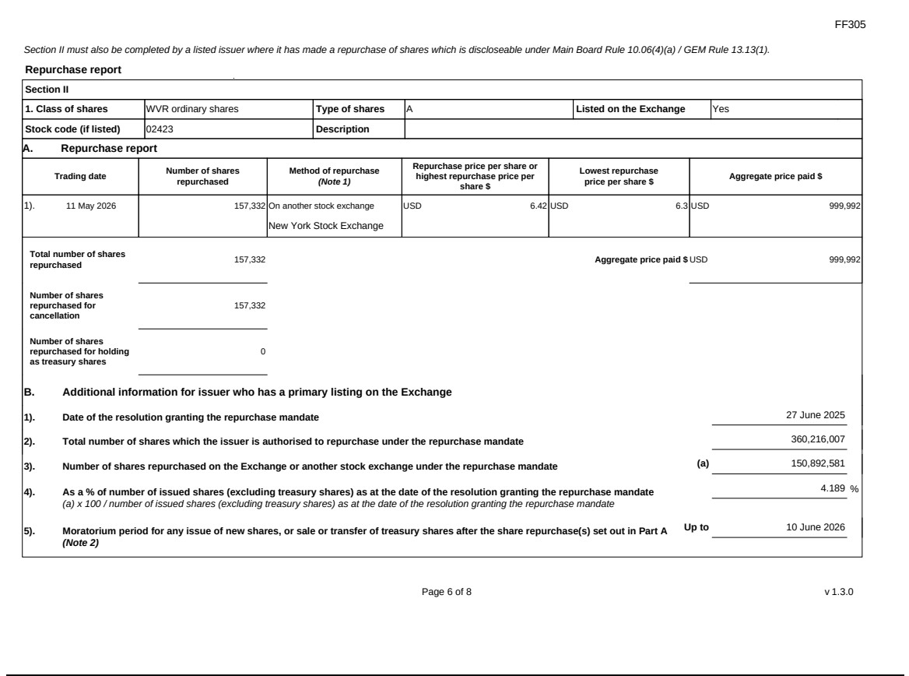

Exhibit 99.3
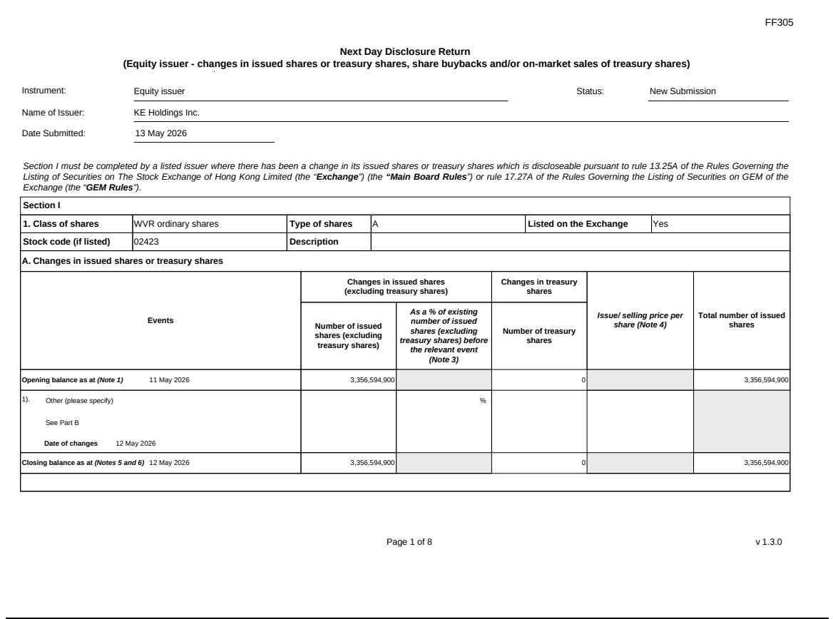

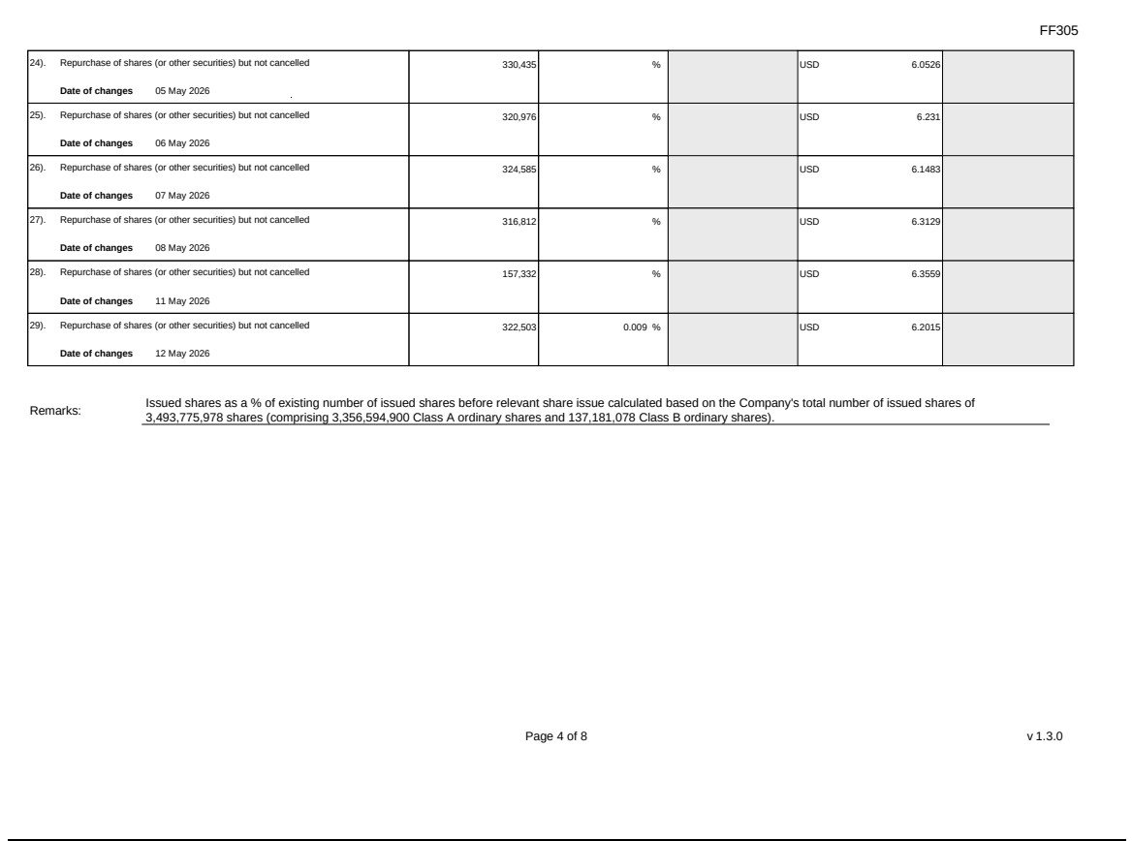

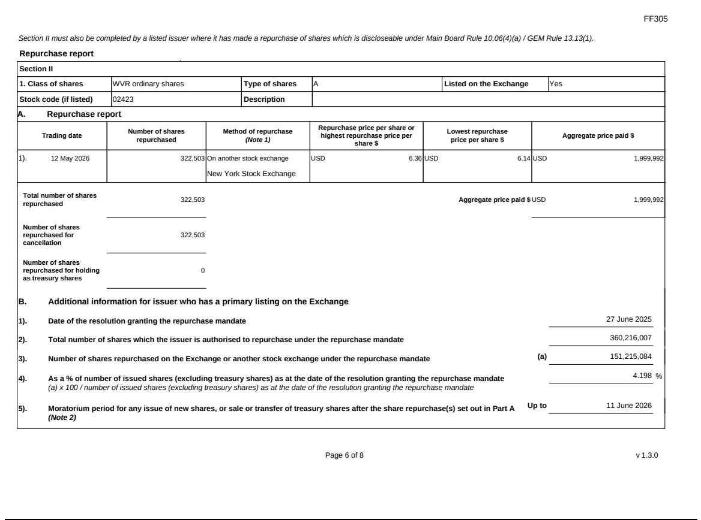

Exhibit 99.4
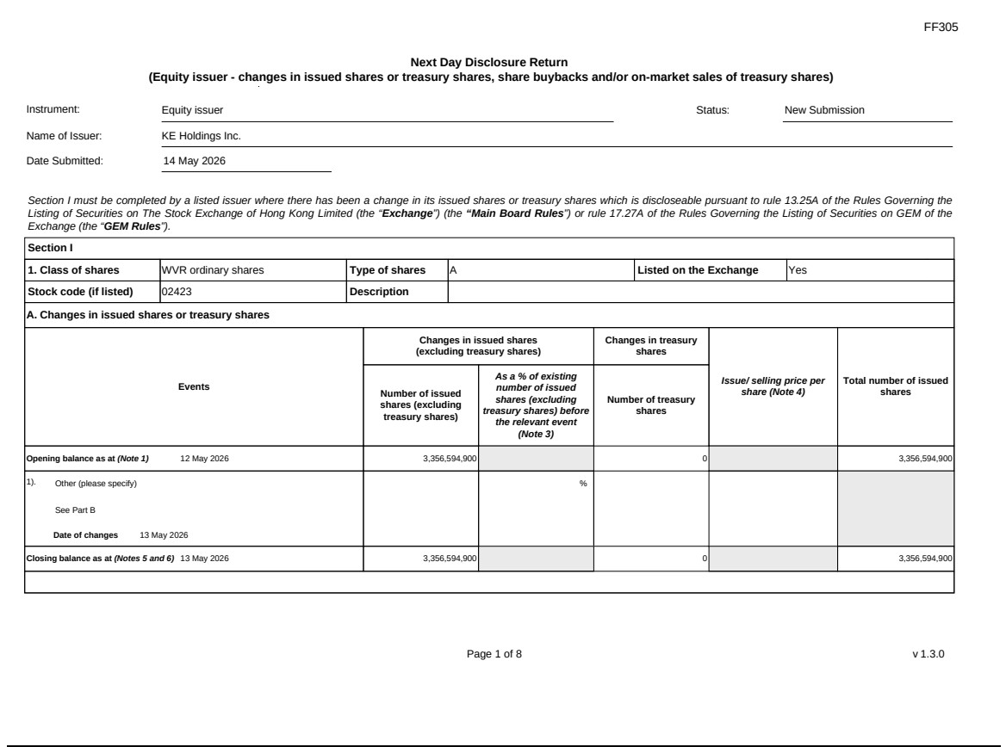

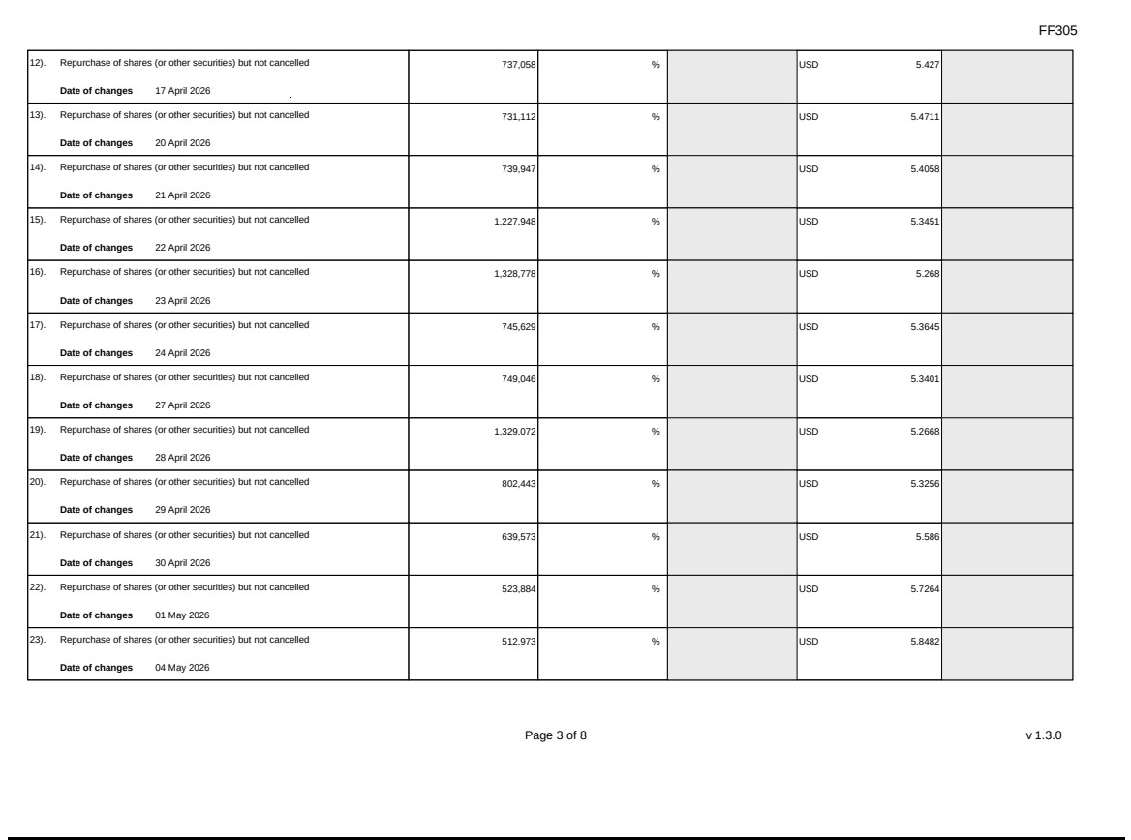

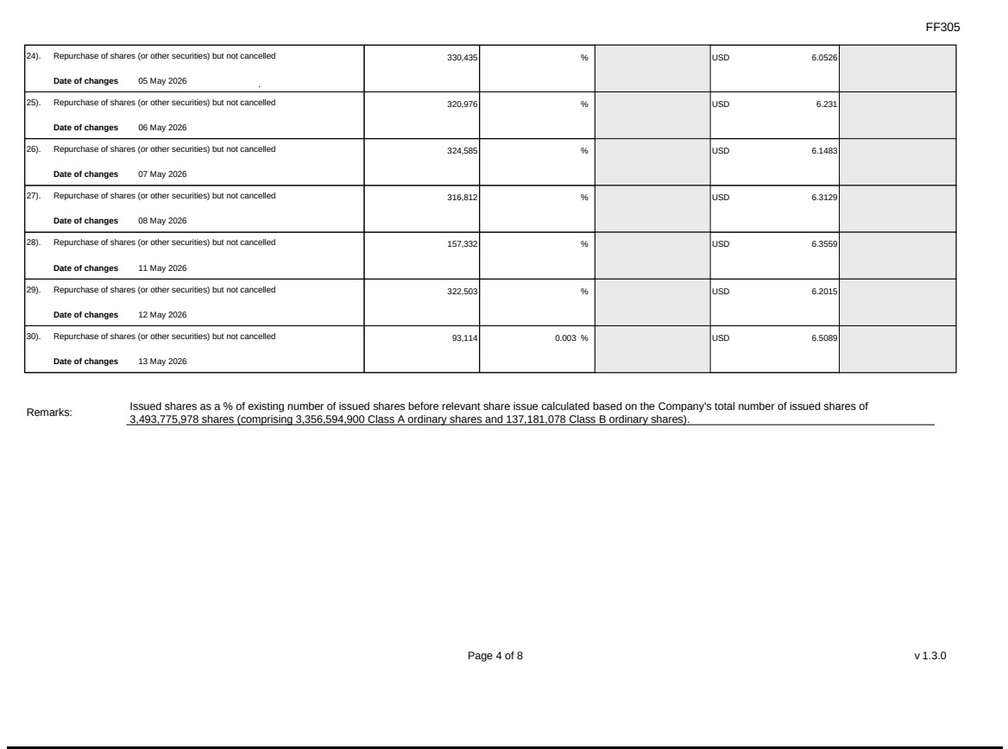

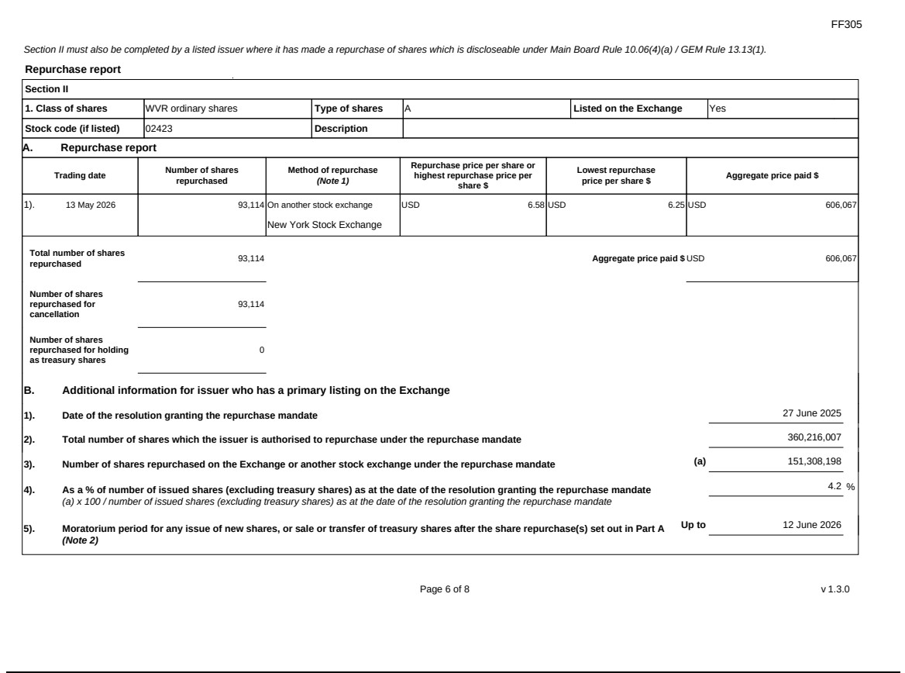

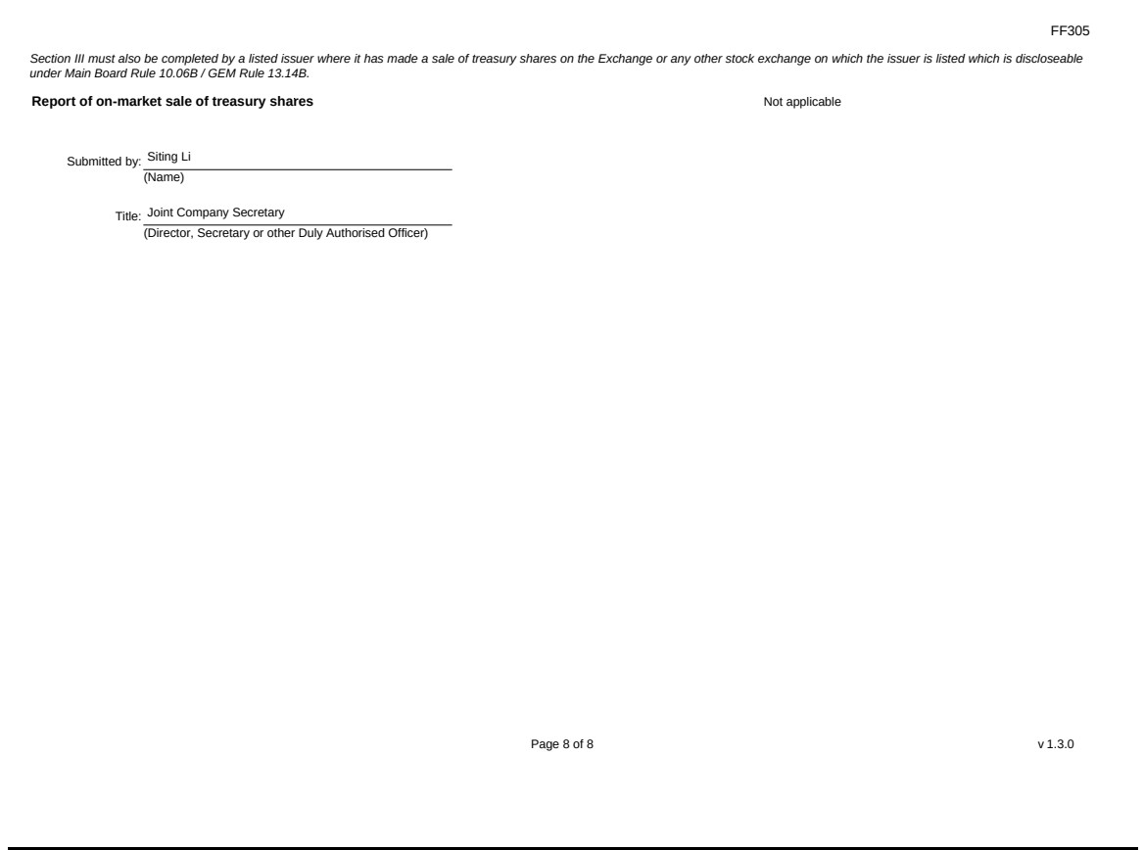

Exhibit 99.5

Hong Kong Exchanges and Clearing Limited and The Stock Exchange of Hong Kong Limited take no responsibility for the contents of this announcement, make no representation as to its accuracy or completeness and expressly disclaim any liability whatsoever for any loss howsoever arising from or in reliance upon the whole or any part of the contents of this announcement.


KE Holdings Inc.

貝殼控股有限公司

(A company controlled through weighted voting rights and incorporated in the Cayman Islands with limited liability)

(Stock Code: 2423)

Supplemental Announcement in Relation to the Board Meeting

We refer to the announcement of KE Holdings Inc. (the “Company”, together with its subsidiaries and consolidated affiliated entities, the “Group”) dated May 7, 2026 (the “Announcement”) in relation to the date of board meeting and earnings conference call in relation to the unaudited financial results of the Group for the three months ended March 31, 2026. Unless otherwise defined, capitalized terms used in this announcement shall have the same meanings as defined in the Announcement.

The Company hereby further announces that the earnings conference call, which will be held by the Company’s management on Tuesday, May 19, 2026, at 8:00 A.M. U.S. Eastern Time or 8:00

P.M. Beijing/Hong Kong Time on the same day as the board meeting, will be conducted in Chinese with English simultaneous interpretation.

For participants who wish to join the call using dial-in numbers, please complete online registration using the link provided below at least 20 minutes prior to the scheduled call start time. Dial-in numbers, passcode and unique access PIN would be provided upon registering.

Participant Online Registration:

Chinese Line: https://s1.c-conf.com/diamondpass/10054239-fn5s21.html

1

English Simultaneous Interpretation Line (listen-only mode): https://s1.c-conf.com/diamondpass/10054238-3nd54a.html
A replay of the conference call will be accessible through May 26, 2026, by dialing the following numbers:
United States: |  |  | +1-855-883-1031
Mainland, China: |  |  | 400-1209-216
Hong Kong, China: |  |  | 800-930-639
International: |  |  | +61-7-3107-6325
Replay PIN (Chinese line): |  |  | 10054239
Replay PIN (English simultaneous interpretation line): |  |  | 10054238

Save as disclosed above, all other information contained in the Announcement remains unchanged. This announcement is supplemental to and should be read in conjunction with the Announcement.

By Order of the Board

KE Holdings Inc.

Yongdong Peng

Chairman and Chief Executive Officer

Hong Kong, May 15, 2026

As at the date of this announcement, the Board comprises Mr. Yongdong Peng, Mr. Yigang Shan, Mr. Wangang Xu and Mr. Tao Xu as the executive directors, Mr. Jeffrey Zhaohui Li as the non-executive director, and Ms. Xiaohong Chen, Mr. Hansong Zhu and Mr. Jun Wu as the independent non-executive director.

2

