UNITED STATES
SECURITIES AND EXCHANGE COMMISSION
Washington, D.C. 20549

FORM 6-K

REPORT OF FOREIGN PRIVATE ISSUER
PURSUANT TO RULE 13a-16 OR 15d-16 UNDER
THE SECURITIES EXCHANGE ACT OF 1934

For the month of October 2026

Commission File Number: 001-39436

KE Holdings Inc.
(Registrant’s Name)

Oriental Electronic Technology Building,
No. 2 Chuangye Road, Haidian District,
Beijing 100086
People’s Republic of China
(Address of Principal Executive Offices)

Indicate by check mark whether the registrant files or will file annual reports under cover Form 20-F or Form 40-F.

Form 20-F ☒ Form 40-F ☐

EXHIBIT INDEX

Exhibit No. |  | Description
99.1 |  | Next Day Disclosure Return Dated October 12, 2026
99.2 |  | Next Day Disclosure Return Dated October 13, 2026
99.3 |  | Next Day Disclosure Return Dated October 14, 2026
99.4 |  | Next Day Disclosure Return Dated October 15, 2026
99.5 |  | Next Day Disclosure Return Dated October 16, 2026

SIGNATURES

Pursuant to the requirements of the Securities Exchange Act of 1934, the registrant has duly caused this report to be signed on its behalf by the undersigned, thereunto duly authorized.

 | KE Holdings Inc.
 | By | : | /s/ XU Tao
 | Name | : | XU Tao
 | Title | : | Chief Financial Officer

Date: October 20, 2026

Exhibit 99.1

 | 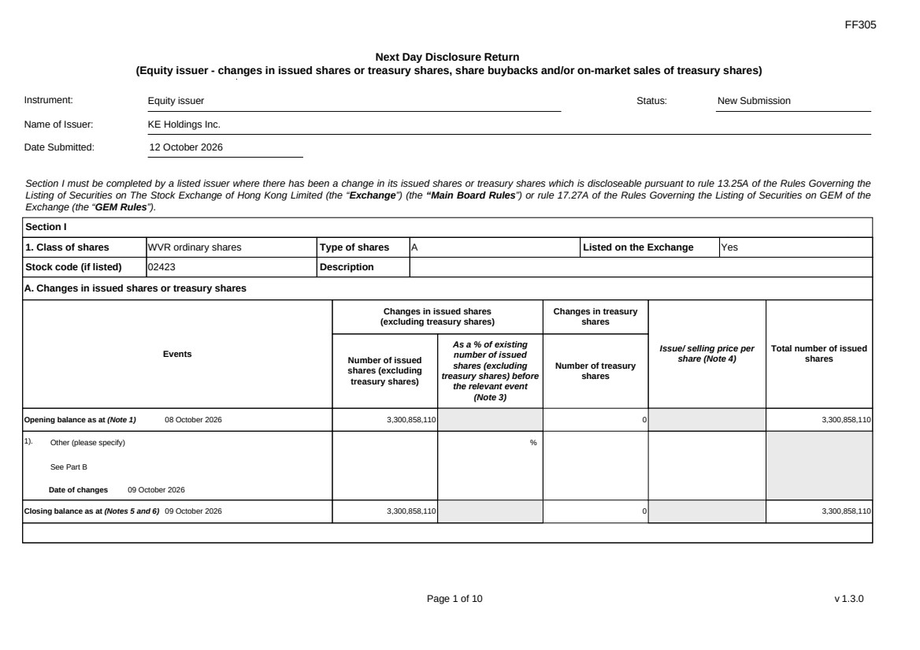 | FF305 Page 1 of 10 v 1.3.0 Next Day Disclosure Return (Equity issuer - changes in issued shares or treasury shares, share buybacks and/or on-market sales of treasury shares) Instrument: Equity issuer Status: New Submission Name of Issuer: KE Holdings Inc. Date Submitted: 12 October 2026 Section I must be completed by a listed issuer where there has been a change in its issued shares or treasury shares which is discloseable pursuant to rule 13.25A of the Rules Governing the Listing of Securities on The Stock Exchange of Hong Kong Limited (the “Exchange”) (the “Main Board Rules”) or rule 17.27A of the Rules Governing the Listing of Securities on GEM of the Exchange (the “GEM Rules”). Section I 1. Class of shares WVR ordinary shares Type of shares A Listed on the Exchange Yes Stock code (if listed) 02423 Description A. Changes in issued shares or treasury shares Events Changes in issued shares (excluding treasury shares) Number of issued shares (excluding treasury shares) As a % of existing number of issued shares (excluding treasury shares) before the relevant event (Note 3) Changes in treasury shares Number of treasury shares Issue/ selling price per share (Note 4) Total number of issued shares Opening balance as at (Note 1) 08 October 2026 3,300,858,110 0 3,300,858,110 1). Other (please specify) See Part B Date of changes 09 October 2026 % Closing balance as at (Notes 5 and 6) 09 October 2026 3,300,858,110 0 3,300,858,110
 | 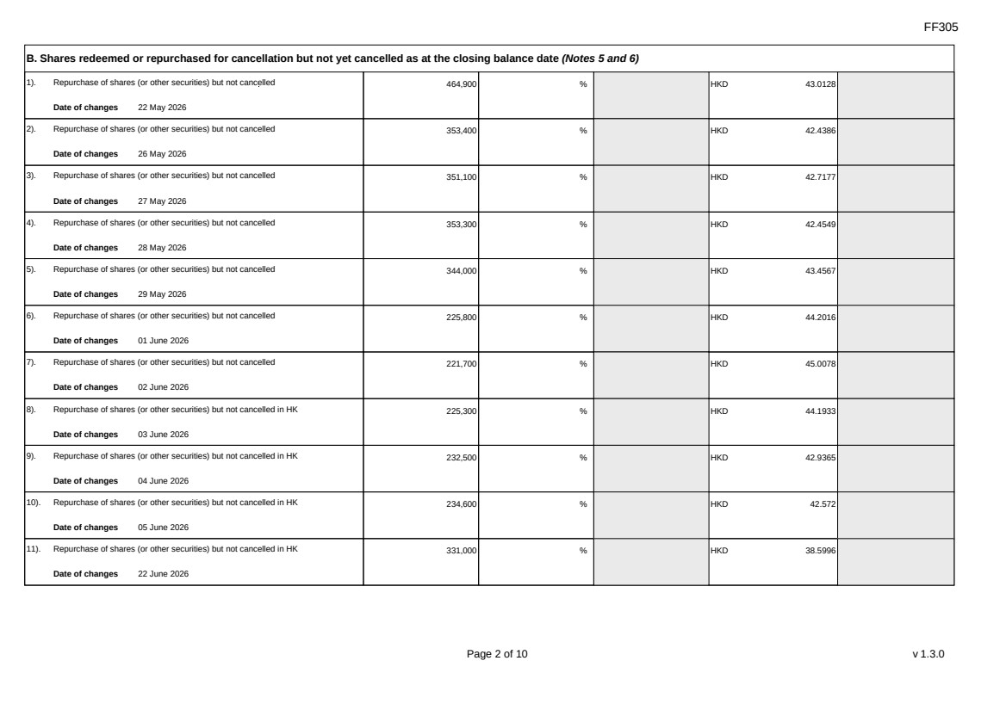 | FF305 Page 2 of 10 v 1.3.0 B. Shares redeemed or repurchased for cancellation but not yet cancelled as at the closing balance date (Notes 5 and 6) 1). Repurchase of shares (or other securities) but not cancelled Date of changes 22 May 2026 464,900 % HKD 43.0128 2). Repurchase of shares (or other securities) but not cancelled Date of changes 26 May 2026 353,400 % HKD 42.4386 3). Repurchase of shares (or other securities) but not cancelled Date of changes 27 May 2026 351,100 % HKD 42.7177 4). Repurchase of shares (or other securities) but not cancelled Date of changes 28 May 2026 353,300 % HKD 42.4549 5). Repurchase of shares (or other securities) but not cancelled Date of changes 29 May 2026 344,000 % HKD 43.4567 6). Repurchase of shares (or other securities) but not cancelled Date of changes 01 June 2026 225,800 % HKD 44.2016 7). Repurchase of shares (or other securities) but not cancelled Date of changes 02 June 2026 221,700 % HKD 45.0078 8). Repurchase of shares (or other securities) but not cancelled in HK Date of changes 03 June 2026 225,300 % HKD 44.1933 9). Repurchase of shares (or other securities) but not cancelled in HK Date of changes 04 June 2026 232,500 % HKD 42.9365 10). Repurchase of shares (or other securities) but not cancelled in HK Date of changes 05 June 2026 234,600 % HKD 42.572 11). Repurchase of shares (or other securities) but not cancelled in HK Date of changes 22 June 2026 331,000 % HKD 38.5996
 | 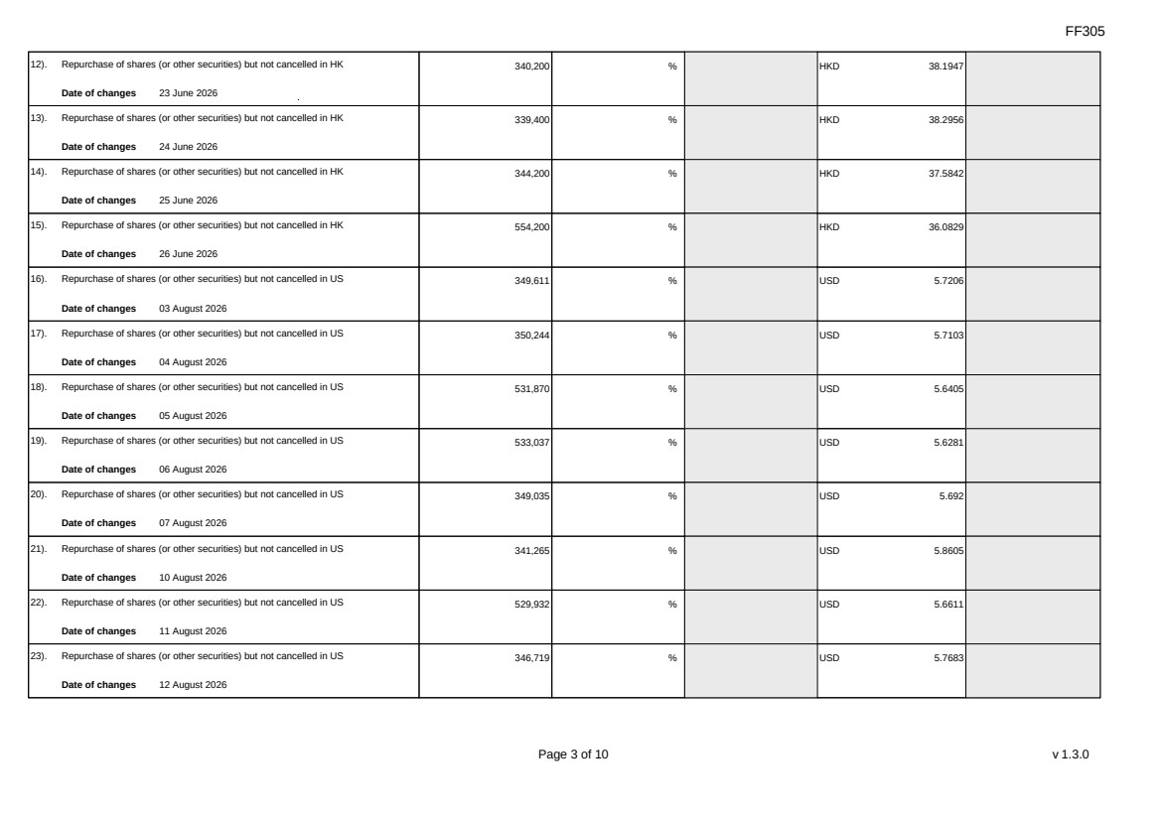 | FF305 Page 3 of 10 v 1.3.0 12). Repurchase of shares (or other securities) but not cancelled in HK Date of changes 23 June 2026 340,200 % HKD 38.1947 13). Repurchase of shares (or other securities) but not cancelled in HK Date of changes 24 June 2026 339,400 % HKD 38.2956 14). Repurchase of shares (or other securities) but not cancelled in HK Date of changes 25 June 2026 344,200 % HKD 37.5842 15). Repurchase of shares (or other securities) but not cancelled in HK Date of changes 26 June 2026 554,200 % HKD 36.0829 16). Repurchase of shares (or other securities) but not cancelled in US Date of changes 03 August 2026 349,611 % USD 5.7206 17). Repurchase of shares (or other securities) but not cancelled in US Date of changes 04 August 2026 350,244 % USD 5.7103 18). Repurchase of shares (or other securities) but not cancelled in US Date of changes 05 August 2026 531,870 % USD 5.6405 19). Repurchase of shares (or other securities) but not cancelled in US Date of changes 06 August 2026 533,037 % USD 5.6281 20). Repurchase of shares (or other securities) but not cancelled in US Date of changes 07 August 2026 349,035 % USD 5.692 21). Repurchase of shares (or other securities) but not cancelled in US Date of changes 10 August 2026 341,265 % USD 5.8605 22). Repurchase of shares (or other securities) but not cancelled in US Date of changes 11 August 2026 529,932 % USD 5.6611 23). Repurchase of shares (or other securities) but not cancelled in US Date of changes 12 August 2026 346,719 % USD 5.7683
 | 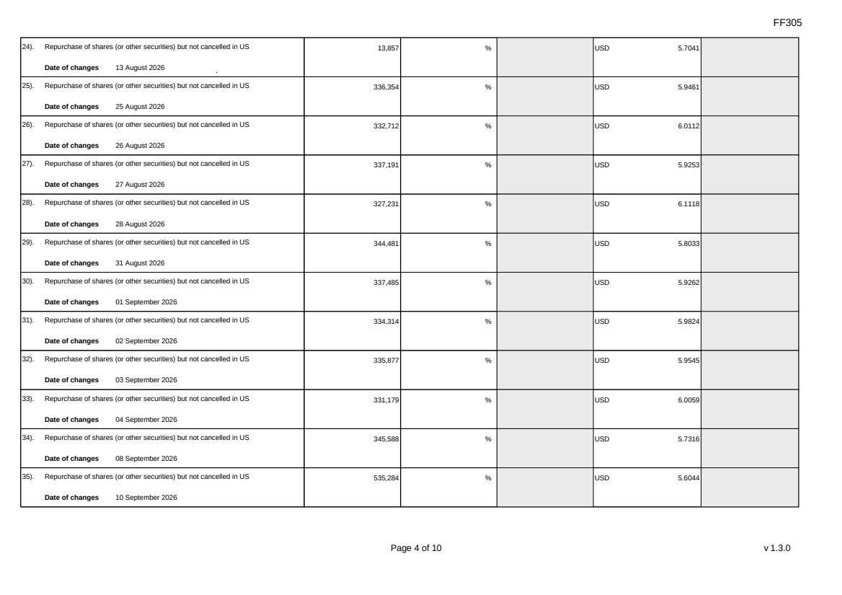 | FF305 Page 4 of 10 v 1.3.0 24). Repurchase of shares (or other securities) but not cancelled in US Date of changes 13 August 2026 13,857 % USD 5.7041 25). Repurchase of shares (or other securities) but not cancelled in US Date of changes 25 August 2026 336,354 % USD 5.9461 26). Repurchase of shares (or other securities) but not cancelled in US Date of changes 26 August 2026 332,712 % USD 6.0112 27). Repurchase of shares (or other securities) but not cancelled in US Date of changes 27 August 2026 337,191 % USD 5.9253 28). Repurchase of shares (or other securities) but not cancelled in US Date of changes 28 August 2026 327,231 % USD 6.1118 29). Repurchase of shares (or other securities) but not cancelled in US Date of changes 31 August 2026 344,481 % USD 5.8033 30). Repurchase of shares (or other securities) but not cancelled in US Date of changes 01 September 2026 337,485 % USD 5.9262 31). Repurchase of shares (or other securities) but not cancelled in US Date of changes 02 September 2026 334,314 % USD 5.9824 32). Repurchase of shares (or other securities) but not cancelled in US Date of changes 03 September 2026 335,877 % USD 5.9545 33). Repurchase of shares (or other securities) but not cancelled in US Date of changes 04 September 2026 331,179 % USD 6.0059 34). Repurchase of shares (or other securities) but not cancelled in US Date of changes 08 September 2026 345,588 % USD 5.7316 35). Repurchase of shares (or other securities) but not cancelled in US Date of changes 10 September 2026 535,284 % USD 5.6044
 | 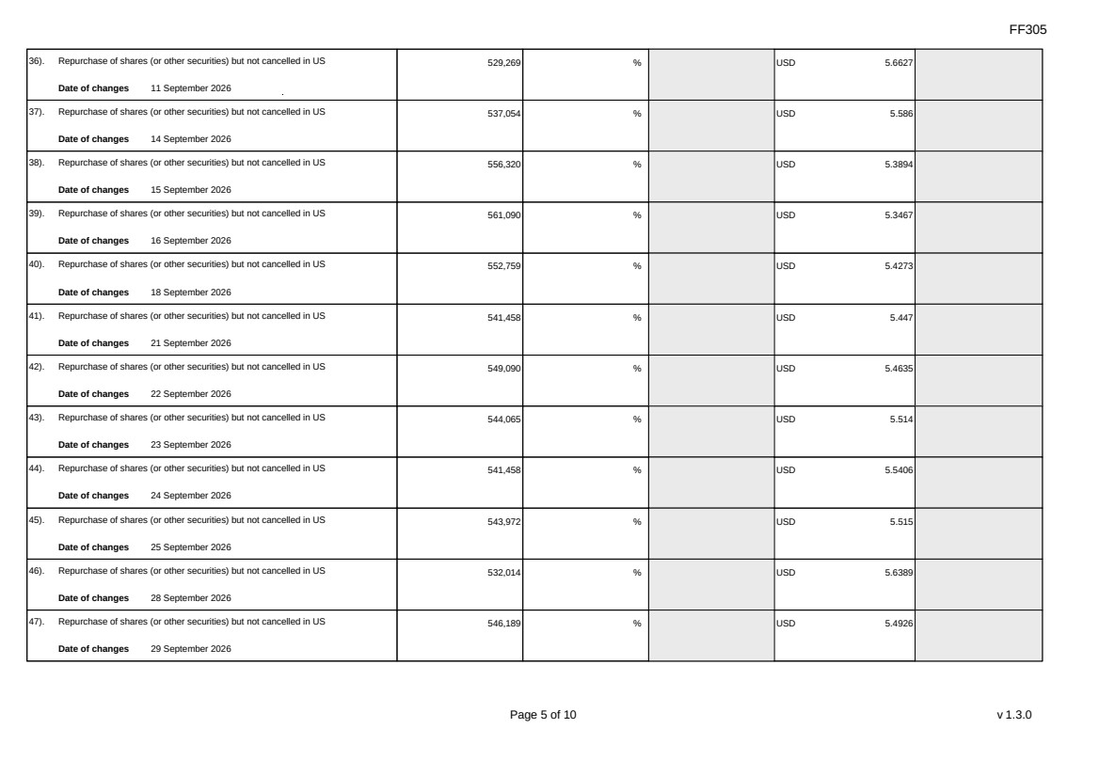 | FF305 Page 5 of 10 v 1.3.0 36). Repurchase of shares (or other securities) but not cancelled in US Date of changes 11 September 2026 529,269 % USD 5.6627 37). Repurchase of shares (or other securities) but not cancelled in US Date of changes 14 September 2026 537,054 % USD 5.586 38). Repurchase of shares (or other securities) but not cancelled in US Date of changes 15 September 2026 556,320 % USD 5.3894 39). Repurchase of shares (or other securities) but not cancelled in US Date of changes 16 September 2026 561,090 % USD 5.3467 40). Repurchase of shares (or other securities) but not cancelled in US Date of changes 18 September 2026 552,759 % USD 5.4273 41). Repurchase of shares (or other securities) but not cancelled in US Date of changes 21 September 2026 541,458 % USD 5.447 42). Repurchase of shares (or other securities) but not cancelled in US Date of changes 22 September 2026 549,090 % USD 5.4635 43). Repurchase of shares (or other securities) but not cancelled in US Date of changes 23 September 2026 544,065 % USD 5.514 44). Repurchase of shares (or other securities) but not cancelled in US Date of changes 24 September 2026 541,458 % USD 5.5406 45). Repurchase of shares (or other securities) but not cancelled in US Date of changes 25 September 2026 543,972 % USD 5.515 46). Repurchase of shares (or other securities) but not cancelled in US Date of changes 28 September 2026 532,014 % USD 5.6389 47). Repurchase of shares (or other securities) but not cancelled in US Date of changes 29 September 2026 546,189 % USD 5.4926
 | 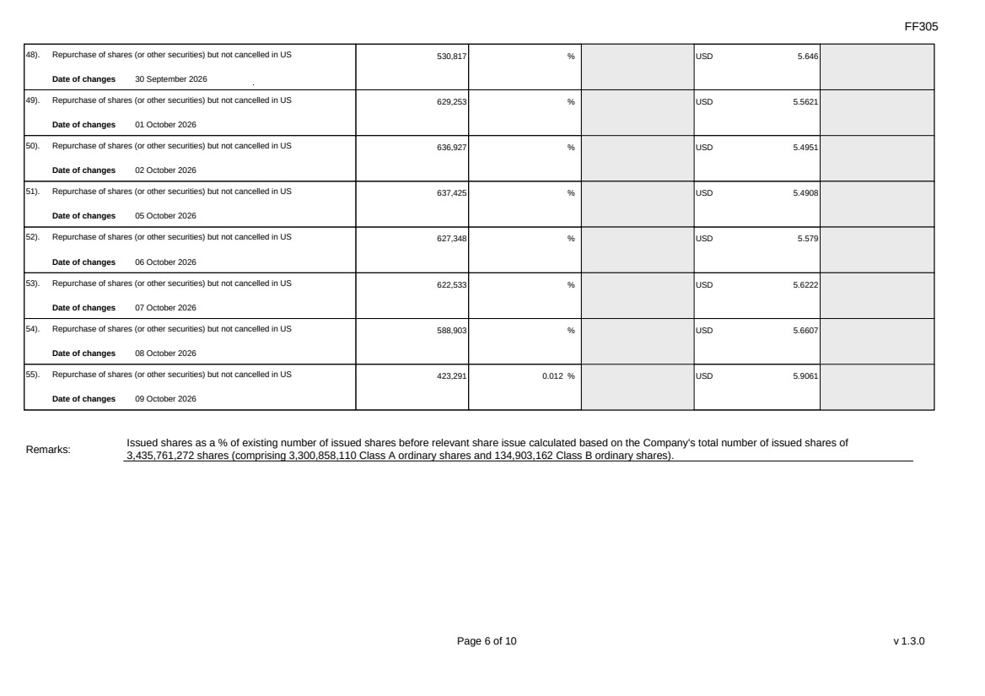 | FF305 Page 6 of 10 v 1.3.0 48). Repurchase of shares (or other securities) but not cancelled in US Date of changes 30 September 2026 530,817 % USD 5.646 49). Repurchase of shares (or other securities) but not cancelled in US Date of changes 01 October 2026 629,253 % USD 5.5621 50). Repurchase of shares (or other securities) but not cancelled in US Date of changes 02 October 2026 636,927 % USD 5.4951 51). Repurchase of shares (or other securities) but not cancelled in US Date of changes 05 October 2026 637,425 % USD 5.4908 52). Repurchase of shares (or other securities) but not cancelled in US Date of changes 06 October 2026 627,348 % USD 5.579 53). Repurchase of shares (or other securities) but not cancelled in US Date of changes 07 October 2026 622,533 % USD 5.6222 54). Repurchase of shares (or other securities) but not cancelled in US Date of changes 08 October 2026 588,903 % USD 5.6607 55). Repurchase of shares (or other securities) but not cancelled in US Date of changes 09 October 2026 423,291 0.012 % USD 5.9061 Remarks: Issued shares as a % of existing number of issued shares before relevant share issue calculated based on the Company's total number of issued shares of 3,435,761,272 shares (comprising 3,300,858,110 Class A ordinary shares and 134,903,162 Class B ordinary shares).
 | 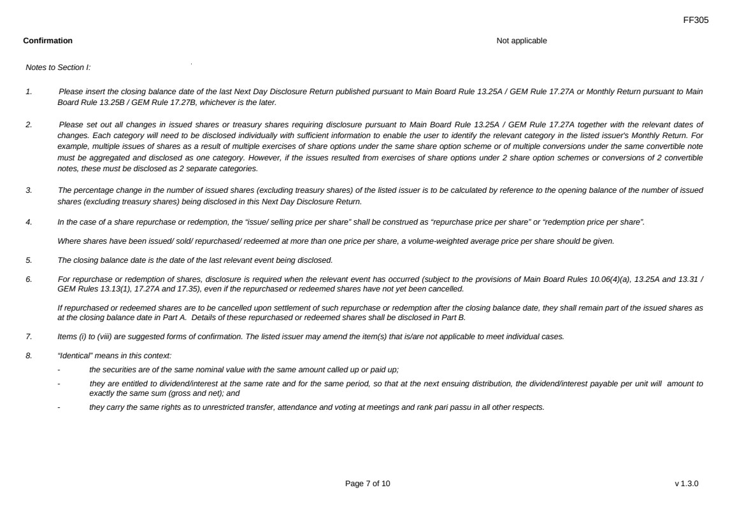 | FF305 Page 7 of 10 v 1.3.0 Confirmation Not applicable Notes to Section I: 1. Please insert the closing balance date of the last Next Day Disclosure Return published pursuant to Main Board Rule 13.25A / GEM Rule 17.27A or Monthly Return pursuant to Main Board Rule 13.25B / GEM Rule 17.27B, whichever is the later. 2. Please set out all changes in issued shares or treasury shares requiring disclosure pursuant to Main Board Rule 13.25A / GEM Rule 17.27A together with the relevant dates of changes. Each category will need to be disclosed individually with sufficient information to enable the user to identify the relevant category in the listed issuer's Monthly Return. For example, multiple issues of shares as a result of multiple exercises of share options under the same share option scheme or of multiple conversions under the same convertible note must be aggregated and disclosed as one category. However, if the issues resulted from exercises of share options under 2 share option schemes or conversions of 2 convertible notes, these must be disclosed as 2 separate categories. 3. The percentage change in the number of issued shares (excluding treasury shares) of the listed issuer is to be calculated by reference to the opening balance of the number of issued shares (excluding treasury shares) being disclosed in this Next Day Disclosure Return. 4. In the case of a share repurchase or redemption, the “issue/ selling price per share” shall be construed as “repurchase price per share” or “redemption price per share”. Where shares have been issued/ sold/ repurchased/ redeemed at more than one price per share, a volume-weighted average price per share should be given. 5. The closing balance date is the date of the last relevant event being disclosed. 6. For repurchase or redemption of shares, disclosure is required when the relevant event has occurred (subject to the provisions of Main Board Rules 10.06(4)(a), 13.25A and 13.31 / GEM Rules 13.13(1), 17.27A and 17.35), even if the repurchased or redeemed shares have not yet been cancelled. If repurchased or redeemed shares are to be cancelled upon settlement of such repurchase or redemption after the closing balance date, they shall remain part of the issued shares as at the closing balance date in Part A. Details of these repurchased or redeemed shares shall be disclosed in Part B. 7. Items (i) to (viii) are suggested forms of confirmation. The listed issuer may amend the item(s) that is/are not applicable to meet individual cases. 8. “Identical” means in this context: - the securities are of the same nominal value with the same amount called up or paid up; - they are entitled to dividend/interest at the same rate and for the same period, so that at the next ensuing distribution, the dividend/interest payable per unit will amount to exactly the same sum (gross and net); and - they carry the same rights as to unrestricted transfer, attendance and voting at meetings and rank pari passu in all other respects.
 | 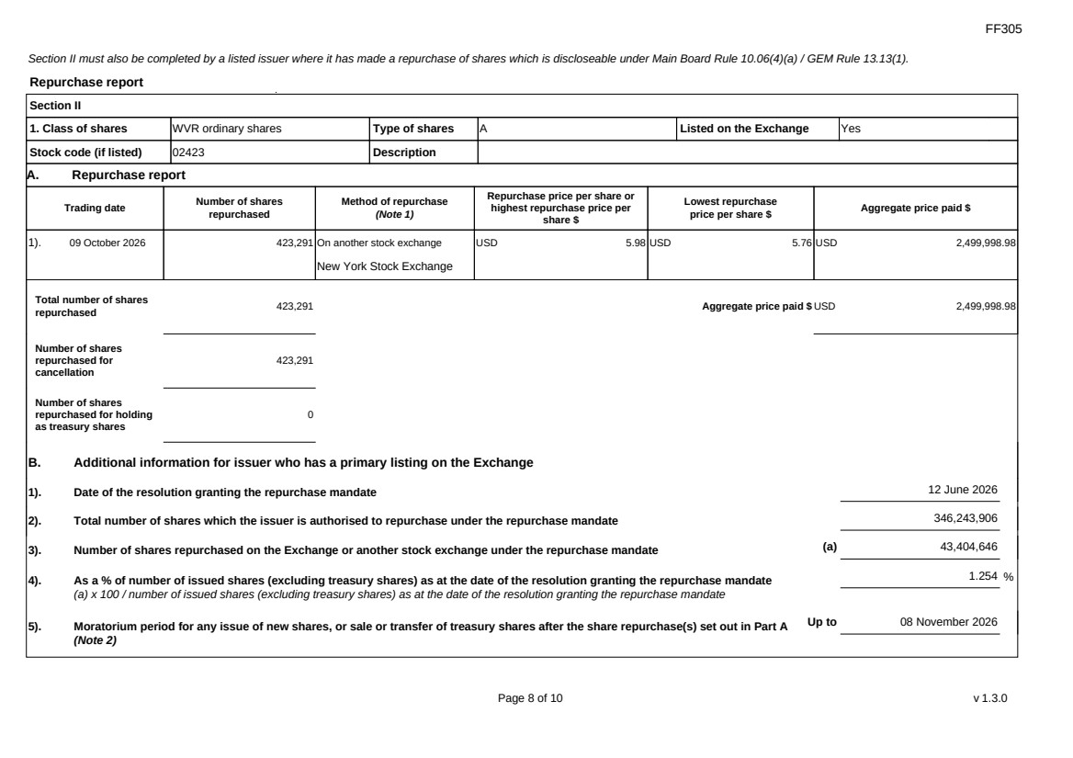 | FF305 Page 8 of 10 v 1.3.0 Section II must also be completed by a listed issuer where it has made a repurchase of shares which is discloseable under Main Board Rule 10.06(4)(a) / GEM Rule 13.13(1). Repurchase report Section II 1. Class of shares WVR ordinary shares Type of shares A Listed on the Exchange Yes Stock code (if listed) 02423 Description A. Repurchase report Trading date Number of shares repurchased Method of repurchase (Note 1) Repurchase price per share or highest repurchase price per share $ Lowest repurchase price per share $ Aggregate price paid $ 1). 09 October 2026 423,291 On another stock exchange New York Stock Exchange USD 5.98 USD 5.76 USD 2,499,998.98 Total number of shares repurchased 423,291 Aggregate price paid $ USD 2,499,998.98 Number of shares repurchased for cancellation 423,291 Number of shares repurchased for holding as treasury shares 0 B. Additional information for issuer who has a primary listing on the Exchange 1). Date of the resolution granting the repurchase mandate 12 June 2026 2). Total number of shares which the issuer is authorised to repurchase under the repurchase mandate 346,243,906 3). Number of shares repurchased on the Exchange or another stock exchange under the repurchase mandate (a) 43,404,646 4). As a % of number of issued shares (excluding treasury shares) as at the date of the resolution granting the repurchase mandate (a) x 100 / number of issued shares (excluding treasury shares) as at the date of the resolution granting the repurchase mandate 1.254 % 5). Moratorium period for any issue of new shares, or sale or transfer of treasury shares after the share repurchase(s) set out in Part A (Note 2) Up to 08 November 2026
 | 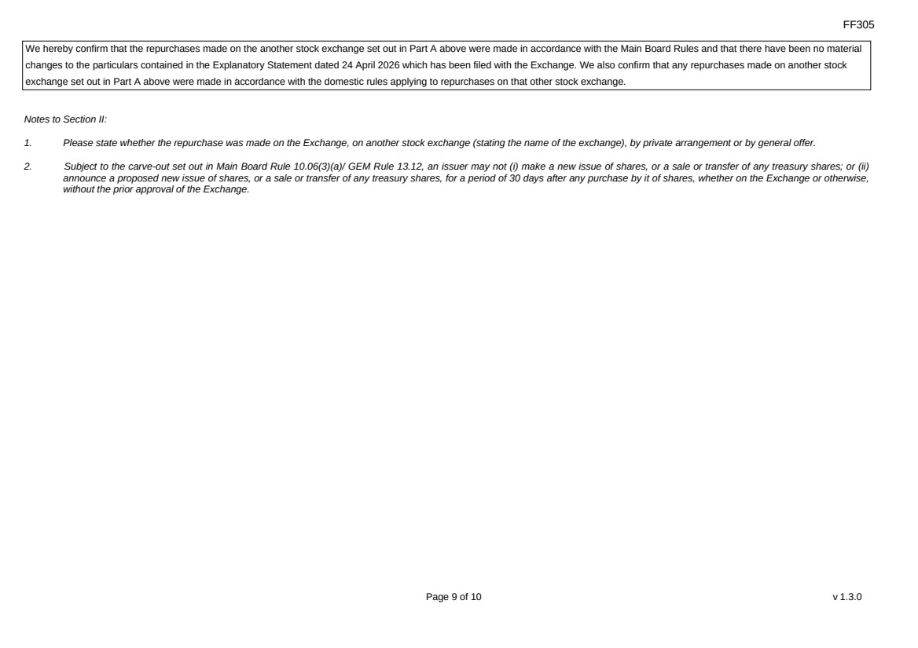 | FF305 Page 9 of 10 v 1.3.0 We hereby confirm that the repurchases made on the another stock exchange set out in Part A above were made in accordance with the Main Board Rules and that there have been no material changes to the particulars contained in the Explanatory Statement dated 24 April 2026 which has been filed with the Exchange. We also confirm that any repurchases made on another stock exchange set out in Part A above were made in accordance with the domestic rules applying to repurchases on that other stock exchange. Notes to Section II: 1. Please state whether the repurchase was made on the Exchange, on another stock exchange (stating the name of the exchange), by private arrangement or by general offer. 2. Subject to the carve-out set out in Main Board Rule 10.06(3)(a)/ GEM Rule 13.12, an issuer may not (i) make a new issue of shares, or a sale or transfer of any treasury shares; or (ii) announce a proposed new issue of shares, or a sale or transfer of any treasury shares, for a period of 30 days after any purchase by it of shares, whether on the Exchange or otherwise, without the prior approval of the Exchange.
 | 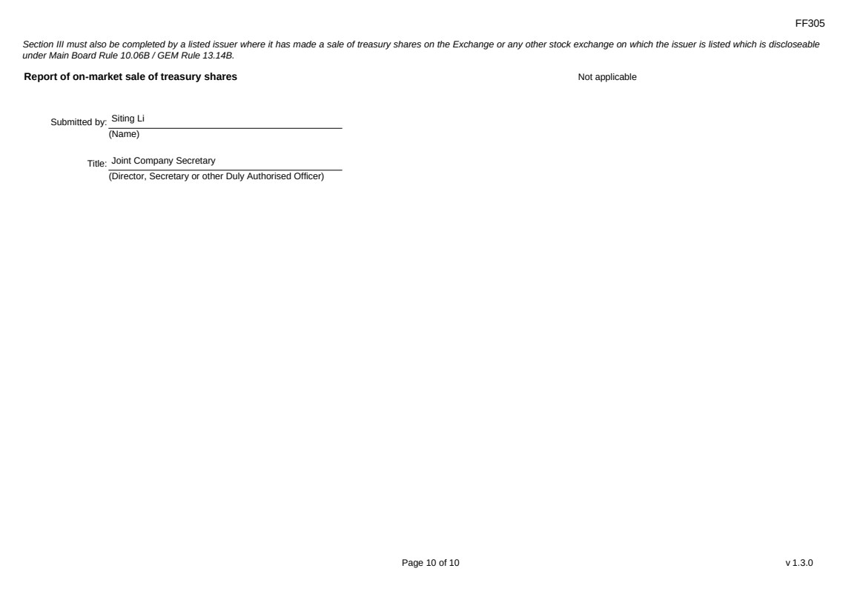 | FF305 Page 10 of 10 v 1.3.0 Section III must also be completed by a listed issuer where it has made a sale of treasury shares on the Exchange or any other stock exchange on which the issuer is listed which is discloseable under Main Board Rule 10.06B / GEM Rule 13.14B. Report of on-market sale of treasury shares Not applicable Submitted by: Siting Li (Name) Title: Joint Company Secretary (Director, Secretary or other Duly Authorised Officer)
Exhibit 99.2

 | 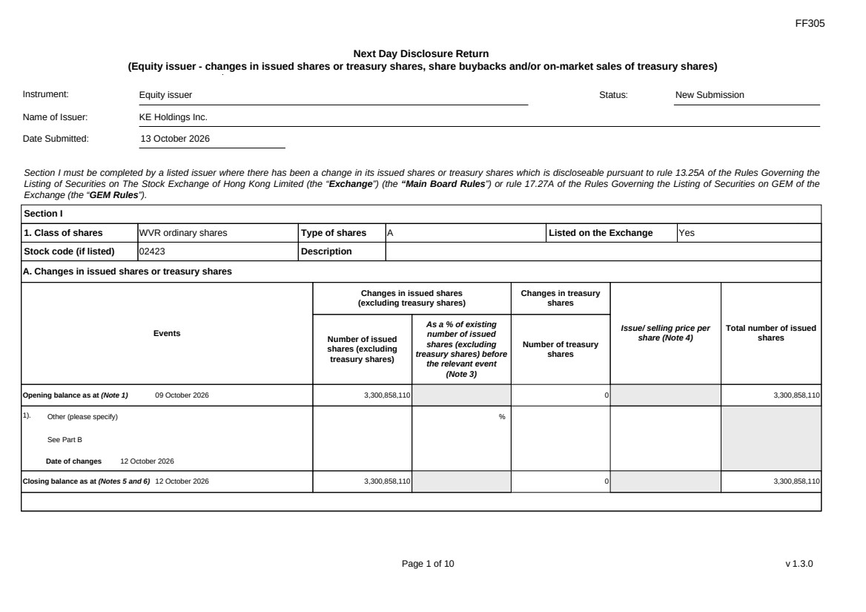 | FF305 Page 1 of 10 v 1.3.0 Next Day Disclosure Return (Equity issuer - changes in issued shares or treasury shares, share buybacks and/or on-market sales of treasury shares) Instrument: Equity issuer Status: New Submission Name of Issuer: KE Holdings Inc. Date Submitted: 13 October 2026 Section I must be completed by a listed issuer where there has been a change in its issued shares or treasury shares which is discloseable pursuant to rule 13.25A of the Rules Governing the Listing of Securities on The Stock Exchange of Hong Kong Limited (the “Exchange”) (the “Main Board Rules”) or rule 17.27A of the Rules Governing the Listing of Securities on GEM of the Exchange (the “GEM Rules”). Section I 1. Class of shares WVR ordinary shares Type of shares A Listed on the Exchange Yes Stock code (if listed) 02423 Description A. Changes in issued shares or treasury shares Events Changes in issued shares (excluding treasury shares) Number of issued shares (excluding treasury shares) As a % of existing number of issued shares (excluding treasury shares) before the relevant event (Note 3) Changes in treasury shares Number of treasury shares Issue/ selling price per share (Note 4) Total number of issued shares Opening balance as at (Note 1) 09 October 2026 3,300,858,110 0 3,300,858,110 1). Other (please specify) See Part B Date of changes 12 October 2026 % Closing balance as at (Notes 5 and 6) 12 October 2026 3,300,858,110 0 3,300,858,110
FF305 Page 2 of 10 v 1.3.0 B. Shares redeemed or repurchased for cancellation but not yet cancelled as at the closing balance date (Notes 5 and 6) 1). Repurchase of shares (or other securities) but not cancelled Date of changes 22 May 2026 464,900 % HKD 43.0128 2). Repurchase of shares (or other securities) but not cancelled Date of changes 26 May 2026 353,400 % HKD 42.4386 3). Repurchase of shares (or other securities) but not cancelled Date of changes 27 May 2026 351,100 % HKD 42.7177 4). Repurchase of shares (or other securities) but not cancelled Date of changes 28 May 2026 353,300 % HKD 42.4549 5). Repurchase of shares (or other securities) but not cancelled Date of changes 29 May 2026 344,000 % HKD 43.4567 6). Repurchase of shares (or other securities) but not cancelled Date of changes 01 June 2026 225,800 % HKD 44.2016 7). Repurchase of shares (or other securities) but not cancelled Date of changes 02 June 2026 221,700 % HKD 45.0078 8). Repurchase of shares (or other securities) but not cancelled in HK Date of changes 03 June 2026 225,300 % HKD 44.1933 9). Repurchase of shares (or other securities) but not cancelled in HK Date of changes 04 June 2026 232,500 % HKD 42.9365 10). Repurchase of shares (or other securities) but not cancelled in HK Date of changes 05 June 2026 234,600 % HKD 42.572 11). Repurchase of shares (or other securities) but not cancelled in HK Date of changes 22 June 2026 331,000 % HKD 38.5996
FF305 Page 3 of 10 v 1.3.0 12). Repurchase of shares (or other securities) but not cancelled in HK Date of changes 23 June 2026 340,200 % HKD 38.1947 13). Repurchase of shares (or other securities) but not cancelled in HK Date of changes 24 June 2026 339,400 % HKD 38.2956 14). Repurchase of shares (or other securities) but not cancelled in HK Date of changes 25 June 2026 344,200 % HKD 37.5842 15). Repurchase of shares (or other securities) but not cancelled in HK Date of changes 26 June 2026 554,200 % HKD 36.0829 16). Repurchase of shares (or other securities) but not cancelled in US Date of changes 03 August 2026 349,611 % USD 5.7206 17). Repurchase of shares (or other securities) but not cancelled in US Date of changes 04 August 2026 350,244 % USD 5.7103 18). Repurchase of shares (or other securities) but not cancelled in US Date of changes 05 August 2026 531,870 % USD 5.6405 19). Repurchase of shares (or other securities) but not cancelled in US Date of changes 06 August 2026 533,037 % USD 5.6281 20). Repurchase of shares (or other securities) but not cancelled in US Date of changes 07 August 2026 349,035 % USD 5.692 21). Repurchase of shares (or other securities) but not cancelled in US Date of changes 10 August 2026 341,265 % USD 5.8605 22). Repurchase of shares (or other securities) but not cancelled in US Date of changes 11 August 2026 529,932 % USD 5.6611 23). Repurchase of shares (or other securities) but not cancelled in US Date of changes 12 August 2026 346,719 % USD 5.7683
FF305 Page 4 of 10 v 1.3.0 24). Repurchase of shares (or other securities) but not cancelled in US Date of changes 13 August 2026 13,857 % USD 5.7041 25). Repurchase of shares (or other securities) but not cancelled in US Date of changes 25 August 2026 336,354 % USD 5.9461 26). Repurchase of shares (or other securities) but not cancelled in US Date of changes 26 August 2026 332,712 % USD 6.0112 27). Repurchase of shares (or other securities) but not cancelled in US Date of changes 27 August 2026 337,191 % USD 5.9253 28). Repurchase of shares (or other securities) but not cancelled in US Date of changes 28 August 2026 327,231 % USD 6.1118 29). Repurchase of shares (or other securities) but not cancelled in US Date of changes 31 August 2026 344,481 % USD 5.8033 30). Repurchase of shares (or other securities) but not cancelled in US Date of changes 01 September 2026 337,485 % USD 5.9262 31). Repurchase of shares (or other securities) but not cancelled in US Date of changes 02 September 2026 334,314 % USD 5.9824 32). Repurchase of shares (or other securities) but not cancelled in US Date of changes 03 September 2026 335,877 % USD 5.9545 33). Repurchase of shares (or other securities) but not cancelled in US Date of changes 04 September 2026 331,179 % USD 6.0059 34). Repurchase of shares (or other securities) but not cancelled in US Date of changes 08 September 2026 345,588 % USD 5.7316 35). Repurchase of shares (or other securities) but not cancelled in US Date of changes 10 September 2026 535,284 % USD 5.6044
FF305 Page 5 of 10 v 1.3.0 36). Repurchase of shares (or other securities) but not cancelled in US Date of changes 11 September 2026 529,269 % USD 5.6627 37). Repurchase of shares (or other securities) but not cancelled in US Date of changes 14 September 2026 537,054 % USD 5.586 38). Repurchase of shares (or other securities) but not cancelled in US Date of changes 15 September 2026 556,320 % USD 5.3894 39). Repurchase of shares (or other securities) but not cancelled in US Date of changes 16 September 2026 561,090 % USD 5.3467 40). Repurchase of shares (or other securities) but not cancelled in US Date of changes 18 September 2026 552,759 % USD 5.4273 41). Repurchase of shares (or other securities) but not cancelled in US Date of changes 21 September 2026 541,458 % USD 5.447 42). Repurchase of shares (or other securities) but not cancelled in US Date of changes 22 September 2026 549,090 % USD 5.4635 43). Repurchase of shares (or other securities) but not cancelled in US Date of changes 23 September 2026 544,065 % USD 5.514 44). Repurchase of shares (or other securities) but not cancelled in US Date of changes 24 September 2026 541,458 % USD 5.5406 45). Repurchase of shares (or other securities) but not cancelled in US Date of changes 25 September 2026 543,972 % USD 5.515 46). Repurchase of shares (or other securities) but not cancelled in US Date of changes 28 September 2026 532,014 % USD 5.6389 47). Repurchase of shares (or other securities) but not cancelled in US Date of changes 29 September 2026 546,189 % USD 5.4926
 | 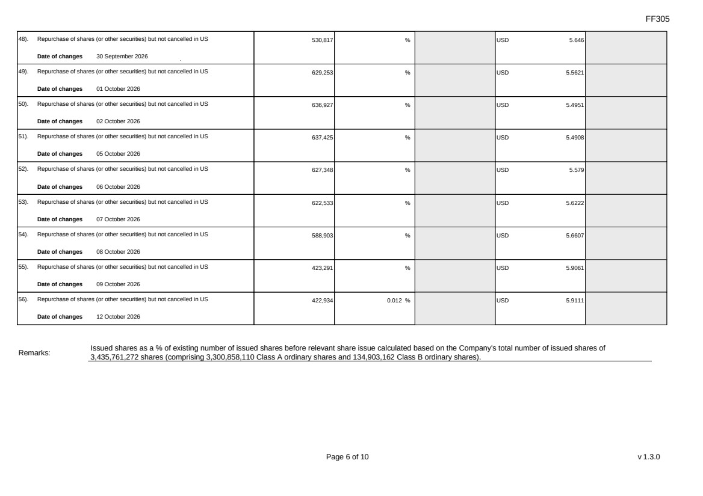 | FF305 Page 6 of 10 v 1.3.0 48). Repurchase of shares (or other securities) but not cancelled in US Date of changes 30 September 2026 530,817 % USD 5.646 49). Repurchase of shares (or other securities) but not cancelled in US Date of changes 01 October 2026 629,253 % USD 5.5621 50). Repurchase of shares (or other securities) but not cancelled in US Date of changes 02 October 2026 636,927 % USD 5.4951 51). Repurchase of shares (or other securities) but not cancelled in US Date of changes 05 October 2026 637,425 % USD 5.4908 52). Repurchase of shares (or other securities) but not cancelled in US Date of changes 06 October 2026 627,348 % USD 5.579 53). Repurchase of shares (or other securities) but not cancelled in US Date of changes 07 October 2026 622,533 % USD 5.6222 54). Repurchase of shares (or other securities) but not cancelled in US Date of changes 08 October 2026 588,903 % USD 5.6607 55). Repurchase of shares (or other securities) but not cancelled in US Date of changes 09 October 2026 423,291 % USD 5.9061 56). Repurchase of shares (or other securities) but not cancelled in US Date of changes 12 October 2026 422,934 0.012 % USD 5.9111 Remarks: Issued shares as a % of existing number of issued shares before relevant share issue calculated based on the Company's total number of issued shares of 3,435,761,272 shares (comprising 3,300,858,110 Class A ordinary shares and 134,903,162 Class B ordinary shares).
FF305 Page 7 of 10 v 1.3.0 Confirmation Not applicable Notes to Section I: 1. Please insert the closing balance date of the last Next Day Disclosure Return published pursuant to Main Board Rule 13.25A / GEM Rule 17.27A or Monthly Return pursuant to Main Board Rule 13.25B / GEM Rule 17.27B, whichever is the later. 2. Please set out all changes in issued shares or treasury shares requiring disclosure pursuant to Main Board Rule 13.25A / GEM Rule 17.27A together with the relevant dates of changes. Each category will need to be disclosed individually with sufficient information to enable the user to identify the relevant category in the listed issuer's Monthly Return. For example, multiple issues of shares as a result of multiple exercises of share options under the same share option scheme or of multiple conversions under the same convertible note must be aggregated and disclosed as one category. However, if the issues resulted from exercises of share options under 2 share option schemes or conversions of 2 convertible notes, these must be disclosed as 2 separate categories. 3. The percentage change in the number of issued shares (excluding treasury shares) of the listed issuer is to be calculated by reference to the opening balance of the number of issued shares (excluding treasury shares) being disclosed in this Next Day Disclosure Return. 4. In the case of a share repurchase or redemption, the “issue/ selling price per share” shall be construed as “repurchase price per share” or “redemption price per share”. Where shares have been issued/ sold/ repurchased/ redeemed at more than one price per share, a volume-weighted average price per share should be given. 5. The closing balance date is the date of the last relevant event being disclosed. 6. For repurchase or redemption of shares, disclosure is required when the relevant event has occurred (subject to the provisions of Main Board Rules 10.06(4)(a), 13.25A and 13.31 / GEM Rules 13.13(1), 17.27A and 17.35), even if the repurchased or redeemed shares have not yet been cancelled. If repurchased or redeemed shares are to be cancelled upon settlement of such repurchase or redemption after the closing balance date, they shall remain part of the issued shares as at the closing balance date in Part A. Details of these repurchased or redeemed shares shall be disclosed in Part B. 7. Items (i) to (viii) are suggested forms of confirmation. The listed issuer may amend the item(s) that is/are not applicable to meet individual cases. 8. “Identical” means in this context: - the securities are of the same nominal value with the same amount called up or paid up; - they are entitled to dividend/interest at the same rate and for the same period, so that at the next ensuing distribution, the dividend/interest payable per unit will amount to exactly the same sum (gross and net); and - they carry the same rights as to unrestricted transfer, attendance and voting at meetings and rank pari passu in all other respects.
 | 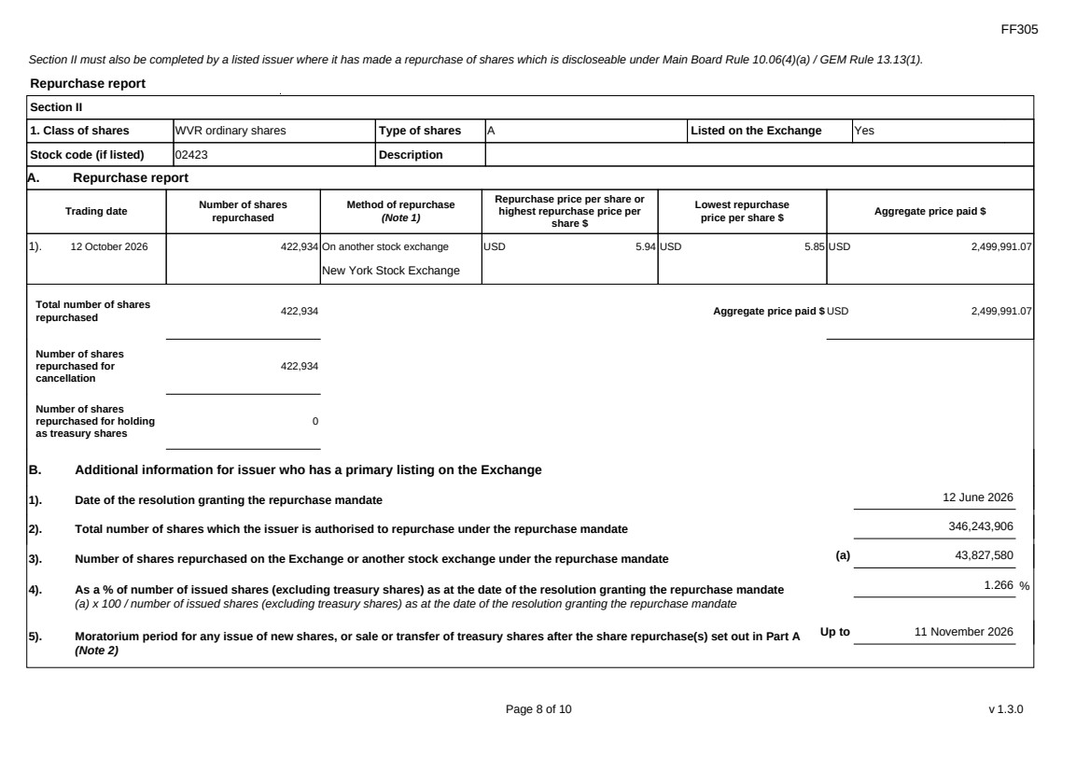 | FF305 Page 8 of 10 v 1.3.0 Section II must also be completed by a listed issuer where it has made a repurchase of shares which is discloseable under Main Board Rule 10.06(4)(a) / GEM Rule 13.13(1). Repurchase report Section II 1. Class of shares WVR ordinary shares Type of shares A Listed on the Exchange Yes Stock code (if listed) 02423 Description A. Repurchase report Trading date Number of shares repurchased Method of repurchase (Note 1) Repurchase price per share or highest repurchase price per share $ Lowest repurchase price per share $ Aggregate price paid $ 1). 12 October 2026 422,934 On another stock exchange New York Stock Exchange USD 5.94 USD 5.85 USD 2,499,991.07 Total number of shares repurchased 422,934 Aggregate price paid $ USD 2,499,991.07 Number of shares repurchased for cancellation 422,934 Number of shares repurchased for holding as treasury shares 0 B. Additional information for issuer who has a primary listing on the Exchange 1). Date of the resolution granting the repurchase mandate 12 June 2026 2). Total number of shares which the issuer is authorised to repurchase under the repurchase mandate 346,243,906 3). Number of shares repurchased on the Exchange or another stock exchange under the repurchase mandate (a) 43,827,580 4). As a % of number of issued shares (excluding treasury shares) as at the date of the resolution granting the repurchase mandate (a) x 100 / number of issued shares (excluding treasury shares) as at the date of the resolution granting the repurchase mandate 1.266 % 5). Moratorium period for any issue of new shares, or sale or transfer of treasury shares after the share repurchase(s) set out in Part A (Note 2) Up to 11 November 2026
FF305 Page 9 of 10 v 1.3.0 We hereby confirm that the repurchases made on the another stock exchange set out in Part A above were made in accordance with the Main Board Rules and that there have been no material changes to the particulars contained in the Explanatory Statement dated 24 April 2026 which has been filed with the Exchange. We also confirm that any repurchases made on another stock exchange set out in Part A above were made in accordance with the domestic rules applying to repurchases on that other stock exchange. Notes to Section II: 1. Please state whether the repurchase was made on the Exchange, on another stock exchange (stating the name of the exchange), by private arrangement or by general offer. 2. Subject to the carve-out set out in Main Board Rule 10.06(3)(a)/ GEM Rule 13.12, an issuer may not (i) make a new issue of shares, or a sale or transfer of any treasury shares; or (ii) announce a proposed new issue of shares, or a sale or transfer of any treasury shares, for a period of 30 days after any purchase by it of shares, whether on the Exchange or otherwise, without the prior approval of the Exchange.
FF305 Page 10 of 10 v 1.3.0 Section III must also be completed by a listed issuer where it has made a sale of treasury shares on the Exchange or any other stock exchange on which the issuer is listed which is discloseable under Main Board Rule 10.06B / GEM Rule 13.14B. Report of on-market sale of treasury shares Not applicable Submitted by: Siting Li (Name) Title: Joint Company Secretary (Director, Secretary or other Duly Authorised Officer)
Exhibit 99.3

 | 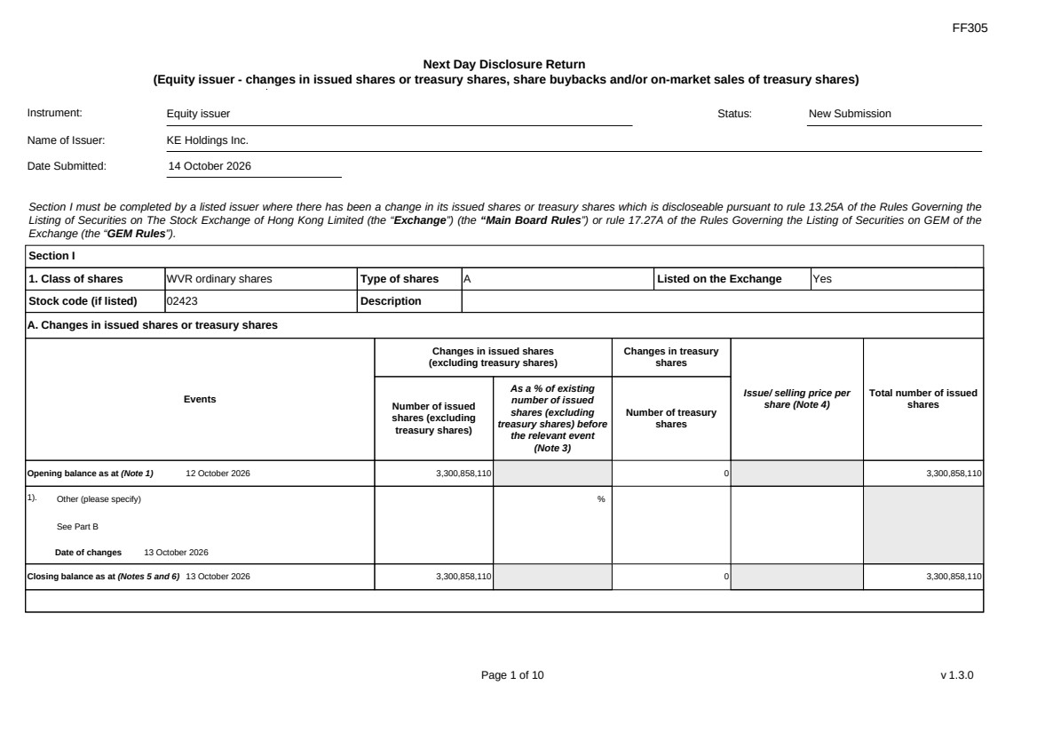 | FF305 Page 1 of 10 v 1.3.0 Next Day Disclosure Return (Equity issuer - changes in issued shares or treasury shares, share buybacks and/or on-market sales of treasury shares) Instrument: Equity issuer Status: New Submission Name of Issuer: KE Holdings Inc. Date Submitted: 14 October 2026 Section I must be completed by a listed issuer where there has been a change in its issued shares or treasury shares which is discloseable pursuant to rule 13.25A of the Rules Governing the Listing of Securities on The Stock Exchange of Hong Kong Limited (the “Exchange”) (the “Main Board Rules”) or rule 17.27A of the Rules Governing the Listing of Securities on GEM of the Exchange (the “GEM Rules”). Section I 1. Class of shares WVR ordinary shares Type of shares A Listed on the Exchange Yes Stock code (if listed) 02423 Description A. Changes in issued shares or treasury shares Events Changes in issued shares (excluding treasury shares) Number of issued shares (excluding treasury shares) As a % of existing number of issued shares (excluding treasury shares) before the relevant event (Note 3) Changes in treasury shares Number of treasury shares Issue/ selling price per share (Note 4) Total number of issued shares Opening balance as at (Note 1) 12 October 2026 3,300,858,110 0 3,300,858,110 1). Other (please specify) See Part B Date of changes 13 October 2026 % Closing balance as at (Notes 5 and 6) 13 October 2026 3,300,858,110 0 3,300,858,110
FF305 Page 2 of 10 v 1.3.0 B. Shares redeemed or repurchased for cancellation but not yet cancelled as at the closing balance date (Notes 5 and 6) 1). Repurchase of shares (or other securities) but not cancelled Date of changes 22 May 2026 464,900 % HKD 43.0128 2). Repurchase of shares (or other securities) but not cancelled Date of changes 26 May 2026 353,400 % HKD 42.4386 3). Repurchase of shares (or other securities) but not cancelled Date of changes 27 May 2026 351,100 % HKD 42.7177 4). Repurchase of shares (or other securities) but not cancelled Date of changes 28 May 2026 353,300 % HKD 42.4549 5). Repurchase of shares (or other securities) but not cancelled Date of changes 29 May 2026 344,000 % HKD 43.4567 6). Repurchase of shares (or other securities) but not cancelled Date of changes 01 June 2026 225,800 % HKD 44.2016 7). Repurchase of shares (or other securities) but not cancelled Date of changes 02 June 2026 221,700 % HKD 45.0078 8). Repurchase of shares (or other securities) but not cancelled in HK Date of changes 03 June 2026 225,300 % HKD 44.1933 9). Repurchase of shares (or other securities) but not cancelled in HK Date of changes 04 June 2026 232,500 % HKD 42.9365 10). Repurchase of shares (or other securities) but not cancelled in HK Date of changes 05 June 2026 234,600 % HKD 42.572 11). Repurchase of shares (or other securities) but not cancelled in HK Date of changes 22 June 2026 331,000 % HKD 38.5996
FF305 Page 3 of 10 v 1.3.0 12). Repurchase of shares (or other securities) but not cancelled in HK Date of changes 23 June 2026 340,200 % HKD 38.1947 13). Repurchase of shares (or other securities) but not cancelled in HK Date of changes 24 June 2026 339,400 % HKD 38.2956 14). Repurchase of shares (or other securities) but not cancelled in HK Date of changes 25 June 2026 344,200 % HKD 37.5842 15). Repurchase of shares (or other securities) but not cancelled in HK Date of changes 26 June 2026 554,200 % HKD 36.0829 16). Repurchase of shares (or other securities) but not cancelled in US Date of changes 03 August 2026 349,611 % USD 5.7206 17). Repurchase of shares (or other securities) but not cancelled in US Date of changes 04 August 2026 350,244 % USD 5.7103 18). Repurchase of shares (or other securities) but not cancelled in US Date of changes 05 August 2026 531,870 % USD 5.6405 19). Repurchase of shares (or other securities) but not cancelled in US Date of changes 06 August 2026 533,037 % USD 5.6281 20). Repurchase of shares (or other securities) but not cancelled in US Date of changes 07 August 2026 349,035 % USD 5.692 21). Repurchase of shares (or other securities) but not cancelled in US Date of changes 10 August 2026 341,265 % USD 5.8605 22). Repurchase of shares (or other securities) but not cancelled in US Date of changes 11 August 2026 529,932 % USD 5.6611 23). Repurchase of shares (or other securities) but not cancelled in US Date of changes 12 August 2026 346,719 % USD 5.7683
FF305 Page 4 of 10 v 1.3.0 24). Repurchase of shares (or other securities) but not cancelled in US Date of changes 13 August 2026 13,857 % USD 5.7041 25). Repurchase of shares (or other securities) but not cancelled in US Date of changes 25 August 2026 336,354 % USD 5.9461 26). Repurchase of shares (or other securities) but not cancelled in US Date of changes 26 August 2026 332,712 % USD 6.0112 27). Repurchase of shares (or other securities) but not cancelled in US Date of changes 27 August 2026 337,191 % USD 5.9253 28). Repurchase of shares (or other securities) but not cancelled in US Date of changes 28 August 2026 327,231 % USD 6.1118 29). Repurchase of shares (or other securities) but not cancelled in US Date of changes 31 August 2026 344,481 % USD 5.8033 30). Repurchase of shares (or other securities) but not cancelled in US Date of changes 01 September 2026 337,485 % USD 5.9262 31). Repurchase of shares (or other securities) but not cancelled in US Date of changes 02 September 2026 334,314 % USD 5.9824 32). Repurchase of shares (or other securities) but not cancelled in US Date of changes 03 September 2026 335,877 % USD 5.9545 33). Repurchase of shares (or other securities) but not cancelled in US Date of changes 04 September 2026 331,179 % USD 6.0059 34). Repurchase of shares (or other securities) but not cancelled in US Date of changes 08 September 2026 345,588 % USD 5.7316 35). Repurchase of shares (or other securities) but not cancelled in US Date of changes 10 September 2026 535,284 % USD 5.6044
FF305 Page 5 of 10 v 1.3.0 36). Repurchase of shares (or other securities) but not cancelled in US Date of changes 11 September 2026 529,269 % USD 5.6627 37). Repurchase of shares (or other securities) but not cancelled in US Date of changes 14 September 2026 537,054 % USD 5.586 38). Repurchase of shares (or other securities) but not cancelled in US Date of changes 15 September 2026 556,320 % USD 5.3894 39). Repurchase of shares (or other securities) but not cancelled in US Date of changes 16 September 2026 561,090 % USD 5.3467 40). Repurchase of shares (or other securities) but not cancelled in US Date of changes 18 September 2026 552,759 % USD 5.4273 41). Repurchase of shares (or other securities) but not cancelled in US Date of changes 21 September 2026 541,458 % USD 5.447 42). Repurchase of shares (or other securities) but not cancelled in US Date of changes 22 September 2026 549,090 % USD 5.4635 43). Repurchase of shares (or other securities) but not cancelled in US Date of changes 23 September 2026 544,065 % USD 5.514 44). Repurchase of shares (or other securities) but not cancelled in US Date of changes 24 September 2026 541,458 % USD 5.5406 45). Repurchase of shares (or other securities) but not cancelled in US Date of changes 25 September 2026 543,972 % USD 5.515 46). Repurchase of shares (or other securities) but not cancelled in US Date of changes 28 September 2026 532,014 % USD 5.6389 47). Repurchase of shares (or other securities) but not cancelled in US Date of changes 29 September 2026 546,189 % USD 5.4926
 | 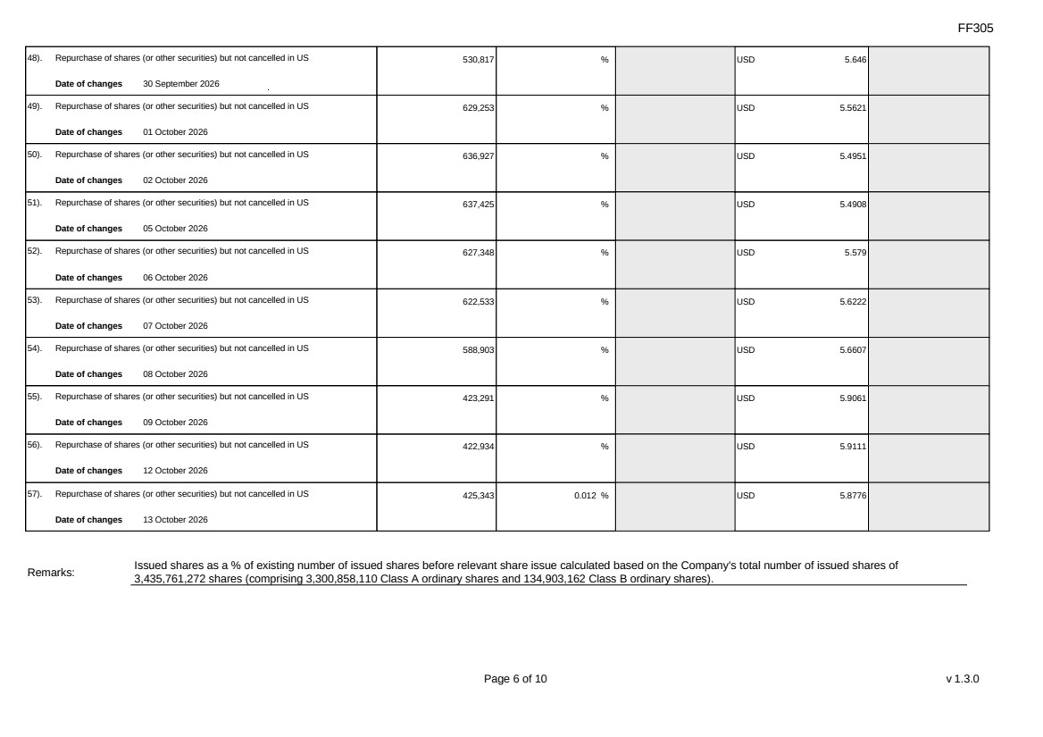 | FF305 Page 6 of 10 v 1.3.0 48). Repurchase of shares (or other securities) but not cancelled in US Date of changes 30 September 2026 530,817 % USD 5.646 49). Repurchase of shares (or other securities) but not cancelled in US Date of changes 01 October 2026 629,253 % USD 5.5621 50). Repurchase of shares (or other securities) but not cancelled in US Date of changes 02 October 2026 636,927 % USD 5.4951 51). Repurchase of shares (or other securities) but not cancelled in US Date of changes 05 October 2026 637,425 % USD 5.4908 52). Repurchase of shares (or other securities) but not cancelled in US Date of changes 06 October 2026 627,348 % USD 5.579 53). Repurchase of shares (or other securities) but not cancelled in US Date of changes 07 October 2026 622,533 % USD 5.6222 54). Repurchase of shares (or other securities) but not cancelled in US Date of changes 08 October 2026 588,903 % USD 5.6607 55). Repurchase of shares (or other securities) but not cancelled in US Date of changes 09 October 2026 423,291 % USD 5.9061 56). Repurchase of shares (or other securities) but not cancelled in US Date of changes 12 October 2026 422,934 % USD 5.9111 57). Repurchase of shares (or other securities) but not cancelled in US Date of changes 13 October 2026 425,343 0.012 % USD 5.8776 Remarks: Issued shares as a % of existing number of issued shares before relevant share issue calculated based on the Company's total number of issued shares of 3,435,761,272 shares (comprising 3,300,858,110 Class A ordinary shares and 134,903,162 Class B ordinary shares).
FF305 Page 7 of 10 v 1.3.0 Confirmation Not applicable Notes to Section I: 1. Please insert the closing balance date of the last Next Day Disclosure Return published pursuant to Main Board Rule 13.25A / GEM Rule 17.27A or Monthly Return pursuant to Main Board Rule 13.25B / GEM Rule 17.27B, whichever is the later. 2. Please set out all changes in issued shares or treasury shares requiring disclosure pursuant to Main Board Rule 13.25A / GEM Rule 17.27A together with the relevant dates of changes. Each category will need to be disclosed individually with sufficient information to enable the user to identify the relevant category in the listed issuer's Monthly Return. For example, multiple issues of shares as a result of multiple exercises of share options under the same share option scheme or of multiple conversions under the same convertible note must be aggregated and disclosed as one category. However, if the issues resulted from exercises of share options under 2 share option schemes or conversions of 2 convertible notes, these must be disclosed as 2 separate categories. 3. The percentage change in the number of issued shares (excluding treasury shares) of the listed issuer is to be calculated by reference to the opening balance of the number of issued shares (excluding treasury shares) being disclosed in this Next Day Disclosure Return. 4. In the case of a share repurchase or redemption, the “issue/ selling price per share” shall be construed as “repurchase price per share” or “redemption price per share”. Where shares have been issued/ sold/ repurchased/ redeemed at more than one price per share, a volume-weighted average price per share should be given. 5. The closing balance date is the date of the last relevant event being disclosed. 6. For repurchase or redemption of shares, disclosure is required when the relevant event has occurred (subject to the provisions of Main Board Rules 10.06(4)(a), 13.25A and 13.31 / GEM Rules 13.13(1), 17.27A and 17.35), even if the repurchased or redeemed shares have not yet been cancelled. If repurchased or redeemed shares are to be cancelled upon settlement of such repurchase or redemption after the closing balance date, they shall remain part of the issued shares as at the closing balance date in Part A. Details of these repurchased or redeemed shares shall be disclosed in Part B. 7. Items (i) to (viii) are suggested forms of confirmation. The listed issuer may amend the item(s) that is/are not applicable to meet individual cases. 8. “Identical” means in this context: - the securities are of the same nominal value with the same amount called up or paid up; - they are entitled to dividend/interest at the same rate and for the same period, so that at the next ensuing distribution, the dividend/interest payable per unit will amount to exactly the same sum (gross and net); and - they carry the same rights as to unrestricted transfer, attendance and voting at meetings and rank pari passu in all other respects.
 | 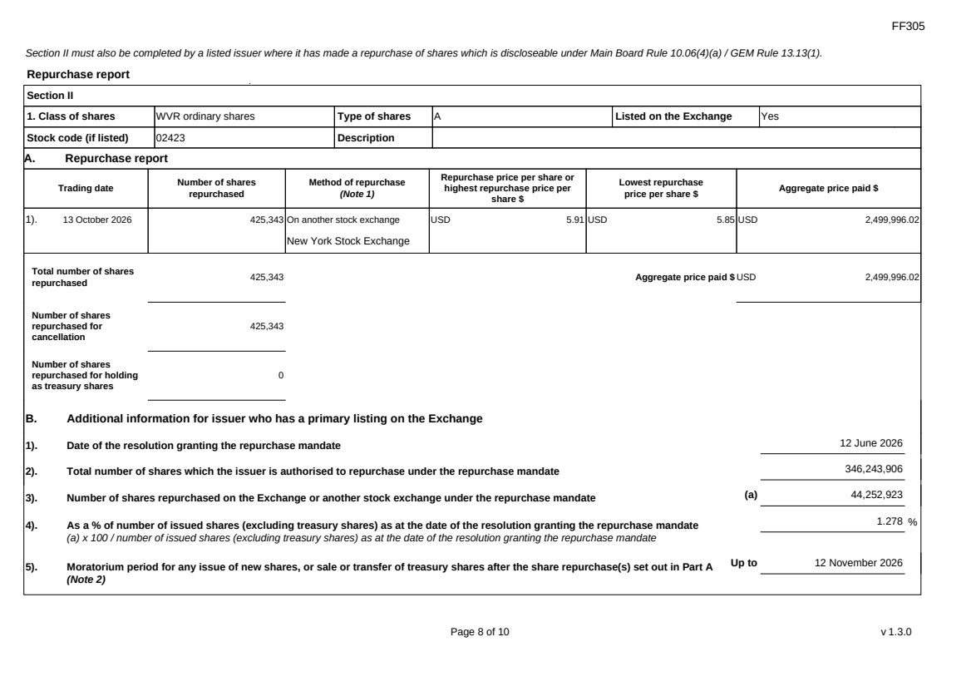 | FF305 Page 8 of 10 v 1.3.0 Section II must also be completed by a listed issuer where it has made a repurchase of shares which is discloseable under Main Board Rule 10.06(4)(a) / GEM Rule 13.13(1). Repurchase report Section II 1. Class of shares WVR ordinary shares Type of shares A Listed on the Exchange Yes Stock code (if listed) 02423 Description A. Repurchase report Trading date Number of shares repurchased Method of repurchase (Note 1) Repurchase price per share or highest repurchase price per share $ Lowest repurchase price per share $ Aggregate price paid $ 1). 13 October 2026 425,343 On another stock exchange New York Stock Exchange USD 5.91 USD 5.85 USD 2,499,996.02 Total number of shares repurchased 425,343 Aggregate price paid $ USD 2,499,996.02 Number of shares repurchased for cancellation 425,343 Number of shares repurchased for holding as treasury shares 0 B. Additional information for issuer who has a primary listing on the Exchange 1). Date of the resolution granting the repurchase mandate 12 June 2026 2). Total number of shares which the issuer is authorised to repurchase under the repurchase mandate 346,243,906 3). Number of shares repurchased on the Exchange or another stock exchange under the repurchase mandate (a) 44,252,923 4). As a % of number of issued shares (excluding treasury shares) as at the date of the resolution granting the repurchase mandate (a) x 100 / number of issued shares (excluding treasury shares) as at the date of the resolution granting the repurchase mandate 1.278 % 5). Moratorium period for any issue of new shares, or sale or transfer of treasury shares after the share repurchase(s) set out in Part A (Note 2) Up to 12 November 2026
FF305 Page 9 of 10 v 1.3.0 We hereby confirm that the repurchases made on the another stock exchange set out in Part A above were made in accordance with the Main Board Rules and that there have been no material changes to the particulars contained in the Explanatory Statement dated 24 April 2026 which has been filed with the Exchange. We also confirm that any repurchases made on another stock exchange set out in Part A above were made in accordance with the domestic rules applying to repurchases on that other stock exchange. Notes to Section II: 1. Please state whether the repurchase was made on the Exchange, on another stock exchange (stating the name of the exchange), by private arrangement or by general offer. 2. Subject to the carve-out set out in Main Board Rule 10.06(3)(a)/ GEM Rule 13.12, an issuer may not (i) make a new issue of shares, or a sale or transfer of any treasury shares; or (ii) announce a proposed new issue of shares, or a sale or transfer of any treasury shares, for a period of 30 days after any purchase by it of shares, whether on the Exchange or otherwise, without the prior approval of the Exchange.
FF305 Page 10 of 10 v 1.3.0 Section III must also be completed by a listed issuer where it has made a sale of treasury shares on the Exchange or any other stock exchange on which the issuer is listed which is discloseable under Main Board Rule 10.06B / GEM Rule 13.14B. Report of on-market sale of treasury shares Not applicable Submitted by: Siting Li (Name) Title: Joint Company Secretary (Director, Secretary or other Duly Authorised Officer)
Exhibit 99.4

 | 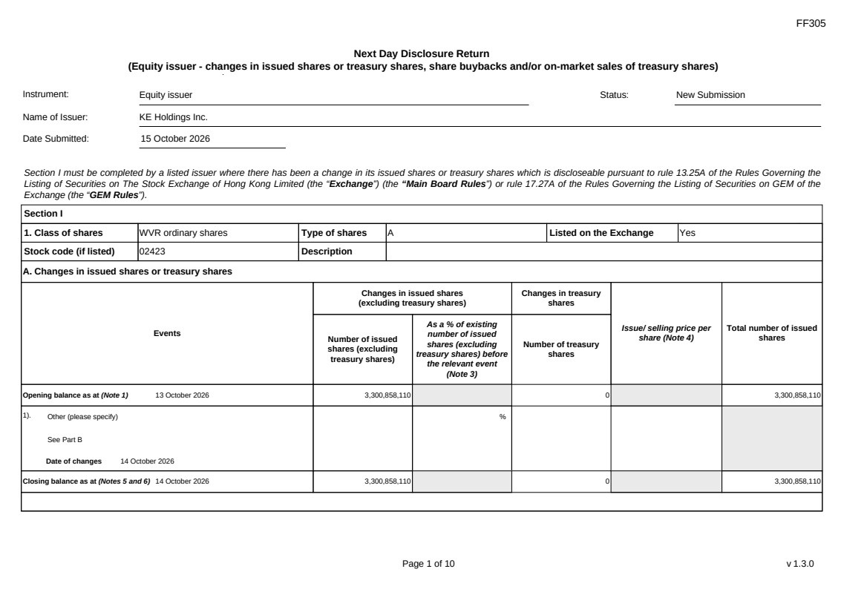 | FF305 Page 1 of 10 v 1.3.0 Next Day Disclosure Return (Equity issuer - changes in issued shares or treasury shares, share buybacks and/or on-market sales of treasury shares) Instrument: Equity issuer Status: New Submission Name of Issuer: KE Holdings Inc. Date Submitted: 15 October 2026 Section I must be completed by a listed issuer where there has been a change in its issued shares or treasury shares which is discloseable pursuant to rule 13.25A of the Rules Governing the Listing of Securities on The Stock Exchange of Hong Kong Limited (the “Exchange”) (the “Main Board Rules”) or rule 17.27A of the Rules Governing the Listing of Securities on GEM of the Exchange (the “GEM Rules”). Section I 1. Class of shares WVR ordinary shares Type of shares A Listed on the Exchange Yes Stock code (if listed) 02423 Description A. Changes in issued shares or treasury shares Events Changes in issued shares (excluding treasury shares) Number of issued shares (excluding treasury shares) As a % of existing number of issued shares (excluding treasury shares) before the relevant event (Note 3) Changes in treasury shares Number of treasury shares Issue/ selling price per share (Note 4) Total number of issued shares Opening balance as at (Note 1) 13 October 2026 3,300,858,110 0 3,300,858,110 1). Other (please specify) See Part B Date of changes 14 October 2026 % Closing balance as at (Notes 5 and 6) 14 October 2026 3,300,858,110 0 3,300,858,110
FF305 Page 2 of 10 v 1.3.0 B. Shares redeemed or repurchased for cancellation but not yet cancelled as at the closing balance date (Notes 5 and 6) 1). Repurchase of shares (or other securities) but not cancelled Date of changes 22 May 2026 464,900 % HKD 43.0128 2). Repurchase of shares (or other securities) but not cancelled Date of changes 26 May 2026 353,400 % HKD 42.4386 3). Repurchase of shares (or other securities) but not cancelled Date of changes 27 May 2026 351,100 % HKD 42.7177 4). Repurchase of shares (or other securities) but not cancelled Date of changes 28 May 2026 353,300 % HKD 42.4549 5). Repurchase of shares (or other securities) but not cancelled Date of changes 29 May 2026 344,000 % HKD 43.4567 6). Repurchase of shares (or other securities) but not cancelled Date of changes 01 June 2026 225,800 % HKD 44.2016 7). Repurchase of shares (or other securities) but not cancelled Date of changes 02 June 2026 221,700 % HKD 45.0078 8). Repurchase of shares (or other securities) but not cancelled in HK Date of changes 03 June 2026 225,300 % HKD 44.1933 9). Repurchase of shares (or other securities) but not cancelled in HK Date of changes 04 June 2026 232,500 % HKD 42.9365 10). Repurchase of shares (or other securities) but not cancelled in HK Date of changes 05 June 2026 234,600 % HKD 42.572 11). Repurchase of shares (or other securities) but not cancelled in HK Date of changes 22 June 2026 331,000 % HKD 38.5996
FF305 Page 3 of 10 v 1.3.0 12). Repurchase of shares (or other securities) but not cancelled in HK Date of changes 23 June 2026 340,200 % HKD 38.1947 13). Repurchase of shares (or other securities) but not cancelled in HK Date of changes 24 June 2026 339,400 % HKD 38.2956 14). Repurchase of shares (or other securities) but not cancelled in HK Date of changes 25 June 2026 344,200 % HKD 37.5842 15). Repurchase of shares (or other securities) but not cancelled in HK Date of changes 26 June 2026 554,200 % HKD 36.0829 16). Repurchase of shares (or other securities) but not cancelled in US Date of changes 03 August 2026 349,611 % USD 5.7206 17). Repurchase of shares (or other securities) but not cancelled in US Date of changes 04 August 2026 350,244 % USD 5.7103 18). Repurchase of shares (or other securities) but not cancelled in US Date of changes 05 August 2026 531,870 % USD 5.6405 19). Repurchase of shares (or other securities) but not cancelled in US Date of changes 06 August 2026 533,037 % USD 5.6281 20). Repurchase of shares (or other securities) but not cancelled in US Date of changes 07 August 2026 349,035 % USD 5.692 21). Repurchase of shares (or other securities) but not cancelled in US Date of changes 10 August 2026 341,265 % USD 5.8605 22). Repurchase of shares (or other securities) but not cancelled in US Date of changes 11 August 2026 529,932 % USD 5.6611 23). Repurchase of shares (or other securities) but not cancelled in US Date of changes 12 August 2026 346,719 % USD 5.7683
FF305 Page 4 of 10 v 1.3.0 24). Repurchase of shares (or other securities) but not cancelled in US Date of changes 13 August 2026 13,857 % USD 5.7041 25). Repurchase of shares (or other securities) but not cancelled in US Date of changes 25 August 2026 336,354 % USD 5.9461 26). Repurchase of shares (or other securities) but not cancelled in US Date of changes 26 August 2026 332,712 % USD 6.0112 27). Repurchase of shares (or other securities) but not cancelled in US Date of changes 27 August 2026 337,191 % USD 5.9253 28). Repurchase of shares (or other securities) but not cancelled in US Date of changes 28 August 2026 327,231 % USD 6.1118 29). Repurchase of shares (or other securities) but not cancelled in US Date of changes 31 August 2026 344,481 % USD 5.8033 30). Repurchase of shares (or other securities) but not cancelled in US Date of changes 01 September 2026 337,485 % USD 5.9262 31). Repurchase of shares (or other securities) but not cancelled in US Date of changes 02 September 2026 334,314 % USD 5.9824 32). Repurchase of shares (or other securities) but not cancelled in US Date of changes 03 September 2026 335,877 % USD 5.9545 33). Repurchase of shares (or other securities) but not cancelled in US Date of changes 04 September 2026 331,179 % USD 6.0059 34). Repurchase of shares (or other securities) but not cancelled in US Date of changes 08 September 2026 345,588 % USD 5.7316 35). Repurchase of shares (or other securities) but not cancelled in US Date of changes 10 September 2026 535,284 % USD 5.6044
FF305 Page 5 of 10 v 1.3.0 36). Repurchase of shares (or other securities) but not cancelled in US Date of changes 11 September 2026 529,269 % USD 5.6627 37). Repurchase of shares (or other securities) but not cancelled in US Date of changes 14 September 2026 537,054 % USD 5.586 38). Repurchase of shares (or other securities) but not cancelled in US Date of changes 15 September 2026 556,320 % USD 5.3894 39). Repurchase of shares (or other securities) but not cancelled in US Date of changes 16 September 2026 561,090 % USD 5.3467 40). Repurchase of shares (or other securities) but not cancelled in US Date of changes 18 September 2026 552,759 % USD 5.4273 41). Repurchase of shares (or other securities) but not cancelled in US Date of changes 21 September 2026 541,458 % USD 5.447 42). Repurchase of shares (or other securities) but not cancelled in US Date of changes 22 September 2026 549,090 % USD 5.4635 43). Repurchase of shares (or other securities) but not cancelled in US Date of changes 23 September 2026 544,065 % USD 5.514 44). Repurchase of shares (or other securities) but not cancelled in US Date of changes 24 September 2026 541,458 % USD 5.5406 45). Repurchase of shares (or other securities) but not cancelled in US Date of changes 25 September 2026 543,972 % USD 5.515 46). Repurchase of shares (or other securities) but not cancelled in US Date of changes 28 September 2026 532,014 % USD 5.6389 47). Repurchase of shares (or other securities) but not cancelled in US Date of changes 29 September 2026 546,189 % USD 5.4926
 | 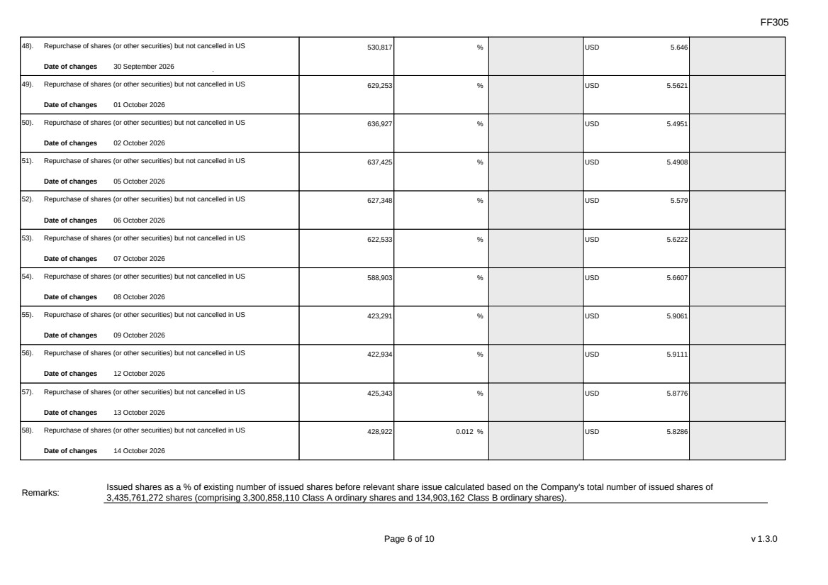 | FF305 Page 6 of 10 v 1.3.0 48). Repurchase of shares (or other securities) but not cancelled in US Date of changes 30 September 2026 530,817 % USD 5.646 49). Repurchase of shares (or other securities) but not cancelled in US Date of changes 01 October 2026 629,253 % USD 5.5621 50). Repurchase of shares (or other securities) but not cancelled in US Date of changes 02 October 2026 636,927 % USD 5.4951 51). Repurchase of shares (or other securities) but not cancelled in US Date of changes 05 October 2026 637,425 % USD 5.4908 52). Repurchase of shares (or other securities) but not cancelled in US Date of changes 06 October 2026 627,348 % USD 5.579 53). Repurchase of shares (or other securities) but not cancelled in US Date of changes 07 October 2026 622,533 % USD 5.6222 54). Repurchase of shares (or other securities) but not cancelled in US Date of changes 08 October 2026 588,903 % USD 5.6607 55). Repurchase of shares (or other securities) but not cancelled in US Date of changes 09 October 2026 423,291 % USD 5.9061 56). Repurchase of shares (or other securities) but not cancelled in US Date of changes 12 October 2026 422,934 % USD 5.9111 57). Repurchase of shares (or other securities) but not cancelled in US Date of changes 13 October 2026 425,343 % USD 5.8776 58). Repurchase of shares (or other securities) but not cancelled in US Date of changes 14 October 2026 428,922 0.012 % USD 5.8286 Remarks: Issued shares as a % of existing number of issued shares before relevant share issue calculated based on the Company's total number of issued shares of 3,435,761,272 shares (comprising 3,300,858,110 Class A ordinary shares and 134,903,162 Class B ordinary shares).
FF305 Page 7 of 10 v 1.3.0 Confirmation Not applicable Notes to Section I: 1. Please insert the closing balance date of the last Next Day Disclosure Return published pursuant to Main Board Rule 13.25A / GEM Rule 17.27A or Monthly Return pursuant to Main Board Rule 13.25B / GEM Rule 17.27B, whichever is the later. 2. Please set out all changes in issued shares or treasury shares requiring disclosure pursuant to Main Board Rule 13.25A / GEM Rule 17.27A together with the relevant dates of changes. Each category will need to be disclosed individually with sufficient information to enable the user to identify the relevant category in the listed issuer's Monthly Return. For example, multiple issues of shares as a result of multiple exercises of share options under the same share option scheme or of multiple conversions under the same convertible note must be aggregated and disclosed as one category. However, if the issues resulted from exercises of share options under 2 share option schemes or conversions of 2 convertible notes, these must be disclosed as 2 separate categories. 3. The percentage change in the number of issued shares (excluding treasury shares) of the listed issuer is to be calculated by reference to the opening balance of the number of issued shares (excluding treasury shares) being disclosed in this Next Day Disclosure Return. 4. In the case of a share repurchase or redemption, the “issue/ selling price per share” shall be construed as “repurchase price per share” or “redemption price per share”. Where shares have been issued/ sold/ repurchased/ redeemed at more than one price per share, a volume-weighted average price per share should be given. 5. The closing balance date is the date of the last relevant event being disclosed. 6. For repurchase or redemption of shares, disclosure is required when the relevant event has occurred (subject to the provisions of Main Board Rules 10.06(4)(a), 13.25A and 13.31 / GEM Rules 13.13(1), 17.27A and 17.35), even if the repurchased or redeemed shares have not yet been cancelled. If repurchased or redeemed shares are to be cancelled upon settlement of such repurchase or redemption after the closing balance date, they shall remain part of the issued shares as at the closing balance date in Part A. Details of these repurchased or redeemed shares shall be disclosed in Part B. 7. Items (i) to (viii) are suggested forms of confirmation. The listed issuer may amend the item(s) that is/are not applicable to meet individual cases. 8. “Identical” means in this context: - the securities are of the same nominal value with the same amount called up or paid up; - they are entitled to dividend/interest at the same rate and for the same period, so that at the next ensuing distribution, the dividend/interest payable per unit will amount to exactly the same sum (gross and net); and - they carry the same rights as to unrestricted transfer, attendance and voting at meetings and rank pari passu in all other respects.
 | 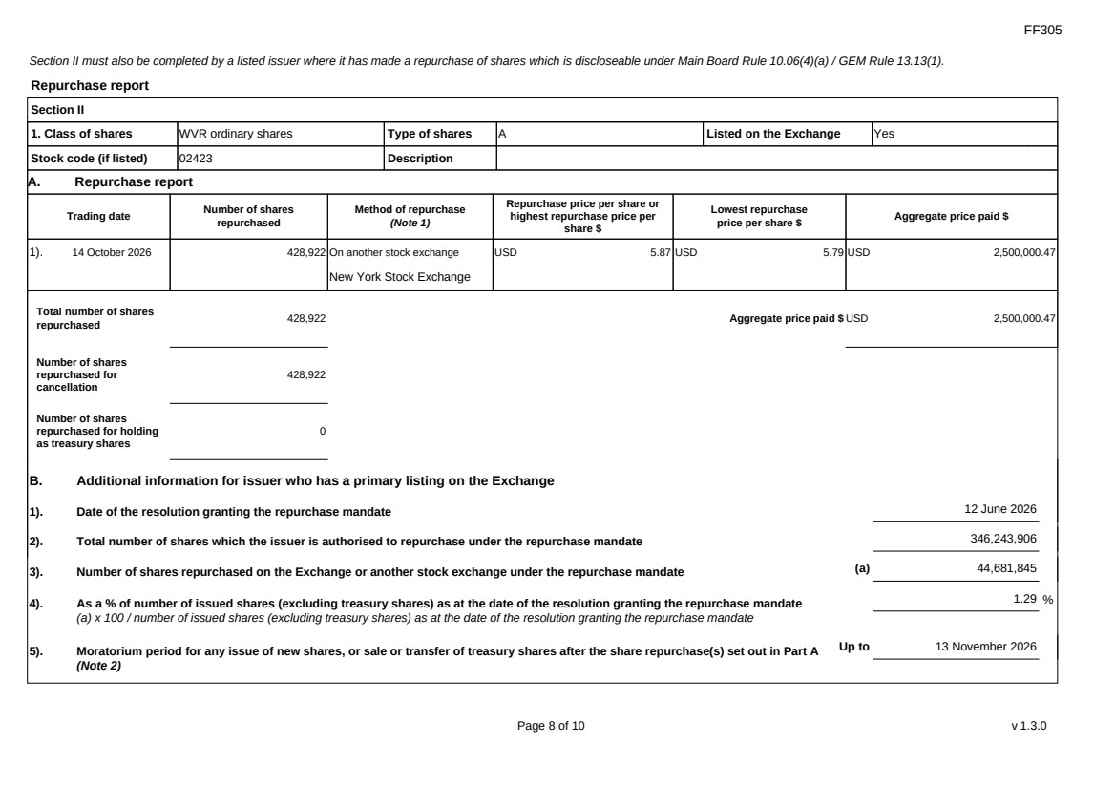 | FF305 Page 8 of 10 v 1.3.0 Section II must also be completed by a listed issuer where it has made a repurchase of shares which is discloseable under Main Board Rule 10.06(4)(a) / GEM Rule 13.13(1). Repurchase report Section II 1. Class of shares WVR ordinary shares Type of shares A Listed on the Exchange Yes Stock code (if listed) 02423 Description A. Repurchase report Trading date Number of shares repurchased Method of repurchase (Note 1) Repurchase price per share or highest repurchase price per share $ Lowest repurchase price per share $ Aggregate price paid $ 1). 14 October 2026 428,922 On another stock exchange New York Stock Exchange USD 5.87 USD 5.79 USD 2,500,000.47 Total number of shares repurchased 428,922 Aggregate price paid $ USD 2,500,000.47 Number of shares repurchased for cancellation 428,922 Number of shares repurchased for holding as treasury shares 0 B. Additional information for issuer who has a primary listing on the Exchange 1). Date of the resolution granting the repurchase mandate 12 June 2026 2). Total number of shares which the issuer is authorised to repurchase under the repurchase mandate 346,243,906 3). Number of shares repurchased on the Exchange or another stock exchange under the repurchase mandate (a) 44,681,845 4). As a % of number of issued shares (excluding treasury shares) as at the date of the resolution granting the repurchase mandate (a) x 100 / number of issued shares (excluding treasury shares) as at the date of the resolution granting the repurchase mandate 1.29 % 5). Moratorium period for any issue of new shares, or sale or transfer of treasury shares after the share repurchase(s) set out in Part A (Note 2) Up to 13 November 2026
FF305 Page 9 of 10 v 1.3.0 We hereby confirm that the repurchases made on the another stock exchange set out in Part A above were made in accordance with the Main Board Rules and that there have been no material changes to the particulars contained in the Explanatory Statement dated 24 April 2026 which has been filed with the Exchange. We also confirm that any repurchases made on another stock exchange set out in Part A above were made in accordance with the domestic rules applying to repurchases on that other stock exchange. Notes to Section II: 1. Please state whether the repurchase was made on the Exchange, on another stock exchange (stating the name of the exchange), by private arrangement or by general offer. 2. Subject to the carve-out set out in Main Board Rule 10.06(3)(a)/ GEM Rule 13.12, an issuer may not (i) make a new issue of shares, or a sale or transfer of any treasury shares; or (ii) announce a proposed new issue of shares, or a sale or transfer of any treasury shares, for a period of 30 days after any purchase by it of shares, whether on the Exchange or otherwise, without the prior approval of the Exchange.
FF305 Page 10 of 10 v 1.3.0 Section III must also be completed by a listed issuer where it has made a sale of treasury shares on the Exchange or any other stock exchange on which the issuer is listed which is discloseable under Main Board Rule 10.06B / GEM Rule 13.14B. Report of on-market sale of treasury shares Not applicable Submitted by: Siting Li (Name) Title: Joint Company Secretary (Director, Secretary or other Duly Authorised Officer)
Exhibit 99.5

 | 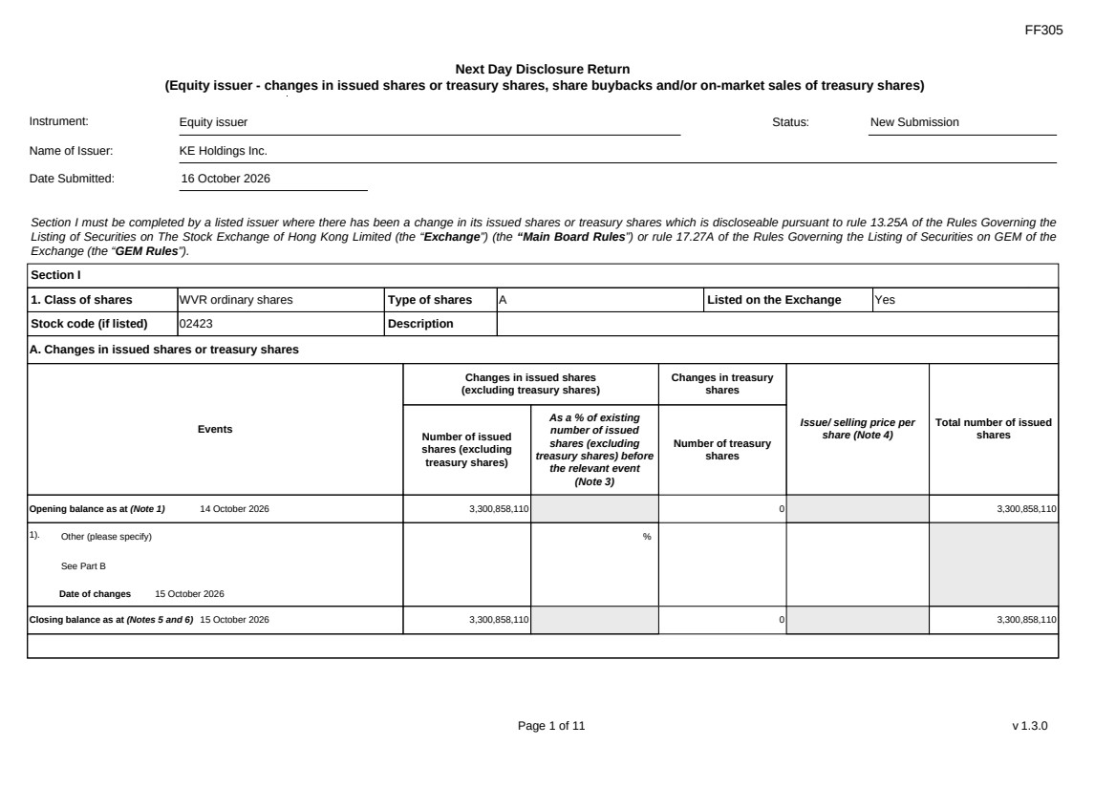 | FF305 Page 1 of 11 v 1.3.0 Next Day Disclosure Return (Equity issuer - changes in issued shares or treasury shares, share buybacks and/or on-market sales of treasury shares) Instrument: Equity issuer Status: New Submission Name of Issuer: KE Holdings Inc. Date Submitted: 16 October 2026 Section I must be completed by a listed issuer where there has been a change in its issued shares or treasury shares which is discloseable pursuant to rule 13.25A of the Rules Governing the Listing of Securities on The Stock Exchange of Hong Kong Limited (the “Exchange”) (the “Main Board Rules”) or rule 17.27A of the Rules Governing the Listing of Securities on GEM of the Exchange (the “GEM Rules”). Section I 1. Class of shares WVR ordinary shares Type of shares A Listed on the Exchange Yes Stock code (if listed) 02423 Description A. Changes in issued shares or treasury shares Events Changes in issued shares (excluding treasury shares) Number of issued shares (excluding treasury shares) As a % of existing number of issued shares (excluding treasury shares) before the relevant event (Note 3) Changes in treasury shares Number of treasury shares Issue/ selling price per share (Note 4) Total number of issued shares Opening balance as at (Note 1) 14 October 2026 3,300,858,110 0 3,300,858,110 1). Other (please specify) See Part B Date of changes 15 October 2026 % Closing balance as at (Notes 5 and 6) 15 October 2026 3,300,858,110 0 3,300,858,110
 | 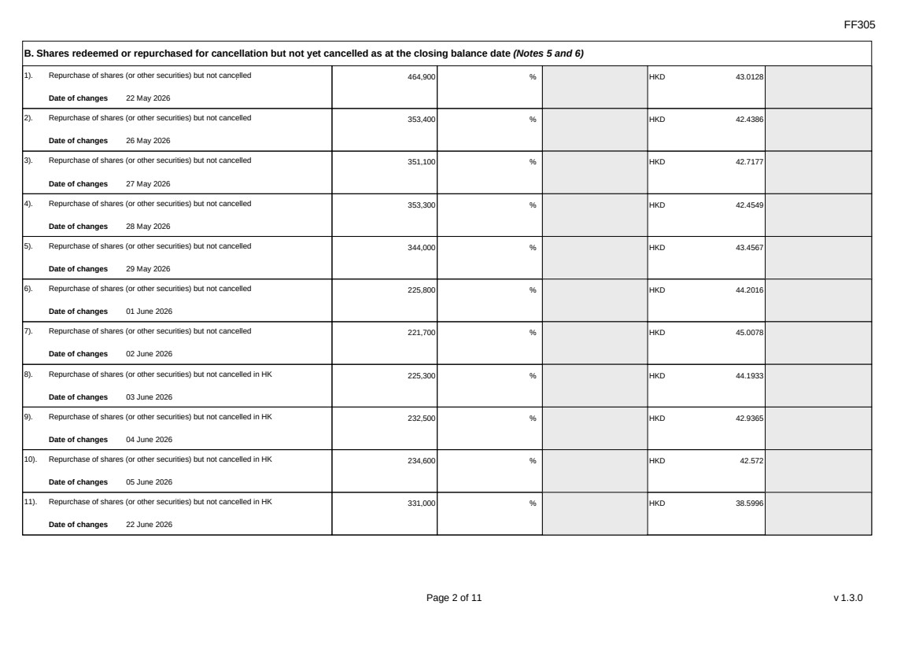 | FF305 Page 2 of 11 v 1.3.0 B. Shares redeemed or repurchased for cancellation but not yet cancelled as at the closing balance date (Notes 5 and 6) 1). Repurchase of shares (or other securities) but not cancelled Date of changes 22 May 2026 464,900 % HKD 43.0128 2). Repurchase of shares (or other securities) but not cancelled Date of changes 26 May 2026 353,400 % HKD 42.4386 3). Repurchase of shares (or other securities) but not cancelled Date of changes 27 May 2026 351,100 % HKD 42.7177 4). Repurchase of shares (or other securities) but not cancelled Date of changes 28 May 2026 353,300 % HKD 42.4549 5). Repurchase of shares (or other securities) but not cancelled Date of changes 29 May 2026 344,000 % HKD 43.4567 6). Repurchase of shares (or other securities) but not cancelled Date of changes 01 June 2026 225,800 % HKD 44.2016 7). Repurchase of shares (or other securities) but not cancelled Date of changes 02 June 2026 221,700 % HKD 45.0078 8). Repurchase of shares (or other securities) but not cancelled in HK Date of changes 03 June 2026 225,300 % HKD 44.1933 9). Repurchase of shares (or other securities) but not cancelled in HK Date of changes 04 June 2026 232,500 % HKD 42.9365 10). Repurchase of shares (or other securities) but not cancelled in HK Date of changes 05 June 2026 234,600 % HKD 42.572 11). Repurchase of shares (or other securities) but not cancelled in HK Date of changes 22 June 2026 331,000 % HKD 38.5996
 | 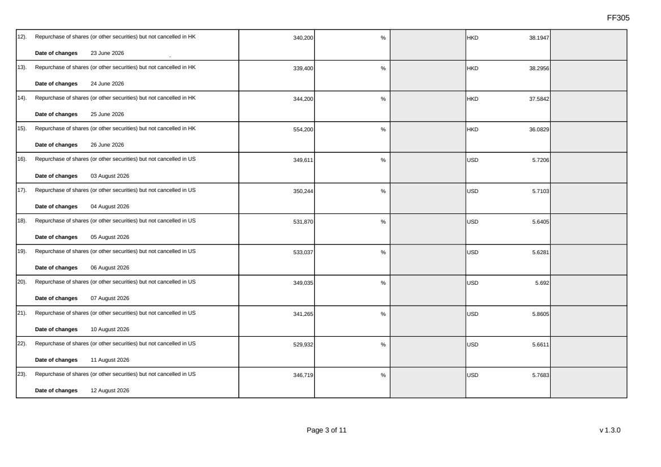 | FF305 Page 3 of 11 v 1.3.0 12). Repurchase of shares (or other securities) but not cancelled in HK Date of changes 23 June 2026 340,200 % HKD 38.1947 13). Repurchase of shares (or other securities) but not cancelled in HK Date of changes 24 June 2026 339,400 % HKD 38.2956 14). Repurchase of shares (or other securities) but not cancelled in HK Date of changes 25 June 2026 344,200 % HKD 37.5842 15). Repurchase of shares (or other securities) but not cancelled in HK Date of changes 26 June 2026 554,200 % HKD 36.0829 16). Repurchase of shares (or other securities) but not cancelled in US Date of changes 03 August 2026 349,611 % USD 5.7206 17). Repurchase of shares (or other securities) but not cancelled in US Date of changes 04 August 2026 350,244 % USD 5.7103 18). Repurchase of shares (or other securities) but not cancelled in US Date of changes 05 August 2026 531,870 % USD 5.6405 19). Repurchase of shares (or other securities) but not cancelled in US Date of changes 06 August 2026 533,037 % USD 5.6281 20). Repurchase of shares (or other securities) but not cancelled in US Date of changes 07 August 2026 349,035 % USD 5.692 21). Repurchase of shares (or other securities) but not cancelled in US Date of changes 10 August 2026 341,265 % USD 5.8605 22). Repurchase of shares (or other securities) but not cancelled in US Date of changes 11 August 2026 529,932 % USD 5.6611 23). Repurchase of shares (or other securities) but not cancelled in US Date of changes 12 August 2026 346,719 % USD 5.7683
 | 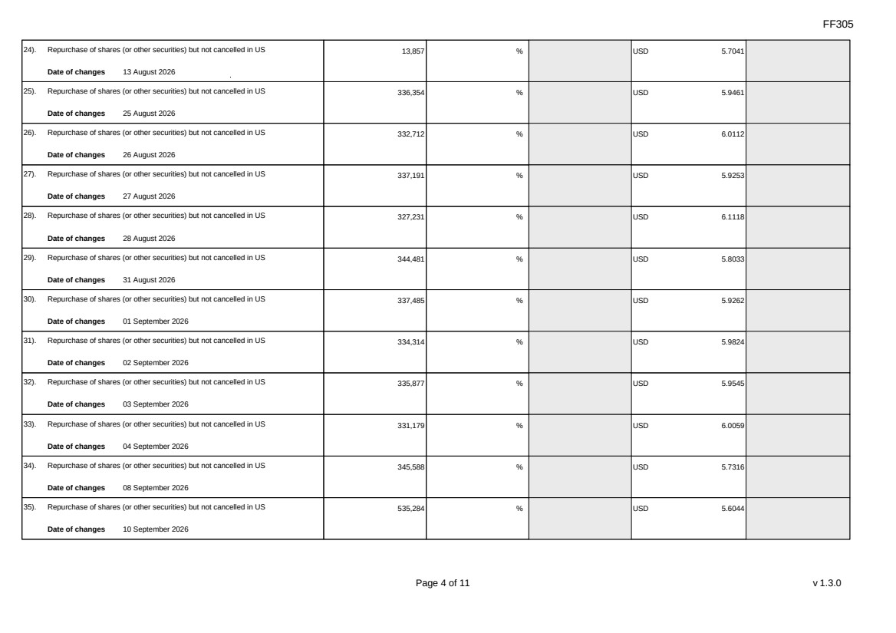 | FF305 Page 4 of 11 v 1.3.0 24). Repurchase of shares (or other securities) but not cancelled in US Date of changes 13 August 2026 13,857 % USD 5.7041 25). Repurchase of shares (or other securities) but not cancelled in US Date of changes 25 August 2026 336,354 % USD 5.9461 26). Repurchase of shares (or other securities) but not cancelled in US Date of changes 26 August 2026 332,712 % USD 6.0112 27). Repurchase of shares (or other securities) but not cancelled in US Date of changes 27 August 2026 337,191 % USD 5.9253 28). Repurchase of shares (or other securities) but not cancelled in US Date of changes 28 August 2026 327,231 % USD 6.1118 29). Repurchase of shares (or other securities) but not cancelled in US Date of changes 31 August 2026 344,481 % USD 5.8033 30). Repurchase of shares (or other securities) but not cancelled in US Date of changes 01 September 2026 337,485 % USD 5.9262 31). Repurchase of shares (or other securities) but not cancelled in US Date of changes 02 September 2026 334,314 % USD 5.9824 32). Repurchase of shares (or other securities) but not cancelled in US Date of changes 03 September 2026 335,877 % USD 5.9545 33). Repurchase of shares (or other securities) but not cancelled in US Date of changes 04 September 2026 331,179 % USD 6.0059 34). Repurchase of shares (or other securities) but not cancelled in US Date of changes 08 September 2026 345,588 % USD 5.7316 35). Repurchase of shares (or other securities) but not cancelled in US Date of changes 10 September 2026 535,284 % USD 5.6044
 | 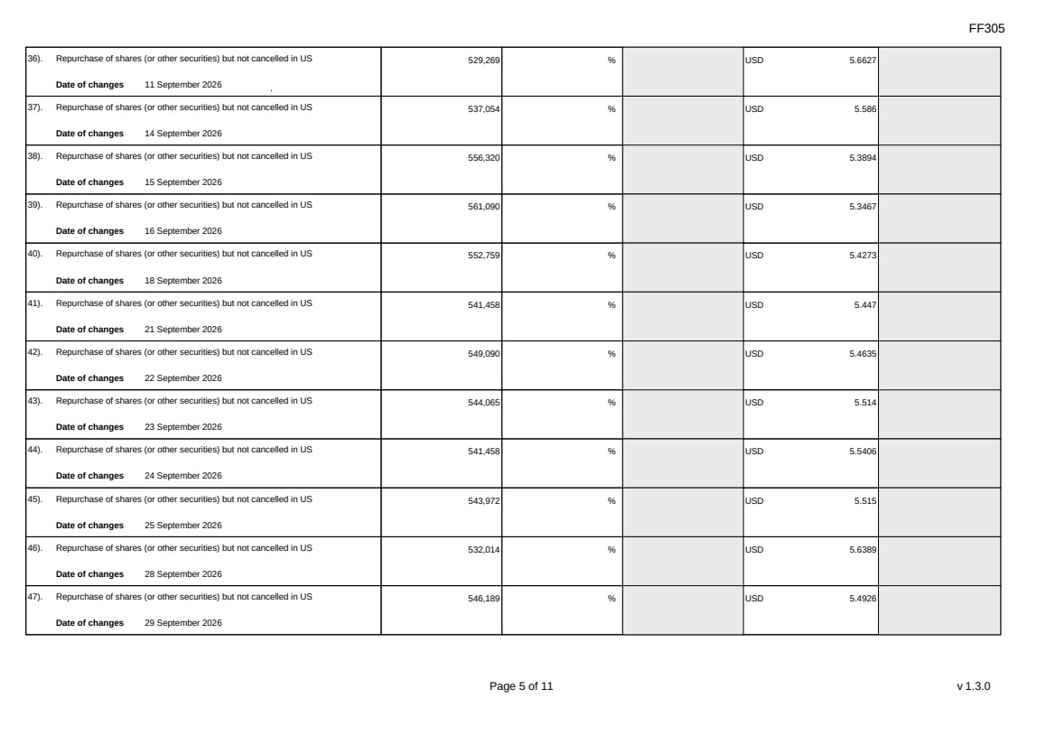 | FF305 Page 5 of 11 v 1.3.0 36). Repurchase of shares (or other securities) but not cancelled in US Date of changes 11 September 2026 529,269 % USD 5.6627 37). Repurchase of shares (or other securities) but not cancelled in US Date of changes 14 September 2026 537,054 % USD 5.586 38). Repurchase of shares (or other securities) but not cancelled in US Date of changes 15 September 2026 556,320 % USD 5.3894 39). Repurchase of shares (or other securities) but not cancelled in US Date of changes 16 September 2026 561,090 % USD 5.3467 40). Repurchase of shares (or other securities) but not cancelled in US Date of changes 18 September 2026 552,759 % USD 5.4273 41). Repurchase of shares (or other securities) but not cancelled in US Date of changes 21 September 2026 541,458 % USD 5.447 42). Repurchase of shares (or other securities) but not cancelled in US Date of changes 22 September 2026 549,090 % USD 5.4635 43). Repurchase of shares (or other securities) but not cancelled in US Date of changes 23 September 2026 544,065 % USD 5.514 44). Repurchase of shares (or other securities) but not cancelled in US Date of changes 24 September 2026 541,458 % USD 5.5406 45). Repurchase of shares (or other securities) but not cancelled in US Date of changes 25 September 2026 543,972 % USD 5.515 46). Repurchase of shares (or other securities) but not cancelled in US Date of changes 28 September 2026 532,014 % USD 5.6389 47). Repurchase of shares (or other securities) but not cancelled in US Date of changes 29 September 2026 546,189 % USD 5.4926
 | 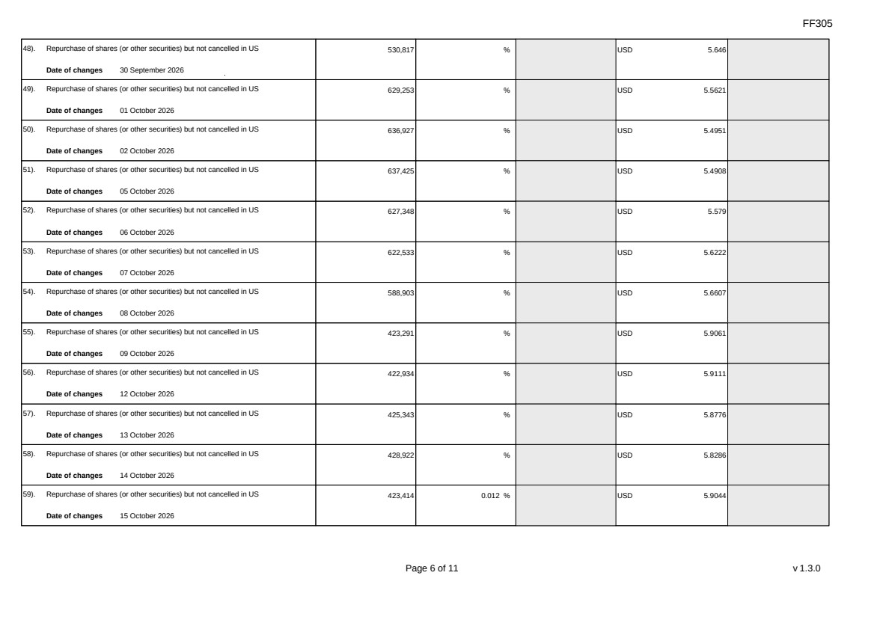 | FF305 Page 6 of 11 v 1.3.0 48). Repurchase of shares (or other securities) but not cancelled in US Date of changes 30 September 2026 530,817 % USD 5.646 49). Repurchase of shares (or other securities) but not cancelled in US Date of changes 01 October 2026 629,253 % USD 5.5621 50). Repurchase of shares (or other securities) but not cancelled in US Date of changes 02 October 2026 636,927 % USD 5.4951 51). Repurchase of shares (or other securities) but not cancelled in US Date of changes 05 October 2026 637,425 % USD 5.4908 52). Repurchase of shares (or other securities) but not cancelled in US Date of changes 06 October 2026 627,348 % USD 5.579 53). Repurchase of shares (or other securities) but not cancelled in US Date of changes 07 October 2026 622,533 % USD 5.6222 54). Repurchase of shares (or other securities) but not cancelled in US Date of changes 08 October 2026 588,903 % USD 5.6607 55). Repurchase of shares (or other securities) but not cancelled in US Date of changes 09 October 2026 423,291 % USD 5.9061 56). Repurchase of shares (or other securities) but not cancelled in US Date of changes 12 October 2026 422,934 % USD 5.9111 57). Repurchase of shares (or other securities) but not cancelled in US Date of changes 13 October 2026 425,343 % USD 5.8776 58). Repurchase of shares (or other securities) but not cancelled in US Date of changes 14 October 2026 428,922 % USD 5.8286 59). Repurchase of shares (or other securities) but not cancelled in US Date of changes 15 October 2026 423,414 0.012 % USD 5.9044
 | 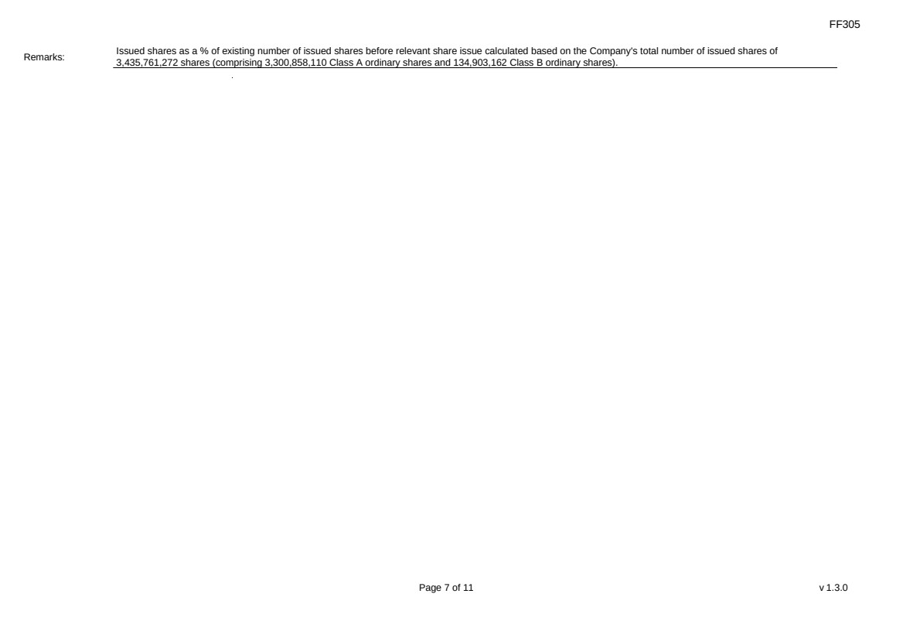 | FF305 Page 7 of 11 v 1.3.0 Remarks: Issued shares as a % of existing number of issued shares before relevant share issue calculated based on the Company's total number of issued shares of 3,435,761,272 shares (comprising 3,300,858,110 Class A ordinary shares and 134,903,162 Class B ordinary shares).
 | 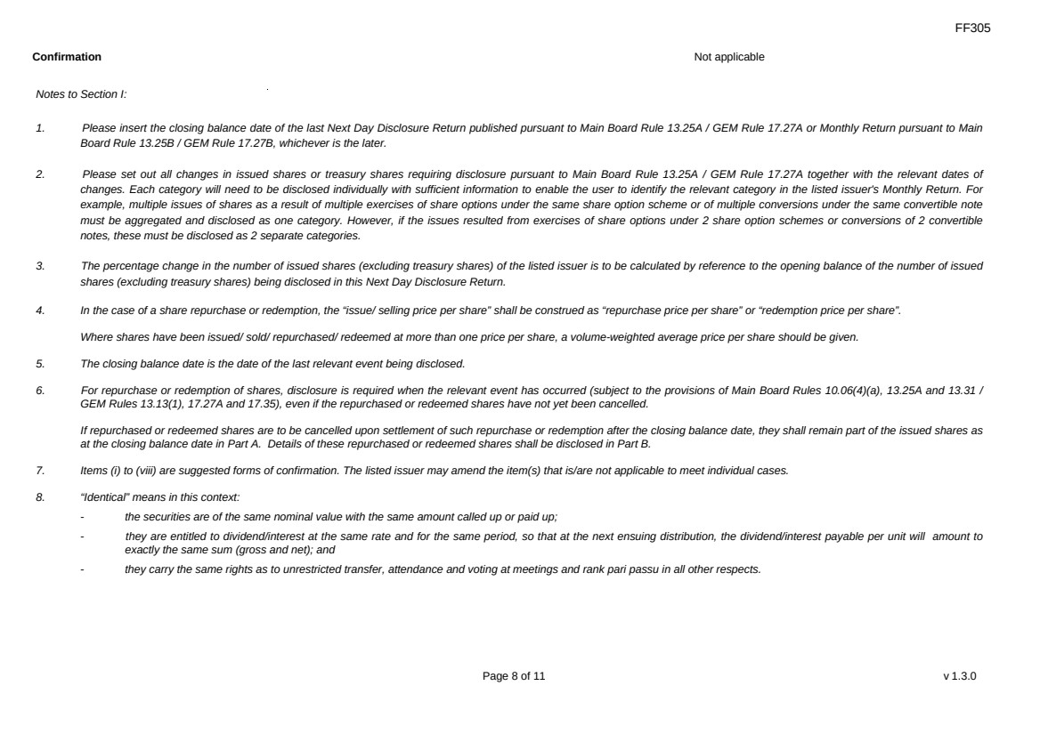 | FF305 Page 8 of 11 v 1.3.0 Confirmation Not applicable Notes to Section I: 1. Please insert the closing balance date of the last Next Day Disclosure Return published pursuant to Main Board Rule 13.25A / GEM Rule 17.27A or Monthly Return pursuant to Main Board Rule 13.25B / GEM Rule 17.27B, whichever is the later. 2. Please set out all changes in issued shares or treasury shares requiring disclosure pursuant to Main Board Rule 13.25A / GEM Rule 17.27A together with the relevant dates of changes. Each category will need to be disclosed individually with sufficient information to enable the user to identify the relevant category in the listed issuer's Monthly Return. For example, multiple issues of shares as a result of multiple exercises of share options under the same share option scheme or of multiple conversions under the same convertible note must be aggregated and disclosed as one category. However, if the issues resulted from exercises of share options under 2 share option schemes or conversions of 2 convertible notes, these must be disclosed as 2 separate categories. 3. The percentage change in the number of issued shares (excluding treasury shares) of the listed issuer is to be calculated by reference to the opening balance of the number of issued shares (excluding treasury shares) being disclosed in this Next Day Disclosure Return. 4. In the case of a share repurchase or redemption, the “issue/ selling price per share” shall be construed as “repurchase price per share” or “redemption price per share”. Where shares have been issued/ sold/ repurchased/ redeemed at more than one price per share, a volume-weighted average price per share should be given. 5. The closing balance date is the date of the last relevant event being disclosed. 6. For repurchase or redemption of shares, disclosure is required when the relevant event has occurred (subject to the provisions of Main Board Rules 10.06(4)(a), 13.25A and 13.31 / GEM Rules 13.13(1), 17.27A and 17.35), even if the repurchased or redeemed shares have not yet been cancelled. If repurchased or redeemed shares are to be cancelled upon settlement of such repurchase or redemption after the closing balance date, they shall remain part of the issued shares as at the closing balance date in Part A. Details of these repurchased or redeemed shares shall be disclosed in Part B. 7. Items (i) to (viii) are suggested forms of confirmation. The listed issuer may amend the item(s) that is/are not applicable to meet individual cases. 8. “Identical” means in this context: - the securities are of the same nominal value with the same amount called up or paid up; - they are entitled to dividend/interest at the same rate and for the same period, so that at the next ensuing distribution, the dividend/interest payable per unit will amount to exactly the same sum (gross and net); and - they carry the same rights as to unrestricted transfer, attendance and voting at meetings and rank pari passu in all other respects.
 | 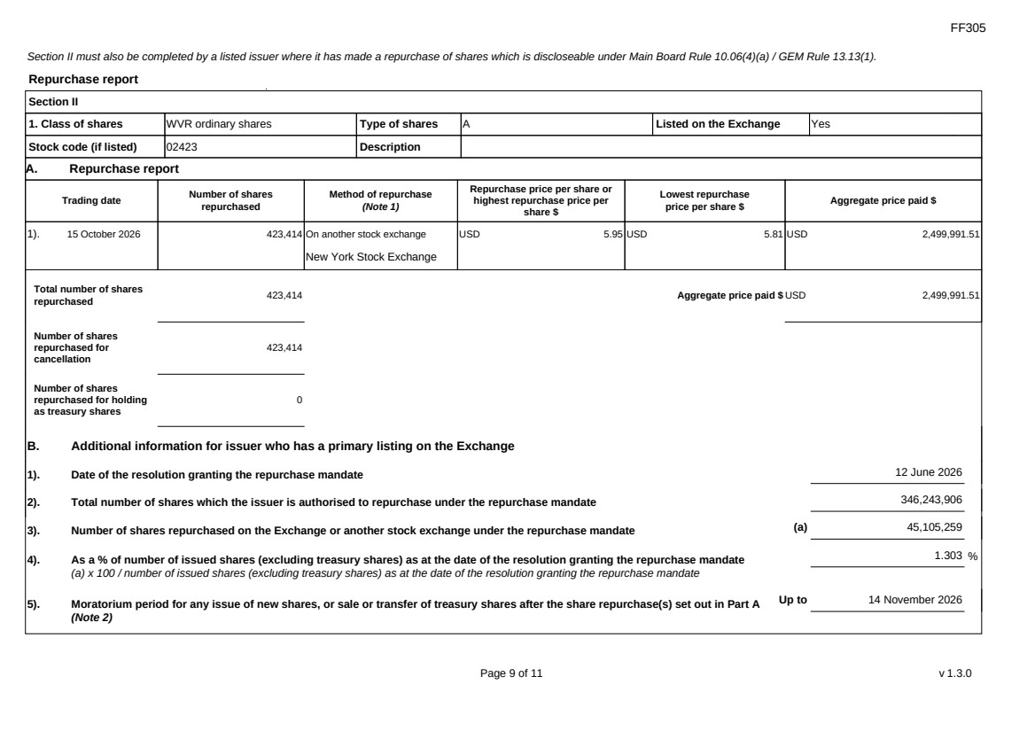 | FF305 Page 9 of 11 v 1.3.0 Section II must also be completed by a listed issuer where it has made a repurchase of shares which is discloseable under Main Board Rule 10.06(4)(a) / GEM Rule 13.13(1). Repurchase report Section II 1. Class of shares WVR ordinary shares Type of shares A Listed on the Exchange Yes Stock code (if listed) 02423 Description A. Repurchase report Trading date Number of shares repurchased Method of repurchase (Note 1) Repurchase price per share or highest repurchase price per share $ Lowest repurchase price per share $ Aggregate price paid $ 1). 15 October 2026 423,414 On another stock exchange New York Stock Exchange USD 5.95 USD 5.81 USD 2,499,991.51 Total number of shares repurchased 423,414 Aggregate price paid $ USD 2,499,991.51 Number of shares repurchased for cancellation 423,414 Number of shares repurchased for holding as treasury shares 0 B. Additional information for issuer who has a primary listing on the Exchange 1). Date of the resolution granting the repurchase mandate 12 June 2026 2). Total number of shares which the issuer is authorised to repurchase under the repurchase mandate 346,243,906 3). Number of shares repurchased on the Exchange or another stock exchange under the repurchase mandate (a) 45,105,259 4). As a % of number of issued shares (excluding treasury shares) as at the date of the resolution granting the repurchase mandate (a) x 100 / number of issued shares (excluding treasury shares) as at the date of the resolution granting the repurchase mandate 1.303 % 5). Moratorium period for any issue of new shares, or sale or transfer of treasury shares after the share repurchase(s) set out in Part A (Note 2) Up to 14 November 2026
 | 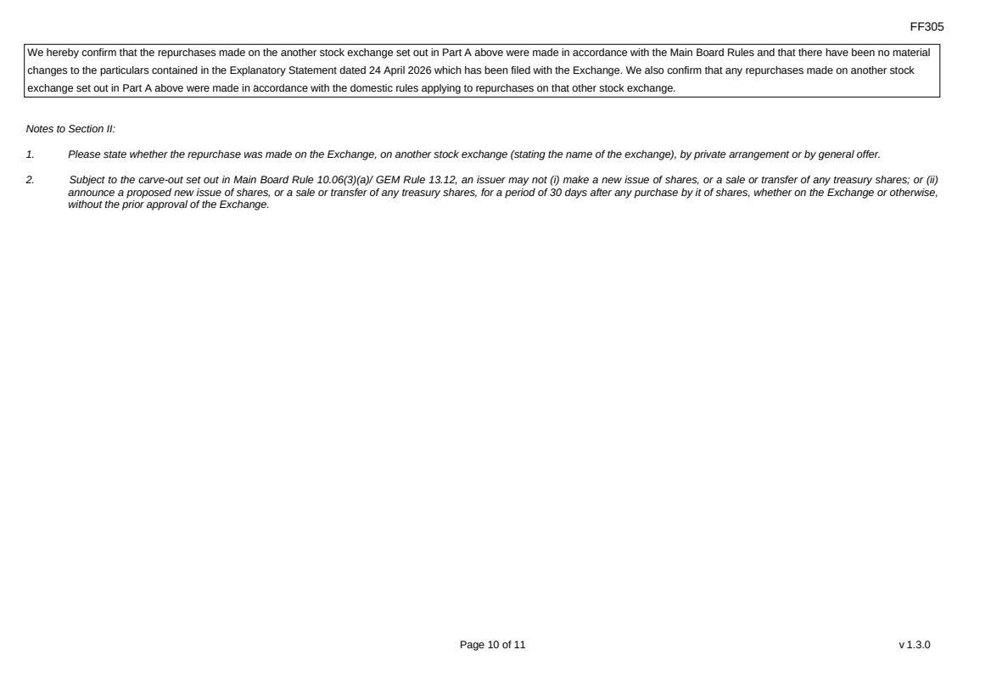 | FF305 Page 10 of 11 v 1.3.0 We hereby confirm that the repurchases made on the another stock exchange set out in Part A above were made in accordance with the Main Board Rules and that there have been no material changes to the particulars contained in the Explanatory Statement dated 24 April 2026 which has been filed with the Exchange. We also confirm that any repurchases made on another stock exchange set out in Part A above were made in accordance with the domestic rules applying to repurchases on that other stock exchange. Notes to Section II: 1. Please state whether the repurchase was made on the Exchange, on another stock exchange (stating the name of the exchange), by private arrangement or by general offer. 2. Subject to the carve-out set out in Main Board Rule 10.06(3)(a)/ GEM Rule 13.12, an issuer may not (i) make a new issue of shares, or a sale or transfer of any treasury shares; or (ii) announce a proposed new issue of shares, or a sale or transfer of any treasury shares, for a period of 30 days after any purchase by it of shares, whether on the Exchange or otherwise, without the prior approval of the Exchange.
 | 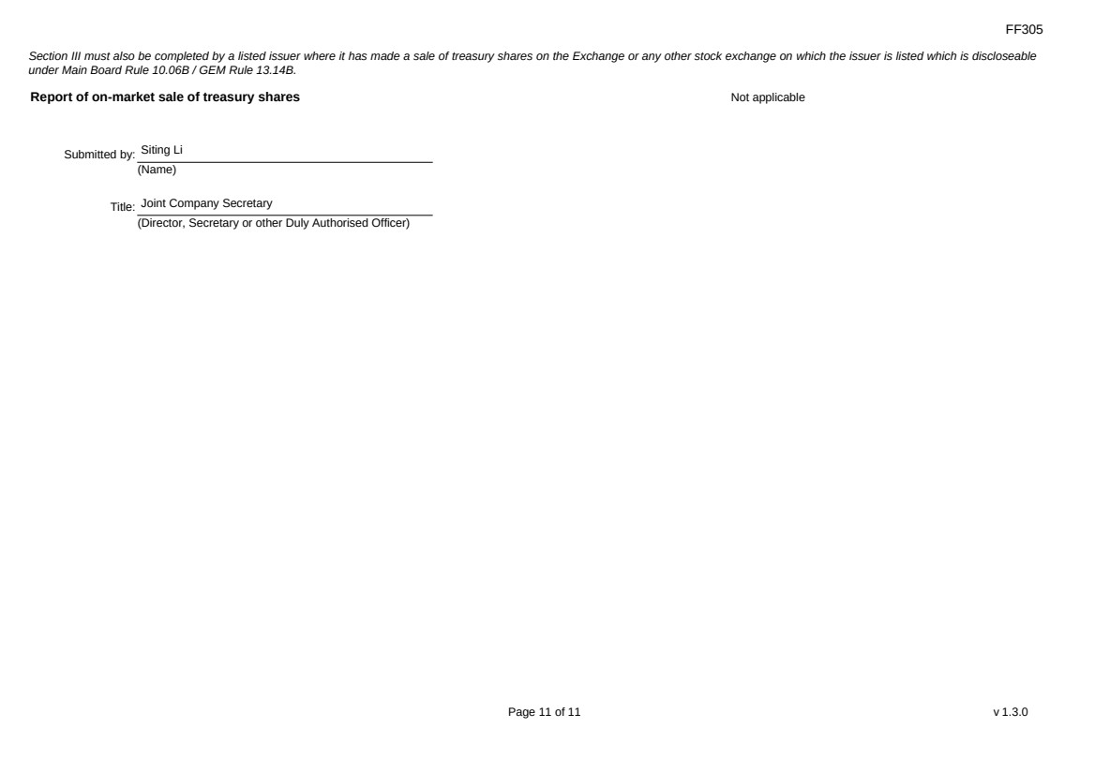 | FF305 Page 11 of 11 v 1.3.0 Section III must also be completed by a listed issuer where it has made a sale of treasury shares on the Exchange or any other stock exchange on which the issuer is listed which is discloseable under Main Board Rule 10.06B / GEM Rule 13.14B. Report of on-market sale of treasury shares Not applicable Submitted by: Siting Li (Name) Title: Joint Company Secretary (Director, Secretary or other Duly Authorised Officer)

