UNITED STATES
SECURITIES AND EXCHANGE COMMISSION
Washington, D.C. 20549

FORM 6-K

REPORT OF FOREIGN PRIVATE ISSUER
PURSUANT TO RULE 13a-16 OR 15d-16 UNDER
THE SECURITIES EXCHANGE ACT OF 1934

For the month of August 2026

Commission File Number: 001-39436

KE Holdings Inc.
(Registrant’s Name)

Oriental Electronic Technology Building,
No. 2 Chuangye Road, Haidian District,
Beijing 100086
People’s Republic of China
(Address of Principal Executive Offices)

Indicate by check mark whether the registrant files or will file annual reports under cover Form 20-F or Form 40-F.

Form 20-F ☒ Form 40-F ☐

EXHIBIT INDEX

Exhibit No. |  | Description
99.1 |  | Next Day Disclosure Return Dated July 27, 2026
99.2 |  | Next Day Disclosure Return Dated July 28, 2026
99.3 |  | Next Day Disclosure Return Dated July 29, 2026
99.4 |  | Next Day Disclosure Return Dated July 30, 2026
99.5 |  | Next Day Disclosure Return Dated July 31, 2026

SIGNATURES

Pursuant to the requirements of the Securities Exchange Act of 1934, the registrant has duly caused this report to be signed on its behalf by the undersigned, thereunto duly authorized.

KE Holdings Inc.

 | By | : | /s/ XU Tao
 | Name | : | XU Tao
 | Title | : | Chief Financial Officer

Date: August 3, 2026

Exhibit 99.1
 | 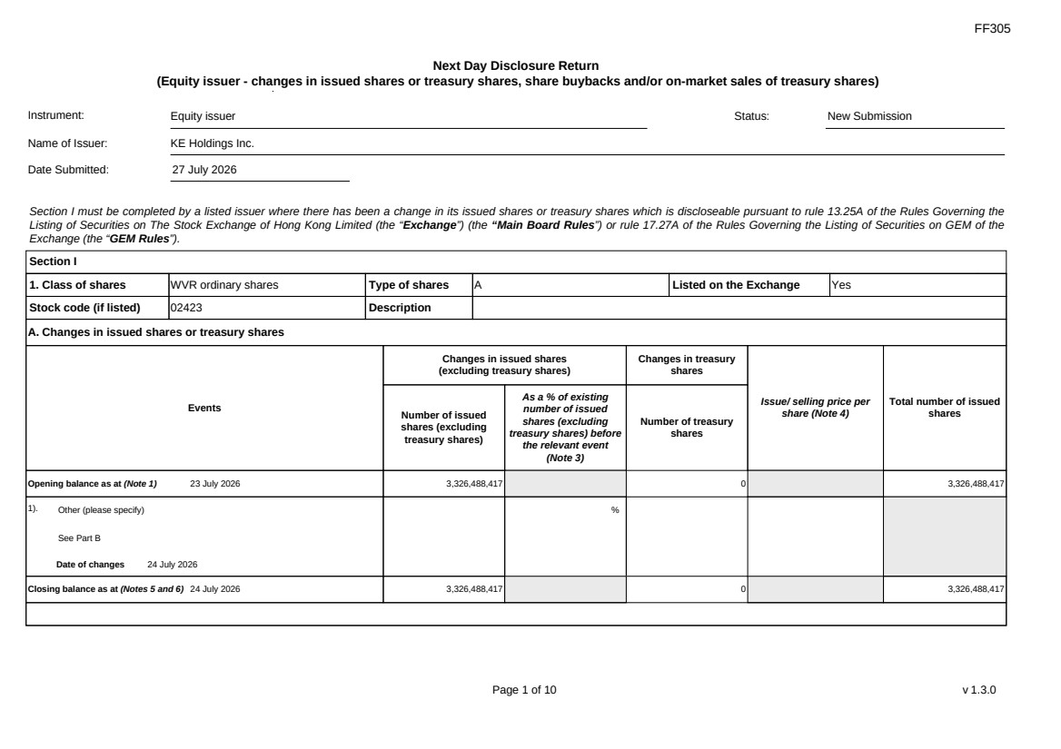 | FF305 Page 1 of 10 v 1.3.0 Next Day Disclosure Return (Equity issuer - changes in issued shares or treasury shares, share buybacks and/or on-market sales of treasury shares) Instrument: Equity issuer Status: New Submission Name of Issuer: KE Holdings Inc. Date Submitted: 27 July 2026 Section I must be completed by a listed issuer where there has been a change in its issued shares or treasury shares which is discloseable pursuant to rule 13.25A of the Rules Governing the Listing of Securities on The Stock Exchange of Hong Kong Limited (the “Exchange”) (the “Main Board Rules”) or rule 17.27A of the Rules Governing the Listing of Securities on GEM of the Exchange (the “GEM Rules”). Section I 1. Class of shares WVR ordinary shares Type of shares A Listed on the Exchange Yes Stock code (if listed) 02423 Description A. Changes in issued shares or treasury shares Events Changes in issued shares (excluding treasury shares) Number of issued shares (excluding treasury shares) As a % of existing number of issued shares (excluding treasury shares) before the relevant event (Note 3) Changes in treasury shares Number of treasury shares Issue/ selling price per share (Note 4) Total number of issued shares Opening balance as at (Note 1) 23 July 2026 3,326,488,417 0 3,326,488,417 1). Other (please specify) See Part B Date of changes 24 July 2026 % Closing balance as at (Notes 5 and 6) 24 July 2026 3,326,488,417 0 3,326,488,417
 | 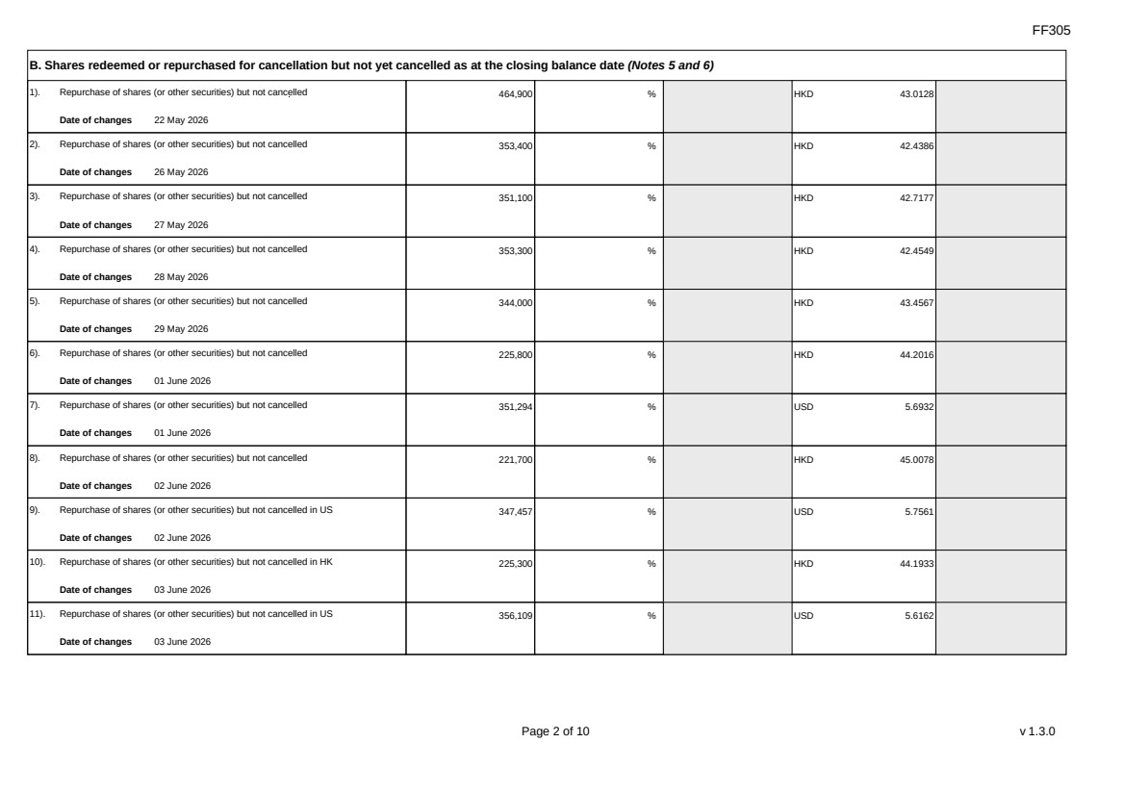 | FF305 Page 2 of 10 v 1.3.0 B. Shares redeemed or repurchased for cancellation but not yet cancelled as at the closing balance date (Notes 5 and 6) 1). Repurchase of shares (or other securities) but not cancelled Date of changes 22 May 2026 464,900 % HKD 43.0128 2). Repurchase of shares (or other securities) but not cancelled Date of changes 26 May 2026 353,400 % HKD 42.4386 3). Repurchase of shares (or other securities) but not cancelled Date of changes 27 May 2026 351,100 % HKD 42.7177 4). Repurchase of shares (or other securities) but not cancelled Date of changes 28 May 2026 353,300 % HKD 42.4549 5). Repurchase of shares (or other securities) but not cancelled Date of changes 29 May 2026 344,000 % HKD 43.4567 6). Repurchase of shares (or other securities) but not cancelled Date of changes 01 June 2026 225,800 % HKD 44.2016 7). Repurchase of shares (or other securities) but not cancelled Date of changes 01 June 2026 351,294 % USD 5.6932 8). Repurchase of shares (or other securities) but not cancelled Date of changes 02 June 2026 221,700 % HKD 45.0078 9). Repurchase of shares (or other securities) but not cancelled in US Date of changes 02 June 2026 347,457 % USD 5.7561 10). Repurchase of shares (or other securities) but not cancelled in HK Date of changes 03 June 2026 225,300 % HKD 44.1933 11). Repurchase of shares (or other securities) but not cancelled in US Date of changes 03 June 2026 356,109 % USD 5.6162
 | 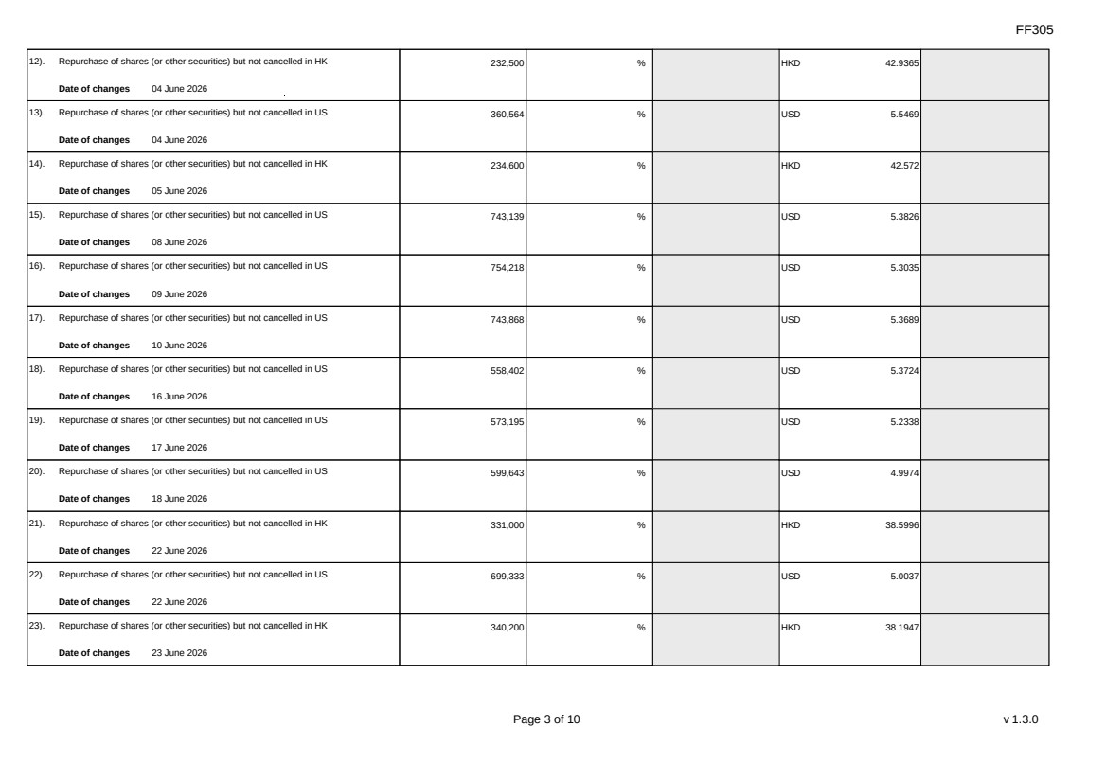 | FF305 Page 3 of 10 v 1.3.0 12). Repurchase of shares (or other securities) but not cancelled in HK Date of changes 04 June 2026 232,500 % HKD 42.9365 13). Repurchase of shares (or other securities) but not cancelled in US Date of changes 04 June 2026 360,564 % USD 5.5469 14). Repurchase of shares (or other securities) but not cancelled in HK Date of changes 05 June 2026 234,600 % HKD 42.572 15). Repurchase of shares (or other securities) but not cancelled in US Date of changes 08 June 2026 743,139 % USD 5.3826 16). Repurchase of shares (or other securities) but not cancelled in US Date of changes 09 June 2026 754,218 % USD 5.3035 17). Repurchase of shares (or other securities) but not cancelled in US Date of changes 10 June 2026 743,868 % USD 5.3689 18). Repurchase of shares (or other securities) but not cancelled in US Date of changes 16 June 2026 558,402 % USD 5.3724 19). Repurchase of shares (or other securities) but not cancelled in US Date of changes 17 June 2026 573,195 % USD 5.2338 20). Repurchase of shares (or other securities) but not cancelled in US Date of changes 18 June 2026 599,643 % USD 4.9974 21). Repurchase of shares (or other securities) but not cancelled in HK Date of changes 22 June 2026 331,000 % HKD 38.5996 22). Repurchase of shares (or other securities) but not cancelled in US Date of changes 22 June 2026 699,333 % USD 5.0037 23). Repurchase of shares (or other securities) but not cancelled in HK Date of changes 23 June 2026 340,200 % HKD 38.1947
 | 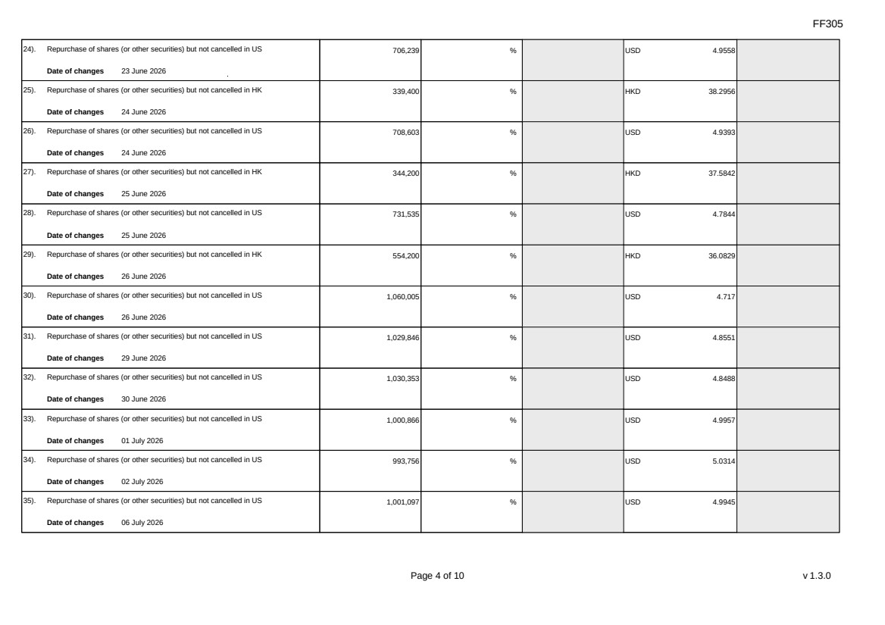 | FF305 Page 4 of 10 v 1.3.0 24). Repurchase of shares (or other securities) but not cancelled in US Date of changes 23 June 2026 706,239 % USD 4.9558 25). Repurchase of shares (or other securities) but not cancelled in HK Date of changes 24 June 2026 339,400 % HKD 38.2956 26). Repurchase of shares (or other securities) but not cancelled in US Date of changes 24 June 2026 708,603 % USD 4.9393 27). Repurchase of shares (or other securities) but not cancelled in HK Date of changes 25 June 2026 344,200 % HKD 37.5842 28). Repurchase of shares (or other securities) but not cancelled in US Date of changes 25 June 2026 731,535 % USD 4.7844 29). Repurchase of shares (or other securities) but not cancelled in HK Date of changes 26 June 2026 554,200 % HKD 36.0829 30). Repurchase of shares (or other securities) but not cancelled in US Date of changes 26 June 2026 1,060,005 % USD 4.717 31). Repurchase of shares (or other securities) but not cancelled in US Date of changes 29 June 2026 1,029,846 % USD 4.8551 32). Repurchase of shares (or other securities) but not cancelled in US Date of changes 30 June 2026 1,030,353 % USD 4.8488 33). Repurchase of shares (or other securities) but not cancelled in US Date of changes 01 July 2026 1,000,866 % USD 4.9957 34). Repurchase of shares (or other securities) but not cancelled in US Date of changes 02 July 2026 993,756 % USD 5.0314 35). Repurchase of shares (or other securities) but not cancelled in US Date of changes 06 July 2026 1,001,097 % USD 4.9945
 | 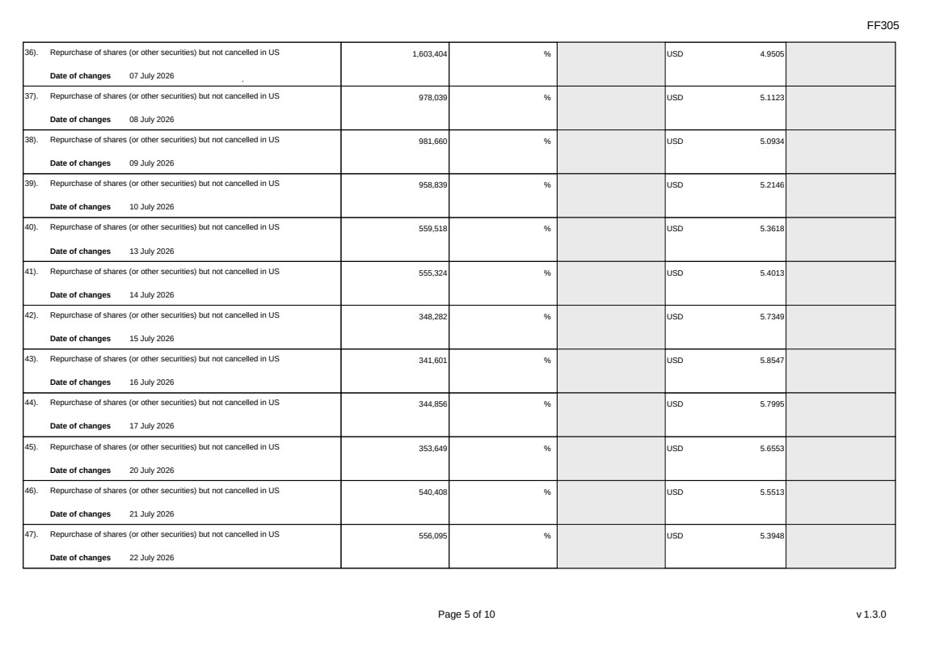 | FF305 Page 5 of 10 v 1.3.0 36). Repurchase of shares (or other securities) but not cancelled in US Date of changes 07 July 2026 1,603,404 % USD 4.9505 37). Repurchase of shares (or other securities) but not cancelled in US Date of changes 08 July 2026 978,039 % USD 5.1123 38). Repurchase of shares (or other securities) but not cancelled in US Date of changes 09 July 2026 981,660 % USD 5.0934 39). Repurchase of shares (or other securities) but not cancelled in US Date of changes 10 July 2026 958,839 % USD 5.2146 40). Repurchase of shares (or other securities) but not cancelled in US Date of changes 13 July 2026 559,518 % USD 5.3618 41). Repurchase of shares (or other securities) but not cancelled in US Date of changes 14 July 2026 555,324 % USD 5.4013 42). Repurchase of shares (or other securities) but not cancelled in US Date of changes 15 July 2026 348,282 % USD 5.7349 43). Repurchase of shares (or other securities) but not cancelled in US Date of changes 16 July 2026 341,601 % USD 5.8547 44). Repurchase of shares (or other securities) but not cancelled in US Date of changes 17 July 2026 344,856 % USD 5.7995 45). Repurchase of shares (or other securities) but not cancelled in US Date of changes 20 July 2026 353,649 % USD 5.6553 46). Repurchase of shares (or other securities) but not cancelled in US Date of changes 21 July 2026 540,408 % USD 5.5513 47). Repurchase of shares (or other securities) but not cancelled in US Date of changes 22 July 2026 556,095 % USD 5.3948
 | 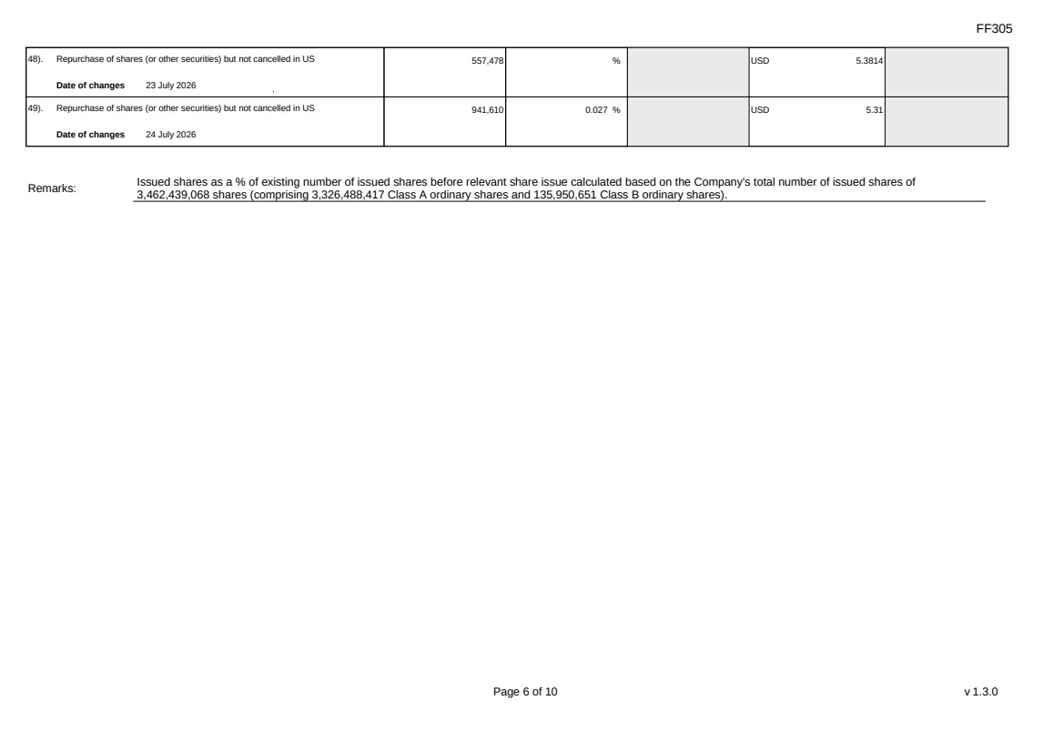 | FF305 Page 6 of 10 v 1.3.0 48). Repurchase of shares (or other securities) but not cancelled in US Date of changes 23 July 2026 557,478 % USD 5.3814 49). Repurchase of shares (or other securities) but not cancelled in US Date of changes 24 July 2026 941,610 0.027 % USD 5.31 Remarks: Issued shares as a % of existing number of issued shares before relevant share issue calculated based on the Company's total number of issued shares of 3,462,439,068 shares (comprising 3,326,488,417 Class A ordinary shares and 135,950,651 Class B ordinary shares).
 | 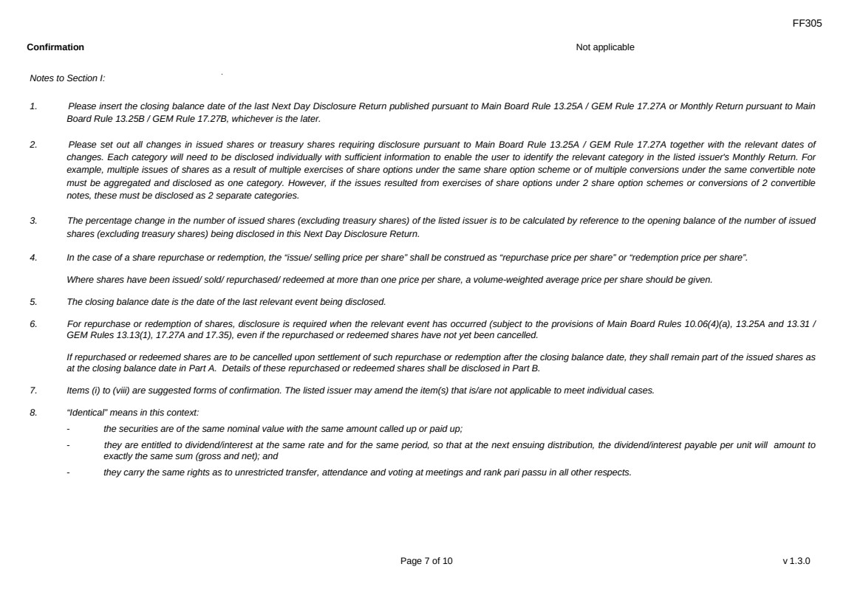 | FF305 Page 7 of 10 v 1.3.0 Confirmation Not applicable Notes to Section I: 1. Please insert the closing balance date of the last Next Day Disclosure Return published pursuant to Main Board Rule 13.25A / GEM Rule 17.27A or Monthly Return pursuant to Main Board Rule 13.25B / GEM Rule 17.27B, whichever is the later. 2. Please set out all changes in issued shares or treasury shares requiring disclosure pursuant to Main Board Rule 13.25A / GEM Rule 17.27A together with the relevant dates of changes. Each category will need to be disclosed individually with sufficient information to enable the user to identify the relevant category in the listed issuer's Monthly Return. For example, multiple issues of shares as a result of multiple exercises of share options under the same share option scheme or of multiple conversions under the same convertible note must be aggregated and disclosed as one category. However, if the issues resulted from exercises of share options under 2 share option schemes or conversions of 2 convertible notes, these must be disclosed as 2 separate categories. 3. The percentage change in the number of issued shares (excluding treasury shares) of the listed issuer is to be calculated by reference to the opening balance of the number of issued shares (excluding treasury shares) being disclosed in this Next Day Disclosure Return. 4. In the case of a share repurchase or redemption, the “issue/ selling price per share” shall be construed as “repurchase price per share” or “redemption price per share”. Where shares have been issued/ sold/ repurchased/ redeemed at more than one price per share, a volume-weighted average price per share should be given. 5. The closing balance date is the date of the last relevant event being disclosed. 6. For repurchase or redemption of shares, disclosure is required when the relevant event has occurred (subject to the provisions of Main Board Rules 10.06(4)(a), 13.25A and 13.31 / GEM Rules 13.13(1), 17.27A and 17.35), even if the repurchased or redeemed shares have not yet been cancelled. If repurchased or redeemed shares are to be cancelled upon settlement of such repurchase or redemption after the closing balance date, they shall remain part of the issued shares as at the closing balance date in Part A. Details of these repurchased or redeemed shares shall be disclosed in Part B. 7. Items (i) to (viii) are suggested forms of confirmation. The listed issuer may amend the item(s) that is/are not applicable to meet individual cases. 8. “Identical” means in this context: - the securities are of the same nominal value with the same amount called up or paid up; - they are entitled to dividend/interest at the same rate and for the same period, so that at the next ensuing distribution, the dividend/interest payable per unit will amount to exactly the same sum (gross and net); and - they carry the same rights as to unrestricted transfer, attendance and voting at meetings and rank pari passu in all other respects.
 | 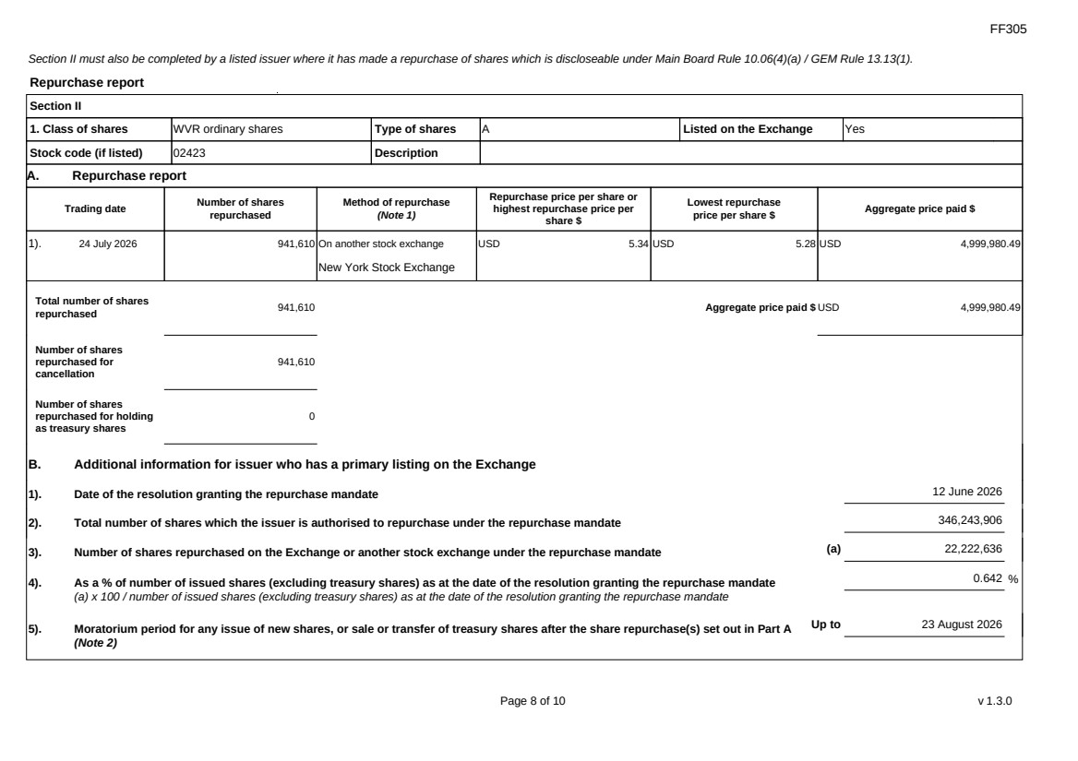 | FF305 Page 8 of 10 v 1.3.0 Section II must also be completed by a listed issuer where it has made a repurchase of shares which is discloseable under Main Board Rule 10.06(4)(a) / GEM Rule 13.13(1). Repurchase report Section II 1. Class of shares WVR ordinary shares Type of shares A Listed on the Exchange Yes Stock code (if listed) 02423 Description A. Repurchase report Trading date Number of shares repurchased Method of repurchase (Note 1) Repurchase price per share or highest repurchase price per share $ Lowest repurchase price per share $ Aggregate price paid $ 1). 24 July 2026 941,610 On another stock exchange New York Stock Exchange USD 5.34 USD 5.28 USD 4,999,980.49 Total number of shares repurchased 941,610 Aggregate price paid $ USD 4,999,980.49 Number of shares repurchased for cancellation 941,610 Number of shares repurchased for holding as treasury shares 0 B. Additional information for issuer who has a primary listing on the Exchange 1). Date of the resolution granting the repurchase mandate 12 June 2026 2). Total number of shares which the issuer is authorised to repurchase under the repurchase mandate 346,243,906 3). Number of shares repurchased on the Exchange or another stock exchange under the repurchase mandate (a) 22,222,636 4). As a % of number of issued shares (excluding treasury shares) as at the date of the resolution granting the repurchase mandate (a) x 100 / number of issued shares (excluding treasury shares) as at the date of the resolution granting the repurchase mandate 0.642 % 5). Moratorium period for any issue of new shares, or sale or transfer of treasury shares after the share repurchase(s) set out in Part A (Note 2) Up to 23 August 2026
 | 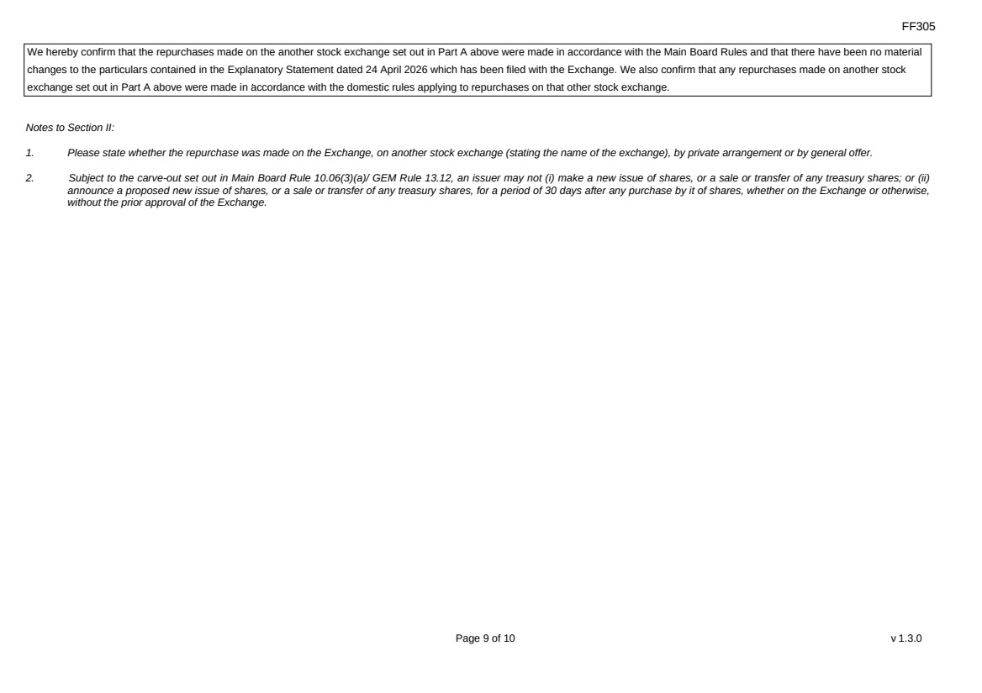 | FF305 Page 9 of 10 v 1.3.0 We hereby confirm that the repurchases made on the another stock exchange set out in Part A above were made in accordance with the Main Board Rules and that there have been no material changes to the particulars contained in the Explanatory Statement dated 24 April 2026 which has been filed with the Exchange. We also confirm that any repurchases made on another stock exchange set out in Part A above were made in accordance with the domestic rules applying to repurchases on that other stock exchange. Notes to Section II: 1. Please state whether the repurchase was made on the Exchange, on another stock exchange (stating the name of the exchange), by private arrangement or by general offer. 2. Subject to the carve-out set out in Main Board Rule 10.06(3)(a)/ GEM Rule 13.12, an issuer may not (i) make a new issue of shares, or a sale or transfer of any treasury shares; or (ii) announce a proposed new issue of shares, or a sale or transfer of any treasury shares, for a period of 30 days after any purchase by it of shares, whether on the Exchange or otherwise, without the prior approval of the Exchange.
 | 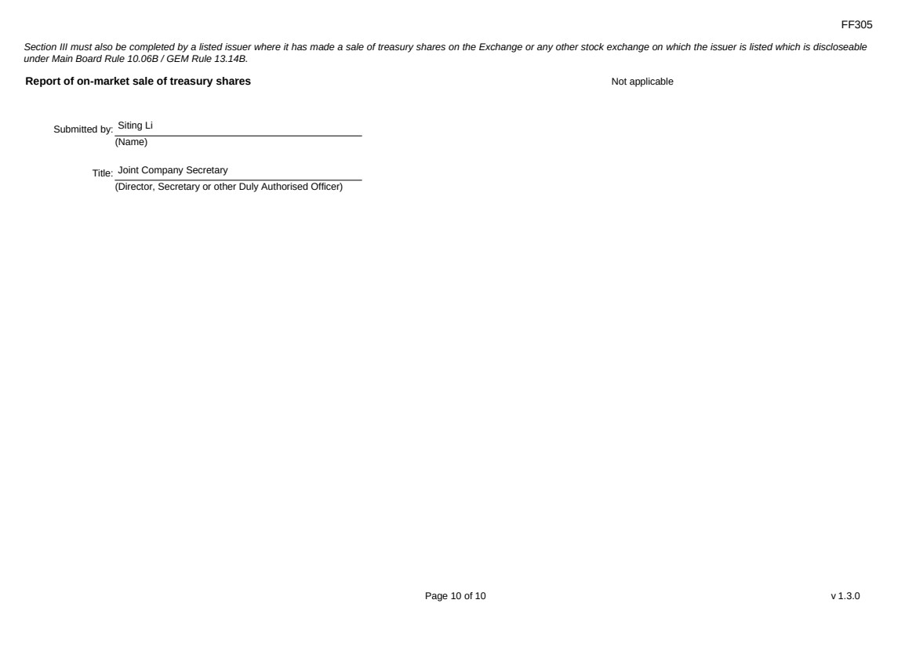 | FF305 Page 10 of 10 v 1.3.0 Section III must also be completed by a listed issuer where it has made a sale of treasury shares on the Exchange or any other stock exchange on which the issuer is listed which is discloseable under Main Board Rule 10.06B / GEM Rule 13.14B. Report of on-market sale of treasury shares Not applicable Submitted by: Siting Li (Name) Title: Joint Company Secretary (Director, Secretary or other Duly Authorised Officer)
Exhibit 99.2
 | 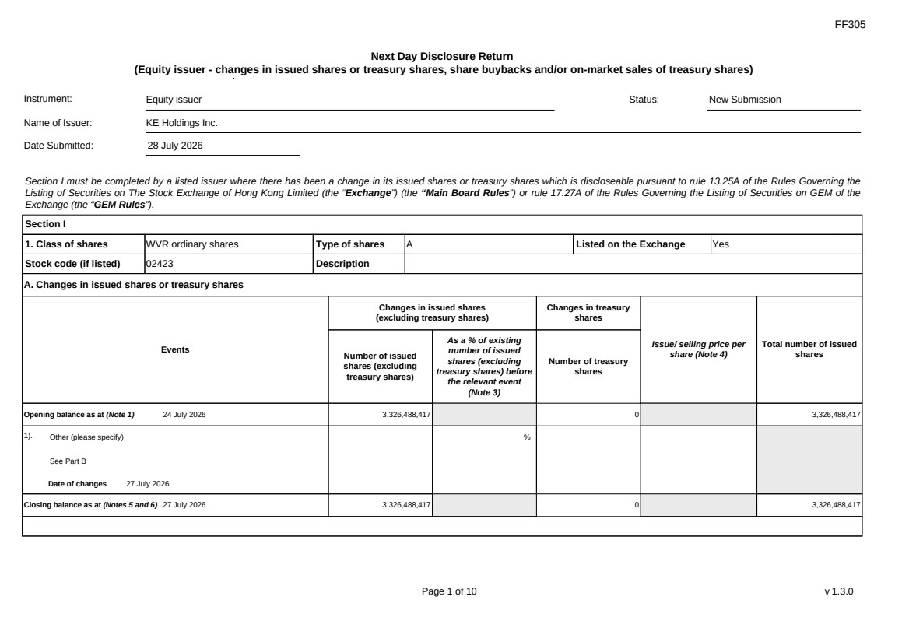 | FF305 Page 1 of 10 v 1.3.0 Next Day Disclosure Return (Equity issuer - changes in issued shares or treasury shares, share buybacks and/or on-market sales of treasury shares) Instrument: Equity issuer Status: New Submission Name of Issuer: KE Holdings Inc. Date Submitted: 28 July 2026 Section I must be completed by a listed issuer where there has been a change in its issued shares or treasury shares which is discloseable pursuant to rule 13.25A of the Rules Governing the Listing of Securities on The Stock Exchange of Hong Kong Limited (the “Exchange”) (the “Main Board Rules”) or rule 17.27A of the Rules Governing the Listing of Securities on GEM of the Exchange (the “GEM Rules”). Section I 1. Class of shares WVR ordinary shares Type of shares A Listed on the Exchange Yes Stock code (if listed) 02423 Description A. Changes in issued shares or treasury shares Events Changes in issued shares (excluding treasury shares) Number of issued shares (excluding treasury shares) As a % of existing number of issued shares (excluding treasury shares) before the relevant event (Note 3) Changes in treasury shares Number of treasury shares Issue/ selling price per share (Note 4) Total number of issued shares Opening balance as at (Note 1) 24 July 2026 3,326,488,417 0 3,326,488,417 1). Other (please specify) See Part B Date of changes 27 July 2026 % Closing balance as at (Notes 5 and 6) 27 July 2026 3,326,488,417 0 3,326,488,417
FF305 Page 2 of 10 v 1.3.0 B. Shares redeemed or repurchased for cancellation but not yet cancelled as at the closing balance date (Notes 5 and 6) 1). Repurchase of shares (or other securities) but not cancelled Date of changes 22 May 2026 464,900 % HKD 43.0128 2). Repurchase of shares (or other securities) but not cancelled Date of changes 26 May 2026 353,400 % HKD 42.4386 3). Repurchase of shares (or other securities) but not cancelled Date of changes 27 May 2026 351,100 % HKD 42.7177 4). Repurchase of shares (or other securities) but not cancelled Date of changes 28 May 2026 353,300 % HKD 42.4549 5). Repurchase of shares (or other securities) but not cancelled Date of changes 29 May 2026 344,000 % HKD 43.4567 6). Repurchase of shares (or other securities) but not cancelled Date of changes 01 June 2026 225,800 % HKD 44.2016 7). Repurchase of shares (or other securities) but not cancelled Date of changes 01 June 2026 351,294 % USD 5.6932 8). Repurchase of shares (or other securities) but not cancelled Date of changes 02 June 2026 221,700 % HKD 45.0078 9). Repurchase of shares (or other securities) but not cancelled in US Date of changes 02 June 2026 347,457 % USD 5.7561 10). Repurchase of shares (or other securities) but not cancelled in HK Date of changes 03 June 2026 225,300 % HKD 44.1933 11). Repurchase of shares (or other securities) but not cancelled in US Date of changes 03 June 2026 356,109 % USD 5.6162
FF305 Page 3 of 10 v 1.3.0 12). Repurchase of shares (or other securities) but not cancelled in HK Date of changes 04 June 2026 232,500 % HKD 42.9365 13). Repurchase of shares (or other securities) but not cancelled in US Date of changes 04 June 2026 360,564 % USD 5.5469 14). Repurchase of shares (or other securities) but not cancelled in HK Date of changes 05 June 2026 234,600 % HKD 42.572 15). Repurchase of shares (or other securities) but not cancelled in US Date of changes 08 June 2026 743,139 % USD 5.3826 16). Repurchase of shares (or other securities) but not cancelled in US Date of changes 09 June 2026 754,218 % USD 5.3035 17). Repurchase of shares (or other securities) but not cancelled in US Date of changes 10 June 2026 743,868 % USD 5.3689 18). Repurchase of shares (or other securities) but not cancelled in US Date of changes 16 June 2026 558,402 % USD 5.3724 19). Repurchase of shares (or other securities) but not cancelled in US Date of changes 17 June 2026 573,195 % USD 5.2338 20). Repurchase of shares (or other securities) but not cancelled in US Date of changes 18 June 2026 599,643 % USD 4.9974 21). Repurchase of shares (or other securities) but not cancelled in HK Date of changes 22 June 2026 331,000 % HKD 38.5996 22). Repurchase of shares (or other securities) but not cancelled in US Date of changes 22 June 2026 699,333 % USD 5.0037 23). Repurchase of shares (or other securities) but not cancelled in HK Date of changes 23 June 2026 340,200 % HKD 38.1947
FF305 Page 4 of 10 v 1.3.0 24). Repurchase of shares (or other securities) but not cancelled in US Date of changes 23 June 2026 706,239 % USD 4.9558 25). Repurchase of shares (or other securities) but not cancelled in HK Date of changes 24 June 2026 339,400 % HKD 38.2956 26). Repurchase of shares (or other securities) but not cancelled in US Date of changes 24 June 2026 708,603 % USD 4.9393 27). Repurchase of shares (or other securities) but not cancelled in HK Date of changes 25 June 2026 344,200 % HKD 37.5842 28). Repurchase of shares (or other securities) but not cancelled in US Date of changes 25 June 2026 731,535 % USD 4.7844 29). Repurchase of shares (or other securities) but not cancelled in HK Date of changes 26 June 2026 554,200 % HKD 36.0829 30). Repurchase of shares (or other securities) but not cancelled in US Date of changes 26 June 2026 1,060,005 % USD 4.717 31). Repurchase of shares (or other securities) but not cancelled in US Date of changes 29 June 2026 1,029,846 % USD 4.8551 32). Repurchase of shares (or other securities) but not cancelled in US Date of changes 30 June 2026 1,030,353 % USD 4.8488 33). Repurchase of shares (or other securities) but not cancelled in US Date of changes 01 July 2026 1,000,866 % USD 4.9957 34). Repurchase of shares (or other securities) but not cancelled in US Date of changes 02 July 2026 993,756 % USD 5.0314 35). Repurchase of shares (or other securities) but not cancelled in US Date of changes 06 July 2026 1,001,097 % USD 4.9945
FF305 Page 5 of 10 v 1.3.0 36). Repurchase of shares (or other securities) but not cancelled in US Date of changes 07 July 2026 1,603,404 % USD 4.9505 37). Repurchase of shares (or other securities) but not cancelled in US Date of changes 08 July 2026 978,039 % USD 5.1123 38). Repurchase of shares (or other securities) but not cancelled in US Date of changes 09 July 2026 981,660 % USD 5.0934 39). Repurchase of shares (or other securities) but not cancelled in US Date of changes 10 July 2026 958,839 % USD 5.2146 40). Repurchase of shares (or other securities) but not cancelled in US Date of changes 13 July 2026 559,518 % USD 5.3618 41). Repurchase of shares (or other securities) but not cancelled in US Date of changes 14 July 2026 555,324 % USD 5.4013 42). Repurchase of shares (or other securities) but not cancelled in US Date of changes 15 July 2026 348,282 % USD 5.7349 43). Repurchase of shares (or other securities) but not cancelled in US Date of changes 16 July 2026 341,601 % USD 5.8547 44). Repurchase of shares (or other securities) but not cancelled in US Date of changes 17 July 2026 344,856 % USD 5.7995 45). Repurchase of shares (or other securities) but not cancelled in US Date of changes 20 July 2026 353,649 % USD 5.6553 46). Repurchase of shares (or other securities) but not cancelled in US Date of changes 21 July 2026 540,408 % USD 5.5513 47). Repurchase of shares (or other securities) but not cancelled in US Date of changes 22 July 2026 556,095 % USD 5.3948
 | 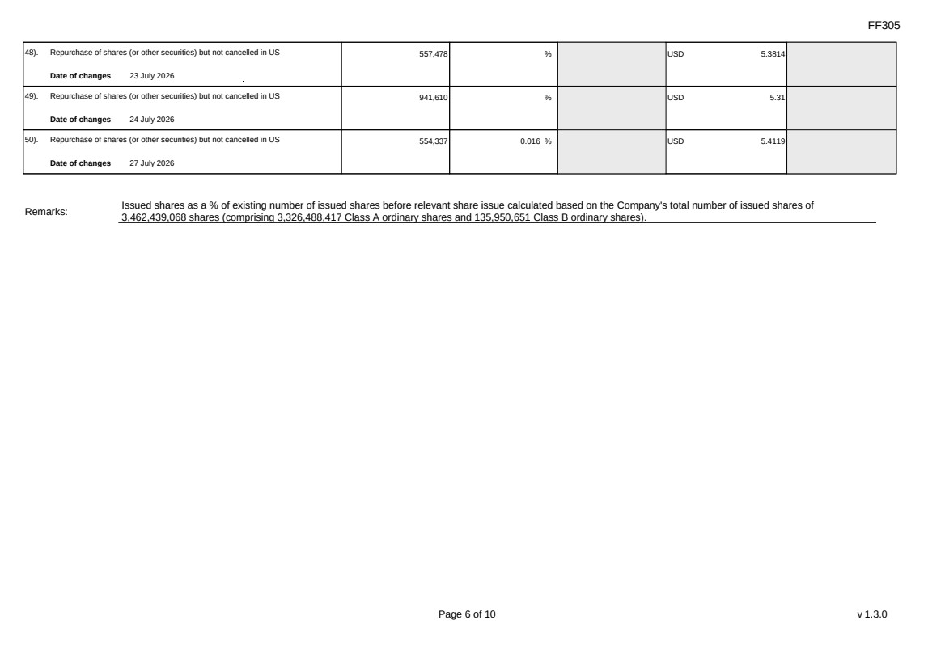 | FF305 Page 6 of 10 v 1.3.0 48). Repurchase of shares (or other securities) but not cancelled in US Date of changes 23 July 2026 557,478 % USD 5.3814 49). Repurchase of shares (or other securities) but not cancelled in US Date of changes 24 July 2026 941,610 % USD 5.31 50). Repurchase of shares (or other securities) but not cancelled in US Date of changes 27 July 2026 554,337 0.016 % USD 5.4119 Remarks: Issued shares as a % of existing number of issued shares before relevant share issue calculated based on the Company's total number of issued shares of 3,462,439,068 shares (comprising 3,326,488,417 Class A ordinary shares and 135,950,651 Class B ordinary shares).
FF305 Page 7 of 10 v 1.3.0 Confirmation Not applicable Notes to Section I: 1. Please insert the closing balance date of the last Next Day Disclosure Return published pursuant to Main Board Rule 13.25A / GEM Rule 17.27A or Monthly Return pursuant to Main Board Rule 13.25B / GEM Rule 17.27B, whichever is the later. 2. Please set out all changes in issued shares or treasury shares requiring disclosure pursuant to Main Board Rule 13.25A / GEM Rule 17.27A together with the relevant dates of changes. Each category will need to be disclosed individually with sufficient information to enable the user to identify the relevant category in the listed issuer's Monthly Return. For example, multiple issues of shares as a result of multiple exercises of share options under the same share option scheme or of multiple conversions under the same convertible note must be aggregated and disclosed as one category. However, if the issues resulted from exercises of share options under 2 share option schemes or conversions of 2 convertible notes, these must be disclosed as 2 separate categories. 3. The percentage change in the number of issued shares (excluding treasury shares) of the listed issuer is to be calculated by reference to the opening balance of the number of issued shares (excluding treasury shares) being disclosed in this Next Day Disclosure Return. 4. In the case of a share repurchase or redemption, the “issue/ selling price per share” shall be construed as “repurchase price per share” or “redemption price per share”. Where shares have been issued/ sold/ repurchased/ redeemed at more than one price per share, a volume-weighted average price per share should be given. 5. The closing balance date is the date of the last relevant event being disclosed. 6. For repurchase or redemption of shares, disclosure is required when the relevant event has occurred (subject to the provisions of Main Board Rules 10.06(4)(a), 13.25A and 13.31 / GEM Rules 13.13(1), 17.27A and 17.35), even if the repurchased or redeemed shares have not yet been cancelled. If repurchased or redeemed shares are to be cancelled upon settlement of such repurchase or redemption after the closing balance date, they shall remain part of the issued shares as at the closing balance date in Part A. Details of these repurchased or redeemed shares shall be disclosed in Part B. 7. Items (i) to (viii) are suggested forms of confirmation. The listed issuer may amend the item(s) that is/are not applicable to meet individual cases. 8. “Identical” means in this context: - the securities are of the same nominal value with the same amount called up or paid up; - they are entitled to dividend/interest at the same rate and for the same period, so that at the next ensuing distribution, the dividend/interest payable per unit will amount to exactly the same sum (gross and net); and - they carry the same rights as to unrestricted transfer, attendance and voting at meetings and rank pari passu in all other respects.
 | 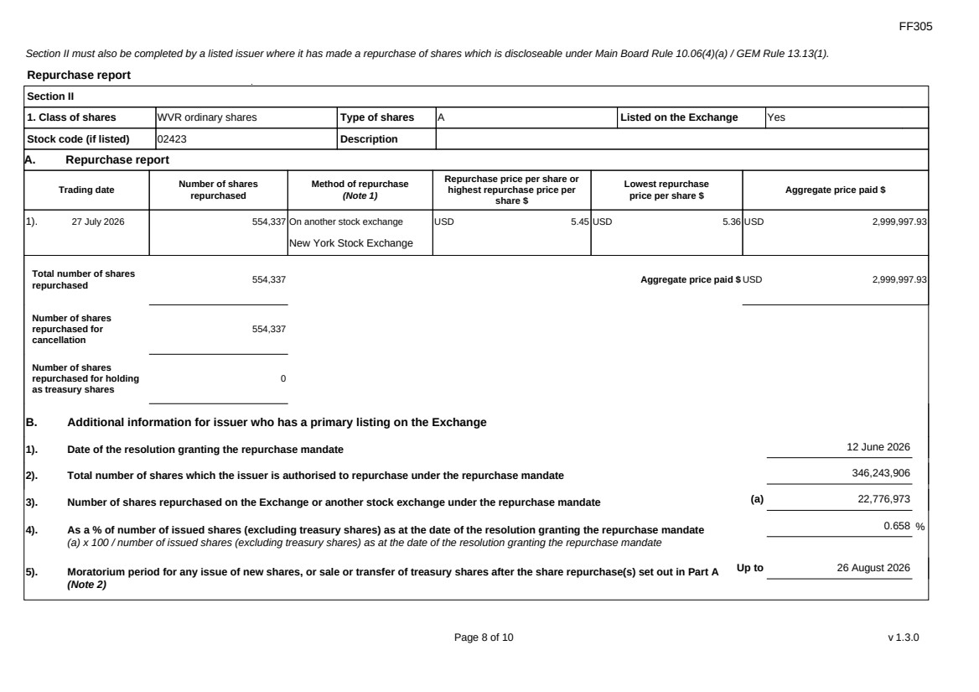 | FF305 Page 8 of 10 v 1.3.0 Section II must also be completed by a listed issuer where it has made a repurchase of shares which is discloseable under Main Board Rule 10.06(4)(a) / GEM Rule 13.13(1). Repurchase report Section II 1. Class of shares WVR ordinary shares Type of shares A Listed on the Exchange Yes Stock code (if listed) 02423 Description A. Repurchase report Trading date Number of shares repurchased Method of repurchase (Note 1) Repurchase price per share or highest repurchase price per share $ Lowest repurchase price per share $ Aggregate price paid $ 1). 27 July 2026 554,337 On another stock exchange New York Stock Exchange USD 5.45 USD 5.36 USD 2,999,997.93 Total number of shares repurchased 554,337 Aggregate price paid $ USD 2,999,997.93 Number of shares repurchased for cancellation 554,337 Number of shares repurchased for holding as treasury shares 0 B. Additional information for issuer who has a primary listing on the Exchange 1). Date of the resolution granting the repurchase mandate 12 June 2026 2). Total number of shares which the issuer is authorised to repurchase under the repurchase mandate 346,243,906 3). Number of shares repurchased on the Exchange or another stock exchange under the repurchase mandate (a) 22,776,973 4). As a % of number of issued shares (excluding treasury shares) as at the date of the resolution granting the repurchase mandate (a) x 100 / number of issued shares (excluding treasury shares) as at the date of the resolution granting the repurchase mandate 0.658 % 5). Moratorium period for any issue of new shares, or sale or transfer of treasury shares after the share repurchase(s) set out in Part A (Note 2) Up to 26 August 2026
FF305 Page 9 of 10 v 1.3.0 We hereby confirm that the repurchases made on the another stock exchange set out in Part A above were made in accordance with the Main Board Rules and that there have been no material changes to the particulars contained in the Explanatory Statement dated 24 April 2026 which has been filed with the Exchange. We also confirm that any repurchases made on another stock exchange set out in Part A above were made in accordance with the domestic rules applying to repurchases on that other stock exchange. Notes to Section II: 1. Please state whether the repurchase was made on the Exchange, on another stock exchange (stating the name of the exchange), by private arrangement or by general offer. 2. Subject to the carve-out set out in Main Board Rule 10.06(3)(a)/ GEM Rule 13.12, an issuer may not (i) make a new issue of shares, or a sale or transfer of any treasury shares; or (ii) announce a proposed new issue of shares, or a sale or transfer of any treasury shares, for a period of 30 days after any purchase by it of shares, whether on the Exchange or otherwise, without the prior approval of the Exchange.
FF305 Page 10 of 10 v 1.3.0 Section III must also be completed by a listed issuer where it has made a sale of treasury shares on the Exchange or any other stock exchange on which the issuer is listed which is discloseable under Main Board Rule 10.06B / GEM Rule 13.14B. Report of on-market sale of treasury shares Not applicable Submitted by: Siting Li (Name) Title: Joint Company Secretary (Director, Secretary or other Duly Authorised Officer)
Exhibit 99.3
 | 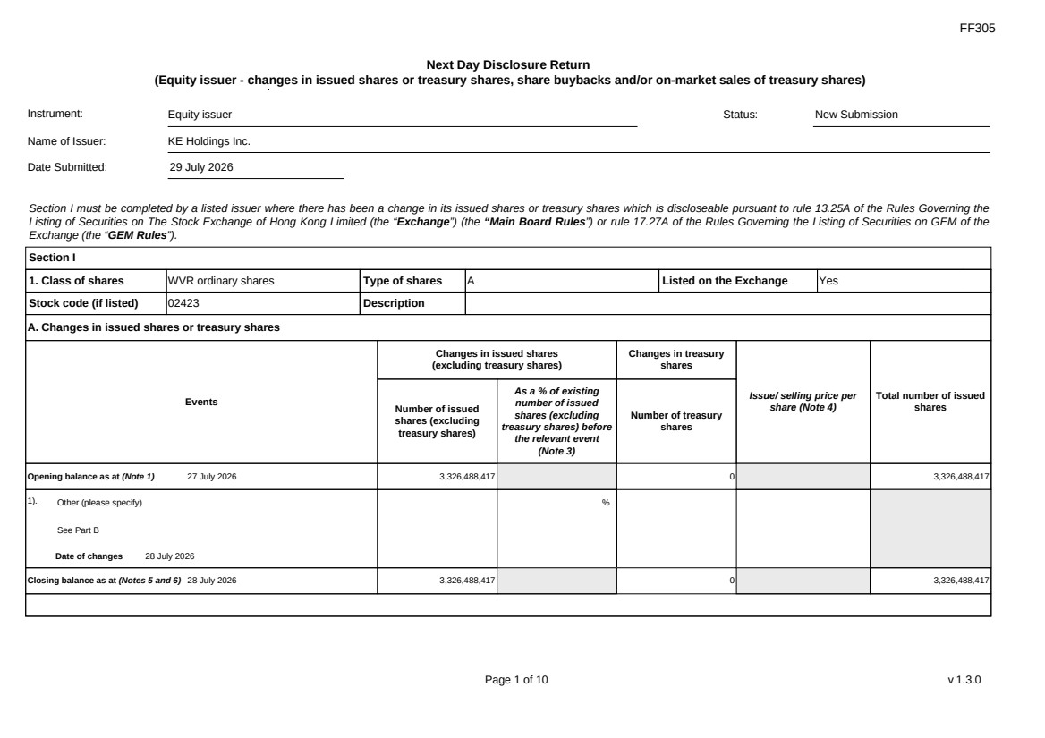 | FF305 Page 1 of 10 v 1.3.0 Next Day Disclosure Return (Equity issuer - changes in issued shares or treasury shares, share buybacks and/or on-market sales of treasury shares) Instrument: Equity issuer Status: New Submission Name of Issuer: KE Holdings Inc. Date Submitted: 29 July 2026 Section I must be completed by a listed issuer where there has been a change in its issued shares or treasury shares which is discloseable pursuant to rule 13.25A of the Rules Governing the Listing of Securities on The Stock Exchange of Hong Kong Limited (the “Exchange”) (the “Main Board Rules”) or rule 17.27A of the Rules Governing the Listing of Securities on GEM of the Exchange (the “GEM Rules”). Section I 1. Class of shares WVR ordinary shares Type of shares A Listed on the Exchange Yes Stock code (if listed) 02423 Description A. Changes in issued shares or treasury shares Events Changes in issued shares (excluding treasury shares) Number of issued shares (excluding treasury shares) As a % of existing number of issued shares (excluding treasury shares) before the relevant event (Note 3) Changes in treasury shares Number of treasury shares Issue/ selling price per share (Note 4) Total number of issued shares Opening balance as at (Note 1) 27 July 2026 3,326,488,417 0 3,326,488,417 1). Other (please specify) See Part B Date of changes 28 July 2026 % Closing balance as at (Notes 5 and 6) 28 July 2026 3,326,488,417 0 3,326,488,417
FF305 Page 2 of 10 v 1.3.0 B. Shares redeemed or repurchased for cancellation but not yet cancelled as at the closing balance date (Notes 5 and 6) 1). Repurchase of shares (or other securities) but not cancelled Date of changes 22 May 2026 464,900 % HKD 43.0128 2). Repurchase of shares (or other securities) but not cancelled Date of changes 26 May 2026 353,400 % HKD 42.4386 3). Repurchase of shares (or other securities) but not cancelled Date of changes 27 May 2026 351,100 % HKD 42.7177 4). Repurchase of shares (or other securities) but not cancelled Date of changes 28 May 2026 353,300 % HKD 42.4549 5). Repurchase of shares (or other securities) but not cancelled Date of changes 29 May 2026 344,000 % HKD 43.4567 6). Repurchase of shares (or other securities) but not cancelled Date of changes 01 June 2026 225,800 % HKD 44.2016 7). Repurchase of shares (or other securities) but not cancelled Date of changes 01 June 2026 351,294 % USD 5.6932 8). Repurchase of shares (or other securities) but not cancelled Date of changes 02 June 2026 221,700 % HKD 45.0078 9). Repurchase of shares (or other securities) but not cancelled in US Date of changes 02 June 2026 347,457 % USD 5.7561 10). Repurchase of shares (or other securities) but not cancelled in HK Date of changes 03 June 2026 225,300 % HKD 44.1933 11). Repurchase of shares (or other securities) but not cancelled in US Date of changes 03 June 2026 356,109 % USD 5.6162
FF305 Page 3 of 10 v 1.3.0 12). Repurchase of shares (or other securities) but not cancelled in HK Date of changes 04 June 2026 232,500 % HKD 42.9365 13). Repurchase of shares (or other securities) but not cancelled in US Date of changes 04 June 2026 360,564 % USD 5.5469 14). Repurchase of shares (or other securities) but not cancelled in HK Date of changes 05 June 2026 234,600 % HKD 42.572 15). Repurchase of shares (or other securities) but not cancelled in US Date of changes 08 June 2026 743,139 % USD 5.3826 16). Repurchase of shares (or other securities) but not cancelled in US Date of changes 09 June 2026 754,218 % USD 5.3035 17). Repurchase of shares (or other securities) but not cancelled in US Date of changes 10 June 2026 743,868 % USD 5.3689 18). Repurchase of shares (or other securities) but not cancelled in US Date of changes 16 June 2026 558,402 % USD 5.3724 19). Repurchase of shares (or other securities) but not cancelled in US Date of changes 17 June 2026 573,195 % USD 5.2338 20). Repurchase of shares (or other securities) but not cancelled in US Date of changes 18 June 2026 599,643 % USD 4.9974 21). Repurchase of shares (or other securities) but not cancelled in HK Date of changes 22 June 2026 331,000 % HKD 38.5996 22). Repurchase of shares (or other securities) but not cancelled in US Date of changes 22 June 2026 699,333 % USD 5.0037 23). Repurchase of shares (or other securities) but not cancelled in HK Date of changes 23 June 2026 340,200 % HKD 38.1947
FF305 Page 4 of 10 v 1.3.0 24). Repurchase of shares (or other securities) but not cancelled in US Date of changes 23 June 2026 706,239 % USD 4.9558 25). Repurchase of shares (or other securities) but not cancelled in HK Date of changes 24 June 2026 339,400 % HKD 38.2956 26). Repurchase of shares (or other securities) but not cancelled in US Date of changes 24 June 2026 708,603 % USD 4.9393 27). Repurchase of shares (or other securities) but not cancelled in HK Date of changes 25 June 2026 344,200 % HKD 37.5842 28). Repurchase of shares (or other securities) but not cancelled in US Date of changes 25 June 2026 731,535 % USD 4.7844 29). Repurchase of shares (or other securities) but not cancelled in HK Date of changes 26 June 2026 554,200 % HKD 36.0829 30). Repurchase of shares (or other securities) but not cancelled in US Date of changes 26 June 2026 1,060,005 % USD 4.717 31). Repurchase of shares (or other securities) but not cancelled in US Date of changes 29 June 2026 1,029,846 % USD 4.8551 32). Repurchase of shares (or other securities) but not cancelled in US Date of changes 30 June 2026 1,030,353 % USD 4.8488 33). Repurchase of shares (or other securities) but not cancelled in US Date of changes 01 July 2026 1,000,866 % USD 4.9957 34). Repurchase of shares (or other securities) but not cancelled in US Date of changes 02 July 2026 993,756 % USD 5.0314 35). Repurchase of shares (or other securities) but not cancelled in US Date of changes 06 July 2026 1,001,097 % USD 4.9945
FF305 Page 5 of 10 v 1.3.0 36). Repurchase of shares (or other securities) but not cancelled in US Date of changes 07 July 2026 1,603,404 % USD 4.9505 37). Repurchase of shares (or other securities) but not cancelled in US Date of changes 08 July 2026 978,039 % USD 5.1123 38). Repurchase of shares (or other securities) but not cancelled in US Date of changes 09 July 2026 981,660 % USD 5.0934 39). Repurchase of shares (or other securities) but not cancelled in US Date of changes 10 July 2026 958,839 % USD 5.2146 40). Repurchase of shares (or other securities) but not cancelled in US Date of changes 13 July 2026 559,518 % USD 5.3618 41). Repurchase of shares (or other securities) but not cancelled in US Date of changes 14 July 2026 555,324 % USD 5.4013 42). Repurchase of shares (or other securities) but not cancelled in US Date of changes 15 July 2026 348,282 % USD 5.7349 43). Repurchase of shares (or other securities) but not cancelled in US Date of changes 16 July 2026 341,601 % USD 5.8547 44). Repurchase of shares (or other securities) but not cancelled in US Date of changes 17 July 2026 344,856 % USD 5.7995 45). Repurchase of shares (or other securities) but not cancelled in US Date of changes 20 July 2026 353,649 % USD 5.6553 46). Repurchase of shares (or other securities) but not cancelled in US Date of changes 21 July 2026 540,408 % USD 5.5513 47). Repurchase of shares (or other securities) but not cancelled in US Date of changes 22 July 2026 556,095 % USD 5.3948
 | 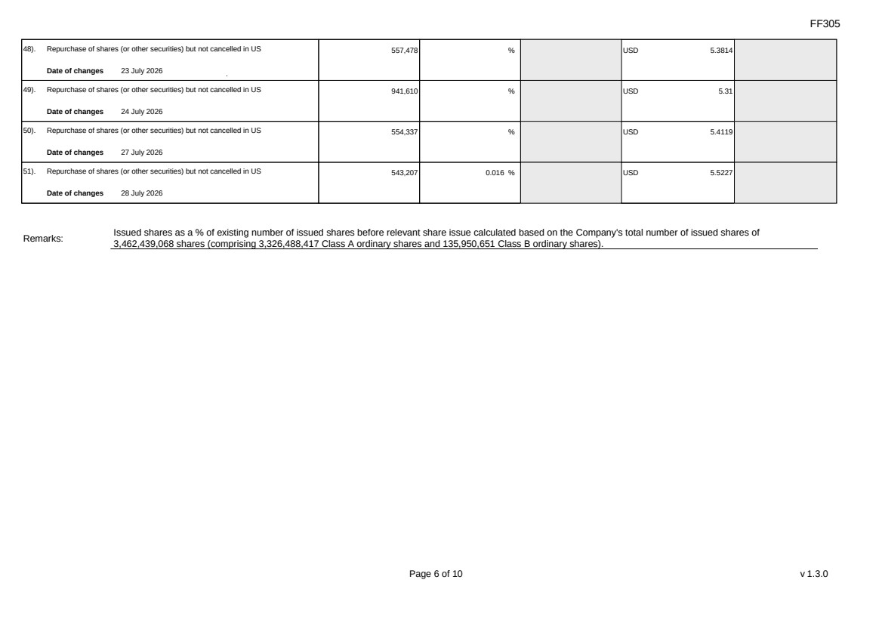 | FF305 Page 6 of 10 v 1.3.0 48). Repurchase of shares (or other securities) but not cancelled in US Date of changes 23 July 2026 557,478 % USD 5.3814 49). Repurchase of shares (or other securities) but not cancelled in US Date of changes 24 July 2026 941,610 % USD 5.31 50). Repurchase of shares (or other securities) but not cancelled in US Date of changes 27 July 2026 554,337 % USD 5.4119 51). Repurchase of shares (or other securities) but not cancelled in US Date of changes 28 July 2026 543,207 0.016 % USD 5.5227 Remarks: Issued shares as a % of existing number of issued shares before relevant share issue calculated based on the Company's total number of issued shares of 3,462,439,068 shares (comprising 3,326,488,417 Class A ordinary shares and 135,950,651 Class B ordinary shares).
FF305 Page 7 of 10 v 1.3.0 Confirmation Not applicable Notes to Section I: 1. Please insert the closing balance date of the last Next Day Disclosure Return published pursuant to Main Board Rule 13.25A / GEM Rule 17.27A or Monthly Return pursuant to Main Board Rule 13.25B / GEM Rule 17.27B, whichever is the later. 2. Please set out all changes in issued shares or treasury shares requiring disclosure pursuant to Main Board Rule 13.25A / GEM Rule 17.27A together with the relevant dates of changes. Each category will need to be disclosed individually with sufficient information to enable the user to identify the relevant category in the listed issuer's Monthly Return. For example, multiple issues of shares as a result of multiple exercises of share options under the same share option scheme or of multiple conversions under the same convertible note must be aggregated and disclosed as one category. However, if the issues resulted from exercises of share options under 2 share option schemes or conversions of 2 convertible notes, these must be disclosed as 2 separate categories. 3. The percentage change in the number of issued shares (excluding treasury shares) of the listed issuer is to be calculated by reference to the opening balance of the number of issued shares (excluding treasury shares) being disclosed in this Next Day Disclosure Return. 4. In the case of a share repurchase or redemption, the “issue/ selling price per share” shall be construed as “repurchase price per share” or “redemption price per share”. Where shares have been issued/ sold/ repurchased/ redeemed at more than one price per share, a volume-weighted average price per share should be given. 5. The closing balance date is the date of the last relevant event being disclosed. 6. For repurchase or redemption of shares, disclosure is required when the relevant event has occurred (subject to the provisions of Main Board Rules 10.06(4)(a), 13.25A and 13.31 / GEM Rules 13.13(1), 17.27A and 17.35), even if the repurchased or redeemed shares have not yet been cancelled. If repurchased or redeemed shares are to be cancelled upon settlement of such repurchase or redemption after the closing balance date, they shall remain part of the issued shares as at the closing balance date in Part A. Details of these repurchased or redeemed shares shall be disclosed in Part B. 7. Items (i) to (viii) are suggested forms of confirmation. The listed issuer may amend the item(s) that is/are not applicable to meet individual cases. 8. “Identical” means in this context: - the securities are of the same nominal value with the same amount called up or paid up; - they are entitled to dividend/interest at the same rate and for the same period, so that at the next ensuing distribution, the dividend/interest payable per unit will amount to exactly the same sum (gross and net); and - they carry the same rights as to unrestricted transfer, attendance and voting at meetings and rank pari passu in all other respects.
 | 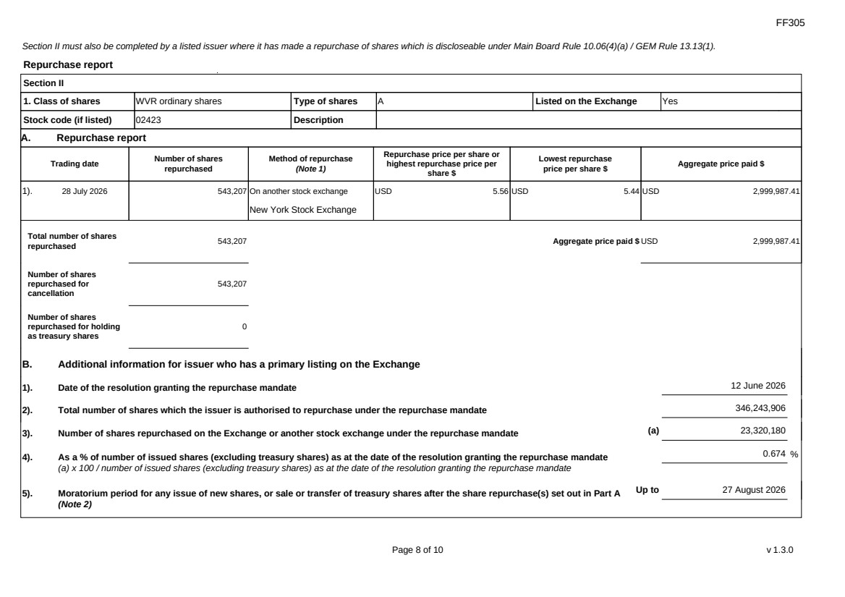 | FF305 Page 8 of 10 v 1.3.0 Section II must also be completed by a listed issuer where it has made a repurchase of shares which is discloseable under Main Board Rule 10.06(4)(a) / GEM Rule 13.13(1). Repurchase report Section II 1. Class of shares WVR ordinary shares Type of shares A Listed on the Exchange Yes Stock code (if listed) 02423 Description A. Repurchase report Trading date Number of shares repurchased Method of repurchase (Note 1) Repurchase price per share or highest repurchase price per share $ Lowest repurchase price per share $ Aggregate price paid $ 1). 28 July 2026 543,207 On another stock exchange New York Stock Exchange USD 5.56 USD 5.44 USD 2,999,987.41 Total number of shares repurchased 543,207 Aggregate price paid $ USD 2,999,987.41 Number of shares repurchased for cancellation 543,207 Number of shares repurchased for holding as treasury shares 0 B. Additional information for issuer who has a primary listing on the Exchange 1). Date of the resolution granting the repurchase mandate 12 June 2026 2). Total number of shares which the issuer is authorised to repurchase under the repurchase mandate 346,243,906 3). Number of shares repurchased on the Exchange or another stock exchange under the repurchase mandate (a) 23,320,180 4). As a % of number of issued shares (excluding treasury shares) as at the date of the resolution granting the repurchase mandate (a) x 100 / number of issued shares (excluding treasury shares) as at the date of the resolution granting the repurchase mandate 0.674 % 5). Moratorium period for any issue of new shares, or sale or transfer of treasury shares after the share repurchase(s) set out in Part A (Note 2) Up to 27 August 2026
FF305 Page 9 of 10 v 1.3.0 We hereby confirm that the repurchases made on the another stock exchange set out in Part A above were made in accordance with the Main Board Rules and that there have been no material changes to the particulars contained in the Explanatory Statement dated 24 April 2026 which has been filed with the Exchange. We also confirm that any repurchases made on another stock exchange set out in Part A above were made in accordance with the domestic rules applying to repurchases on that other stock exchange. Notes to Section II: 1. Please state whether the repurchase was made on the Exchange, on another stock exchange (stating the name of the exchange), by private arrangement or by general offer. 2. Subject to the carve-out set out in Main Board Rule 10.06(3)(a)/ GEM Rule 13.12, an issuer may not (i) make a new issue of shares, or a sale or transfer of any treasury shares; or (ii) announce a proposed new issue of shares, or a sale or transfer of any treasury shares, for a period of 30 days after any purchase by it of shares, whether on the Exchange or otherwise, without the prior approval of the Exchange.
FF305 Page 10 of 10 v 1.3.0 Section III must also be completed by a listed issuer where it has made a sale of treasury shares on the Exchange or any other stock exchange on which the issuer is listed which is discloseable under Main Board Rule 10.06B / GEM Rule 13.14B. Report of on-market sale of treasury shares Not applicable Submitted by: Siting Li (Name) Title: Joint Company Secretary (Director, Secretary or other Duly Authorised Officer)
Exhibit 99.4
 | 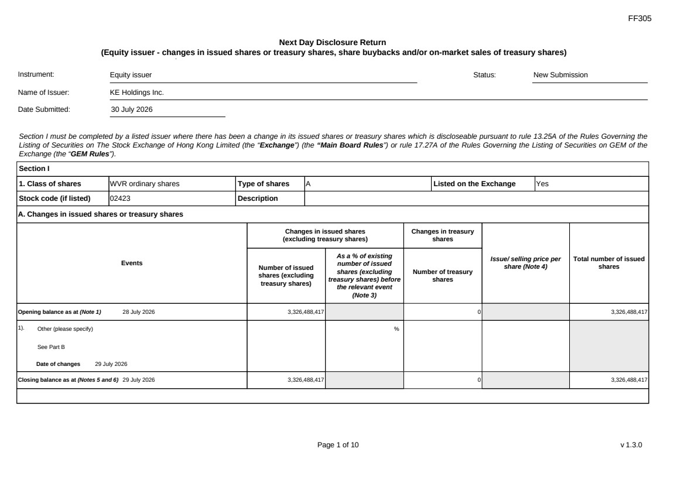 | FF305 Page 1 of 10 v 1.3.0 Next Day Disclosure Return (Equity issuer - changes in issued shares or treasury shares, share buybacks and/or on-market sales of treasury shares) Instrument: Equity issuer Status: New Submission Name of Issuer: KE Holdings Inc. Date Submitted: 30 July 2026 Section I must be completed by a listed issuer where there has been a change in its issued shares or treasury shares which is discloseable pursuant to rule 13.25A of the Rules Governing the Listing of Securities on The Stock Exchange of Hong Kong Limited (the “Exchange”) (the “Main Board Rules”) or rule 17.27A of the Rules Governing the Listing of Securities on GEM of the Exchange (the “GEM Rules”). Section I 1. Class of shares WVR ordinary shares Type of shares A Listed on the Exchange Yes Stock code (if listed) 02423 Description A. Changes in issued shares or treasury shares Events Changes in issued shares (excluding treasury shares) Number of issued shares (excluding treasury shares) As a % of existing number of issued shares (excluding treasury shares) before the relevant event (Note 3) Changes in treasury shares Number of treasury shares Issue/ selling price per share (Note 4) Total number of issued shares Opening balance as at (Note 1) 28 July 2026 3,326,488,417 0 3,326,488,417 1). Other (please specify) See Part B Date of changes 29 July 2026 % Closing balance as at (Notes 5 and 6) 29 July 2026 3,326,488,417 0 3,326,488,417
FF305 Page 2 of 10 v 1.3.0 B. Shares redeemed or repurchased for cancellation but not yet cancelled as at the closing balance date (Notes 5 and 6) 1). Repurchase of shares (or other securities) but not cancelled Date of changes 22 May 2026 464,900 % HKD 43.0128 2). Repurchase of shares (or other securities) but not cancelled Date of changes 26 May 2026 353,400 % HKD 42.4386 3). Repurchase of shares (or other securities) but not cancelled Date of changes 27 May 2026 351,100 % HKD 42.7177 4). Repurchase of shares (or other securities) but not cancelled Date of changes 28 May 2026 353,300 % HKD 42.4549 5). Repurchase of shares (or other securities) but not cancelled Date of changes 29 May 2026 344,000 % HKD 43.4567 6). Repurchase of shares (or other securities) but not cancelled Date of changes 01 June 2026 225,800 % HKD 44.2016 7). Repurchase of shares (or other securities) but not cancelled Date of changes 01 June 2026 351,294 % USD 5.6932 8). Repurchase of shares (or other securities) but not cancelled Date of changes 02 June 2026 221,700 % HKD 45.0078 9). Repurchase of shares (or other securities) but not cancelled in US Date of changes 02 June 2026 347,457 % USD 5.7561 10). Repurchase of shares (or other securities) but not cancelled in HK Date of changes 03 June 2026 225,300 % HKD 44.1933 11). Repurchase of shares (or other securities) but not cancelled in US Date of changes 03 June 2026 356,109 % USD 5.6162
FF305 Page 3 of 10 v 1.3.0 12). Repurchase of shares (or other securities) but not cancelled in HK Date of changes 04 June 2026 232,500 % HKD 42.9365 13). Repurchase of shares (or other securities) but not cancelled in US Date of changes 04 June 2026 360,564 % USD 5.5469 14). Repurchase of shares (or other securities) but not cancelled in HK Date of changes 05 June 2026 234,600 % HKD 42.572 15). Repurchase of shares (or other securities) but not cancelled in US Date of changes 08 June 2026 743,139 % USD 5.3826 16). Repurchase of shares (or other securities) but not cancelled in US Date of changes 09 June 2026 754,218 % USD 5.3035 17). Repurchase of shares (or other securities) but not cancelled in US Date of changes 10 June 2026 743,868 % USD 5.3689 18). Repurchase of shares (or other securities) but not cancelled in US Date of changes 16 June 2026 558,402 % USD 5.3724 19). Repurchase of shares (or other securities) but not cancelled in US Date of changes 17 June 2026 573,195 % USD 5.2338 20). Repurchase of shares (or other securities) but not cancelled in US Date of changes 18 June 2026 599,643 % USD 4.9974 21). Repurchase of shares (or other securities) but not cancelled in HK Date of changes 22 June 2026 331,000 % HKD 38.5996 22). Repurchase of shares (or other securities) but not cancelled in US Date of changes 22 June 2026 699,333 % USD 5.0037 23). Repurchase of shares (or other securities) but not cancelled in HK Date of changes 23 June 2026 340,200 % HKD 38.1947
FF305 Page 4 of 10 v 1.3.0 24). Repurchase of shares (or other securities) but not cancelled in US Date of changes 23 June 2026 706,239 % USD 4.9558 25). Repurchase of shares (or other securities) but not cancelled in HK Date of changes 24 June 2026 339,400 % HKD 38.2956 26). Repurchase of shares (or other securities) but not cancelled in US Date of changes 24 June 2026 708,603 % USD 4.9393 27). Repurchase of shares (or other securities) but not cancelled in HK Date of changes 25 June 2026 344,200 % HKD 37.5842 28). Repurchase of shares (or other securities) but not cancelled in US Date of changes 25 June 2026 731,535 % USD 4.7844 29). Repurchase of shares (or other securities) but not cancelled in HK Date of changes 26 June 2026 554,200 % HKD 36.0829 30). Repurchase of shares (or other securities) but not cancelled in US Date of changes 26 June 2026 1,060,005 % USD 4.717 31). Repurchase of shares (or other securities) but not cancelled in US Date of changes 29 June 2026 1,029,846 % USD 4.8551 32). Repurchase of shares (or other securities) but not cancelled in US Date of changes 30 June 2026 1,030,353 % USD 4.8488 33). Repurchase of shares (or other securities) but not cancelled in US Date of changes 01 July 2026 1,000,866 % USD 4.9957 34). Repurchase of shares (or other securities) but not cancelled in US Date of changes 02 July 2026 993,756 % USD 5.0314 35). Repurchase of shares (or other securities) but not cancelled in US Date of changes 06 July 2026 1,001,097 % USD 4.9945
FF305 Page 5 of 10 v 1.3.0 36). Repurchase of shares (or other securities) but not cancelled in US Date of changes 07 July 2026 1,603,404 % USD 4.9505 37). Repurchase of shares (or other securities) but not cancelled in US Date of changes 08 July 2026 978,039 % USD 5.1123 38). Repurchase of shares (or other securities) but not cancelled in US Date of changes 09 July 2026 981,660 % USD 5.0934 39). Repurchase of shares (or other securities) but not cancelled in US Date of changes 10 July 2026 958,839 % USD 5.2146 40). Repurchase of shares (or other securities) but not cancelled in US Date of changes 13 July 2026 559,518 % USD 5.3618 41). Repurchase of shares (or other securities) but not cancelled in US Date of changes 14 July 2026 555,324 % USD 5.4013 42). Repurchase of shares (or other securities) but not cancelled in US Date of changes 15 July 2026 348,282 % USD 5.7349 43). Repurchase of shares (or other securities) but not cancelled in US Date of changes 16 July 2026 341,601 % USD 5.8547 44). Repurchase of shares (or other securities) but not cancelled in US Date of changes 17 July 2026 344,856 % USD 5.7995 45). Repurchase of shares (or other securities) but not cancelled in US Date of changes 20 July 2026 353,649 % USD 5.6553 46). Repurchase of shares (or other securities) but not cancelled in US Date of changes 21 July 2026 540,408 % USD 5.5513 47). Repurchase of shares (or other securities) but not cancelled in US Date of changes 22 July 2026 556,095 % USD 5.3948
 | 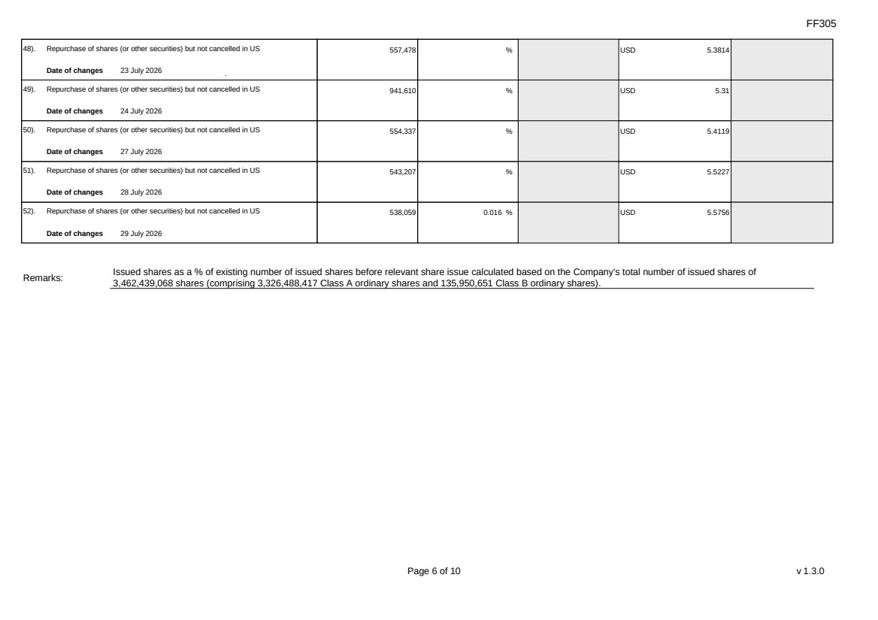 | FF305 Page 6 of 10 v 1.3.0 48). Repurchase of shares (or other securities) but not cancelled in US Date of changes 23 July 2026 557,478 % USD 5.3814 49). Repurchase of shares (or other securities) but not cancelled in US Date of changes 24 July 2026 941,610 % USD 5.31 50). Repurchase of shares (or other securities) but not cancelled in US Date of changes 27 July 2026 554,337 % USD 5.4119 51). Repurchase of shares (or other securities) but not cancelled in US Date of changes 28 July 2026 543,207 % USD 5.5227 52). Repurchase of shares (or other securities) but not cancelled in US Date of changes 29 July 2026 538,059 0.016 % USD 5.5756 Remarks: Issued shares as a % of existing number of issued shares before relevant share issue calculated based on the Company's total number of issued shares of 3,462,439,068 shares (comprising 3,326,488,417 Class A ordinary shares and 135,950,651 Class B ordinary shares).
FF305 Page 7 of 10 v 1.3.0 Confirmation Not applicable Notes to Section I: 1. Please insert the closing balance date of the last Next Day Disclosure Return published pursuant to Main Board Rule 13.25A / GEM Rule 17.27A or Monthly Return pursuant to Main Board Rule 13.25B / GEM Rule 17.27B, whichever is the later. 2. Please set out all changes in issued shares or treasury shares requiring disclosure pursuant to Main Board Rule 13.25A / GEM Rule 17.27A together with the relevant dates of changes. Each category will need to be disclosed individually with sufficient information to enable the user to identify the relevant category in the listed issuer's Monthly Return. For example, multiple issues of shares as a result of multiple exercises of share options under the same share option scheme or of multiple conversions under the same convertible note must be aggregated and disclosed as one category. However, if the issues resulted from exercises of share options under 2 share option schemes or conversions of 2 convertible notes, these must be disclosed as 2 separate categories. 3. The percentage change in the number of issued shares (excluding treasury shares) of the listed issuer is to be calculated by reference to the opening balance of the number of issued shares (excluding treasury shares) being disclosed in this Next Day Disclosure Return. 4. In the case of a share repurchase or redemption, the “issue/ selling price per share” shall be construed as “repurchase price per share” or “redemption price per share”. Where shares have been issued/ sold/ repurchased/ redeemed at more than one price per share, a volume-weighted average price per share should be given. 5. The closing balance date is the date of the last relevant event being disclosed. 6. For repurchase or redemption of shares, disclosure is required when the relevant event has occurred (subject to the provisions of Main Board Rules 10.06(4)(a), 13.25A and 13.31 / GEM Rules 13.13(1), 17.27A and 17.35), even if the repurchased or redeemed shares have not yet been cancelled. If repurchased or redeemed shares are to be cancelled upon settlement of such repurchase or redemption after the closing balance date, they shall remain part of the issued shares as at the closing balance date in Part A. Details of these repurchased or redeemed shares shall be disclosed in Part B. 7. Items (i) to (viii) are suggested forms of confirmation. The listed issuer may amend the item(s) that is/are not applicable to meet individual cases. 8. “Identical” means in this context: - the securities are of the same nominal value with the same amount called up or paid up; - they are entitled to dividend/interest at the same rate and for the same period, so that at the next ensuing distribution, the dividend/interest payable per unit will amount to exactly the same sum (gross and net); and - they carry the same rights as to unrestricted transfer, attendance and voting at meetings and rank pari passu in all other respects.
 | 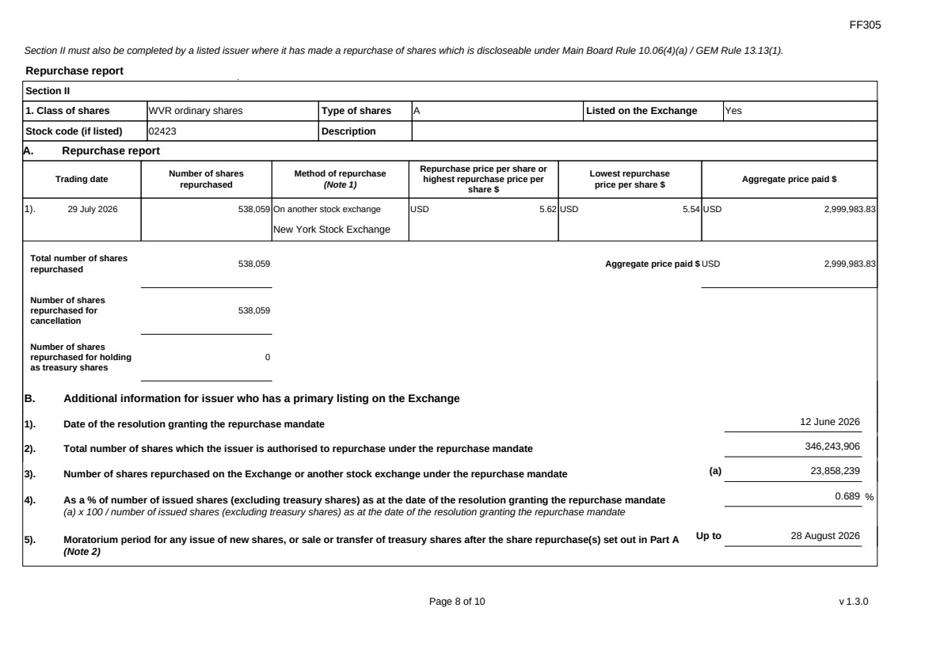 | FF305 Page 8 of 10 v 1.3.0 Section II must also be completed by a listed issuer where it has made a repurchase of shares which is discloseable under Main Board Rule 10.06(4)(a) / GEM Rule 13.13(1). Repurchase report Section II 1. Class of shares WVR ordinary shares Type of shares A Listed on the Exchange Yes Stock code (if listed) 02423 Description A. Repurchase report Trading date Number of shares repurchased Method of repurchase (Note 1) Repurchase price per share or highest repurchase price per share $ Lowest repurchase price per share $ Aggregate price paid $ 1). 29 July 2026 538,059 On another stock exchange New York Stock Exchange USD 5.62 USD 5.54 USD 2,999,983.83 Total number of shares repurchased 538,059 Aggregate price paid $ USD 2,999,983.83 Number of shares repurchased for cancellation 538,059 Number of shares repurchased for holding as treasury shares 0 B. Additional information for issuer who has a primary listing on the Exchange 1). Date of the resolution granting the repurchase mandate 12 June 2026 2). Total number of shares which the issuer is authorised to repurchase under the repurchase mandate 346,243,906 3). Number of shares repurchased on the Exchange or another stock exchange under the repurchase mandate (a) 23,858,239 4). As a % of number of issued shares (excluding treasury shares) as at the date of the resolution granting the repurchase mandate (a) x 100 / number of issued shares (excluding treasury shares) as at the date of the resolution granting the repurchase mandate 0.689 % 5). Moratorium period for any issue of new shares, or sale or transfer of treasury shares after the share repurchase(s) set out in Part A (Note 2) Up to 28 August 2026
FF305 Page 9 of 10 v 1.3.0 We hereby confirm that the repurchases made on the another stock exchange set out in Part A above were made in accordance with the Main Board Rules and that there have been no material changes to the particulars contained in the Explanatory Statement dated 24 April 2026 which has been filed with the Exchange. We also confirm that any repurchases made on another stock exchange set out in Part A above were made in accordance with the domestic rules applying to repurchases on that other stock exchange. Notes to Section II: 1. Please state whether the repurchase was made on the Exchange, on another stock exchange (stating the name of the exchange), by private arrangement or by general offer. 2. Subject to the carve-out set out in Main Board Rule 10.06(3)(a)/ GEM Rule 13.12, an issuer may not (i) make a new issue of shares, or a sale or transfer of any treasury shares; or (ii) announce a proposed new issue of shares, or a sale or transfer of any treasury shares, for a period of 30 days after any purchase by it of shares, whether on the Exchange or otherwise, without the prior approval of the Exchange.
FF305 Page 10 of 10 v 1.3.0 Section III must also be completed by a listed issuer where it has made a sale of treasury shares on the Exchange or any other stock exchange on which the issuer is listed which is discloseable under Main Board Rule 10.06B / GEM Rule 13.14B. Report of on-market sale of treasury shares Not applicable Submitted by: Siting Li (Name) Title: Joint Company Secretary (Director, Secretary or other Duly Authorised Officer)
Exhibit 99.5
 | 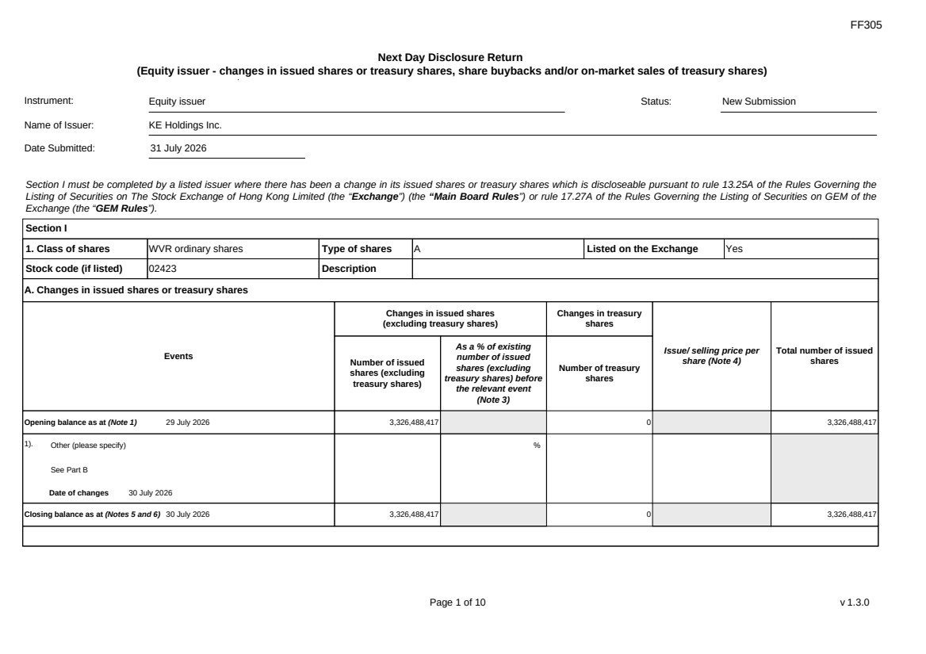 | FF305 Page 1 of 10 v 1.3.0 Next Day Disclosure Return (Equity issuer - changes in issued shares or treasury shares, share buybacks and/or on-market sales of treasury shares) Instrument: Equity issuer Status: New Submission Name of Issuer: KE Holdings Inc. Date Submitted: 31 July 2026 Section I must be completed by a listed issuer where there has been a change in its issued shares or treasury shares which is discloseable pursuant to rule 13.25A of the Rules Governing the Listing of Securities on The Stock Exchange of Hong Kong Limited (the “Exchange”) (the “Main Board Rules”) or rule 17.27A of the Rules Governing the Listing of Securities on GEM of the Exchange (the “GEM Rules”). Section I 1. Class of shares WVR ordinary shares Type of shares A Listed on the Exchange Yes Stock code (if listed) 02423 Description A. Changes in issued shares or treasury shares Events Changes in issued shares (excluding treasury shares) Number of issued shares (excluding treasury shares) As a % of existing number of issued shares (excluding treasury shares) before the relevant event (Note 3) Changes in treasury shares Number of treasury shares Issue/ selling price per share (Note 4) Total number of issued shares Opening balance as at (Note 1) 29 July 2026 3,326,488,417 0 3,326,488,417 1). Other (please specify) See Part B Date of changes 30 July 2026 % Closing balance as at (Notes 5 and 6) 30 July 2026 3,326,488,417 0 3,326,488,417
FF305 Page 2 of 10 v 1.3.0 B. Shares redeemed or repurchased for cancellation but not yet cancelled as at the closing balance date (Notes 5 and 6) 1). Repurchase of shares (or other securities) but not cancelled Date of changes 22 May 2026 464,900 % HKD 43.0128 2). Repurchase of shares (or other securities) but not cancelled Date of changes 26 May 2026 353,400 % HKD 42.4386 3). Repurchase of shares (or other securities) but not cancelled Date of changes 27 May 2026 351,100 % HKD 42.7177 4). Repurchase of shares (or other securities) but not cancelled Date of changes 28 May 2026 353,300 % HKD 42.4549 5). Repurchase of shares (or other securities) but not cancelled Date of changes 29 May 2026 344,000 % HKD 43.4567 6). Repurchase of shares (or other securities) but not cancelled Date of changes 01 June 2026 225,800 % HKD 44.2016 7). Repurchase of shares (or other securities) but not cancelled Date of changes 01 June 2026 351,294 % USD 5.6932 8). Repurchase of shares (or other securities) but not cancelled Date of changes 02 June 2026 221,700 % HKD 45.0078 9). Repurchase of shares (or other securities) but not cancelled in US Date of changes 02 June 2026 347,457 % USD 5.7561 10). Repurchase of shares (or other securities) but not cancelled in HK Date of changes 03 June 2026 225,300 % HKD 44.1933 11). Repurchase of shares (or other securities) but not cancelled in US Date of changes 03 June 2026 356,109 % USD 5.6162
FF305 Page 3 of 10 v 1.3.0 12). Repurchase of shares (or other securities) but not cancelled in HK Date of changes 04 June 2026 232,500 % HKD 42.9365 13). Repurchase of shares (or other securities) but not cancelled in US Date of changes 04 June 2026 360,564 % USD 5.5469 14). Repurchase of shares (or other securities) but not cancelled in HK Date of changes 05 June 2026 234,600 % HKD 42.572 15). Repurchase of shares (or other securities) but not cancelled in US Date of changes 08 June 2026 743,139 % USD 5.3826 16). Repurchase of shares (or other securities) but not cancelled in US Date of changes 09 June 2026 754,218 % USD 5.3035 17). Repurchase of shares (or other securities) but not cancelled in US Date of changes 10 June 2026 743,868 % USD 5.3689 18). Repurchase of shares (or other securities) but not cancelled in US Date of changes 16 June 2026 558,402 % USD 5.3724 19). Repurchase of shares (or other securities) but not cancelled in US Date of changes 17 June 2026 573,195 % USD 5.2338 20). Repurchase of shares (or other securities) but not cancelled in US Date of changes 18 June 2026 599,643 % USD 4.9974 21). Repurchase of shares (or other securities) but not cancelled in HK Date of changes 22 June 2026 331,000 % HKD 38.5996 22). Repurchase of shares (or other securities) but not cancelled in US Date of changes 22 June 2026 699,333 % USD 5.0037 23). Repurchase of shares (or other securities) but not cancelled in HK Date of changes 23 June 2026 340,200 % HKD 38.1947
FF305 Page 4 of 10 v 1.3.0 24). Repurchase of shares (or other securities) but not cancelled in US Date of changes 23 June 2026 706,239 % USD 4.9558 25). Repurchase of shares (or other securities) but not cancelled in HK Date of changes 24 June 2026 339,400 % HKD 38.2956 26). Repurchase of shares (or other securities) but not cancelled in US Date of changes 24 June 2026 708,603 % USD 4.9393 27). Repurchase of shares (or other securities) but not cancelled in HK Date of changes 25 June 2026 344,200 % HKD 37.5842 28). Repurchase of shares (or other securities) but not cancelled in US Date of changes 25 June 2026 731,535 % USD 4.7844 29). Repurchase of shares (or other securities) but not cancelled in HK Date of changes 26 June 2026 554,200 % HKD 36.0829 30). Repurchase of shares (or other securities) but not cancelled in US Date of changes 26 June 2026 1,060,005 % USD 4.717 31). Repurchase of shares (or other securities) but not cancelled in US Date of changes 29 June 2026 1,029,846 % USD 4.8551 32). Repurchase of shares (or other securities) but not cancelled in US Date of changes 30 June 2026 1,030,353 % USD 4.8488 33). Repurchase of shares (or other securities) but not cancelled in US Date of changes 01 July 2026 1,000,866 % USD 4.9957 34). Repurchase of shares (or other securities) but not cancelled in US Date of changes 02 July 2026 993,756 % USD 5.0314 35). Repurchase of shares (or other securities) but not cancelled in US Date of changes 06 July 2026 1,001,097 % USD 4.9945
FF305 Page 5 of 10 v 1.3.0 36). Repurchase of shares (or other securities) but not cancelled in US Date of changes 07 July 2026 1,603,404 % USD 4.9505 37). Repurchase of shares (or other securities) but not cancelled in US Date of changes 08 July 2026 978,039 % USD 5.1123 38). Repurchase of shares (or other securities) but not cancelled in US Date of changes 09 July 2026 981,660 % USD 5.0934 39). Repurchase of shares (or other securities) but not cancelled in US Date of changes 10 July 2026 958,839 % USD 5.2146 40). Repurchase of shares (or other securities) but not cancelled in US Date of changes 13 July 2026 559,518 % USD 5.3618 41). Repurchase of shares (or other securities) but not cancelled in US Date of changes 14 July 2026 555,324 % USD 5.4013 42). Repurchase of shares (or other securities) but not cancelled in US Date of changes 15 July 2026 348,282 % USD 5.7349 43). Repurchase of shares (or other securities) but not cancelled in US Date of changes 16 July 2026 341,601 % USD 5.8547 44). Repurchase of shares (or other securities) but not cancelled in US Date of changes 17 July 2026 344,856 % USD 5.7995 45). Repurchase of shares (or other securities) but not cancelled in US Date of changes 20 July 2026 353,649 % USD 5.6553 46). Repurchase of shares (or other securities) but not cancelled in US Date of changes 21 July 2026 540,408 % USD 5.5513 47). Repurchase of shares (or other securities) but not cancelled in US Date of changes 22 July 2026 556,095 % USD 5.3948
 | 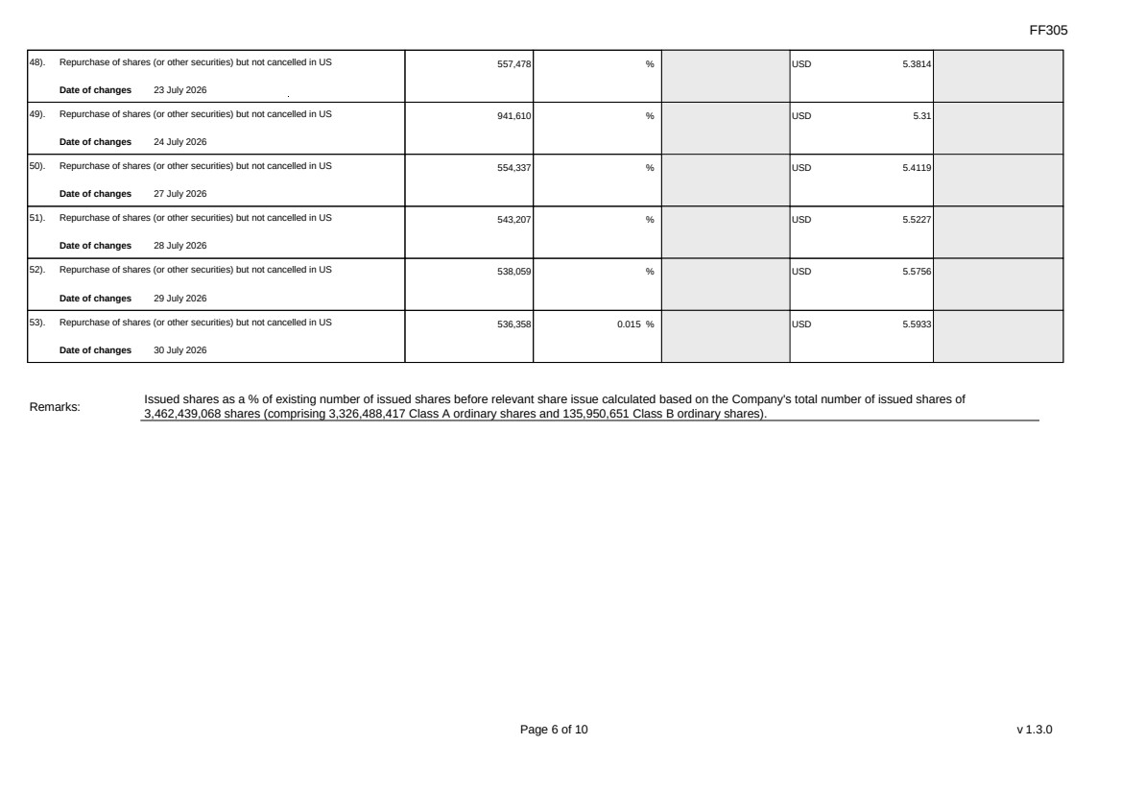 | FF305 Page 6 of 10 v 1.3.0 48). Repurchase of shares (or other securities) but not cancelled in US Date of changes 23 July 2026 557,478 % USD 5.3814 49). Repurchase of shares (or other securities) but not cancelled in US Date of changes 24 July 2026 941,610 % USD 5.31 50). Repurchase of shares (or other securities) but not cancelled in US Date of changes 27 July 2026 554,337 % USD 5.4119 51). Repurchase of shares (or other securities) but not cancelled in US Date of changes 28 July 2026 543,207 % USD 5.5227 52). Repurchase of shares (or other securities) but not cancelled in US Date of changes 29 July 2026 538,059 % USD 5.5756 53). Repurchase of shares (or other securities) but not cancelled in US Date of changes 30 July 2026 536,358 0.015 % USD 5.5933 Remarks: Issued shares as a % of existing number of issued shares before relevant share issue calculated based on the Company's total number of issued shares of 3,462,439,068 shares (comprising 3,326,488,417 Class A ordinary shares and 135,950,651 Class B ordinary shares).
FF305 Page 7 of 10 v 1.3.0 Confirmation Not applicable Notes to Section I: 1. Please insert the closing balance date of the last Next Day Disclosure Return published pursuant to Main Board Rule 13.25A / GEM Rule 17.27A or Monthly Return pursuant to Main Board Rule 13.25B / GEM Rule 17.27B, whichever is the later. 2. Please set out all changes in issued shares or treasury shares requiring disclosure pursuant to Main Board Rule 13.25A / GEM Rule 17.27A together with the relevant dates of changes. Each category will need to be disclosed individually with sufficient information to enable the user to identify the relevant category in the listed issuer's Monthly Return. For example, multiple issues of shares as a result of multiple exercises of share options under the same share option scheme or of multiple conversions under the same convertible note must be aggregated and disclosed as one category. However, if the issues resulted from exercises of share options under 2 share option schemes or conversions of 2 convertible notes, these must be disclosed as 2 separate categories. 3. The percentage change in the number of issued shares (excluding treasury shares) of the listed issuer is to be calculated by reference to the opening balance of the number of issued shares (excluding treasury shares) being disclosed in this Next Day Disclosure Return. 4. In the case of a share repurchase or redemption, the “issue/ selling price per share” shall be construed as “repurchase price per share” or “redemption price per share”. Where shares have been issued/ sold/ repurchased/ redeemed at more than one price per share, a volume-weighted average price per share should be given. 5. The closing balance date is the date of the last relevant event being disclosed. 6. For repurchase or redemption of shares, disclosure is required when the relevant event has occurred (subject to the provisions of Main Board Rules 10.06(4)(a), 13.25A and 13.31 / GEM Rules 13.13(1), 17.27A and 17.35), even if the repurchased or redeemed shares have not yet been cancelled. If repurchased or redeemed shares are to be cancelled upon settlement of such repurchase or redemption after the closing balance date, they shall remain part of the issued shares as at the closing balance date in Part A. Details of these repurchased or redeemed shares shall be disclosed in Part B. 7. Items (i) to (viii) are suggested forms of confirmation. The listed issuer may amend the item(s) that is/are not applicable to meet individual cases. 8. “Identical” means in this context: - the securities are of the same nominal value with the same amount called up or paid up; - they are entitled to dividend/interest at the same rate and for the same period, so that at the next ensuing distribution, the dividend/interest payable per unit will amount to exactly the same sum (gross and net); and - they carry the same rights as to unrestricted transfer, attendance and voting at meetings and rank pari passu in all other respects.
 | 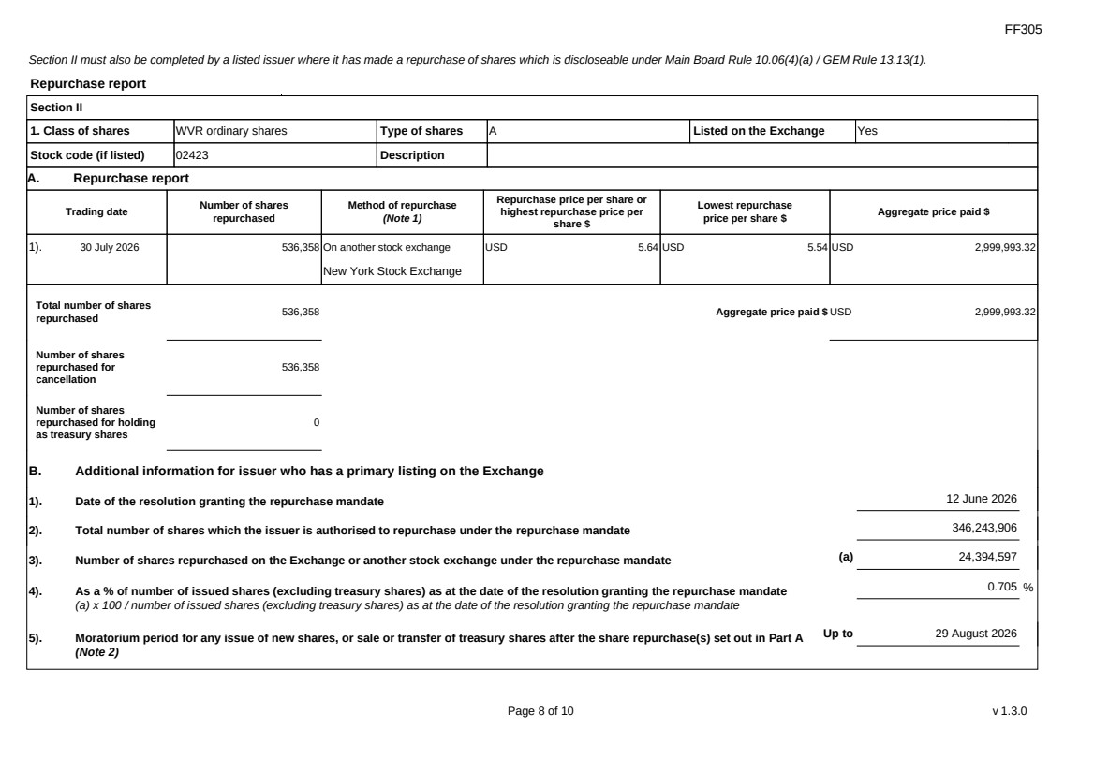 | FF305 Page 8 of 10 v 1.3.0 Section II must also be completed by a listed issuer where it has made a repurchase of shares which is discloseable under Main Board Rule 10.06(4)(a) / GEM Rule 13.13(1). Repurchase report Section II 1. Class of shares WVR ordinary shares Type of shares A Listed on the Exchange Yes Stock code (if listed) 02423 Description A. Repurchase report Trading date Number of shares repurchased Method of repurchase (Note 1) Repurchase price per share or highest repurchase price per share $ Lowest repurchase price per share $ Aggregate price paid $ 1). 30 July 2026 536,358 On another stock exchange New York Stock Exchange USD 5.64 USD 5.54 USD 2,999,993.32 Total number of shares repurchased 536,358 Aggregate price paid $ USD 2,999,993.32 Number of shares repurchased for cancellation 536,358 Number of shares repurchased for holding as treasury shares 0 B. Additional information for issuer who has a primary listing on the Exchange 1). Date of the resolution granting the repurchase mandate 12 June 2026 2). Total number of shares which the issuer is authorised to repurchase under the repurchase mandate 346,243,906 3). Number of shares repurchased on the Exchange or another stock exchange under the repurchase mandate (a) 24,394,597 4). As a % of number of issued shares (excluding treasury shares) as at the date of the resolution granting the repurchase mandate (a) x 100 / number of issued shares (excluding treasury shares) as at the date of the resolution granting the repurchase mandate 0.705 % 5). Moratorium period for any issue of new shares, or sale or transfer of treasury shares after the share repurchase(s) set out in Part A (Note 2) Up to 29 August 2026
FF305 Page 9 of 10 v 1.3.0 We hereby confirm that the repurchases made on the another stock exchange set out in Part A above were made in accordance with the Main Board Rules and that there have been no material changes to the particulars contained in the Explanatory Statement dated 24 April 2026 which has been filed with the Exchange. We also confirm that any repurchases made on another stock exchange set out in Part A above were made in accordance with the domestic rules applying to repurchases on that other stock exchange. Notes to Section II: 1. Please state whether the repurchase was made on the Exchange, on another stock exchange (stating the name of the exchange), by private arrangement or by general offer. 2. Subject to the carve-out set out in Main Board Rule 10.06(3)(a)/ GEM Rule 13.12, an issuer may not (i) make a new issue of shares, or a sale or transfer of any treasury shares; or (ii) announce a proposed new issue of shares, or a sale or transfer of any treasury shares, for a period of 30 days after any purchase by it of shares, whether on the Exchange or otherwise, without the prior approval of the Exchange.
FF305 Page 10 of 10 v 1.3.0 Section III must also be completed by a listed issuer where it has made a sale of treasury shares on the Exchange or any other stock exchange on which the issuer is listed which is discloseable under Main Board Rule 10.06B / GEM Rule 13.14B. Report of on-market sale of treasury shares Not applicable Submitted by: Siting Li (Name) Title: Joint Company Secretary (Director, Secretary or other Duly Authorised Officer)

